Chapter 9 Module 18: Correlational Research
- Label each of the scatterplots below to indicate whether the correlation it shows is
positive, negative, curvilinear, or zero or near zero.

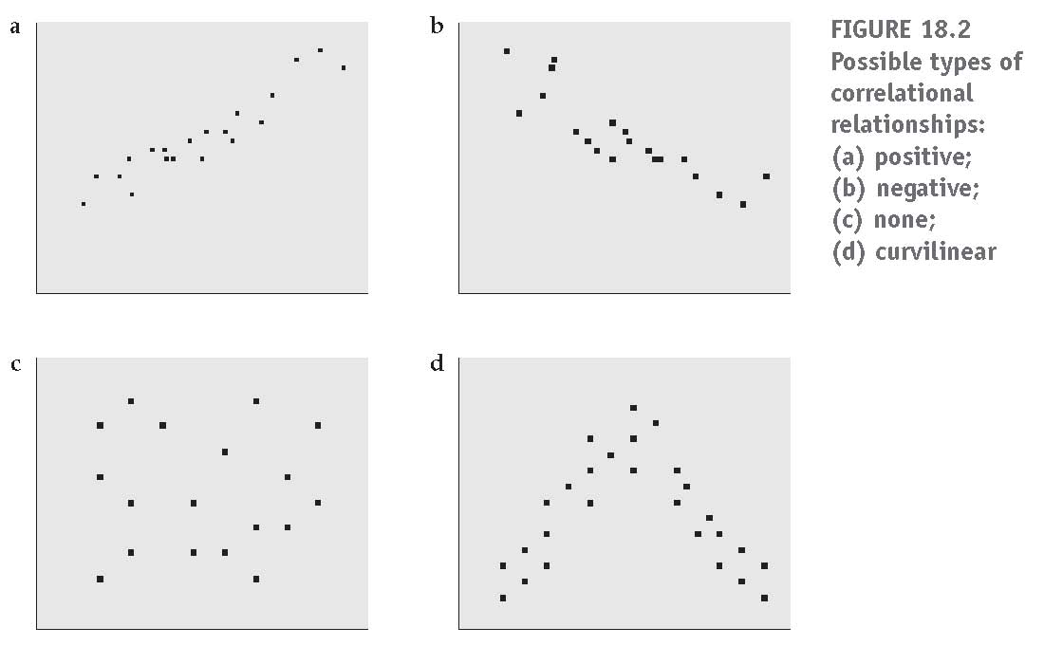
a. ___Negative Correlation____ b. _Positive Correlation__
c. _Zero or near zero Correlation_ d. ___Curvilinear Correlation___

- In a recent study the correlation between self-esteem and depression was found to be –0.64.
Tom interprets this to mean that low levels of self-esteem lead to high levels of depression.
a. Explain what a correlation of –0.64 means.

There is a strong negative relationship between self-esteem and depression.

b. Calculate the coefficient of determination for this correlation and explain what this indicates. SHOW YOUR CALCULATIONS.

R² = (-0.64)²
= 0.4096

c. What is incorrect about Tom’s interpretation of the correlation?

It is not true that low levels of self-esteem lead to high levels of depression. While causation and correlation can exist at the same time, correlation does not imply causation. Causation explicitly applies to cases where action A causes outcome B. On the other hand, correlation is simply a relationship

Chapter 9 Module 19: Correlation Coefficients
- Use the following data to answer the questions below. (This is based on Module 19 Exercise 4.)

 | Student | IQ Score | Statistics Exam Score | IQ z Score | Stat Exam z Score | Z_{IQ}Z_{Stat}
 | 1 | 140 | 47 | 2.367 | 1.163 | 2.754
 | 2 | 98 | 32 | -1.413 | -1.745 | 2.466
 | 3 | 105 | 38 | -0.783 | -0.582 | 0.456
 | 4 | 120 | 40 | 0.567 | -0.194 | -0.110
 | 5 | 119 | 40 | 0.477 | -0.194 | -0.093
 | 6 | 114 | 43 | 0.027 | 0.388 | 0.010
 | 7 | 102 | 33 | -1.053 | -1.551 | 1.634
 | 8 | 112 | 47 | -0.153 | 1.163 | -0.178
 | 9 | 111 | 46 | -0.243 | 0.969 | -0.236
 | 10 | 116 | 44 | 0.207 | 0.581 | 0.120
Means |  | 113.70 | 41.00 | r=
Dev Squared |  | 1,234.10 | 266.00 | r²=
Sample Std Dev |  | 11.11 | 5.16

- Fill in the last three columns for Student 10. In other words, determine the z scores for Student 10 and then the cross-product that goes in the last column. SHOW YOUR CALCULATIONS.

IQ z Score = $\frac{116-113.7}{11.11}$ = 0.207

Stat Exam Z score = $\frac{44-41}{5.16}$ = 0.581

- Determine the Pearson product-moment correlation between IQ scores and statistics exam scores. SHOW YOUR CALCULATIONS.

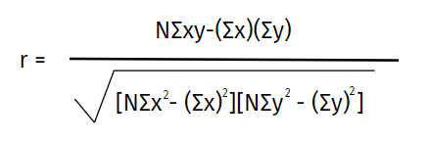
Pair | X | Y | X² | Y² | XY
1 | 140 | 47 | 19600 | 2209 | 6580
2 | 98 | 32 | 9604 | 1024 | 3136
3 | 105 | 38 | 11025 | 1444 | 3990
4 | 120 | 40 | 14400 | 1600 | 4800
5 | 119 | 40 | 14161 | 1600 | 4760
6 | 114 | 43 | 12996 | 1849 | 4902
7 | 102 | 33 | 10404 | 1089 | 3366
8 | 112 | 47 | 12544 | 2209 | 5264
9 | 111 | 46 | 12321 | 2116 | 5106
10 | 116 | 44 | 13456 | 1936 | 5104
∑ | 1137 | 410 | 130511 | 17076 | 47008

r = $\frac{10\left(47008\right)-(1137*410)}{\sqrt{(10*130511-{1137}^{2})(10*17076- {17076}^{2})}}$

= 0.6824
- Calculate the coefficient of determination for the correlation coefficient between IQ scores and statistics exam scores. Explain what this means.

R² = ${0.6824}^{2}$

= 0.4657
46.57% of variability in Statistics Exam score can be explained by IQ score.

Chapter 09 Module 20: Regression Analysis
- For the data in Question 3 above, determine the regression equation for IQ scores and statistics exam scores. Let Y' represent the predicted statistics exam score for a certain IQ score X.

ŷ = bX + a
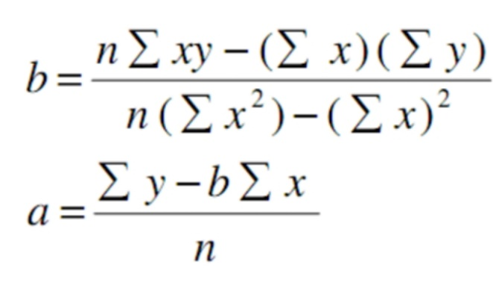

b = $\frac{10*47008-1137*410}{10*130511- {1137}^{2}}$

=$0.3168$

a = $\frac{410* -0.3168*1137}{10}$

= 4.9746

Regression equation: ŷ = 0.317X + 4.975

- Assume that the regression equation for statistics exam scores and psychology exam scores is
Y' = 0.586X + 17.43, where Y' represents the predicted statistics exam score and X is a particular psychology exam score. What would you expect the statistics exam score to be for each of the following individuals whose psychology exam scores are given?

Student | Psychology Exam Score | Statistics Exam Score
Linda | 30 | 35.01
Marilyn | 39 | 40.28
Heidi | 48 | 45.56

Chapter 10 Module 21: Chi-Square Tests
- According to the U.S. Bureau of the Census, 75% of adults regularly drank alcohol in 1985. An investigator predicts that fewer adults drink now than they did back then. A sample of 100 adults is asked about their current drinking habits and 67 report drinking while 33 report not drinking. Fill in the table below as though you were going to conduct a χ2 goodness-of-fit test.

Frequencies | Report Drinking | Report Not Drinking | Totals
Observed | 67 | 33 | 100
Expected | 75 | 25 | 100
Totals | 142 | 58 | 200

- In your introductory psychology class, more men seem to sit near the door and more women seem to sit away from the door. To determine whether men sit near the door significantly more often than women, you collect data on the seating preferences for the students in your class. The data appear below, and the questions follow.

 | Males | Females
Near the Door | 25 | 14
Away from the Door | 12 | 20

- Identify H₀ and H_{a} for this study.

H₀: There is no difference in sitting preferences
H_{a}: There are difference in sitting preferences

- Conduct a χ² test of independence. SHOW YOUR CALCULATIONS.

EXPECTED VALUES | M | F | Total
Near | $\frac{37*39}{71}$ = 20.324 | $\frac{34*39}{71}$ = 18.676 | 39
Away | $\frac{37*32}{71}$ = 16.676 | $\frac{34*32}{71}$ = 15.324 | 32
Total | 37 | 34 | 71

Computing squared distance using the formula: $\frac{{(0-E)}^{2}}{E}$

SQUARED DISTANCES | M | F
Near | $$1.076$$ | $$1.171$$
Away | 1.311 | $$1.427$$

df = (2-1) (2-1) = 1
Rejection region: R = {χ² > 3.841}

χ² = 1.076 + 1.311 + 1.171 + 1.427
= 4.985
- Should H₀ be rejected? What should the researcher conclude?

Since it is observed that χ2=4.985> χ²_{c} = 3.841, it is then concluded that the null hypothesis is rejected. Therefore, there is not enough evidence to claim that the two variables are dependent, at the α=0.05 significance level.

Chapter 10 Module 22: Tests for Ordinal Data
- A researcher wants to compare the maturity level of students who volunteer for community service to the maturity level of those who do not. She believes that completing community service leads to higher maturity scores. Maturity scores tend to be skewed (not normally distributed). The maturity scores follow. Higher scores indicate higher maturity levels. (This is Module 22 Exercise 4.)

 | Sorted Data | Original Data | Original Data | Sorted Data
Community Service Rank | Community Service | Community Service | No Community Service | No Community Service | No Community Service Rank
 | 41 | 41 | 33 | 13
 | 48 | 48 | 41 | 22
 | 55 | 61 | 54 | 26
 | 61 | 72 | 13 | 33
 | 72 | 83 | 22 | 41
 | 83 | 55 | 26 | 54
Sum = 360 |  |  |  |  | Sum = 189

a. Fill in the ranks in the first and last columns, giving the lowest number a rank of 1, etc. Then write the sum of the ranks in the first column at the bottom of that column and the sum of the ranks in the second column at the bottom of that column.

b. For n₁=6 and n₂=6, Table A.8 gives 28 as the critical value. Which sum is compared to this critical value to determine if there is a significant difference between those who complete community service and those who do not?
W - $\frac{n(n+1)}{2}$ where W is the sum of ranks for Community Service

c. Is there a significant difference or not? What do you conclude about community service?

