Steep Analysis
Name:
Course:
Date:

Introduction
In this text, the environmental aspect of Taiwan in support of the production of the beer industry will be analyzed. The focus is to understand whether Taiwan as a country has the potential to support and embrace the craft beer industry. In the STEEP analysis, the environment covers a number of factors such as pollution, water, wind, energy and the environmental regulations. In this analysis, there are questions that need to answer in order to determine the ability of Taiwan to support the production of craft beer while taking care of the customers’ health, the environmental resources such as water. The environment is an important factor in any society and must be taken care of. Therefore, caring for the environment calls for measures such as laws and regulations that protect it from damage and pollution. In the beer industry, there must be the implementation of laws that guide waste management and disposal, energy saving technologies, clean air and water and then a positive attitude towards the environment in the community (In Slocum, et. al., 2018).
Inside Taiwan’s craft beer, industry lies a lot of potentials and breweries have taken advantage of both the local and foreign beer markets. The beer has been popular in Taiwan for many years. In 2002, Taiwan gained a desire for small batch microbrewing. In the same year, in order to comply with the WTO environmental and trade regulations, Taiwan joined the member policy, which broke up the industry monopolies. Investors joined the craft beer industry quickly and began brewing operations. Volumes of craft beer were produced by the new market entries. The generation of small restaurants began and has since then expanded (Carr-Harris, et. al., 2016).
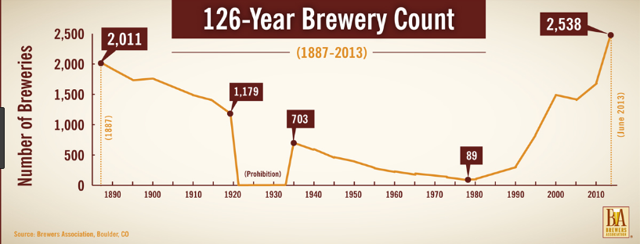
Recycling
In Taiwan, the Beer industry brewers, as well as the suppliers, have worked hard in ensuring that the beer packaging is well done. This is to ensure that the customer is safe and can consume the beer without any health issues. The packaging involves the use of recyclable plastic, cardboard, paper, or glass in the beer cans or the beer bottles and packs. The recycled glass totals to over 30% of the materials are used to make new bottles (International Business Publications & USA., 2016). Major bottling companies are using this strategy in Taiwan to manage waste in the community. Different bodies in the country have been championing for corporate recycling programs by both the brewers and the brewer suppliers to recycle their waste as well. Reuse of beer bottles has also been encouraged, for example, Heineken usually packages beer in returnable bottles and this is an initiative encouraged in Taiwan to control environment pollution (International Business Publications & USA., 2016).
Water conservation and treatment
Water is necessary and an important ingredient in beer production. It is used in the production process and a lot of waste is released. This waste is directed to the environmental resources such as rivers, sea, or the soil. Some of it might cause damage to the environment because of the chemicals present in the effluent. The government of Taiwan under the department of environment has put across strategies that are key to preventing not only careless disposal of waste but also use of water sparingly. Brewers have been encouraged to keep regular maintenance of the piping and faucets in order to ensure that water leaks are repaired in time and loss of water is minimized. Water treatment plans are also necessary for the brewers in order to treat the wastewater before releasing it to the environment. Water treatment reduces the strength of the chemicals and the volume of wastewater released. It is one way that the brewers produce biogas, which is used as fuel in the plants. Investment in new water treatment systems has helped the country to save the environment from pollution (Kong, et. al., 2015).
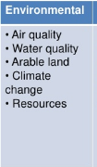
Energy management
Beer production consumes a lot of energy. This demands a lot of power from the national grid and the Taiwan energy department has devised ways to that are natural in energy production to cater for energy need in the industry. Constant monitoring of the energy utilization in the beer industry has been maintained in order to ensure that the craft brewing process used the modern technology. Modern equipment helps in reducing the energy used as well as generating heat in the brewing process. These modern equipment use anaerobic treatment of the plants to reduce energy by using the biogas produced. Anaerobic treatment is an opportunity for the beer industry to reduce emissions and other types of pollutants. These poisonous gasses react in the environment causing upsets in the climate, sea levels, and the balance in the ecosystems. Green energy is key in caring for the natural resources and natural ways of energy production have been used in controlling pollution and environmental degradation. For example, instead of using diesel, the local brewers in Taiwan use husks from rice producers for fuel. This has not only helped in controlling the exploitation of non-renewable sources of energy but also created jobs for the youth in the country. The Brewers have also been encouraged to green freeze, which uses hydrocarbon. These refrigerators are ozone friendly. This is one way to ensure that there is minimal global warming (Q, A. A. P. D., 2012).
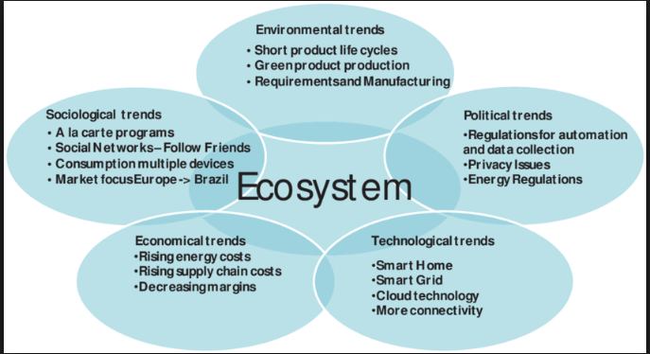
Farming of barley
In Taiwan, the craft beer industry uses many natural resources such as water, energy. In order to control the exploitation of resources, the beer industry has done many technological improvements that control water consumption, solid waste management, wastewater in control of major environmental challenges. On the other hand, barley farming and beer production consume a lot of water. Traditional ways of growing barley have been embraced in the farming method that ensure water is used sparingly. This method has also reduced the consumption of fertilizers and pesticides, which pollute the soil with chemicals. Intensive tilling practices have also been done away with which have offset carbon in the soil (Q, A. A. P. D., 2012).
In conclusion, Taiwan’s craft beer industry has worked towards conservation of the environment or the ecosystem. A lot of policies have been implemented in the country that ensures beer brewers are monitored to adhere to the set environmental regulations. Firms that are dealing with beer production have a mandate to ensure that the process does not result in over-exploitation of natural resources such as water and pollution of the environment.

References
Carr-Harris, H., UNEP. Industry and Environment., & Danbrew (Firm: Copenhagen). (2016). Environmental management in the brewing industry. Paris: UNEP Industry and Environment.
In Slocum, S. L., In Kline, C., & In Cavaliere, C. T. (2018). Craft beverages and tourism: Volume 2.
International Business Publications, USA. (2016). Taiwan: craft beer industry handbook. Washington, D.C: International Business Publications, USA.
Kong, L., Ching, C., & Chou, T.-L. (2015). Arts, culture and the making of global cities: Creating new urban landscapes in Asia.
Q, A. A. P. D. (2012). Advances in Environment Environment and Conservation Research and Application. Atlanta: ScholarlyMedia LLC.

