Student’s Name
Institutional Affiliation
Course Name
Instructor’s Name
Date

Abstract
This research paper seeks to establish the possibility of an outbreak of Salmonella enteritis infection at Flinn Corporation. The investigation entailed recording of the total number of employees who were indisposed after consumption of food from the cafeteria and those who did not get ill. Additionally, a retrospective cohort study was done to establish the attack rate and the risk (through the risk ratio) of the available foods at the cafeteria by analyzing the number of people who got sick from eating the foods in question; baked chicken, spinach, mashed potatoes, egg salad and so forth. After analysis of the findings, an outbreak of salmonellosis at Flinn Corporation was established.

Introduction
Salmonellosis is a food-borne infection that is caused by several serotypes of the bacteria Salmonella excluding Salmonella typhi and paratyphi species (Alena, 2019). Salmonella enteritidis is especially implicated in food poisoning and causes significant morbidity across all age groups with children under five years, geriatric and immunocompromised individuals being at a higher risk. On several occasions, salmonellosis manifests as gastroenteritis and rarely in severe cases, it may enter the circulatory system leading to bacteremia, a condition requiring more aggressive medical intervention. According to the World Health Organization, almost three million lives are lost yearly due to salmonella infections, thus it poses a great burden worldwide.
Pathogenesis and manifestation
Salmonellosis results from the ingestion of food or water contaminated by these pathogens. Milk and milk products, vegetables, beef, eggs, and poultry are important sources of this disease-causing microbe (Michael, 2018). Upon ingestion, the bacteria primarily colonize the small bowel. With its special abilities to induce phagocytosis, the bacterium can penetrate the host cells that are normally non-phagocytic (Shu-Kee Eng, 2015). Once phagocytosed, neutrophils are recruited to surmount the invasion; however, the bacteria possess a virulence factor, VI antigen that protects it from lysis by the compliment as well as antibodies. After resisting phagocytosis, the bacteria invade the reticuloendothelial system, kidneys, lungs, and gall bladder after massive replication.
Clinical manifestation of the disease comprises of acute onset of diarrhea, pyrexia, chills, and abdominal cramping that set in eight to forty-eight hours after eating food contaminated with the pathogen. Fever usually lasts for three days after the establishment of the infection. Diarrhea lasts for three to seven days and can be blood-stained (Michael, 2018). Nausea, myalgia, and vomiting are also experienced and can lead to electrolyte disturbance in the body. In most cases, the disease is self-limiting and goes away in one week however some cases need to be treated forthwith. In immunocompromised invalids, the disease can progress to bacteremia and also infect the central nervous system
Salmonellosis Outbreak at the Flinn Corporation
It is correct to state that an outbreak of salmonellosis occurred at the company as it meets the criteria: bouts of diarrhea and vomiting in two or more people within 24 hours. According to the data collected, 12 out of 21 staff members were infected over 5 days. None of the ill patients exhibited all the symptoms in the criteria, however, fever, diarrhea, and headache were experienced almost universally. 3 out of 12 ill employees had nausea = 25%; 2 ill employees had vomiting = 16.67%; 6 employees had abdominal cramping = 50%; 8 employees had diarrhea = 66.67%; 8 indisposed employees had fever = 66.67%; 7 employees had chills = 58.33%; 8 ill employees had headache = 66.67%; 1 out of 12 ill employees had blood in stool = 8.33%.
Of the twelve ill individuals, only one did not eat at the cafeteria, therefore 91.67% ate at the cafeteria. 2 out of 9 individuals ate at the cafeteria and did not fall ill = 22.22%. 50% (6 out of twelve) of the ill employees were male. The mean age of the ill employees is ((55+38+32+25+36+31+41+60+33+45+44+48)/12= 40.7) approximately 41 years.

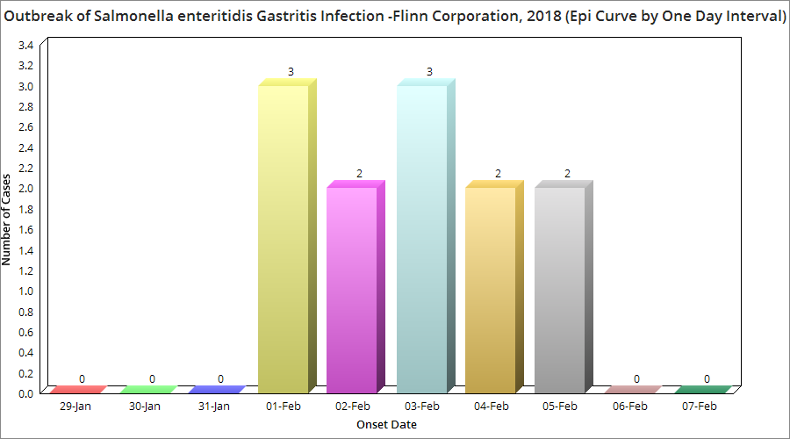
With respect to the retrospective cohort study, based on the risk ratio, baked chicken with a ratio of 4.14 is the most likely source of the illness. Out of eleven people who ate the delicacy ten people fell ill. While out of the nine people who never ate the chicken only two became sick.
Discussion
The evidence strongly suggests that the illness was indeed caused by the food being served at the cafeteria with baked chicken, as aforementioned, being the greatest source of the pathogen. A probable cause could be poor hygiene of the catering employees or improper handling or cooking of the food. To mitigate the outbreak, adequate rehydration is required for those who are ill and antibiotics such as ceftriaxone may be administered after laboratory confirmation of the causative organisms or empirically in dire situations. Oral rehydration is normally sufficient for gastroenteritis; however, enteric fever and bacteremia need proper antibiotic treatment (Giannella, 1996).
In preventing the infection, the key step is sanitation. Measures should be put in place to ensure proper sanitation, and availability of clean water (Shu-Kee Eng 2015). Milk should also be properly pasteurized and food refrigeration should be done meticulously. Additionally, salmonella vaccines should be dispensed. Food should also be handled properly and with care, and cooked thoroughly to kill the pathogens. Hand hygiene should also be observed, especially by food handlers.
Conclusion
Salmonellosis causes significant morbidity and mortality worldwide. Its total eradication has proved to be impossible as it has both human and animal hosts and remarkable capabilities to survive in harsh environments in vivo. Thus sanitation and vaccination will play a major role in controlling and reducing the incidence of this disease.

Reference
Shu-Kee Eng, Priya Pusparajah, Nurul-Syakima Ab Mutalib, Hooi-Leng Ser, Kok-Gan Chan & Learn-Han Lee (2015) Salmonella: A review on pathogenesis, epidemiology and antibiotic resistance, Frontiers in Life Science, 8:3, 284-293, DOI: 10.1080/21553769.2015.1051243
Micheal. D (2018). Salmonella Infection in Emergency Medicine Workup. Medscape https://emedicine.medscape.com/article/785774-workup
WHO, (2018). Salmonella (non-typhoidal). Retrieved 20 February 2021, from https://www.who.int/news-room/fact-sheets/detail/salmonella-(non-typhoidal)
Giannella, R. (1996). Salmonella. University Of Texas Medical Branch At Galveston. Retrieved from https://www.ncbi.nlm.nih.gov/books/NBK8435/#:~:text=General%20salmonellosis%20treatment%20measures%20include,should%20be%20treated%20with%20antibiotics.
CDC, (2021). Principles of Epidemiology: Lesson 6, Section 2|Self-Study Course SS1978| Retrieved 20 February 2021, from https://www.cdc.gov/csels/dsepd/ss1978/lesson6/section2.html#step6
CDC (2021). Questions and Answers | Salmonella |. Retrieved 20 February 2021, from https://www.cdc.gov/salmonella/general/index.html#:~:text=Children%20under%205%20years%20old,likely%20to%20have%20severe%20infections.
CDC. (2021). Principles of Epidemiology: Lesson 6, Section 2|Self-Study Course SS1978| Retrieved 20 February 2021, from https://www.cdc.gov/csels/dsepd/ss1978/lesson6/section2.html#step8

