Schedule

Schedule Baseline:
After having the WBS ready we can go to the schedule baseline and divide the work in time basis. Baseline schedules create a road map to prepare the baseline budget, mobilisation plans, and resource allocation plans. We used Microsoft Excel to develop the schedule timeline. The work shall start at 1/1/2017 and end at 1/7/2020. Below is more explaining of each activity.

Mobilization:

site survey:

- system design

material procurement:

system installation:

system commissioning and testing:

Schedule Development
The packages developed and shows that there are many activities, which made a schedule development achievable. It has a purpose of allocating available time to the project activities in order to complete the project successfully. The breakdown of activities supports estimating required duration and resources. The table (4) shows different activities for each main package and when its required to finish
The project was awarded to a contractor besides, the additional scope of work.
The team members decided to have the overall schedule based on the estimations given in the Table (4)
# | Activity | Duration (Days) | Start date | Finish Date
1 | Replacement of HEX Side  Corrugated Sheet | 4 | 4/15/17 | 4/20/17
1.1 | Demolition of Existing  steel fence | 5 | 4/20/17 | 4/26/17
1.2 | Concrete Cutting and  Excavation | 10 | 4/26/17 | 5/8/17
1.3 | Construction of Footing | 5 | 5/8/17 | 5/14/17
1.4 | Construction of Column  up to Bottom Beam | 2 | 5/14/17 | 5/16/17
1.5 | Construction of Column  up to Intermediate Beam | 3 | 5/16/17 | 5/20/17
1.6 | Time for Concrete  Hardening | 4 | 5/20/17 | 5/24/17
2 | Repair of Steel Column | 5 | 5/22/17 | 5/28/17
2.1 | Construction of CMU  Wall | 3 | 5/30/17 | 6/3/17
2.2 | Construction of  Intermediate Beam | 3 | 6/3/17 | 6/5/17
2.3 | Construction of Column  up to top beam | 2 | 6/10/17 | 6/5/17
2.4 | Time for Concrete  Hardening | 4 | 6/5/17 | 6/10/17
3 | Excavation and repair of  damaged foundation | 7 | 6/5/17 | 6/13/17
3.1 | Construction of CMU  Wall | 3 | 6/10/17 | 6/13/17
3.2 | Construction of Top  Beam | 3 | 6/13/17 | 6/17/17
3.3 | Plastering | 5 | 6/17/17 | 6/22/17
3.4 | Rearranging Trench | 2 | 6/22/17 | 6/25/17
3.5 | Electrification and light  fixing Work | 4 | 6/22/17 | 6/27/17
3.6 | Painting | 3 | 6/27/17 | 7/1/17
3.7 | Demobilization | 2 | 7/1/17 | 7/3/17
Table 4(Activity schedule)

Schedule Baseline
The approved schedule baseline is aligned with the approach explained in the WBS dictionary. Figure 3 shows the tasks, their durations, planned workshops, and planned report releases.
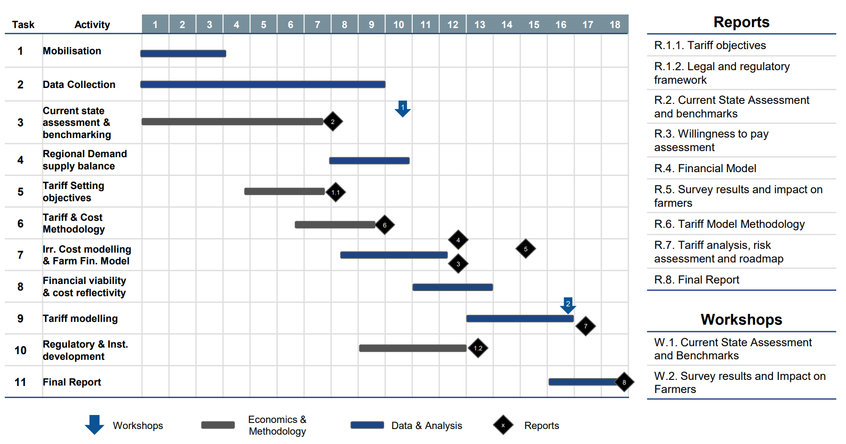
Figure 3: Project Schedule Baseline
Schedule Management Plan

Project schedules will be created using MS Project program starting with the deliverables identified in the project’s Work Breakdown Structure (WBS). Activity definition will identify the specific work packages which must be performed to complete each deliverable. Activity sequencing will be used to determine the order of work packages and assign relationships between project activities. Activity duration estimating will be used to calculate the number of work periods required to complete work packages. Resource estimating will be used to assign resources to work packages in order to complete schedule development.

Once a preliminary schedule has been developed, it will be reviewed by the project team and any resources tentatively assigned to project tasks. The project team and resources must agree to the proposed work package assignments, durations, and schedule. Once this is achieved the Propenent will review and approve the schedule and it will then be baselined.

The following will be designates as milestones for the project schedule:
- Completion of scope statement and WBS/WBS Dictionary
- Baselined project schedule
- Approval of final project budget
- Project kick-off
- Approval of roles and responsibilities
- Requirements definition approval
- Completion of data mapping/inventory
- Project implementation
- Acceptance of final deliverables

Roles and responsibilities for schedule development are as follows:

The project Engineer will be responsible for facilitating work package definition, sequencing, and estimating duration and resources with the project team. The planning group will create the project schedule using MS Project and validate the schedule with the project team, stakeholders, and the project proponent. The project manager will obtain schedule approval from the project proponent and baseline the schedule.

The project team is responsible for participating in work package definition, sequencing, and duration and resource estimating. The project team will also review and validate the proposed schedule and perform assigned activities once the schedule is approved.

The project Sponsor will participate in reviews of the proposed schedule and approve the final schedule before it is baselined.

Project Quality Plan

Project Quality Management Plan
KEYMA Petrochemical has a Turnaround Quality System that consist of two main components:

- Quality Assurance
- Quality Control
The differences of these systems and policies are described as follow:

 | Quality Assurance | Quality Control
Definition | A set of activities to ensure quality in processing of final products. | A set of activities to ensure quality in the final products.
Focus on | Preventing defect. | Reactive to defects.
Goal | To improve the processing of testing so that the defect do not arise when the product is being developed. | To identify a defect after a product is devolved and before it is released.
How | Establish a good quality management system and assess its adequacy. | Finding and eliminating sources of quality problems through tools and equipment.
What | Prevention of quality problems through planned activities. | The activities and techniques used to achieve and maintain the product quality processes and services.
Responsibility | Everyone on the team is involved. | Has specific team that test the products for defects.
Example | Verification is an example of QA | Validation testing
Statistical Technique | They can be applied to the process | Statistical Quality control
As a Tool | Managerial tool | Corrective tool

Table 8: QA/QC policies

A Quality Assurance / Quality Control plan shall be prepared for the project which deals with quality as it pertains to the effective planning and execution of Turnaround. As discussed in the table, Quality Assurance plans are actions taken before the event to eliminate faults and Quality Control plans are actions performed after the task to expose and rectify faults. Good QA plans shall render QC simpler and easier to perform.

The Quality assurance plan will cover but not limited to these aspects:
- Procedures
- Standards
- Equipment
- Knowledge and Skill
The Quality control plan will cover but not limited to these aspects:
- Job Package Reviews ( Job plan, Material, schedule, Welding / Rigging plans)
- Phase Assessments ( Milestone, Documentation, Communication )
- Pressure testing / inspection / checks
- Joint Inspection
- Hand over quality checks

The main objective in quality plan is to maintain the machines properly and within schedule. Any delay in one operation will cause delay on the overall schedule and any error in the maintenance operation itself might cause a shut down in the operation in the long run. The purpose of the quality management plan is prevention over inspection.

The project management team plans to meet the quality requirement by having a standard operation manual for preventive maintenance for all items and operations, these standards are gathered in one manual for each item or operation. The manual includes the procedure for visual inspection and the preventive maintenance for each equipment, it includes the machine description and the responsibility of doing the inspection (direct stakeholders for doing the actual inspection), the safety and health plans and finally the inspection procedure.
The manual in essence include (project procedure manual, inspection test plan and the project quality manual). These manual have a checklist which is the main tool for quality planning in the company. These Checklists ensure that the process of inspection is being done properly and according to requirements.
The sample includes these main points:

- Project quality statement signed by the PM.
- Quality assurance authority and responsibility.
- Procedures manual.
The Project quality manual, the project detailed procedure and the contracted work (with KBR Engineering and Al Fanner Workshop) scope is the major input to the project quality plan. Since maintenance is a process not a product the inspection and test plan will focus on KPIs instead of using actual testing, the major KPIs that relates to quality, cost, scheduling and time are:
- Percentage of work requests submitted on time:
- Timeliness of the submitting of scope requests.
- Measured as Number of approved requests before freeze date work list divided by the total number of approved requests at end of project. (Target: More than 90%)
- Percentage of job packages scoped on time:
- Measures the timeliness of the scoping.
- Measured as Number of job packages detailed scoped before scoping freeze date divided by total number of job packages at end of project. (Target: More than 90%)
- Percentage of scope changes:
- Measures the quality of the scope.
- Measured as Number of scope changes (Less Work, Additional Work, and Extra Work, excluding waiting hours) divided by total number of job packages at end of project. (Target: Less than 10%)
- Percentage of job packages planned on time:
- Measures the timeliness of the planning.
- Measured as Number of job packages planned before planning milestone date divided by total number of job packages received at end of project. (Target: More than 90%)
- Percentage services contracts on time:
- Measures the timeliness of the contracting.
- Measured as Number of services PO issued before contracting milestone date divided by total number of services contracts at end of project. (Target: More than 90%)
- Percentage of job packages materials acquired on time:
- Measures the timeliness of the material coordination.
- Measured as Number of job packages material delivered before material milestone date divided by total number of job packages at end of project. (Target: More than 90%)
- Time Deviation final schedule:
- Measures the timeliness of the scheduling.
- Measured as Deviation in between realizations of final schedule versus final schedule ready milestone. (Target: Less than 30)
- Performance of EHSS recordable:
- Measures the EHSS performance.
- Measured as Number of EHSS recordable. (Target: 0)
- Predictability of the TA duration:
- Measures the schedule performance.
- Measured as Realized duration (shut-down, execution and start-up) divided by the targeted duration. (Target: ±5%)
- Predictability of the costs:
- Measures the costs performance.
- Measured as Realized costs (preparation and execution) divided by the Final Project budget. (Target: ±10%)
- Kemya response to these changes in the Quality plan:

Change Control | Include minimal disruption to services, reduction in back-out activities, and cost-effective utilization of resources involved in implementing change. Any Change Order has to go through the steering committee who will decide on the action required.
Document Control | A recorded is kept for the inspection procedures, the quality level of the maintenance and any outliers (defects) in the system. These documents are kept for both ISO and statistical purposes.
Control of Purchased material | A random sampling technique is used to test the quality of purchased material, that is for small items with huge quantities, however if the quantity is small a quality assurance test is implanted.
Non-Conforming Items | Since the materials are extremely expensive in the overall maintenance, they have to fix the problem instead of replacing the item.
Corrective Action | Kemya has a corrective action plan for most operations and the quality department is required to follow it.
Handling and Storage items | Items are stored in the main warehouse at the same condition required by the material supplier to ensure that these item will be in shape when using.
Records | A record is kept for testing procedure, number of defectives per patch, the corrective action for each case and response to nonconforming processes.
Audit | The company has two Audits systems, internal and external systems. They both indicate what actions were taken when the company faced a defect.

Table 9: Kemya response in quality plan

- Change orders in the company have to go through the steering committee, the committee flow chart is presented as follow:

Figure 7: Steering committee flow chart

All the People in the flow chart must be informed about any change orders so that can take the necessary actions, all the parties involved should agree upon the decision.

5.Quality Management Plan
Quality Management Plan documents are the essential information required to efficiently manage project quality from project planning to delivery. It defines a project's quality procedures, criteria for and areas of application, and roles, responsibilities, and authorities.

5.1 Roles & Responsibilities.
The below table shows clearly defined roles and responsibilities for each member of the team.
Role | Responsibilities
Project Steering Committee | Set overall direction and provide senior sponsorship
SIO Project Sponsor | ● Provide day-to-day guidance and direction and monitor project progress and performance  ● Provide local expertise and data as needed, facilitate access to stakeholders, review project deliverables and provide feedback  ● Approve all project deliverables, take key decisions, solve critical issues (if necessary) and oversee the overall risk and quality of the project
SIO Project Team | ● Provide local expertise and data as needed, facilitate access to stakeholders, review project deliverables and provide feedback  ● If agreed by SIO, appointed individuals from SIO to work as part of the Core team
Engagement Partner | Provide strategic oversight and senior stakeholder management, and assure all deliverables and outputs for technical quality
Quality Assurance Partner | Provide a sounding board for the team and provide independent quality assurance on deliverables and outputs
Project Director | Provide overall day to day direction, guidance, and technical input to the project teams, and provide senior stakeholder management alongside the engagement partner
PMO | Monitor and track the progress of the project to ensure milestones are met, risks and issues identified, escalated and resolved, provide direction to the project teams, and participate in the delivery process of the project
Subject Matter Experts | Provide technical expertise and support and ensure delivery of key outputs

5.2 Sign-off Criteria
Using our revised approach, sign-off criteria are established for each deliverable
Phase | Description | Deliverables | Sign-off Criteria
Mobilization | To ensure a smooth project kick-off with agreement on the project approach, governance, timeline, and deliverables. | •Contact details and communication protocol  • PowerPoint: Project Initiation Document (PID) including a detailed project plan | • Task to phase mapping agreed  • Detailed plan agreed  • Detailed task descriptions and deliverables agreed  • Project assumptions agreed
PHASE 1
Tariff Objections |  | PowerPoint: Report on tariff objectives and to be agreed with SIO stakeholders | • Tariff objectives report is able to be used for consultation/agreement on tariff objectives with agreed SIO stakeholders and contains - An initial list of objectives with a definition - Tariff objective assessment framework explained - Short list of objectives with justification - Description of objectives used in 5 agreed jurisdictions
Regulatory & Institutional Framework | Report on the legal and regulatory framework related to implementing irrigation tariff services, including the tariffs and objectives of the tariff /model framework | PowerPoint: Report setting the future institutional and regulatory framework for KSA | • Benchmarks from 5 jurisdictions showing the institutional and regulatory framework  • Recommendation on the institutional framework for KSA  • Recommendation on the legal and regulatory framework for KSA
PHASE 2
Current State Assessment | Report and workshop on the benchmarking results (regional and global benchmarks on imposing irrigation tariffs, implementation and collection methodology) comparing the SIO situation, pros and cons, and lessons learned | • PowerPoint: Report on the assessment of the current situation and benchmarks  • Workshop on the current situation in KSA, benchmarks, and lessons learned | • Captures the current situation with regard to strategy, costs organization, and management, in so far as information is available  • Captures existing charging and funding mechanisms  • Uses 5 agreed jurisdictions to benchmark KSA in terms of implementation of tariffs, charging methodologies, and organization structure and assesses pros, cons, and lessons learned
PHASE 3
Cost & Financial Model | Report evaluating farmers' willingness to pay, based on the budget/harvest analysis compared with farmers' revenues. | • Excel: An agreed data request  • PowerPoint: An agreed farm survey and sampling methodology  • (Format to be confirmed): An agreed farm survey  • PowerPoint: Brief functional specification of for demand/supply model  • Excel: Data and assumptions book  • Excel: Model of regional demand/supply balance | • All data types/requirements documents captured and explained  • Communication protocol for data request agreed  • Farm survey sampling methodology defined  • Farm survey captures data information requirement  • Data/farm survey follow-up strategy defined  • Data cut off date if explicit  • A functional specification that will deliver a demand-supply balance that is sufficient for input into the cost of service model  • Available data received by the data cut off date required for the demand-supply model and agreed assumptions where data is unavailable  • A model that is consistent with the agreed functional specification
Cost & Financial Model… Continued |  | • A brief function specification for the cost and financial models  • A data and assumptions book for the cost and financial models  • User-friendly operational cost model in Excel  • User-friendly farm financial model in Excel  • PowerPoint: Report covering model data, assumptions methodology, and benchmarks  • PowerPoint: A report covering the farm financial model and willingness to pay/accept  • A workshop with stakeholders to discuss the output and assumptions  • Templates for data collection and reporting in Excel | • The functional specification describes the methodology for both models and how the models will be constructed, including key areas where flexibility is required • The data and assumptions book contains available data and assumption where data is unavailable  • The cost model captures the key elements of capital and operating costs irrigation for the next 10 years in a way that is sufficient for use in the tariff model  • The farm financial model provides an analysis of willingness to pay/accept and affordability and a range of potential outcomes in a way that can be used in the tariff model  • The results of the tariff model provide a range of values for willingness to pay/accept by farm category/size/region  • The cost of service benchmarks the total cost of service against up to 5 jurisdictions, if these benchmarks are available
PHASE 4
Tariff & Cost Methodology | Report to SIO on the proposed tariff model for different areas served by SIO including all factors and variables (eg O&M). | A working paper in PowerPoint that is able to be used for consultation/agreement on the tariff/cost/subsidy methodology with agreed SIO stakeholders | • Methodologies and principles for setting tariffs explained  • Cost of service methodology explained  • Options for tariff structures explained  • Calculation of subsidy explained  • Methodology for financial analysis of farms explained  • Clear recommendation on each of the above areas
PHASE 5
Farmers willingness to pay/accept | Workshop and report on the expected impact on farmers of imposing the irrigation tariffs and measuring their acceptance of the imposed tariffs by conducting a survey of up to 20 farms per region. In addition, we will design a guiding awareness program for the farmers. | • A workshop for key stakeholders in SIO  • Report on the expected impact on farmers of imposing the irrigation tariffs | The workshop covers the following areas:  • Overview of the farm financial model  • Key Assumptions  • Summary of results - willingness to pay/accept charging  • Affordability  • Overview of farmers education program
PHASE 6
Tariff Modelling | Report on the tariff model and financial scenarios whilst presenting the best choice out of multiple scenarios. In addition to setting out a suitable collection mechanism execution roadmap and risk assessment. | • A PowerPoint report setting out tariff analysis  • A PowerPoint report setting out the regulatory impact & risk assessment | • Tariff report presents a reasonable range of tariff scenarios and makes recommendations on a final tariff  • Final tariff is benchmarked with up to 5 jurisdictions for tariff level and structure (if this information is available)  • Tariff report contains a high-level implementation plan  • Impact assessment shows the final impact on farmers and an affordability assessment  • Impact Assessment shows a qualitative assessment of the risks of implementing the final tariff
Final Report | The complete report including all project stages and other studies (electronic and including 5 printed copies) with the databases used together with a presentation to SIO. | A final report in PowerPoint | • Data and assumptions are clear and assumptions are agreed with SIO  • Methodologies and models are clearly explained  • Up to 5 benchmarks are used for tariff objectives, tariff structures, and legal/regulatory frameworks  • Final recommendations for tariff structures and levels are clear and well explained  • There is a clear roadmap and communication/education plan

5.3 Deliverables Sign-off
A formal sign of process ensures a proper document version control and sign-off process
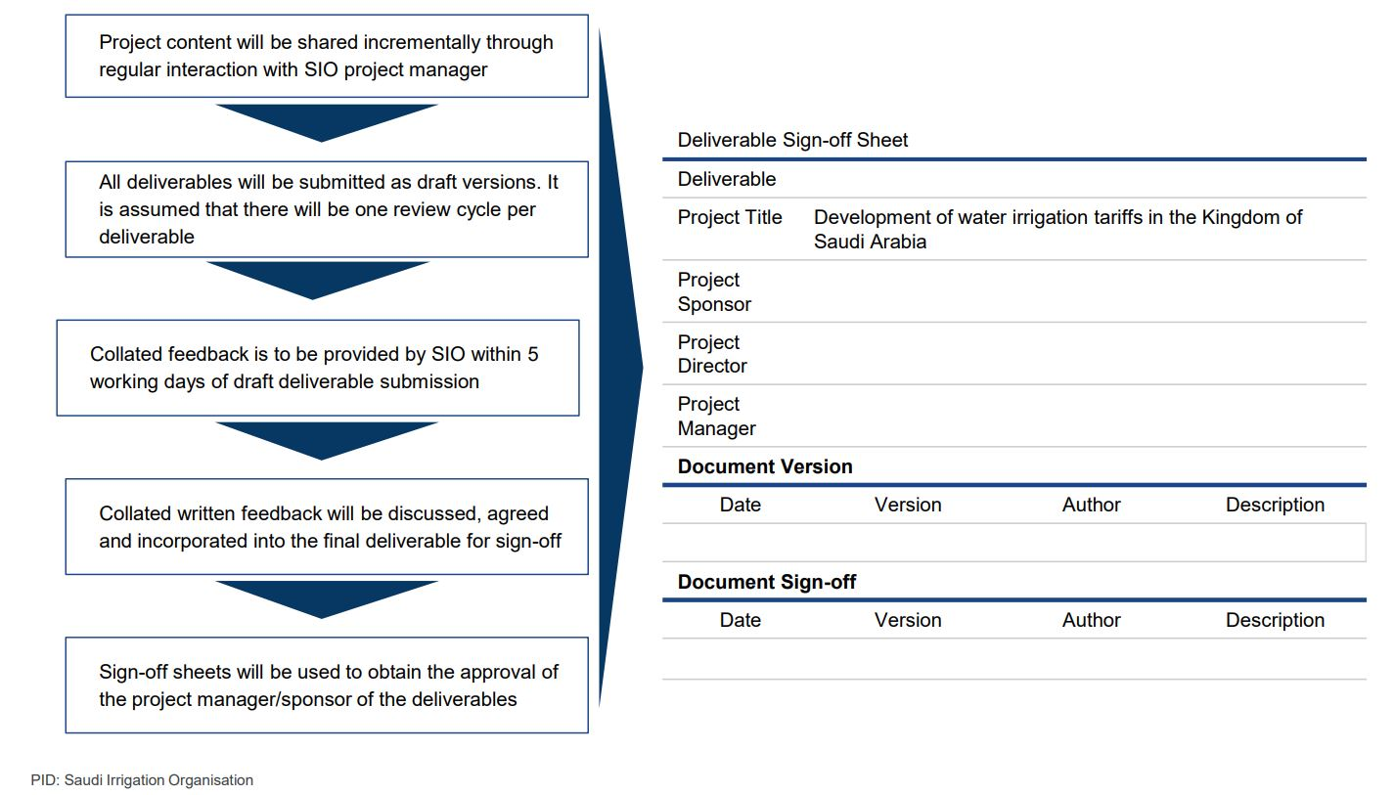
Figure 6: Sign-Off Process

Risk Management Plan

Project Risk Management Plan

The following techniques are useful system for identifying the risk:

- Analysis of processes: will facilitate the identification of operation risk.
- Brainstorming: A group of employees put forward their ideas or sensation of risk
- Interviews: A specialist in business risk prepares interviews with various management level members of the company in order to elicit their concerns.
- Workshops: Meeting of a group of employees in a comfortable atmosphere in order to identify the risks and assess their possible impact on the company.
- Comparison with other organizations: Benchmarking is the technique used for comparing one’s own organization with competitors.
- Questionnaires: focused on detecting the concerns of staff with respect to the risk or threats

Risk prioritization

Project Team shall develop contingency Plan to address any emergency situation which may hinder the job progress and overall completion of project (EHSS Risk). Main emergency factors to be considered are

Climate Linked

Contingency plans shall be prepared for unusual natural phenomenon such as Weather sand storm etc. Plans shall address various weather related problem such as:
  - Extreme High pressure (above 3000 Bars)
  - High temperature (more than 100 Cercus)
  - High Humidity

Process Linked

Plans shall be in place for possible process upset while taking shut down and while start up which shall have direct effect on T/A schedule:
  - Process Shut down
  - Process Start Up
  - Handover

Work Linked
There are various scenarios related to work which can directly affect the critical path or sub critical path activities such as:
  - Non availability of Critical equipment
  - Failure of Critical equipment
  - Specialized Manpower Constrain
  - Special Tools Constrain
  - Non availability of Critical Materials
  - Surprise Jobs
The risk prioritization shall be performed based upon the SAFER system which is SABIC Assurance program For EHSS Risk.
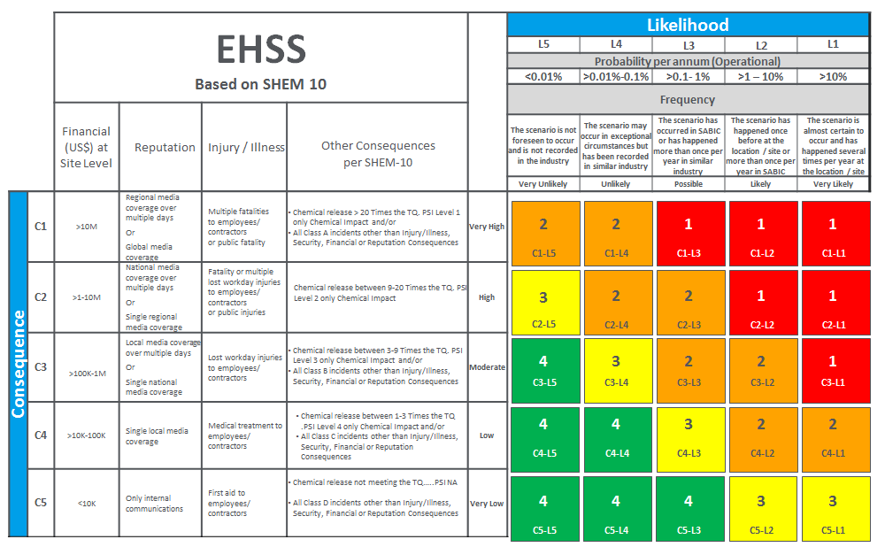
Figure 9: Risk Matrix
The Team conducted a high level review of the proposed installation and assessed risks based on the responses provided by EM HPPE Technology experts. The Team’s conclusions on risks and recommendations for mitigation (if any) are documented in the table below.

Risk with respect to process and saftey

Table 13: Risk with respect to process and safety
Risk with respect to time and budget

The time or the project period is very critical. So, no excuses for extending the shutdown period under any condition. The materials and spare part shall be delivered to site before project date by two month at least to avoid any change in schedule. Otherwise, the Otherwise, the particular activity which associated with material concern should not be performed at all

The risk | Controlled %
Exceed the project period | < 5%
Exceeding the cost | Up to 10%
Table 14: Risk with respect to time and budget

The Risk priority over all project

The Risk Type | Priority | Risk Owner
Safety and Process Risk | 1 | Project sponsor
Project Period | 2 | Project sponsor
Project Cost | 3 | Project sponsor

