Lab Work | Project C | An Industrial Alarm

Objectives
Derive simple combinational logic circuits from the problem description and then to simplify and construct those simple combinational logic circuits.

Hypothesis
We expect that the logic circuit derived from the problem description will produce the same outputs as the truth table derived from the problem description.

Materials
ETS-5000 Logic Trainer
TTL IC 7408: Quad 2-input AND gates Assorted jumper leads
TTL IC 7432: Quad 2-input OR gates

Procedure
- Derive 4 conditions from the following problem statement:
  - A manufacturing plant needs to have an alarm to indicate the time for the operators to leave. The alarm should sound when either of the following conditions is met:
i.
ii.
are shut down.
- Construct a truth table (table 7) using the 4 conditions and using the truth table show the rows in which the conditions are met, and the operators would get to go home.
- Derive a Boolean expression from the truth tables output.
- Simplify the Boolean expression to use 3 AND expression and 1 OR expression.
- Design a circuit that corresponds to the expression created in step 4, represented in figure 6.
- Redesign the circuit ensuring that it is capable of being constructed using the materials provided shown in figure 7.
- Construct the circuit on the logic trainer and confirm its output is the same as the truth table constructed in step 2, photo at figure 8.

Tabulated Data
Table 7: Truth table derived from step 2 with high output highlighted yellow.
Sw7 | Sw6 | Sw2 | Sw3 | Output
D | C | B | A | X
0 | 0 | 0 | 0 | 0
0 | 0 | 0 | 1 | 0
0 | 0 | 1 | 0 | 0
0 | 0 | 1 | 1 | 1
0 | 1 | 0 | 0 | 0
0 | 1 | 0 | 1 | 0
0 | 1 | 1 | 0 | 0
0 | 1 | 1 | 1 | 1
1 | 0 | 0 | 0 | 0
1 | 0 | 0 | 1 | 0
1 | 0 | 1 | 0 | 0
1 | 0 | 1 | 1 | 1
1 | 1 | 0 | 0 | 0
1 | 1 | 0 | 1 | 0
1 | 1 | 1 | 0 | 1
1 | 1 | 1 | 1 | 1

Truth table Boolean expressions

Sum of Boolean expressions:

Simplify the above expression using Boolean algebra (Show that: X = AB + BCD)

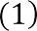Step
1

2
Equation

Justification
Expression derived from the table
Flipped order using trivial applications of Communitive Laws (9) (10).

3

4

5.1
5.2

5.3



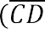
Claim:
Let

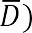
Distributive Law (13a) applied on 5 terms Distributive Law (13a) applied on 4 terms Supposition
Assigning Y as temporary variable
Applications of Communitive Laws (9) (10) for rearranging, multiple applications of Associative Law (11) together with Distributive Law (13a)

5.4
5.5
5.6
6
7
8.1
8.2

8.3
8.4

9

10

Y = 1 which implies that Therefore:

Claim:
Let Z = CD

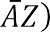

Therefore:

Complement Law (8)
Identity Law (2)
Complement Law (8)
Substitution [5.6 into 4]
Identity Law (2) Supposition
Assigning Z as temporary variable
Substitution [8.2 into 7] Multi-variable Theorem (15a)
Substitution [8.2 into 8.4]
[8.1 into 7] Distributive Law (13a) as well as Commutative Law

End of Proof

NOTES:

Numbering of Boolean algebra laws are based off week 4 lecture slides (slide 52).
We assume that application of these laws for multiple variables are axiomatic. However, we can break these steps down further, for example in step 2, and use the Associative Laws to justify that they are valid.
The Boolean algebra laws used in this proof:

2) x . 1 = x (Identity AND)
- (Complement OR)

Commutative Laws:

x + y = y + x
- xy = yx

Associative Laws:

11) x + (y + z) = (x + y) + z = x + y + z

Distributive Law:

13a) x(y+z) = xy + xz

Multivariable Law:

15a)

Analysis:
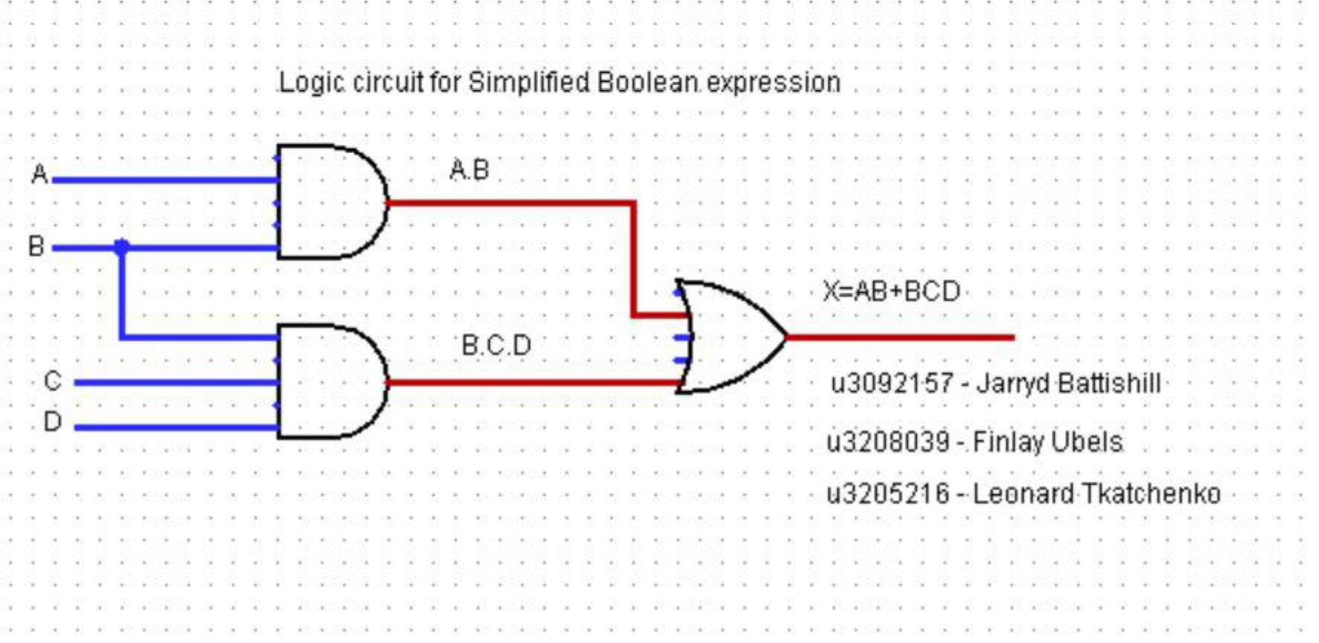
Figure 6. Logic Circuit for Boolean expression.

Logic Circuit Used

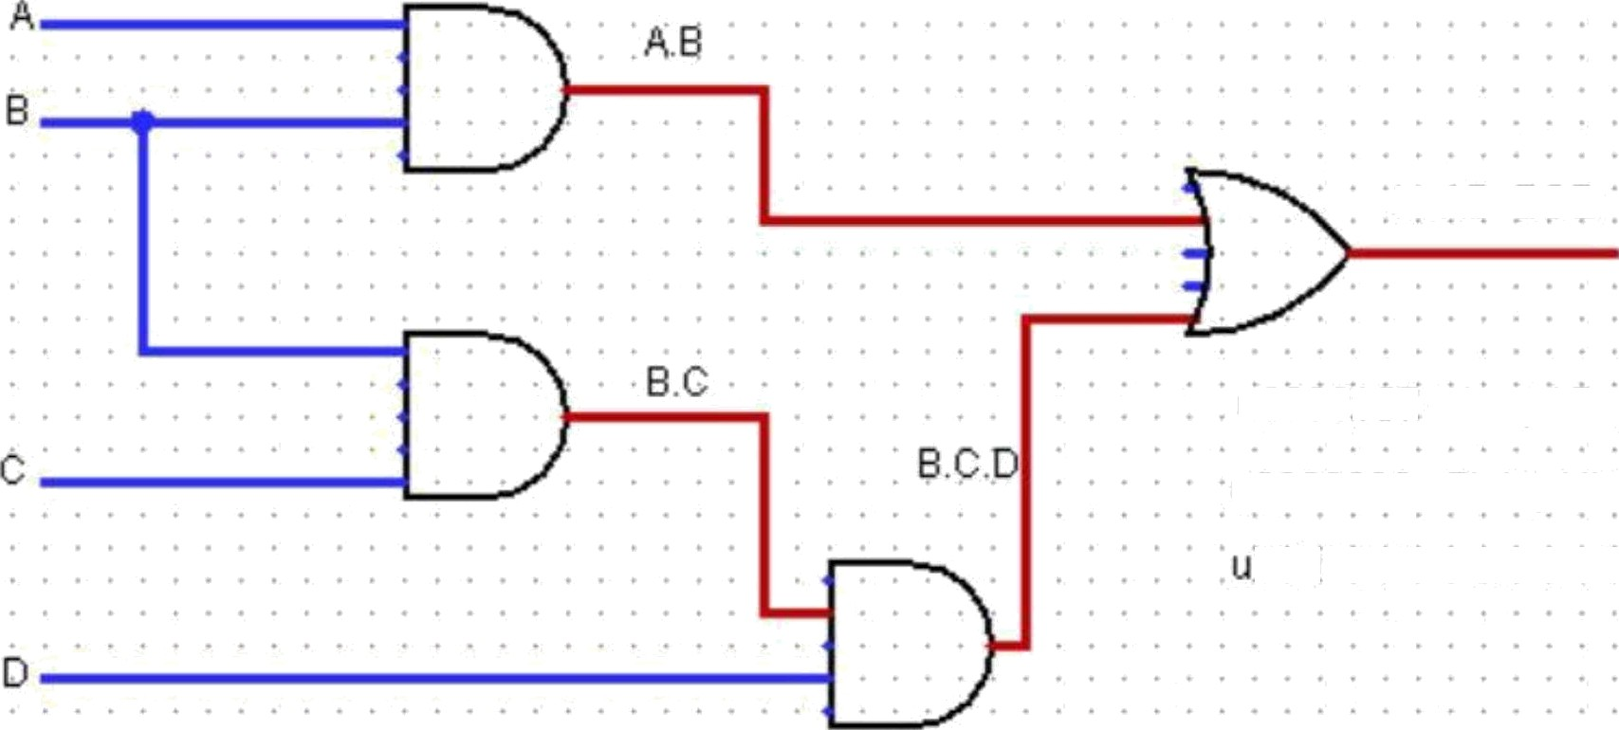
X=AB+BCD

u3092157 - Jartyd Battishill
u3208039 - Finlay Ubels 3205216 - Leonard Tkatchenko

Figure 7. Logic Circuit used for testing.
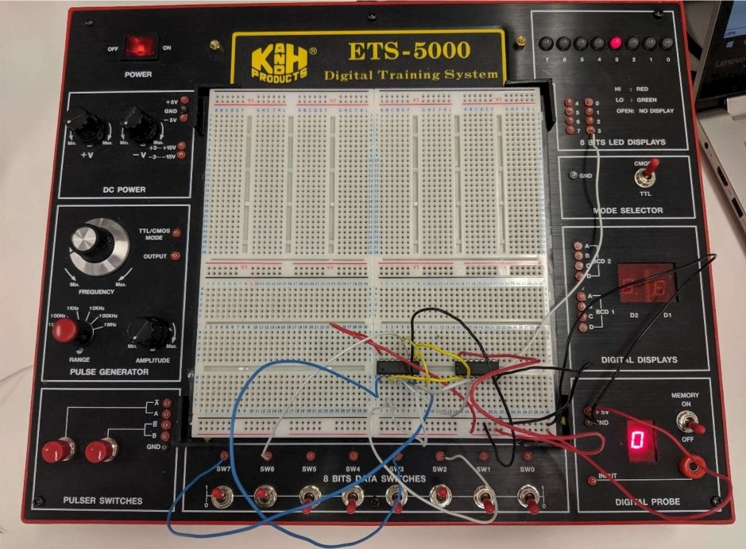

Figure 8. Final Circuit in use.

Figure 7 shows the final circuit derived from the problem description, Figure 8 is a photo taken in the lab of the final circuit in testing, the reason inputs C and D are being on Sw7 and Sw6 rather than in a logical order on Sw1 and Sw0 is due to debugging that occurred when the circuit was not functioning as expected.

We discovered the problem component in the circuit was the TTL IC 7408 (Quad 2-input AND gates) which was not producing a high output from the high input of D(Sw7), C(Sw6) and B(Sw2). Ultimately the circuit produced the expected output matching the truth table depicted in table 7.

Conclusion
The purpose of the experiment was to produce a logic circuit from a problem description. The logic circuit produced was tested using the logic trainer which allowed us to ensure the outputs from the circuit matched the requirements laid out in the problem description.
As tested in the lab our circuit produced the same output as the one found in the truth table which was to be expected.

In this experiment we learnt how to problem solve and debug a faulty circuit. We also learnt how to construct a Boolean expression given a problem description.

