Every Action of our Lives Touches on Some Chord That Will Vibrate in Eternity:
Research of the Stereotypical Misconceptions of Traditional Irish Music

Amy Yarbrough

Music 309
Professor Ric Alviso
November 6, 2012

Introduction:
Music is known to be an art form that expresses emotions and ideas using elements of rhythm, melody, harmony, and color (dictionary.com). When people think about creating music, they picture what they think are the most common tools such as various instruments and sheet music. However, the most important elements one can use to create music are the mind, heart, and soul. Emotion is ultimately what gives a song it’s meaning and without it music would just be a combination of sounds. I chose to research the elements behind Traditional Irish music because of their remarkable dedication and reliance to this art form as a means of survival.
Many who have heard forms of Traditional Irish music, whether it be from the infamous uilleann pipes, fiddle, or rhythms of Sean Nos, know that the power of its captivation cannot be expressed solely with those instruments. Unlike any other group of people, the people of Ireland bleed the rhythms of their melodies, sweat the dedication through a beating drum, cry their souls into a fiddle, and love with every breath of playing the uilleann pipes. Being 95% Irish, I feel a strong connection to the people of Ireland because of how crucial music is to my life. I chose this style because I have always been so interested in learning more about my family history and Traditional Irish music is the only type of music that has so emotionally impacted me, other than a few popular culture songs. Their style and expression just captivates me and leaves me with nothing less than a happy heart and comforted soul. Being as how singing is my passion, trying to mimic the styles of Sean Nos has been very expressive and actually life changing for me.
People have asked me what it is about Sean Nos singing and Irish music that gets me, and after years I still do not have a solid answer. Granted yes I am Irish but I feel that not knowing much about its language is what makes the music so powerful to me. The phrase Sean Nos means, “Old Style” and refers directly to Irish music. Listening to the beautiful hymns of Enya and getting lost in the overpowering melodies of a flute leaves more opportunity for imagination. Countless nights I have fallen asleep to the song, “Hymn to the Sea” by Sissel and have never felt the same emotion twice. The fact that there are no words present allows my imagination to create its own meaning to the music, each one becoming more powerful and emotionally taking than the previous. I have attempted to teach myself the method of Sean Nos singing and found it has been one of the most challenging yet liberating forms of release that singing has ever given me. Sometimes when you yourself do not know what you are feeling, but need to express yourself somehow before you lose control, finding the right words to explain it just adds more stress. With Sean Nos singing, I am able to instantly relax and just hum. I feel that one of the great things about singing this way is you can almost never sing it wrong. Sean Nos is expression through vocal ornamentation, not necessarily lyrics. I really do wish that more people understood this feeling and how powerful something like music can be to saving someone.
Even though I am able to recognize the beauty and emotion behind the Irish and their music, many others do not and follow the common Irish stereotype. Most look to the Irish as violent and constantly inebriated individuals, when in reality they are among the most traditional, caring, and family oriented beings known to man. Although Irish music is normally associated with drinking, partying, and violence, in this paper I will lay out the common misconceptions about traditional Irish music and show that it really reflects suffering, longing, and love.
Background:
In order to understand the meaning and feeling that goes into Traditional Irish music, it is important to know about its history. Through its early years, every country had suffered hardship to see their country prosper, but not many faced the turmoil that the Irish did. Being in a climate stricken by poverty, violence, and emigration, the citizens of Ireland were presented with conflicting conceptions and messages about their culture. Granted, Ireland was an independent and well established state by the 1950's, it was still had it's problems. On one side, there were the nationalist politics that strove to differentiate their Irish cultural symbols from those of their oppressors. On the other side, Ireland was also under the pressure to become a part of the European community by changing their community economically and socially to fit that of a more modern era. These conflicts played a role in how many Irish citizens based their conceptions about traditional Irish music. This crisis with national identity that Ireland went through in the 1940's and their rural, backward, way of life was heavily relayed in traditional Irish songs (Fleming. 2004; 232).
Although the experiences felt by those of Ireland were traumatic and life threatening, they are the main structures that Traditional Irish music was built from. In the present time, we mainly see artists writing songs about love and fantasies they act out in their minds; not to say that personal experiences don’t inspire them as well, but I feel as though most musicians today cannot relate to the level of strife that the Irish have. Imagine growing up in a less developed and more simplistic society than we live in now. Imagine living in Ireland at the time of the great Anglo-Irish war, where death and violence lurked around every corner even for the innocent. Where the British were fighting to prevent your country from having its independence. Many misconceptions about the Irish stemmed from their involvement in their fight for independence against Great Britain. This battle was one of the main reasons Traditional Irish music was full of suffering and loss. They fought and suffered to gain rightful control of their land and culture, and grieved the loss of their people for the times they did not come out momentous. These Traditional Irish songs were not only art forms of personal expression, but they were a means to preserve the history of their culture to be passed down with the next generations. The British wanted to regulate Ireland’s ultimate existence, and those that couldn’t fight back were forced to leave. After much research and a better understanding to the constraints the Irish were faced with, it breaks my heart to hear people speak so negatively about us. Before, I did not feel relatable enough with the Irish culture to classify myself as one of them, but now I speak of them as if they are my relatives that live down the street. Just as Ireland in the early 1900’s faced an identity crisis, I also went through the confusion of my makeup, and it was traditional Irish music that made me realize it. The uniqueness of its instruments and style are relatable to anyone who hears it, and not many cultures offer something so universally accepted and impactful.
Fiddles, pipes, and Celtic lyrics are what made Irish music so distinguishable from other types of music. It is because of the familiar Celtic language and the stories behind their lyrics that traditional Irish music is known all around the world today. Songs of traditional Irish music are passed on from generation to generation and date back over 200 years (Warner, 2009). This helps to explain why the Irish were so family-oriented. The genuine and loving relationships within their families were what made them strong. Family values are what made up a strong basis for a traditional way of life for the Irish and seeing as how music was a key part of the Irish life, its effects were present through traditional music as well.
One of the most innovative pioneers of Irish music is Turlough O'Carolan, who wrote and composed over 200 songs throughout his musical career. O' Carolan was the only national composer of his time and left such a lasting impression on Ireland with his music that Dublin holds a harp festival in his honor each year (Warner, 2009). I wish that this type of recognition still happened in the cities we live in. Over the years, O'Carolan's influence on music helped to create various types of songs like rebel songs and street ballads. Rebel songs were those in remembrance of the heroes that fought for Ireland's battle against England and were later written in rebellion when England banished the Irish from speaking their native tongue. Street ballads were those that mainly showcased Ireland. One of the most commonly known street ballads was called, "Molly Malone", about a local fisherman's ghost that haunted the market. They became the unofficial song of Dublin and held such a historical presence that a statue was built of the fisherman to honor Dublin's millennium (Warner, 2009). Again, this type of praise and appreciation symbolized how close the Irish were and still are. Although the types of songs may be common in Ireland, drinking songs are what they are most known for due to the folk revival (Warner, 2009). This is not to be confused with the perception that Irish are drunks. These drinking songs were created through happiness as a form of celebration, not depression. Like all trends tend to do, traditional Irish music began to fade out of the public eye and many lost interest in it during the 1930's. It was not until later that traditional Irish music became poplar when famous artists reintroduced the drinking song style back to the world (Warner, 2009).
At the beginning of the 1960's, traditional Irish music was not among the important types of music and was considered by most to be part of a time that they wished to leave behind. However, its minority fan base valued it deeply. Traditional Irish music made it's comeback with the aid of the folk boom, and had high hopes of inspiring young Irish people to promote an interest in it that would make it a common part of the twentieth century. This was rather difficult to do considering there were many modern styles that traditional Irish music was competing with. Through much success, traditional Irish music boomed in the modern culture thanks to influence of heyday show bands. The revitalization of this genre showed immense power for the music itself and inspiration to shape Ireland's national culture because it started from a grassroots level, yet still managed to gain official governmental recognition and funding (Smyth. 2004; 90).
Just as the seasons do, ways of live tend to change. As we approached a more modern time, the genres of music evolved with the introduction of new styles, instruments, and technology. Traditional Irish music had made its impact by being orally passed down from generation to generation and started to die out. The fact that Traditional Irish music managed to revive itself in the music scene, given these advanced changes, goes to show that there is something unique about it. Sean O’Raida is the musicologist responsible for the revival of Traditional Irish music and also made Irish Folk music popular around the world. I feel if O’Raida had not stuck with Irish tradition that Traditional Irish music, on one hand, may have been just another thing of the past. On the other hand, I also feel that there would have been others who would have attempted to keep the Irish music culture alive because of how deeply it impacted the lives of the Irish and how important their family heritage is to them. The revival inspired many award winning artists that are admired all over the world such as U2 and The Chieftains.
My point here is this revival has sparked a fire not only in the people of Ireland through its music, but has reached the masses around the world and changed peoples lives. It is so hard to find something so universally accepted and appreciated, and Traditional Irish music continues to inspire numerous people everyday. I personally am a fan of Flogging Molly, Dropkick Murphys, and various works of Enya and Sissel, and I thank this dedication to keep its presence alive for providing something so expressive and moving to my life. However, there is only so much you can take away from hearing a song. I have spoken to a few good friends of mine who are of primary Irish descent about how Traditional Irish music has impacted their lives.
Interview:
Given that the most common misconception about the Irish and their music is violence, I asked Tommy Crain where he thinks this notion came from. He says, “Well, first because people are uneducated, but the land itself has always faced war. Ireland was a hot spot for multiple invaders and there were always some conflicts between the clans. The Vikings invaded and settled. Great Britain took over Ireland as a colony, outlawing their language and destroying their culture. That brought in more conflict and started the Irish freedom fighters. They are all happy cheerful people who have faced a lot of hard times culturally, socially, and economically. The violence is associated with Viking blood, having to fight for their own land and people misconstrue simple things like how the Notre Dames mascot is the fighting Irish. But their violence is nowhere in comparison to England, America, and Spain” (2012). His answer has helped support that this misconception of violence has a lot to do with people’s ignorance and lack of education on the matter.
Going further, I found it important to ask him what he believes Traditional Irish music really comes from and symbolizes. “The heart! Irish music is not something that has ever been forced. It’s a form of expression for them that acted as a means to survive and reflected their hardships, as well as their most fond moments” (Crain, 2012). It was comforting to see that there are people out there who share my sentiments, even having grown up in the United States. A funny thing about most U.S. citizens is they tend to be very racially critical. Even through discussion, I have learned some see the Irish and their music, not only violent, but come off as incapable beings, especially through expressing their emotions. This is the complete opposite of how the Irish really are, and once again, ignorance to the culture may be a cause. On a final note from Tommy, I wanted to know if he believed Irish Traditional music expressed emotions like suffering and loss. To this he states, “A lot yes, but it is done in a cheerful and lively tone. Even though the messages within many Irish songs are sad and lonely, they don’t make people feel that way. When you hear an Irish song about sorrow or love, or in your case, violence, you don’t feel bad about it, but you do feel for the person. This is what is so powerful about Irish music; it can make you laugh, sing, dance, cry, and long for their experience as if it were your own (Crain, 2012). In a sense, it’s our responsibility as Irish people to protect and preserve our culture and Traditional Irish music is one of the most crucial bricks in the foundation of the this culture. The Irish may not been known for writing philosophical novels, but the distinguishing traditional melodies of a tin whistle, Uillean Pipes, and Sean Nos they create leave more emotional and beneficial effects than any paragraph in a book can. They say that the eyes are the windows to the soul, but this is not the case for Traditional Irish music. Once heard, its melodies dance directly to your heart.
Given my admiration for this music, I felt my explanations may be biased as to account for the whole, so I asked another friend of mine, Taylor Finan, what importance Traditional Irish music is to him to get a broader outlook. “It’s very important to me, for me it’s a connection to people that I’ve lost. After my grandfather and my mother passed away, the music became a way for me to remain close to them, it reminds me of them. To this day I can’t hear “Danny Boy” without tearing up a little” (Finan, 2012). Traditional Irish music has impacted Taylor’s way of life and helped him keep the memories of his mother and grandfather alive. The stories and messages within the songs, as well as the personal ties they have provide people with emotional stability and mental reassurance. This type of mesmerizing impact is not the work of violent people. Traditional Irish music is not the product of drunken violent individuals. With every note that comes out of their instruments, you can feel the intense passion and emotion put into playing it. These songs are a cry, not always a sad one, to be heard.
Conclusion:
Towards the beginning of my “wee little life” I always heard stories about my Irish ancestors and everything they went through to make Ireland what is it today, but I never was able to fully understand its significance to my life. Just as it did to my ancestors, music had saved me in more ways than can be expressed. I remember the days playing on my living room floor with my father, listening to my grandfather play his tin whistle whilst listening to my grandmother sang hymns in the kitchen as she made her famous Irish spaghetti. These nights were different from the others and at that time I didn’t know why I saw the world differently.
Being exposed to the Irish culture at a young age, but not really educated on it, left a small but undying fire in my heart. As I grew older, the only Irish influences in my life were my father’s mottos about family values and being a good person and I sadly started to let that fire burn out. I was 7 years old when the movie, “Titanic” came out, and it’s almost like the music in that film was the match that relit a stronger and more vibrant fire not just in my heart, but my whole being. Hearing the stories of how Irish men built that ship, and the beautiful songs made me want to learn more about my Irish heritage. After that I have made sure to not lose sight of the Irish culture because even though I was born and raised in America, I felt homesick. Is it possible to miss a place so much when I have never been there?
Through the research done for this paper and the deeper connections I made through my interviews I have, to my surprise, changed. I have always looked to music as my biggest passion and form of expression, but learning about where I came from has helped me create a stronger relationship with myself. Today’s society is crammed with stereotypes and misconceptions that everyone falls victim to their falsities, and I didn’t want to be one of those victims. I found it important to present the misconceptions against the Irish because everything they stand for is what the people of today are lacking. They are traditionally family oriented, caring, happy, and independent people who had it much worse than we have. I feel that one person speaking out against the crowd can make a solid difference in how the world sees things, and my goal is to correct those who think Irish are just drunken, violent, and weak people. Although Irish music is falsely associated with drinking, partying, and violence, history has shown that traditional Irish music really reflects suffering, longing, and love. Ultimately, it is up to us to preserve this history while passing it on to the next generations. We have to all work together to not feed into the stereotypes and misconceptions that are so present in today’s society, because following the crowd can make you miss out on life’s most liberating moments.

References

- Warner, Melissa. "The History of Traditional Irish Music." EHow. Demand
Media, 26 Aug. 2009. Web. 01 Oct. 2012.
<http://www.ehow.com/about_5349022_history-traditional-irish-
music.htm>.

- Fleming, Rachel C.. Journal of Folklore Research, May-Dec2004, Vol. 41 Issue
2/3, p227-257, 31p, 3 Black and White Photographs.

- Smyth, Gerry. "Ireland Unplugged: The Roots of Irish Folk/Trad." Irish Studies
Review 4th ser. 12.1 (2004): 87-97. Print.

- Finan, Taylor. Personal Interview. October 29, 2012

- Crain, Tommy. Personal Interview. October 31, 2012

- "Music." Dictionary.com. Dictionary.com, n.d. Web. 06 Nov. 2012.
<http://dictionary.reference.com/browse/music?s=t>

My favorite Sean Nos inspired Hymn by Sissel
http://www.youtube.com/watch?v=qyytIPyR59Y

Tommy Crain, playing Irish rebel music for his band. Also here he shows his Celtic pride with a tattoo he got the day get turned 18.
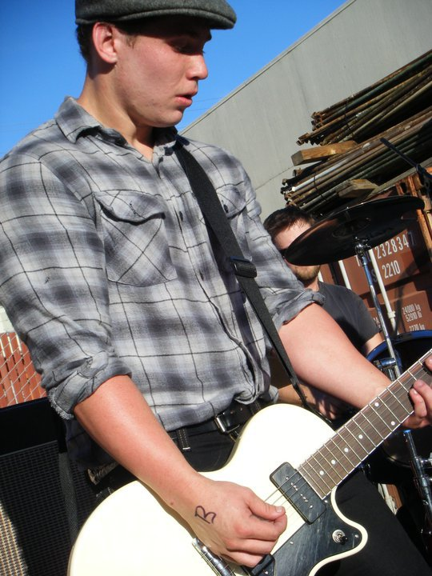
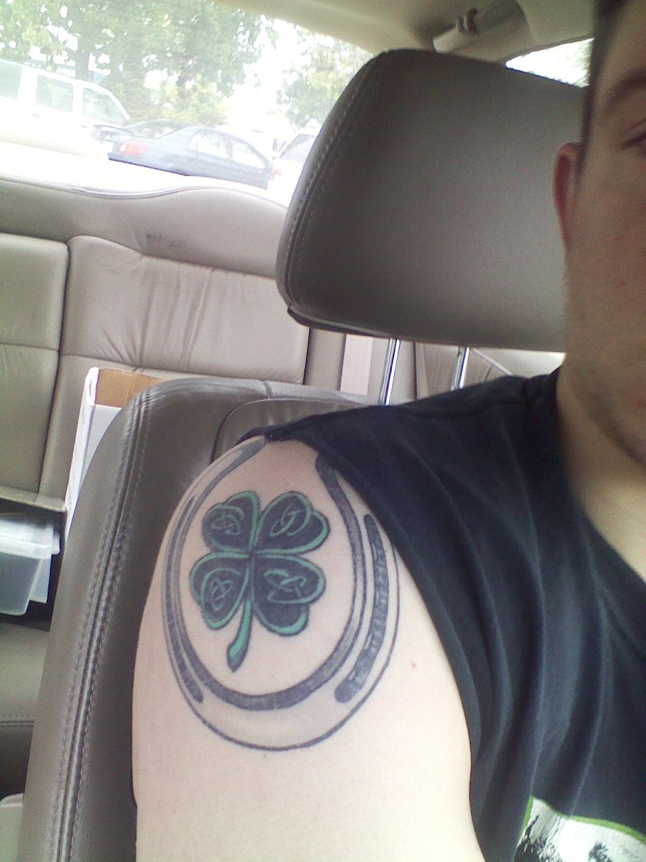

Taylor Patrick Finan, or as I call him, my little Leprechaun

