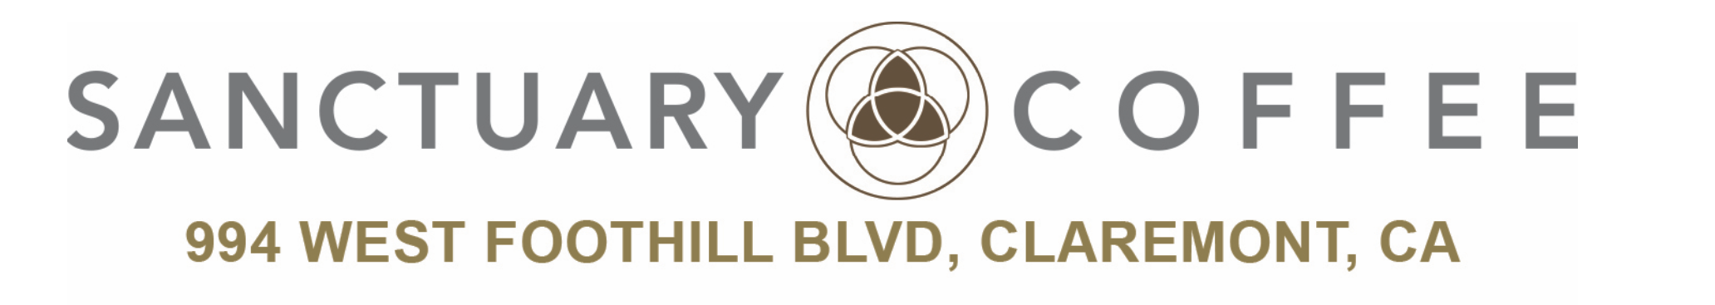
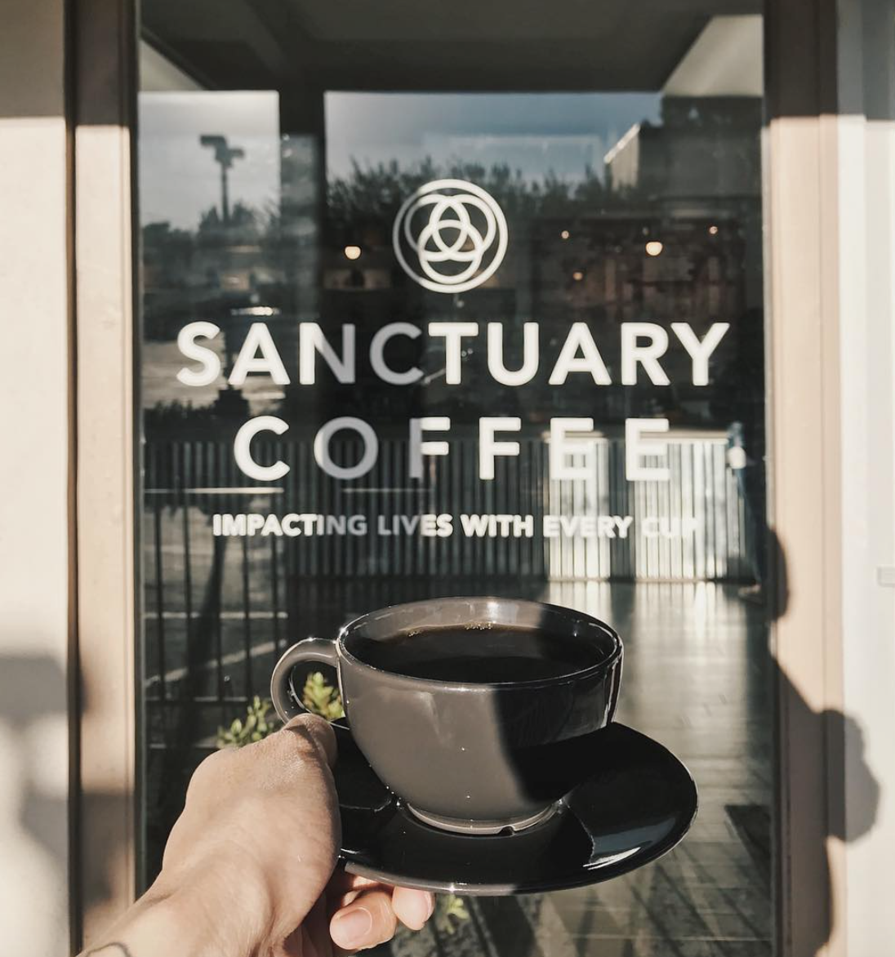

Executive Summary
Sanctuary Coffee, located in Claremont, California, is a 501c3 nonprofit organization founded by former University Dean and Professor, Dr. Steve Gerali along with some former students. The name of the location communicates to all of the visitors that it is both a safe and sacred place, similar to a sanctuary. Dr. Gerali has no desire for Sanctuary Coffee to be the next biggest coffee shop; he simply wants to focus on community enhancement. It started as a place to mentor individuals to help build character and get them inspired to give back. He did not like the fact that other companies lacked integrity as they promised to give back by using charity as a pity tactic to still make a profit. The idea of opening Sanctuary Coffee is just a front for what he intends to do, which is to advocate social justice. He is striving to make a positive impact in the surrounding communities of Claremont while building a community with individuals who share the same vision.
Situation Analysis

Internal
Are you meeting your current objectives? Sales and marketing
The exceeded their expectations of their sales goals. The have a 50,000 debt to personal finances which they will pay back, and afterwards want to hopefully open up another store in hopes to improve a community by offering volunteer work near that community. In the 9 months that they have been open, they have been completely exceeding their goals. They have to think faster about what their next move business wise is.
Do you have any internal organizational challenges that might be affecting your marketing efforts or success?
The store heavily relies on word of mouth. Students tell students and the customer becomes the hero by passing on the word.
The employees have bought into the vision of the business and are either former students of the owner or have a mentoring relationship with the owner. This helps the business. The only problem is that they have grown so quickly and don’t know where or how to grow. This could possibly mean cutting staff from many part time employees to a fewer amount of full time employees. They want to focus on making a profit but also give profits with integrity.

Customer
Who are your current customers? Who are your potential customers?
Their current primary customers consist largely of millenials. This includes current college students or young professionals. They benefit greatly by being near Cal Poly, La Verne, and Western. They also cross the generation divide by reaching the senior market in the morning and groups of high school students in the afternoon.
Where can your customers purchase your products?
They are trying to sell their coffee online, but shipping costs are very high. The cost of the coffee added to the cost of shipping becomes very expensive. Their bags of coffee are also available in store. They came up with a subscription strategy where you are able to pay a flat rate and receive a different coffee every month.
The time of day or year does not really affect the purchasing of coffee so far. The only time they dip in sales is sometime around meal times. Coffee takes a small dive around the summer, which is when they opened, but they did not experience any
Why might customers not purchase your products?

External
Who do you consider your competition?
Sanctuary Coffee is considered by other coffee shops as the competition. They do not want to be considered as a competitor, because they want all businesses to succeed. They even tell customers about other coffee shops and offer tips on how they taste differently. They want to impact other businesses in a good way and
Price wise, they are competitive, but a little lower than some other coffee shops. They have to take their prices in consideration because of minimum wage and other factors, in order to keep their profit margin at a break even point. They want to also prove that they are not about making the most money.
How much have you grown as a business since you began?
They have grown so much as a business that it is hard for them to chart and track. They started with one third of the inventory that they have now, and have also grown into their coffee suppliers largest client. They currently employ a staff of fifthteen baristas.
Was your business affected by any economic activities such as employment rate or taxes?
Is your business affected by technological advancements?
In the coffee industry, there are many upcoming technological advancements. One of their board members is the executive vp of a coffee company Automated machines and Nitro taps are the next best things. They just received new automations in cold brewing. In the coffee business, people aren't looking so much at the technology, but the quality.
POS wise, it is very costly to update their systems. These machines take up a lot of their sales profits, but make
Nitro- this summer

SWOT
Opening a coffee shop is like beginning whatever other business which requires feasibility studies and market review in order to get the economic analysis right. In actuality, the Sanctuary Coffee shop needs to get your financial investigation right in the event that it has goal of building the business is to produce benefits, develop the business and maybe grow the business past one area to different areas inside the United States and different urban communities on the planet. When leading monetary/economic analysis for the coffee business, it is basic to inspect these key variables; product, place, promotion and pricing (4Ps). Indeed, the entrepreneurs behind this venture should keep on reviewing these key variables at consistent interim while running the coffee shop.
It is vital for the coffeehouse proprietors to know that running their own single coffee outlet (a free bistro) is not the same as overseeing or working a café chain or establishment. Overseeing or working a café chain or establishment draws in extra obstructions like administrations, development strategy, and operational rules et al.
Strengths: The concept behind Sanctuary Coffee is one of their biggest strengths. The fact that they are committed to give all profits back to the community is what differentiates them from other coffee shops nearby. A strength aside from their concept is their product. They serve the finest quality artisan coffees and is the only coffee shop in Claremont that does artisan coffee. Another strength is the location as they are located in a college community. With this, they are able to attract more college students who are looking for a place to sit down and study. The relaxed and spacious environment of Sanctuary Coffee is also one of their many strengths. They have a two floor indoor seating area and an outdoor seating area, and they offer endless coffee, wifi, outlets, and a printer to keep customers in longer.

- Concept: gives back to community
- Product: finest quality artisan coffees
- Price: a little cheaper than other coffee shops
- Environment: indoor and outdoor seating area
- Location: near college campuses
- Endless Coffee, Wifi, Outlets, Printer

Driven by the desire to introduce integrity into the business world, and helping people, Sanctuary coffee is strengthened on the organizational culture of service teamwork and integrity that consumers in the market want to identify with.
Sanctuary coffee has made organization-consumer relationship policies which generate repeat consumers on the deepest level. The consumers get emotionally attached to the humanitarian nature of Sanctuary coffee. What each coffee sells, for example, is directed towards helping people. In essence, they make their consumers hero of the society.

Weaknesses:
- New: just opened in May, less popularity
- Reach: word of mouth and social media
Heavy reliance on word of mouth is a weakness for the Sanctuary coffee where in the world today, a failure to get digital means that the business may get redundant.
Cut on profits is also a weakness for the Sanctuary coffee as a major share of its profits is directed towards the charities and not much is left for strategic implementation to see that the business remains profitable in the future.

Opportunities:
- Expansion: opening more stores
- Involvement: more volunteers
- Market: growing demand for coffee shops
Technology presents an opportunity for Sanctuary coffee where moving the business online makes the business take advantage of a lucrative profit as it will be able to reach a larger market
Innovative Products of Sanctuary coffee set it apart in the market and give an opportunity to grow in the international market. The products include Flat Rate coffee, Stamp card and the Endless cup of coffee.

Threats:
- Competition: chain coffee shops
- Price fluctuations: might have to increase price of coffee
- Market: changing taste of customers
- Consumer trends: no caffeine
With such opportunities, Sanctuary Coffee as well faces different threats. One of the biggest threats is stiff competition from numerous coffee shops in the market that try to copy-cat the company’s brand. Another threat is that the coffee market may shrink in future due to the invention of another type of leisure activity or beverage to replace coffee in the near future. This may force Sanctuary Coffee to shut down.

TOWS Matrix
Threats
Since the business is growing and just breakeven recently, there is a milestone to cover and this is somewhat risky but the coffee shop has set up strategies to cater for the competition. The greatest threat to the business is the price gauge set by competitors and the high cost of tax and insurance as a non-profit. This eats into the profit margin.
Opportunities
The business has an unoccupied space that can be pimped and attract passersby who can walk in to have something that they wanted to have somewhere else but chose the business as an alternative. The coffee shop is in a stable condition to create good relationship with its customers e.g. high school students.
Weaknesses
Since the business is at its initial stages of growth, it has financial challenges and sometimes depends on donations to do business. Therefore, financial muscles are limited in the meantime and it is not in a good position to implement some project that need bulk financing such as point of sale system and so forth.
Strengths
The Sanctuary coffee shop has the ability to offer competitive prices and products that are offered by the well-established coffee shop in the market such as the Starbucks. The coffee shop is able to apply technological changes to ensure the taste of their coffee is superb and people are going to like it. It is the only coffee shop in Claremont and its neighboring offering specially blended coffee products and sandwiches that makes up the best out of its offers.
In summary, looking at the internal factors, Sanctuary coffee is looking seriously as the strategic options that will help the shop to overcome its weaknesses and exploit more of its strengths.
Developing competitive advantage
Sanctuary coffee is doing the best to ensure that the customers are satisfied and that the customers develop a feeling of ownership of the coffee joint. It is through customer satisfaction and feeling of accommodation that they are bale to spread a word of mouth to other people in the surrounding who get influenced and choose to visit the shop. In order to develop a competitive advantage, the sanctuary coffee shop has gone ahead to define both its direct and indirect competition i.e. who are the main competitors in the market? Through this, the Sanctuary coffee shop define its roles in the market and seek to fulfil them.
The shop uses social media e.g. instagram, Facebook, twitter to communicate with its client and let them know what they are offering for example, buy one cup of coffee and get another one for free among other offers. They keep he customers posted every day. The coffee shop has done all it can to network with people in the society and create a good public image that wins the clients who turn out to be loyal customers. The Sanctuary Coffee shop also maintains good relationship with its suppliers and distributors. The program set to influence the community is to like the shop is also geared towards giving back to the community by volunteering and supporting projects in the community.

Marketing Goals and Objectives
The marketing goal and objective of Sanctuary Coffee is to impact lives with every cup. Sanctuary Coffee is more than just a coffee shop and this just a front for their mission. They are planted in a community that is fairly affluent and next to community that is in need. They want to inspire others to give back to the community and reconcile social injustice. Their goal is to keep people in longer to build relationships because their customers are more important than their products. It is not only about the amount of sales they get or how much they are profiting, but it is about making customers aware of community needs that they were not aware of before and have them be a part of the movement.
Marketing strategy and Marketing mix
Primary Target Market: The primary target market for Sanctuary Coffee are millennials, specifically current college students and young professionals in their 20’s. There are a few college campuses located within ten miles from Sanctuary Coffee including University of La Verne, The Claremont Colleges, Western University of Health Sciences, and Cal Poly Pomona. Students are usually looking for a place to study, especially when it is midterm or finals week. Sanctuary Coffee provides a spacious seating area and a relaxing atmosphere to their customers as a large segment of their customers are students. Though Sanctuary Coffee primarily targets millennials, they have a wide range of customers throughout the day varying from students from surrounding high schools to elderlies from nearby senior citizen villages.
Product: Sanctuary Coffee consist of a simple product portfolio and a deep product line.

Product Line | Product Mix
Product Line | Coffee Classics | Specialty Coffee | Specialty Drinks | Coffee Beans
Product Line | - Fresh Brew  - Espresso  - Macchiato  - Cappuccino  - Americano  - Cafe Latte  - Cold Brew  - Artisan Tea | - Flavored Latte  - Creme Brûlée Latte  - Cinnamon Mocha Latte  - Caramel Turtle Latte  - Coconut Almond Latte | - Chai Tea Latte  - Dirty Chai  - Green Tea Mint Latte  - Hot Chocolate  - Shot in the Dark  - Tonic Water | - Brazil: Mogiana Peaberry  - Colombia: La Esperanza  - Ethiopia: Wenago  - Espresso: Flight of Fancy  - Guatemala: El Rincon  - Sumatra: Tano Batak  - Espresso: Decaf  - Decaf: Brazil

Price: Sanctuary Coffee sets the price for their products a little lower than other coffee shops. The coffee is at an affordable price for their target market that is predominantly millennials. All of the coffee classics, specialty coffee, and specialty drinks range from $1.75 to $4.95, regular or large size, and the coffee beans range from $12.95 to $15.95 for a 12 ounce bag.
Distribution/Supply Chain Strategy: One of their social justice concern is to ensure that coffee farmers receive an ethical wage. Sanctuary Coffee only deals with coffee beans that are fair or direct trade. The roaster that they work closely with is located in Redlands, California. Sanctuary Coffee has a small supply chain because they do not have a high demand compared to chain coffee shops. A small supply chain allows them to efficiently keep track of inventory, while reducing costs and increasing output. Currently, they are trying to break out of the coffee shop of distribution and sell coffee beans on their website. The problem with online distribution is the shipping cost. With the shipping cost included, the product becomes more expensive and out of the price range. But, they are planning to launch a subscription strategy in which customers can pay a flat rate and they will be sent a different bag of coffee every month.
Promotion Strategy: Sanctuary Coffee is heavily reliant on word of mouth as a way to promote their products and increase awareness of social issues. People are able to quickly spread the word and recommend others to support the cause. Aside from word of mouth, they use social media platforms, Instagram, Facebook, and Twitter to communicate with their followers and keep them updated with current promotions. Their most recent promotional campaign was done at Cal Poly Pomona. It was a 2 for 1 promotion in which students can buy a cup of coffee and get one free to share. They are planning to launch student discounts as early as next month to encourage more college students to visit and help impact lives with every cup. Moreover, they have been implementing a stamp card loyalty program. The stamp cards are stamped per visit and after 10 stamps, anything from the menu could be redeemed for free. Each stamp is initialed by the barista and if the same barista initials four times in a row and does not recognize the customer by name, the barista has to buy the customer a cup of coffee. Customers can potentially get 3 free drinks out of 1 stamp card and it is a way for them to foster and maintain customer relationships.
Public Relation Strategy: The goal of Sanctuary Coffee is to impact lives by supporting local communities. To reach this goal, they network with community leaders, pastors, clergy, civil leaders, police department, fire department, and business leaders. With these connections, it increases community involvement from other organizations. These organizations can inform and educate potential customers about what Sanctuary Coffee does to give back. It helps increase brand reputation, but most importantly raise awareness on social justice. Sanctuary Coffee turns all of its profits into Claremont and the surrounding communities. “One-hundred percent of our profits goes to charities within this community”, said owner Dr. Steve Gerali. “Plus our coffee roaster donates 10 pounds of food for every pound of coffee that we sell”. Since they opened back in May 2017, they have already donated almost 34,000 pounds of food to people in the community. Dr. Steve Gerali hopes a little extra love in each cup will add up to one big donation at the end of the year for families in Claremont.

Consultation to the business owner/manager
As a group, we found that the concept of Sanctuary Coffee is what attracts customers and differentiates them from other coffee shops. Sanctuary Coffee is continuously growing since they opened less than a year ago and their success is a result of their marketing strategy and implementation. As college students, their primary target market, we drink coffee on a daily basis. The consumption of coffee among all ages has increased over the years and after looking at the trends, there has been a significant increase of coffee consumption in the younger generation. Moreover, because students are constantly looking for places to study… One of the recommendations that we have is to be more active on social media. Millenials are always on social media and to increase awareness of not only the coffee shop, but also the cause, postings should be done more frequently at least twice a week.
- Needs more space, already considering a second location
- Create a online thread, where people can talk about their ideas with each other
- Endless coffee
- Stamp card idea, if the barista doesn't know your name by x number of times they buy you a drink

Source of Information

Bulletin, T. I. (2017, June 04). How a Claremont shop is using coffee as a vehicle for change. Retrieved March 02, 2018, from https://www.dailybulletin.com/2017/06/04/how-a-claremont-shop-is-using-coffee-as-a-vehicle-for-change/

Novilla, M. (2017, October 06). Non-profit coffee shop donates to the homeless. Retrieved March 03, 2018, from https://lvcampustimes.org/2017/10/non-profit-coffee-shop-donates-to-the-homeless/

Rhodes, M. (2017, June 12). From academia to nonprofit, creating a unique sanctuary. Retrieved March 03, 2018, from https://www.claremont-courier.com/articles/news/t23608-coffee

Biggest challenge: He thinks strategic. EX: cold brew, wait until summer because that's when it will make them the most money. It is hard to hold out on things like this.

Stand out: Only shop in claremont that only does artisan coffee. Tried sandwiches, but don't want to expand like that. In n out mentality. “Do one thing and do it well.

Challenge: to only sell artisan coffee while people have faster pace lives. They want a place where people feel like they belong and get what they want.

HS student that wants to create an app to pre order very soon.
Customers keep coming because of the cost- it doesn't have to be good, it's just the cost is so good so i'll buy it. It ended up being good as well.

Greatest threat: price gouging. They pay a lot in taxes, such as equipment tax, even as a nonprofit to the government. The high cost of insurance is also a big threat, employees and board included.

Their business would not be as successful as it is today if it wasn’t a non profit. They didn’t have to pay for fees such as public health or business fees to the city. Those fees are based on the value that they bring to the city. They have only brought in about half of a million dollars since they have been open.

They chose claremont to establish their business because he used to meet up with students as a mentor and it they found it hard to bounce between different restaurants and have a conversation and feel comfortable. They are also 1, 2, and 3 miles away from 3 colleges. They did not establish in Pomona because they didn't find a large enough coffee clientele. They understand pomona needs their help, so they can also offer their services thier.

They want to really focus on marketing to Cal Poly Pomona. We, as students, believe that this location is further from our campus, but the area in the shop is much more comfortable.

Three recipients of their community service:

Ability first. They work with people with developmental disabilities

Inland Hope Partners- work with homeless and food pantries, staff them and provide transitional housing for help families in need. Become recipients of food and monetary donation

Everyone Free- working with sex and human trafficking within the I 10 corridor, which includes Pomona and Claremont.

Healing social concerns: really focusing on families that are healing with disabilities. They are trying to stay as humble as they have been since they opened. They were glad to prove to the skeptics that didn’t think their business model could work out.

