Architecture
Name
Institution Affiliation
Class
Author's Note
Professor
Date

Contents
Saqqara's history and location on the map, including when they started and ended 3
Their Religions and Temples and tombs 4
Religions 4
Temples 5
The tombs 6
Their way of living including business they do 7
Their way of living 7
The family 7
Mistress of the house 8
Childbirth 8
The home 9
Food and drinks 9
Clothes 10
Health 10
Architectural works 11
Business they do 11
References 12
Appendices 13
Figure 1: Map of the site 13
Figure 2: Saqqara location in Egypt 14

Saqqara's history and location on the map, including when they started and ended
Saqqara is a vast and ancient burial ground in Egypt which serves as an archaeological site in the Egyptian capital. Saqqara is a famous place containing pyramids and the world-famous tombs, which have existed for an extended period. Saqqara is located 30kilometres to the south of Cairo, and it covers an estimated area of 7 by 1.5 kilometers (Mohamed et al., 2020). At Saqqara, the oldest stone building in history was built, including other structures like the pyramid of Djoser. In Saqqara, several Egyptian kings built pyramids, which are now in various states under proper conservation. This area also contains private funeral monuments, which were built during the entire Pharaonic period.
Saqqara remained an important area where non-royal burials and cult ceremonies were conducted for an extended period, which was more than 3000 years during Roman times (Mohamed et al., 2020). The area is surrounded by other areas in the north and south, designated as a world heritage site by UNESCO in 1979. At the north of Saqqara, several burials of nobles buried in Saqqara plateau can be traced. The history of Saqqara is rich in that the area contained the burial ground for many royal families, including the dynasty kings.
Saqqara's funerary monument, which consisted of rectangular enclosures, inspired the massive enclosure wall around the step pyramid complex. All the early dynastic monuments in Saqqara include; tomb of king Raneb, the tomb of king Nynetjer, the buried pyramid of king Sekhemkhet and the step pyramid of king Djoser (Mohamed et al., 2020). The fifth and the sixth pyramids are not entirely built of stone blocks but also with a core consisting of rubble. The area is well preserved for future references as a historical site where different people from different parts of the world can tour the area and get the area's historical concept. During the middle kingdom, some restrictions were put on the area where Memphis was no longer the country's capital, and kings were advised to build their tomb monuments elsewhere. Through such restrictions, only a few private tomb monuments can be found in the area of Saqqara.
During the new kingdom times, many officials were allowed to build monuments in the area, and many kings build large monuments in the area, although some were not buried in the area. During the new kingdom era, when several cities in Delta served as the capital of Egypt, Saqqara remained as the burial ground for the noble. The area became an important destination for pilgrims and several cult centers (Mohamed et al., 2020). Many activities emerged in this area, like the extensive underground galleries, which were cut into rocks as burial sites for many ibises, baboons, cats, dogs, and falcons—this area about 4700 years ago when the step pyramid of Djoser was established in the area. The step pyramid of Djoser was the first pyramid to be built in Egypt. The last tomb monuments to be constructed in the area were constructed 40 years ago, and the Egyptian government enacted rules which meant that the area should be preserved for archaeological purposes.

Their Religions and Temples and tombs

Religions
In ancient Egypt, religious life was considered static, hierarchically organized, and centered on priests, tombs, and temples. The religious practice that was practiced in Egypt was Christianity. This was necessitated by the fact that many beliefs were that ancient kings' leadership, like Pharaoh, introduced the concept of worship where everybody was to adapt (Mohamed et al., 2020). However, Islamic was introduced in the middle ages where many Egyptians adopted the religious practice, and up to today, Islamic is the largest religion in Egypt, followed by Christianity. The state religion in the area was Islamic, controlled by many aspects of life, and endorsed by law. Many scholars have argued that there are several religious practices in Egypt, but the significant religions widely used in Egypt are Islamic and Christianity.

Temples
The Egyptian temples were built for the primary official purpose of worshiping gods and commemoration of the pharaohs, who were the official controller of all worshiping units. Temples, according to the ancient Egyptians, were seen as houses for the gods or kings to whom they were dedicated to worship and serve (Mohamed et al., 2020). Within the temples, the Egyptians performed a variety of rituals. However, the Egyptians had the central function in the temples, which included; giving offerings to their gods, reviewing their mythological interactions through conducting festivals in the temples, and warding off the chaos forces between the communities.
Temples were also used to conduct wedding ceremonies where people were allowed to exchange vows in the temples. The rituals conducted in the temples were seen as significant events and necessary for the gods to continue providing order and unity in the universe. By building the temples, the Egyptians believed that they had fulfilled the laws from the Pharaoh, who believed that housing and caring for gods were the way to relate well with the gods they believed were powerful than any other human being (Mohamed et al., 2020). Many of the resources were allocated to the construction and maintenance of temples due to the gods' respect. Pharaoh was a dedicated king who could find time to host priests in the temples. However, many of the population were excluded from participating directly in the temples as Christians believed that only sacred people should enter the most sacred area. According to them, it was the temple.
The temple was considered the most important religious site for all classes of people from Egypt who could go to the temple to pray to their gods, offer their offerings to their gods, and seek guidance from the god of dwelling within (Ikram, 2017). By attending the temples' worship activities, Egyptians believed that their gods would offer everlasting peace and forgive them their wrongdoings. The most important part of the temple was the sanctuary, which contained a cult image, its god's statue. The temples are believed to have evolved from late prehistoric Egypt's small shrines to the large stones in the new kingdom. The temples were decorated using architectural ways using the intricate patterns of religious symbols. The temples' design consisted of a series of enclosed halls, entrance pylons along the paths used for the festival procession. The design also hosted several open courts.
Beyond the temple, there was an outer wall which was covering other secondary buildings. The wall was also considered to provide security to worshippers in the temple. The temples were considered to be large as they were established in large tracts of land. The temples also employed thousands of laypeople to supply their needs (Ikram, 2017). Through such employments, the temples were considered to offer economical and religious rights to the population. The priests who were managing these temples and the institutions that the temples hosted were considered influential, which is why these priests were later ordinated to become kings. The priests in the temples were considered powerful as they posed many challenges to the authority due to the large number of people they could influence. The temples were considered to provide a friendly site where humans could interact with their gods through rituals.

The tombs
Most of the tombs in Egypt were built for the kings. The tombs were built of dried bricks, which were then used to shore up shafts and chambers dug into the earth. The tombs were built in sacred places, and a statue of the dead was erected adjacent to the tomb where the spirits and the gods of the dead person could witness and enjoy the ceremonies (Ikram, 2017). The tombs continued to be constructed in Egypt for the ordinary people, where they were replaced by structures called pyramids. The first pyramid was built in Saqqara with a great height, and the Egyptians adopted this and replaced it with tombs. The royal pyramids, which were necessarily constructed for the kings, were adorned with paintings depicting the deceased's life.
The paintings also included the king's accomplishments, which the gods and the spirits were considered to use for the deceased. In Mesopotamia, people were concerned with their loved ones' proper burials, and they often built tombs (Ikram, 2017). These tombs were even built-in people's homes so that people could continue caring for the deceased and prevent many problems that arose due to haunting activities, which rose for fear of ghosts. These tombs always were used to preserve the personal possessions and gifts which the deceased had preserved to offer to his gods.

Their way of living including business they do

Their way of living
Egyptians have several ways of living where their population was supported by slaves, servants, and tenant farmers working in the estates owned by the kings and the rich. There were skilled and semi-skilled artisans who used to work in the temples when paintings and drawings were required (Ikram, 2017). There were also soldiers, sailors, and those who got a chance to be employed by the state to do some projects like building the sites, tombs, and temples. Above all the people, there was a class of educated professionals, and they included the doctors and accountants.

The family
The family was considered only to provide a reliable support mechanism, and it was considered one of the most critical institutions in the social setup. Marriage was the key to building a family where the family could attain a valuable economic unit. In ancient Egypt, everyone, including the gods and goddesses, participated in marriage. An unmarried man was considered an incomplete person in society and could be excommunicated until he marries (Ikram, 2017). Their grandparents advised young schoolboys to marry when they are still young and give birth to as many children as they can. Many children were considered as blessings and wealth to the family. Due to the area's cultural activities, boys were required to follow their fathers' footsteps and their uncles, where they were trained about trade activities and other professions. Girls were required to stay at home and get knowledge from their mothers and grandmothers.

Mistress of the house
Husbands and wives were considered to have complementary but different roles within their marriage circle. Husbands were required to work outside the home to provide for their families with food and other essential factors. However, women or wives were treated as the mistress of the house. They were given the roles of running the household through cooking food for their family, providing drinks for the family, and performing the clothing and cleaning services as needed (Ikram, 2017). Childcare was an essential role that every woman was trained for since the time she was a teenager. When relating to social status, women and men had equal rights, which allowed them to own property as men did. These social rights also allowed women to live alone without the intervention of the male guardian.

Childbirth
It was a cultural practice that most women spent much of their lives, either pregnant or breastfeeding their babies. Charms were used to protect pregnant women as figures of pregnant hippopotamus were erected at the pregnant women's homesteads (Ikram, 2017). These were beliefs that the animals' symbols were going to protect the unborn from malice and death. Mothers were supposed to remove their clothes and loosen their hair as a sign of preparing for birth. In wealthy families, women were given their hurts, which were considered superior, and they could use the hurt to give birth. The mother squatted on the birthing bricks for delivery, and the available midwives were used to cut the umbilical cord using sharp knives. The midwives were not trained on this job, and therefore if something went wrong, they could do very little to offer assistance. Mothers were supposed to breastfeed their babies for up to three years after birth.

The home
Egyptians were considered to build their cities and towns using mud-bricks and preserved stones to build tombs and temples. Building with mud-bricks was considered cheap and fast. However, the Egyptians destroyed all the houses they had built and considered using stones when they were readily available. The workmen in the villages who could carry out construction activities had their ways of doing construction activities. The terraced houses they build in the villages were long, narrow, and dark (Ikram, 2017). The houses also contained a door which was opening directly to the main street. Each house was considered to include two living rooms, a storeroom, and a kitchen equipped with a mud-brick oven. The chicken roofing was supposed to be from matting that would allow smoke and cooking smell to escape. Stairs were also constructed with the main aim of accessing the additional living rooms and the roofing.

Food and drinks
Egypt was considered as one of the regions with fertile soils and large cultivatable land. Food could be acquired through growing at homeland, people, especially men, could go hunting, fishing was also carried out, and people could acquire the food they deserve through barter trade. Water used in the homestead and the agricultural activities were acquired from wells, irrigation canals built by the people, and the Nile. People consumed wheat and barley, which they were gaining carbohydrates from them (Luiselli, 2020). People also ate bread, which was given in the temples during celebrations. Vegetables and fish were widely available due to the cultivation and the fishing activities that people engaged in. The families were considered to feed on a balanced diet through the feeding styles since there was a variety of food. The drinks that were available included; beer, sweet beverages, which was the main drink for many people, and wine made from grapes grown in the Nile delta, privileged for the elite. Most of the drinks were consumed immediately after a meal.

Clothes
They were using the archaeological evidence; women dressed in practical, straightforward, and sleeved dresses. These dresses were made of cotton and silk. The women also wore woven sandals and a shawl for warmth. Men had a similar dressing code though they used to remove such clothes when working in the fields (Luiselli, 2020). These clothes by both men and women were considered expensive and of high quality where we're used to their end and later used as mummy wrappings. Laundry was done in the canals of the river Nile where natron, a salt-rich mineral, was used as a cleaning agent.

Health
There were doctors in Egypt who were considered the best in the ancient Mediterranean world. For the Egyptian people to get the cure, they applied both scientific techniques and magical rituals. Patients were treated using prescriptions where human milk was considered to contain certain ingredients useful to improve one's health or through minor surgeries performed by skilled personnel (Luiselli, 2020). The available doctors offered some specialization to their work; for instance, gynecologists offered treatment to females and fertility and pregnancy tests.

Architectural works
Many people in Egypt had adopted architecture as it was one of the fields which were considered for the elite. Those who had the skill were favored in society and were given a well-paying job in construction. The experts were concerned about constructing tombs, temples, and official buildings where the priests and kings resided (Luiselli, 2020). Road construction was under the supervision of architectures who offered special skills to the construction. Architectural works lasted for a long as most of the substantial buildings in Egypt were built during ancient times. Experienced architects built pyramids, which are still existing in Egypt up to today.

Business they do
People were capable of working hard, and everybody had a job they could specialize in. The businesses in the area included a bakery where trained people were engaged in bakery activities and provided cakes and bread to other people. Fishing was an economic activity that people were engaged in. the presence of many rivers and canals in the region provided a healthy ground for fish breeding. Artworks were done by people who had painting skills and drawing in the temples and tombs (Luiselli, 2020). Hunting was another economic activity where people mostly depended on wild meat for consumption as it was healthy. Farming was an economic and subsistence activity where family members engaged in getting food for consumption. The remains they take them to a market where barter trade occurred.

References
Luiselli, M. M. (2020). Living a Religious Life: The Display of Religious Experience in Egyptian Autobiographies. Ancient Egyptian Biographies: Contexts, Forms, Functions, 6, 307.
Ikram, S. (2017). Animals in ancient Egyptian religion. The Oxford Handbook of Zooarchaeology, 452.
Mohamed, A. M. S., Atya, M., AbouAly, N., Farragawy, K. E., Hegazy, E. E., Saleh, M., ... & El-Mahdi, A. A. (2020). Mapping the archaeological relics of catacombs at Northeast Saqqara using GPR data, Egypt. NRIAG Journal of Astronomy and Geophysics, 9(1), 362-374.

Appendices

Figure 1: Map of the site

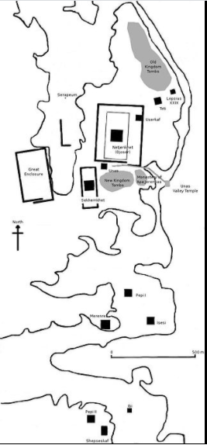

Figure 2: Saqqara location in Egypt
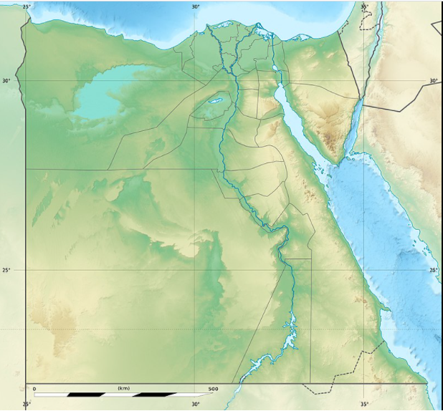

NB: Hello my friend. Remember to delete this part before you submit your work.
Please take a look at this work and see if it meets your expectations. If so, I request you to kindly remember to release the funds on time and leave a 10-star rating if you do not mind. I will really appreciate it. Also, you can find me on this mail (davykikuvi774@gmail.com) for more work in future if you will need my services. Feel free and let me know. I will always be at your service whenever I can. Again, thank you for working with me.

