Student’s Name
Professor’s Name
Course
Date of Submission
Satire: Police Brutality
Police brutality has remained a sensitive sociopolitical issue in the United States (U.S.) and beyond. Law enforcers from across the world are either use or often accused of using illegal and excessive force against individual civilians they are supposed to protect from harm. Given the prevalence of police brutality incidents, scholars, policymakers, and people in the entertainment industry are increasingly resorting to the use of a variety of channels and methods to criticize the police and advocate law enforcement reforms. Satirists are one of these players, utilizing their satirical skills and techniques to portray and ridicule different forms or manifestations of police brutality, including assault and battery, murder, mayhem, harassment, verbal abuse, torture, and intimidation through false arrest. As a result, this essay analyses three satirical pieces on illegal law enforcement practices in the U.S.: Phil Hands’ cartoon image, a 1:12-minute video by Mallory Baker, and an article by Anonymous.
The cartoon image by Hands depicts a scene in which a police officer is shooting Jacob Blake as he opens the door of his car. A woman is seen shouting “without police body cameras somebody’s got to record this.” She is recording the vent using her phone camera. She is also holding an unbalanced weighing scale, with her scarf bearing the word “JUSTICE.” From this cartoon, the cartoonist is ridiculing the one-sided justice system in the U.S. in which a person’s skin color and race override the law. He conveys this ridicule through parody, a common technique among satirist that involves integrating the already-existing story to advance or exaggerate its importance to the audience. For instance, in the presented context, Jacob Blake is black and the shooting police officer is obviously white from the look of his skin color, which means the cartoonist is appealing to his audience’s emotion regarding the issue of rampant police brutality.
Hands targets all Americans, challenging them to act by seeking justice for victims of police brutality if the law enforcers themselves cannot do their job. The caption is the main message: when the police fails to use their body cameras to justify the use of force, the cartoonist urges the public to utilize every tool available, including their smartphones to stop biased policing in their streets and neighborhoods. The cartoonist succeeds in justifying his attack on the unfair law enforcement practices because he suggests a need for police officers to do the right thing by implementing equal justice, especially by taking evidence-based action.
Like Hands’ cartoon, the article by Anonymous, “Police Brutality: Satirical Peace,” and Baker’s video speak of how the black community is yet to be satisfied by the various luxuries that they have received from several years and poor versus best policing practices, respectively,. According to the authors, these luxuries include humiliation, slavery, police brutality, lynching, and persistent segregation (par. 1). The article proceeds to describe the U.S. as a nation that is quite loving to African Americans for gifting them with recent waves of police-involved shootings and deaths. Anonymous and Baker are also ridiculing the discriminative approach to policing in the U.S., with the article targeting law enforcement agencies, the country’s top leadership, and the general public. For instance, the author talks about stereotypes people and police officers have of blacks as threatening (Anonymous par. 1). By including the widely held prejudices against African Americans, the authors remind the public to shun labeling and embrace individual differences.
The article uses exaggeration, while Baker utilizes reversal methods or techniques for conveying their satirical message. In particular Anonymous argues that “black men are such a threat to cops everywhere, they attack at any moment, even if they are weaponless” (par. 2). To the author, an African American man possesses so much power and skilled in way that he easily breaks these highly trained and equipped professionals. Moreover, cops are so holy that they can never be involved in any forms of wrongdoing, only black people. Most importantly, the article hits the target at the very core of the issue at hand, corroborating that, for America and cops to enjoy peace, blacks should stop being dangerous by living with their feet and hands in shackles. Undoubtedly, the satire in this article is successful because it challenges the American society to review and implement proactive reforms in its law enforcement system. On the other hand, Baker feature a male character in her video as the victim of her poor policing skills. For instance, she pounces on the individual instead of arresting him in a legal manner. Additionally, she shows how police officers often use poor investigative skills by arresting an individual without necessarily gathering enough evidence.
Cartoon Image | Video Screenshot
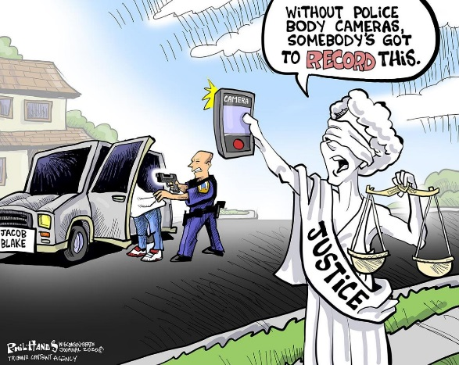 | 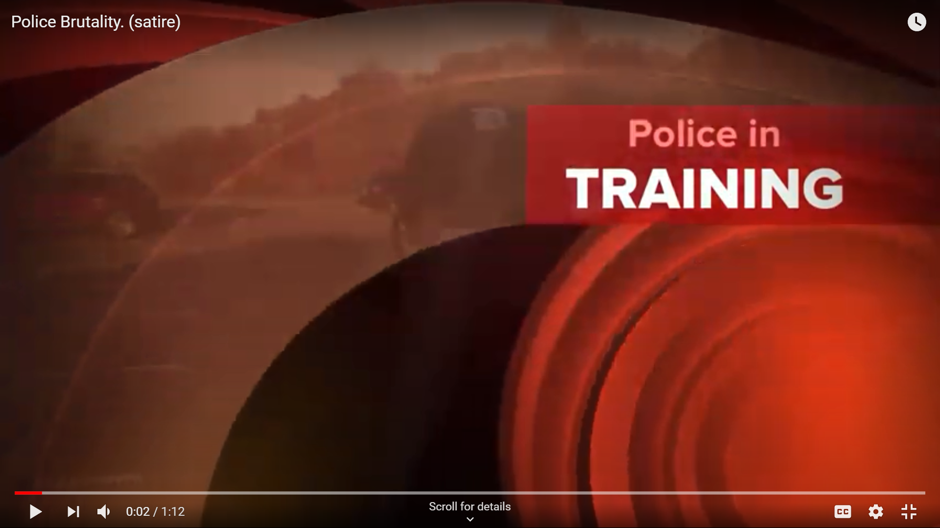
Works Cited
Baker, Mallory. “Police Brutality. (Satire): Police in Training.” YouTube, Oct. 25, 2015. Available at https://www.youtube.com/watch?v=AO8hdrfW0l0
Anonymous. “Police Brutality: A Satirical Piece.” Teen Ink, Mar. 28, 2017. Available at http://www.teenink.com/opinion/current_events_politics/article/948825/Police-Brutality-A-Satirical-Piece
Hands, Phil. “Without Police Body Cameras Somebody’s Got to Record this.” U.S. News, Aug. 27, 2020. Available at https://www.usnews.com/news/cartoons/2020/06/09/political-cartoons-on-protests-against-racism-and-police-brutality

