A Year in the Life of a Manager

Managing Two Employees at Different Stages of Their Professional Lives

Background:
Allies of College Educators (ACE) is a Silicon Valley start-up founded in 2011 as a digitally driven, higher education consultancy that specializes in using the latest technology to aid admissions departments at U.S. colleges to attract, enroll, and retain students from diverse backgrounds. Combined, the core of ACE’s leadership team has more than 40 years of experience in college admissions departments. Like many start-ups, they were able to exploit their combined professional networks to grow ACE’s customer base quickly without a sales department and with only a small team of customer service representatives. By 2013, ACE had gained a strong reputation as the innovative, technologically driven, and cost-effective consultancy for higher education institutions suffering from the budget shortfalls caused by the economic downturn.
In June 2014, the chief executive officer (CEO) and product director introduced a new 3-year plan to the ACE board. Their research showed that access to online college applications among prospective students had dramatically increased the quantity of applications over the past 28 months. The study showed that a typical prospective student submitted an average of 10 applications, up from five applications just 3 years before. As a result, admissions departments were facing a new dilemma. They received a higher number of qualified applicants to accept, but their models could not accurately predict how many accepted students would actually enroll. Without a new solution, the admissions officers ran the risk of over-accepting the incoming freshmen class and overcrowding their facilities or under-accepting the freshmen class and facing revenue short falls.
Given the dynamics of the higher education admissions market, the CEO and product director at ACE proposed a solution that would bring new value to their portfolio of products. They believed that student interactions with ACE’s virtual campus visit app—Campus Walk—could be correlated to student enrollment decisions with 70% accuracy. The product director went on to say that the student data they planned to gather from the popular app would allow her team to improve the accuracy of their analytics and generate actionable estimates for admissions departments within the next 6 months. The CEO and product director announced that ACE’s business had reached an inflection point and that the future was data-driven enrollment intelligence. The new service would greatly distinguish ACE as the premier solution provider in the college admissions consulting market.

Identify and Shape Factors that Can Affect an Individual Employee’s Job Performance: SC2
As the new director of marketing, you have been hired to lead your team to successfully launch the new enrollment intelligence product. Julianne Marquez, Marketing Manager, and Rico Aconda, Marketing Assistant, were hired by the CEO shortly before you arrived. Julianne’s responsibilities will be to improve lead generation, capture customer behaviors, analyze captured data, and make recommendations to optimize your marketing investment strategy. Rico was hired to support the marketing team. The marketing manager will report directly to you, and the marketing assistant will report to you and support the marketing manager. Your new employees will work closely with the product team and the business development team.
Like most tech start-ups, ACE began with a fast-paced, casual work environment and still prizes its unique blend of hard work, informality, and positive collaboration across functional roles. As ACE rapidly develops its products and seeks out new revenue strategies, it also adapts the internal organization to meet aggressive fiscal goals. Employees who interview for positions at ACE are told to expect their roles and responsibilities to change quickly.
Below are brief biographies of your employees:

Julianne Marquez, Marketing Manager
Julianne was a lateral move from a related industry. She earned her degree in marketing from a large state school with a reputable business program. Over the past 6 years, she established a successful track record by exceeding her targets and getting promoted from marketing coordinator to associate marketing manager to marketing manager. She remarked that the marketing manager job description at ACE looked a lot like her previous job but with the added excitement of getting involved with a tech start-up. She sounded enthusiastic about ACE’s new strategic direction. When you presented her with an issue you had recently uncovered, Julianne’s solution was original, analytical, well-informed, and direct. Her deep knowledge of the digital world came through clearly.

Rico Aconda, Marketing Assistant
Like much of the staff at ACE, Rico was a referral—with his referral coming from upper management. Despite your reservations, you were reassured when Rico’s resume and prior experience lined up with the needs of the team. Rico recently graduated with a high grade point average from a small liberal arts university. He earned his degree in communication and minored in graphic design while working as a part-time administrative assistant for the college’s Office of Admissions. His resume also noted that his artwork had been displayed in a local art gallery. During the interview process, Rico appeared comfortable, confident, and agreeable. He described his life as a student, part-time employee, and graphic artist as a juggling act with competing priorities and multiple bosses. Your colleagues who interviewed Rico remarked that he would be a “good fit” at ACE.

Develop a Plan to Help Employees Set, Track Progress Toward, and Achieve Performance Goals: SC3
It did not take long for your two new employees to show the signs of great performance potential.
Rico, for instance, could accomplish most of the day-to-day tasks within the first 2 weeks. When problems occurred, he handled them quickly and learned to prevent them from repeating. Contracts were routed, vendors were paid on time, and marketing content was moved through the approval process quickly. He regularly attended your meetings and took accurate notes. His morale seemed high. You have noticed that he had joined the small circle of product assistants who ate lunch together in the courtyard.
Julianne also appeared to be making progress. In the first 6 weeks on the job, she gained a detailed understanding of the old processes and advocated for improvements. By week 8, she hit the first key milestone. She asked insightful questions and seemed utterly devoted to the work that would lead to continued success. She even responded to your Sunday morning e-mails on Sunday evening so that you had the answers you needed when you arrived to work the following Monday.
Around week 9, you ended each of your regular one-on-one meetings by asking each of your new employees how they thought they are doing 2 months into their new jobs. Below are your quick notes from the meetings:
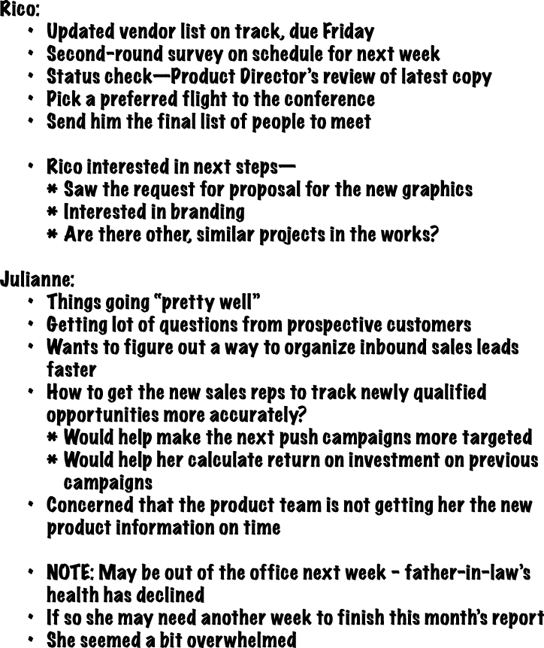

Although you did not suspect that either your conversation with Rico or with Julianne contained information that would rise to the level of an “HR issue,” you decided it was best to share what you learned with Tammy in Human Resources. It just so happened that your monthly meeting with Tammy was scheduled for early the following week.
During the meeting, Tammy listened attentively. Then, she told you that the annual performance review process was about to start. The review process with each one of your employees would include a goal-setting meeting, a mid-year review, and an end-of-year review. You both agreed that preparing for the first meeting of the annual review process would be the perfect way for you to develop a plan to set, track progress toward, and define ways to help Rico and Julianne achieve their individual goals.
That night, Tammy sent you the following e-mail to help you with the next steps.

From: Tamara Hendricks
Sent: 10/7/2015: 10:13pm
Subject: Employee Performance and Development (EPAD) Process
Thank you again for a great meeting earlier this week. You are clearly putting a lot of thought into the development of each of your employees. This month marks the beginning the annual Employee Performance and Development process. So, the timing couldn’t be more appropriate for you to follow up with Rico and Julianne and begin setting formal goals.
The ACE Competencies and Performance Metrics for each functional role have been determined by the executive team and will automatically cascade into the system for Julianne and Rico. I am attaching them to this e-mail for your reference.
Your first step in the EPAD process is an interview with each one of your employees. Please tell me if you have any questions about the process or any trouble getting into the EPAD system.
Best,
Tammy



Attachment 1: ACE Core Competencies
Dealing with ambiguity: Employees at ACE need to be comfortable with a fast-paced start-up environment where new ideas are prized above process. At ACE, our individuals recognize that they are here to discover answers to new questions.
Collaboration: Individual employees at ACE should thrive at working closely with all kinds of people in all kinds of situations.
Bottom-line oriented: At ACE, we play hard because we’ve worked hard. ACE employees regularly make goals—and not just on the foosball table.
Creative problem solver: At ACE, our individuals do more than work outside the box, they work outside. They get to know their customers better than anyone in the market and then they build new, genuine solutions.

Attachment 2: Marketing Manager Performance Metrics
- Recommend strategic efforts and drive execution necessary to deliver high-end marketing performance, providing a critical contribution to growth and, ultimately, revenue: Identify projects and efforts that will have the biggest impact while prioritizing and focusing accordingly; translate business requirements into meaningful interactive experiences with measurable results (30%).
- Capture the various brands and integrate market research data and insights to create a powerful online user experience (30%).
- Oversee and participate in immersive user research, concept analyses, and usability testing (20%).
- Analyze current and historical key performance indicators (KPIs) on an ongoing basis to identify trends, opportunities, strengths and weaknesses, and provide business intelligence to the LeadGen function (20%).

Attachment 3: Marketing Assistant Performance Metrics
- Provide administration support to marketing manager and director of marketing to ensure smooth running of department: Support the execution of marketing initiatives, including campaigns and communications; support marketing events; and coordinate with event organizers and team members (40%)
- Project/manage marketing campaigns and activities (30%).
- Ensure that all marketing events and activities follow brand guidelines and are aligned with marketing objectives (20%).
- Arrange design and production of marketing collateral in line with brand guidelines (10%).

Apply Effective Practices to Conduct Employee Performance Reviews: SC4
The rest of the fall and early winter went by in a blur of activity. With your formal goal-setting interviews with Julianne and Rico behind you, you caught a plane to a conference where you spent a week with the top decision makers of key accounts, co-presenting with the Product Team, and listening to the director of product run focus groups. You left thrilled with the results. ACE’s enrollment intelligence strategy seemed to be generating a lot of buzz at the conference. In mid-December, Rico went home to North Carolina for 2 weeks. Julianne’s second-grade daughter left school for winter break, so Julianne worked from home 3 days a week. At the end of December, you took a much-anticipated vacation.
By February, however, small changes that you had begun to see in your employees seemed to have grown into noticeable issues. Five months after being hired, Rico continued to meet the requirements of the job. At team meetings, he diligently took notes and posted them to the office share site. The regular processes moved smoothly just like before. However, you could not help but notice a diminishing enthusiasm in Rico’s demeanor. The extra projects he requested were completed, but with no “next step” in sight, Rico seemed bored and restive. He rarely contributed ideas unless directly asked. Almost every morning and afternoon you noticed Rico absent from his work station for long periods. A colleague mentioned to you that Rico spent almost 3 hours of the previous week sitting in the lobby and talking on his mobile phone. Admittedly, you saw him there yourself one day last week but you were so preoccupied by an upcoming meeting that it hardly registered. It was time for performance improvement strategies.
About the same time you realized a need for performance improvement strategies with Rico, you began to notice a shift in Julianne. She attended all of the mandatory meetings with the team but rarely left her station otherwise. More than once she hinted that she was stretching to meet an upcoming due date. Then, at a particularly important team meeting, she pushed back on an unexpected change to a process she had championed. Citing the looming deadline, Julianne simply shook her head and fell silent the rest of the meeting. The next afternoon, the director of product stopped by your office and casually asked how Julianne was doing. She told you that she had noticed a growing divide between her Product Team and Julianne. The product director went on to express her concern that ACE—with its small staff and start-up mentality—could suffer a chilling effect from Julianne’s inertia. She even went so far as to characterize Julianne as combative. You reassured the product director that you would work with Julianne before the issue worsened. In fact, you had a one-on-one meeting with Julianne scheduled the very next hour.
That afternoon, Julianne began your meeting by complaining that the Product Team had been unable to provide her with actionable information. She said the lack of communication threatened to further derail her projects. Then, interrupting herself suddenly, Julianne shrunk back into her chair. She was visibly shaking. That’s when she told you that she had spent the last 2 nights with her husband making end-of-life decisions for her father-in-law. The same health conditions Julianne had mentioned back in October were taking their toll, and neither Julianne nor her husband could provide the care her father-in-law needed. They were looking to move him into hospice.

Provide Effective Feedback to Facilitate Employee Development: SC5
When the new branding went live alongside the cleaner, improved functionality of the website, you knew you and your team had turned a critical corner. There were issues, of course, but the biggest bugs were quickly resolved. Very few customers experienced any issues at all. When the first set of numbers arrived, Julianne reported a measurable, positive shift in traffic. It would take more analysis, but she was confident that the strategy and the new website copy were working. When you met with the vice president (VP) of Sales, he relayed his compliments. Existing customers were praising the changes too.
As it would turn out, the Product Team later delayed the enrollment intelligence launch by 6 weeks. Julianne, Rico, and you scrambled to keep customers informed and happy in the meantime. In the end, each of your employees rose to the occasion.
In mid-April, you noticed that Rico described the successful launch on his professional networking profile along with the extra projects you gave him.
Around the same time, the product director thanked Julianne for her immediate effort and flexibility at a time of need for ACE. Shortly afterward, Julianne took time off to help her husband’s family with arrangements. She returned to the office 2 weeks later, just a week before the final employee performance and development review was due.

