Self-Assessment

Student’s Name
University Affiliation
Date

Self-Assessment
Corporate culture is responsible for the solidarity and sociability in an organization. It complies with employees' ethics, perceptions, attitude, values, and practices and achieves organizational objectives. The culture in an organization is responsible for the success or failure of a company, especially when there is a larger pool of employees (Guiso, Sapienza, & Zingales, 2015). Employees appreciate the efforts put by the company in improving culture, which brings togetherness, simplicity, and teamwork. Workers have to work as a team to be productive; thus, the corporate culture is vital. Working together, employees have to adapt to different personalities, and they have to be patient with each other. The management is responsible for helping them transition to new changes in the organization. 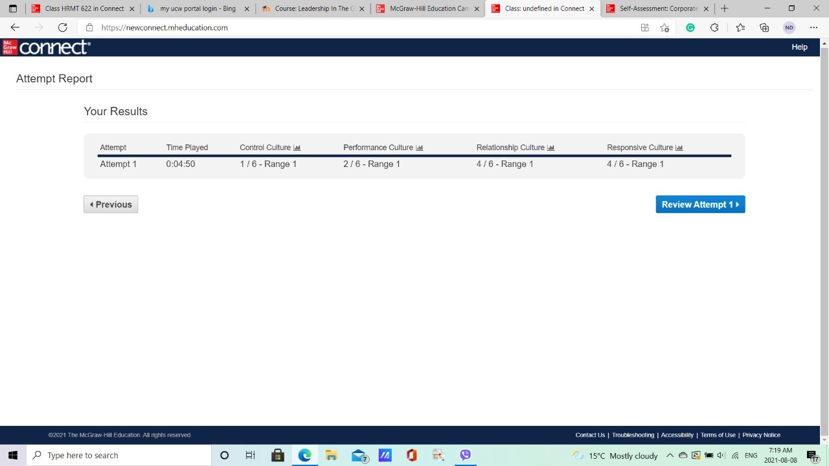
My result shows I value teamwork and would be attracted by a company that values its employees' work. When working in any organization, every dream of an employee is to be recognized by what they produce. I work perfectly under less pressure and work to ensure there are no questions raised in my work. I like perfection as an employee, which is not always the perfect outcome in a company where employers look at factors while managing their employees. For example, highly experienced employees are likely to gain leadership positions in a company; however, they may lack the leadership skills of a younger employee. However, I understand the need to promote loyalty rather than hard work, especially in a competitive environment. My results show that I prefer Responsive culture and dislike a control culture because I value customer satisfaction. Customers are the company's main shareholders, and they should be treated to satisfaction, especially when offering services.
My strongest areas are teamwork, communication, staying competitive, and realizing new opportunities. I value teamwork in an organization, and I am a team player, whereby I can offer something different to my colleagues. At the same time, I stand corrected in areas that I am not perfect. Working together improves the outcome of an organization, whereby everyone improves with the help of other employees (Tarricone & Luca, 2002). I also value communication, and it is one of my strongest areas as an employee. Communication helps both employees and consumers understand vital situations in an organization (Thomson, 2011). Consumers must be notified of every change made by the organization that may affect them directly because they are vital. I support the situation whereby the leaders communicate effectively with the followers to help suit the working environment. Commutation also promotes motivation, whereby employees will remain focused on the task at hand. Effective communication helps in controlling both employees and consumers to behave in a certain way. Employees must comply with the organization's policies, and communication will help solve issues (Guiso, Sapienza & Zingales, 2015). I like the competitive nature of business, and working in an organization, I want it to have an identity on its brand to compete with other companies. I can instill competitiveness in an organization, especially by attracting more customers. Another strength is realizing new opportunities that bring more income to the company and hoping the employer could change its identity product and venture into more trending products. I want to work in an organization that understands the importance of expanding the market through new opportunities.
One of my major weaknesses is following strict orders even when the leaders are wrong. I am vocal, and this does not work best when there are strict rules to stick by because ideas should be heard first, then a decision be made as a team. Working in a strict environment can be challenging, especially whereby experience is considered when making decisions. Another weakness is adaptation. In some cases, organizations expect employees to adapt fast to new requirements. I am slow to change at the workplace, whereby I believe specialization works best to bring the best out of the employees rather than forcing skills on employees. Adapting has been a challenge; however, I believe in other ways, such as working as a team to prevent employees from underperforming or working under immense pressure, which is not healthy. I believe in fairness, but I am weak in implementing it. Abilities in organization help employees get recognized; however, employees need to be given a fair chance to prove themselves (Simon, 2018). As a leader, I would try to implement fairness, especially because top performers should earn more and have the first opportunities.
My plan to improve my weaknesses is to understand why there is a hierarchy in an organization to help me learn to follow strict orders. Understanding the need to follow some rules even when they are unnecessary will help me build my leadership skills when the head of any department in my career. I also learn more skills as an employee, such as sales, management, and accounting, to help me adapt easily in case of role changes in an organization. I have to stay positive so that I would be willing to explore and see what would happen with the change installed in the organization with the help of an experienced employee within six months. When there is change, I worry too much about what will happen if I underperform from my comfort zone. I would change that by focusing on what I can control and be a risk-taker hoping to do better in the future. Setting new goals could also help in adapting to a new role in the organization. I would also rely on my coworkers to help me adapt faster, especially those who understand my role better within three months. Fairness can be challenging to improve, especially when under pressure to deliver as a leader. I would be sincere with the employees by letting them know where they stand and let them know I will offer each one a fair chance to perform. My major weakness is picking the favorite, and I would try to avoid it and ensure everyone has a fair chance. I would work with my experienced leaders in understanding what is special in their work for at least two months.
Employees and organizations are connected, and they need each other. The organization should treat its employees with dignity and not overwork or demand too much with fewer rewards. Corporate culture should create following the demand of the customers and minding the welfare of the employees who make everything possible. My assessment has helped me understand what corporate culture would suit me better, and in this case, it is the responsive culture because I would offer more to consumers than control culture. Performance culture doesn't suit me, especially because it depends on personal performance than relationship culture that promotes teamwork and sharing.

References
Guiso, L., Sapienza, P., & Zingales, L. (2015). The value of corporate culture. Journal of Financial Economics, 117(1), 60-76.
Simon, A. J. (2018). Lessons in adapting to change from Questar. Global Business and Organizational Excellence, 37(2), 6-11.
Tarricone, P., & Luca, J. (2002). Employees, teamwork and social interdependence–a formula for successful business?. Team Performance Management: An International Journal.
Thomson, S. (2011). Importance of Communication in an Organization. Retrieved on November, 12, 2017.

