Self-Efficacy through Social Media
Student’s Name
Institutional Affiliations

Self-Efficacy through Social Media
It is obvious that social media can be terrible and exhausting, especially when one uses it often without a break. However, it is also possible that social media can be of great benefit to the users and everyone else who uses the sites. This essay reflects on the negative and positive social media postings. The kind of information that we put on social media sites can affect the audience negatively or positively. However, it also depends on the attitude of the person doing the posting towards the subject content. The postings that emphasize with other people’s situations are often considered to be positive, while those that criticize or ridicule are considered to be negative.
Positive Postings
Take a look at the following postings in the picture below.
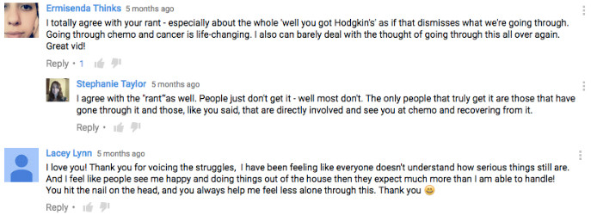

The two postings above are positive, especially in the content because of the motivation and empathy that they all show. In the first posting, I believe that it is positive because it tries to depict the positivity of the people that have gone through the chemotherapy sessions. They all have the same positive outcome and they feel motivated when they are sharing it. In the second posting, someone has gone through a great experience of reading a transformative story that he feels is not only inspiring but has also helped to change his perception. In both postings, the audience will be motivated with great positivity like the people that posted them.
Intent v. Impact
I think that the postings were intended to motivate those that have not gone through the same experiences as the people who posted them. People learn through the experiences that they go through. However, sometimes that learning can occur through an experience that another person has gone through. According to Siddiqi and Singh (2016), social media can help in educating people about certain issues that affect society. People go through different experiences worldwide, but without a platform that can enable them to share the story or experiences; they cannot reach out to those who need it the most. As such, a social network, social media sites facilitate communication which further enhances the learning. As shown in the first posting, the intent was to educate and increase awareness about the importance of sharing information. The first posting was made in Los Angeles and I am sure that it could reach anyone across the world within seconds of posting. Someone who does not have the experience somewhere in Europe, Asia, or even Africa could have the same idea about the journey through cancer. The story has achieved its intent to motivate and help people who are going through difficult times like dealing with cancer to continue with the fight. Sharing stories like these can help others who have not gone through the treatment or who have been looking for the best treatment alternative to use.
Negative Postings
Take a look at the postings below and examine the content and tone used.
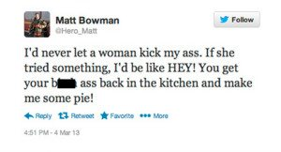
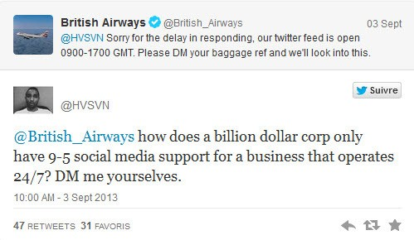
The two postings above negative because they use inappropriate and inconsiderate tone to express their message. It is obvious that social media has a free platform where anyone can post anything, but many people do not think of how their words would impact others who read it, especially when it does not give into consideration the experiences that others are going through. In the first posting, the author uses a ridiculing tone to explain how he cannot let a woman kick him. His choice of words makes the posting even worse as he uses vulgar expressions like “ass” that makes it easy to depict his objectification of women and the female gender in general.
In the second posting, on the other hand, the author uses judgmental tone to express his dissatisfaction with the customer service that the British Airways offers. His choice of words also, like the first posting, uses some strong and accusatory phrases like “how does a billion-dollar corp only have 9-5 social media support.” It is very inconsiderate to expect everyone to be perfect. The fact the British Airways is a billion corporations does not make it perfect. A mistake is part of the progress and ridiculing or negatively criticizing an organization is not providing a solution, but instead, it is adding to it. Amedie (2015) explains that social media can cause depression and anxiety due to the unrealistic and unachievable perception of perfection. This anxiety can affect the audience of this message, which is the British Airways management and even employees who work under social media support.
Intent v. Impact
In the two postings, the intent is very clear, especially in the second posting that was aiming to bring to the attention of the management about the poor customer support at British Airways. Amedie (2015) explains that constant stress from perfection expectation can result in depression. Siddiqui and Singh (2016) explain that social media can impact business operations negatively, especially by the opinion and negative comments that can lead to the organization’s failure. Siddiqui and Singh (2016) believe that the social media platforms that businesses use to get customer feedback also pose them to greater risks because the followers and fans have the freedom to post whatever they feel like that they want to pass. Sometimes, the intent may be genuine, but sometimes, it is not genuine because and someone can post a negative comment that may affect the organization’s image in the market.
In the first post, however, the author may have been making fans and jokes but without knowing that it may have a negative impact on someone who feels that his word choices were demeaning women. The intent may not have been demeaning the women, but the way the message comes out is very clear that it must have used the wrong expression to make fun of women. The expression that “you get your big ass back in the kitchen and make me a pie” is a wrong expression that shows the male dominance and male stereotypical perception about women. It does not matter what the intent was as long as the message has been received in the wrong way. Feminists may find this message demeaning and outrageous towards women and the achievements that they have attained so far. The author could have selected more appropriate words and not use the vulgar statements that he used that made the whole message wrong and negative.
To sum it up, the above discussion has depicted the negative and positive impacts of social media postings. Some people find themselves posting information on the internet without thinking about what impacts it may bring on the audience. Some of the impacts are intentional while others are unintentional. Either way, it is important to consider the impacts of the things that we post online on social networking sites to avoid hurting others. This means that one must consider the message, the tone he uses to pass the message, and the audience to ensure that no unintended consequences as shown in the negative postings discussed above.
References
Amedie, J. (2015). The impact of social media on society. Advanced Writing: Pop Culture Intersections.
Siddiqui, S., & Singh, T. (2016). Social media its impact with positive and negative aspects. International Journal of Computer Applications Technology and Research, 5(2), 71-75.

