Worksheet 6 - Sequences Review

1.Jenny had $10 in her savings account. Her mother will give her $3 allowance every day. She plans to save all the money for her college.
Use f(n) as the amount of money of each day and n as the days:
  - Write the function in an explicit rule and a recursive rule.
  - Make a table to show the first 5 days’ money.
  - Graph the function.
  - Classify the type of the function
  - How much money will Jenny have after 270 days?
n | f(n)
1 | 13
2 | 16
3 | 19
4 | 22

$820

Table  I know this is a increasing pattern because in the table I noticed | Graph  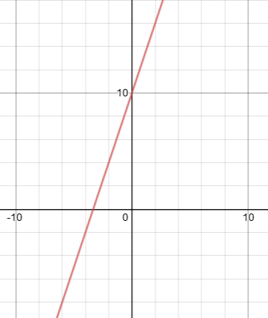  I know this is a increasing pattern because in the graph I noticed
Explicit form  f (n) = d(n − 1) + a  OR  f (n) = a (r) ^{(n−1)}  d =3 , a=13  f(1)=3(1-1)+13=13  f(2)=3(2-1)+13=16  f(3)=3(3-1)+13=19  f(4)=3(4-1)+13=22  I know this is a increasing pattern because in the equation I noticed | Recursive form  f (n) = f (n − 1) + d f (1) = a  OR  f (n) = f (n − 1) · r f (1) = a  a=13, d=3,f(0)=10  f(1)=f(1-1)+3=13  f(2)=f(2-1)+3=16  f(3)=f(3-1)+3=19  f(4)=f(4-1)+3=22  I know this is a increasing pattern because in the equation I noticed

2. A bacteria grows at a rate of 2 per day.
Use f (n) as the number of bacteria’s of each day and n as the number of days:
  - Classify the type of function.
  - Write the function in an explicit rule and a recursive rule.
  - Make a table to show the first five days’ bacteria growth.
  - Graph the function.
  - How many bacteria’s after 3 weeks?
n | f(n)
1 | 3
2 | 5
3 | 7
4 | 9

43

Table  I know this is a increasing pattern because in the table I noticed | Graph  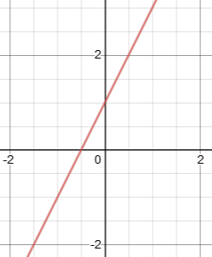  I know this is a increasing pattern because in the graph I noticed
Explicit form  f (n) = d(n − 1) + a  OR  f (n) = a (r) ^{(n−1)}  a=3,d=2  f(1)=2(1-1)+3=3  f(2)=2(2-1)+3=5  f(3)=2(3-1)+3=7  f(4)=2(4-1)+3=9  I know this is a increasing pattern because in the equation I noticed | Recursive form  f (n) = f (n − 1) + d f (1) = a  OR  f (n) = f (n − 1) · r f (1) = a  f(0)=1,a=3,d=2  f(1)=f(1-1)+2=3  f(2)=f(2-1)+2=5  f(3)=f(3-1)+2=7  f(4)=f(4-1)+2=9  I know this is a increasing pattern because in the equation I noticed

3. The Chaffey Auditorium plans to use the function f (1) = 9, f (n) = f(n − 1) + 8 to place seats in rows;
In which f(n) is the number of seats in each row, n is the row number.
  - Use a table to show the number of seats in the first four rows.
  - Write the function in an explicit rule.
  - Graph the function.
  - Classify the type of sequence.
  - Estimate how many seats in the 43th row.
n | f(n)
1 | 17
2 | 25
3 | 33
4 | 41

Table  I know this is a increasing pattern because in the table I noticed | Graph  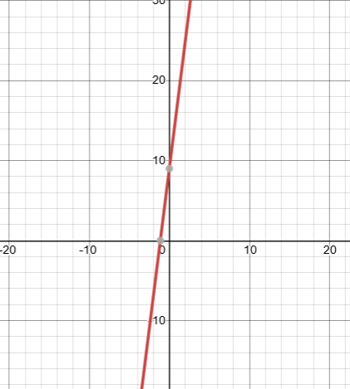  I know this is a increasing pattern because in the graph I noticed
Explicit form
f (n) = d(n − 1) + a
OR
f (n) = a (r) ^{(n−1)}
a=17,d=8
f(1)=8(1-1)+17=17
f(2)=8(2-1)+17=25
f(3)=8(3-1)+17=33
f(4)=8(4-1)+17=41

I know this is a increasing pattern because in the equation I noticed

- What is this function in explicit form? f(1) = 7, f(n) = −3f(n − 1) A. f(n) = −3(n)

B. f (n) = −3(n − 1)
C. f (n) = 7(−3)^{n−1}
D. f (n) = 7(−3)^{(n)}

- Select the equivalent recursively defined function. f(n) = 5n + 3 A. f(1) = 5, f(n) = f(n-1) + 3
B. f(1) = 3, f(n) = f(n-1) + 5
C. f(1) = 8, f(n) = f(n-1) + 5
D. f(1) = 8, f(n) = f(n-1) ٠ 5

- A sequence whose first 5 terms are 3, 9, 27, 81, 243. Write a function that defines this sequence.
a-3,d=3
Explicit: f (n) = d (n − 1) + a
f(n)=3(n-1)+3
Recursive: f (n) = f (n − 1) + d, f (1) = a
f(1)=f(1-1)+3,f(1)=3

5. Write this sequence 6,12,24,48... 1536 in explicit form and recursive form.
a=6,d=6
Explicit: f (n) = d (n − 1) + a
f(n)=6(n-1)+6
Recursive: f (n) = f (n − 1) + d, f (1) = a
f(1)=f(1-1)+6,f(1)=6

6. State the formulas if your sequence has a first term of 3 and your common difference are 5.
a=3,d=5
Explicit: f (n) = d (n − 1) + a
f(n)=5(n-1)+3
Recursive: f (n) = f (n − 1) + d, f (1) = a
f(1)=f(1-1)+5,f(1)=3

IM 3 Worksheet 7 - Sequences

- Sara has $35 savings. She earns $10 each day (n) for babysitting her neighbor’s five-year-old son. Fill out the table to show how much money Sara will have after babysitting by days.

Tablefdeebeee

e

n | f(n)
1 | 45

I know this is a increasing pattern because in the table I noticed | 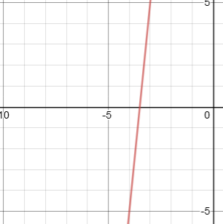  I know this is a increasing pattern because in the graph I noticed
Explicit form ( Circle one)  f (n) = d(n − 1) + a  OR  f (n) = a (r) ^{(n−1)}  Formula:  a=45,d=10  f(1)=10(1-1)+3=45  f(2)=10(2-1)+3=55  f(3)=10(3-1)+3=65  f(4)=10(4-1)+3=75  I know this is a increasing pattern because in the equation I noticed | Recursive form (Circle one)  f (1) = a  f (n) = f (n − 1) + d  OR  f (1) = a  f (n) = f (n − 1) · r  Formula:  f(0)=35,a=45,d=10  f(1)=f(1-1)+10=45  f(2)=f(2-1)+10=55  f(3)=f(3-1)+10=65  f(4)=f(4-1)+10=75  I know this is a increasing pattern because in the equation I noticed

- There were 64 students playing games. Half of the students were eliminated each round (n).
2

The following equation models the game results:
2 | 55
3 | 65
4 | 75
5 | 85
6 | 95

f (n) =
64( 1) (n−1)

Table  I know this is a decreasing pattern because in the table I noticed | Graph  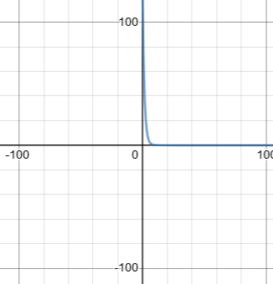  I know this is a decreasing pattern because in the graph I noticed
Explicit form ( Circle one)  f (n) = d(n − 1) + a  OR  f (n) = a (r) ^{(n−1)}  Formula:  a=64,r=1/2  f(1)=64(1/2)⁽¹⁻¹⁾⁼⁶⁴  f(2)=64(1/2)⁽²⁻¹⁾⁼³²  f(3)=64(1/2)⁽³⁻¹⁾⁼¹⁶  f(4)=64(1/2)⁽⁴⁻¹⁾⁼⁸  f(5)=64(1/2)⁽⁵⁻¹⁾⁼⁴  f(6)=64(1/2)⁽⁶⁻¹⁾⁼²  I know this is a decreasing pattern because in the equation I noticed | Recursive form (Circle one)  f (1) = a  f (n) = f (n − 1) + d  OR  f (1) = a  f (n) = f (n − 1) · r  Formula:  f(1)=64  f(2)=f(2-1)(1/2)=32  f(3)=f(3-1)(1/2)=16  f(4)=f(4-1)(1/2)=8  f(5)=f(5-1)(1/2)=4  f(6)=f(6-1)(1/2)=2  I know this is a decreasing pattern because in the equation I noticed
n | f(n)
1 | 64
2 | 32
3 | 16
4 | 8
5 | 4
6 | 2

Worksheet 8
Choose 2 problems to complete and then explain how you completed each problem in a video/written explanation. There is a vocabulary word bank which is highly recommended to use for the explanations of your work. You do not need to use all of the vocabulary for each explanation.
You will have to use a written response to explain your thinking. When explaining your thinking, please plan on writing 1 paragraph for each question. Hint: You can use Desmos to help with your explanations.

Here are your 4 possible questions:
  - Jimmy decided to go to Vegas because he was feeling lucky. He didn’t have much money on him but decided to play a game in Vegas to see if he could win some money. He started off with 4 dollars in his pocket and he won his first, second, third, and fourth game, doubling his money each time( n ). Here would be his winnings:

f (1)
= 4, f (2)
= 8, f (3)
= 16, f (4)
= 32

  - You and some friends decided to play in a basketball tournament with high school kids in Southern California. There were 64 teams to start the tournament and each round( n ), where half of the teams were eliminated. The following equation models the
2

tournaments results:
f (n)
= 64( 1) (n−1)

  - Maria decided to start saving her allowance because she was having a really hard time saving up to buy a video game system she wanted. She only had 50 cents on her but was able to save an additional 4 dollars each week( n ). Here is the equation that models

her savings: f (n)
= f (n − 1)
+ 4.00, f (1) =
4.50

  - Henry borrowed 32 dollars to buy some tools to help start his tree trimming business.
He will earn 8 dollars every tree( n ) he trims. Here is the rate of change which models his
business: constant rate of change: 8, f (1) = − 32

Use the following vocabulary word bank in your explanations:

Arithmetic, Geometric, Quadratic, Term, Recursive, Explicit, Pattern, Slope, Rate of change, Sequence, Common Difference, Common Ratio, Constant, Second Rate of Change, Regression, Exponential Model, Linear Model, Parabolic Model

- Jimmy decided to go to Vegas because he was feeling lucky. He didn’t have much money on him but decided to play a game in Vegas to see if he could win some money. He started off with 4 dollars in his pocket and he won his first, second, third, and fourth game, doubling his money each time (n). Here would be his winnings
f(1)=4, f(2)=8, f(3)=16, f(4)=32

The explicit form of the problem is f (n) = 4 (2) ^{(n−1)} where the first term of the sequence is 4 and the
Constant is 2 and the recursive form is f (n) = f (n − 1) · 2, f (1) = 4.
The function is increasing pattern and the slope of the graph is increasing and shows exponential model

Fill out the following:
n | f(n)
1 | 4
2 | 8
3 | 16
4 | 32

Table  I know this is a increasing pattern because in the table I noticed | Graph  Add in graph to represent table points (Hint: you can use Desmos)  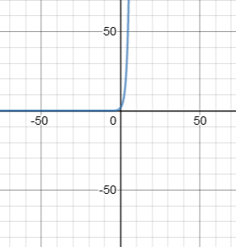  I know this is a increasing pattern because in the graph I noticed
Explicit form  f (n) = d(n − 1) + a | Recursive form  f (n) = f (n − 1) + d
OR  f (n) = a (r) ^{(n−1)}  a=4,r=2  f(1)=4(2)⁽¹⁻¹⁾⁼⁴  f(2)=4(2)⁽²⁻¹⁾⁼⁸  f(3)=4(1/2)⁽³⁻¹⁾⁼¹⁶  f(4)=4(1/2)⁽⁴⁻¹⁾⁼³² | f (1) = a  OR  f (n) = f (n − 1) · r  f (1) = a  f(1)=4  f(2)=f(2-1)(2)=8  f(3)=f(3-1)(2)=16  f(4)=f(4-1)(2)=32
I know this is a increasing pattern because in the equation I noticed | I know this is a increasing pattern because in the equation I noticed

2. You and some friends decided to play in a basketball tournament with high school kids in Southern California. There were 64 teams to start the tournament and each round( n ), where half of the teams were eliminated. The following equation models the tournaments results:
2

The explicit form of the problem is f (n) = 4 (1/2) ^{(n−1)} where the first term of the sequence is 64 and the
Constant is 1/2 and the recursive form is f (n) = f (n − 1) · 1/2, f (1) = 64.
The function is decreasing pattern and the slope of the graph is decreasing and shows exponential mode
Fill out the following:
n | f(n)
1 | 64
2 | 8
3 | 16
4 | 32

Table  I know this is a decreasing pattern because in the table I noticed | Graph  Add in graph to represent table points (Hint: you can use Desmos)  I know this is a decreasing pattern because in the graph I noticed
Explicit form  f (n) = d(n − 1) + a | Recursive form  f (n) = f (n − 1) + d
OR  f (n) = a (r) ^{(n−1)}  a=64,r=1/2  f(1)=64(1/2)⁽¹⁻¹⁾⁼⁶⁴  f(2)=64(1/2)⁽²⁻¹⁾⁼³²  f(3)=64(1/2)⁽³⁻¹⁾⁼¹⁶  f(4)=64(1/2)⁽⁴⁻¹⁾⁼⁸ | f (1) = a  OR  f (n) = f (n − 1) · r  f (1) = a  f(1)=64  f(2)=f(2-1)(1/2)=32  f(3)=f(3-1)(1/2)=16  f(4)=f(4-1)(1/2)=8
I know this is a decreasing pattern because in the equation I noticed | I know this is a decreasing pattern because in the equation I noticed

