Sharjah Roads and Transport Authority
Name
Institution Affiliation
Date

Table of Contents
Introduction 3
Background of the Study 3
Problem description: 4
Problem boundaries and impacts: 6
Solution criteria and limitations: 6
Solution Criteria 6
Solution One: Cutting off Electricity in the whole room using a contractor. 6
Solution Two: Cutting of Electricity in the door only. 7
Solution Three: Cutting off the electricity from the door only using a software. 7
Limitation 8
Time- Analysis: 9
Conclusion 10
Reference 11

List of Figures
Figure 1 : Organization Structure of SRTA. 4
Figure 3: Coordinated Traffic Control System Circuit and Loop Diagram. 7
Figure 4: Density Traffic Control Circuit and Block Diagram. 9
Figure 6: Circuit and Block diagram for Micro Computer. 10
Figure 7: Functionality of the Dynamic Control System. 11
Figure 8: Human resource required for implementation. 13

List of figures
Table 1b: Time per Branch (In Seconds) 7
Table 2: Street Lighting Without sensor 8
Table 3: Specifications of the problem 8
Table 4: Description of the solution 9
Table 5Time-based plan for researching problem solutions: 9

Introduction
Due to the increasing number of vehicles in Sharjah City, there is need to come up with a solution to the traffic jams witnessed in the City especially during the rush hours. This project comes with an improvement to the already existing traffic light system that do not put into consideration a case where one side of the road is not in use at a particular time. With the sensor traffic system, the vehicles are allowed to cross a lane when not in use just by obtaining a signal that the lane is free.

Background of the Study
Various research undertaken in the transport system in Asian has shown has been an increase in the traffic congestions. In Sharjah, traffic congestion in the City results to about 15% of employees getting late to their places of work as a result of the unending traffic jams in the city. The traffic jams in addition results to excessive wastage of fuels in the jams and pollution of the environment.
Due to these traffic jam related problems and the increasing number of vehicles in the United Arab Emirates and the high rate of growth of population in Sharjah town, there is need to come up with a way of increasing the traffic flows in the major roads in the city especially in the city (PTV AG, 2007).
Sharjah Roads and Transport Authority located in located in Al Aezzrh has responsibilities of planning as well as ensuring a smooth implementation of roads and transport projects in the City. The Authority also has responsibilities of preparing strategic plans and legislation. In addition to these the authority also comes up with the integrated solution to road and marine network systems that is of international standard and ensure that they are safe and according to the various laid down economic development of the country. Every road project in the SRTA system must be environmental friendly and provide a favorable for people (PTV AG, 2007).
Figure 1 : Organization Structure of SRTA.
Director General and Chairman of the Board of Directors
Internal audit
Services of technical support of enterprises
Institutional Support Services
Railway Corporation
Traffic & Roads Est.
Transportation Foundation
Control Room
Sharjah Roads and Transport Authority
Engineer Mohammed Iqbal Mir

Source: (PTV AG, 2007)

Problem description:
As a result of the increasing number of people in Sharjah accompanied by the increasing number of vehicles in the City there is need to use traffic lights to control traffic in the City as this has been seen to be successful in other parts such as in Dubai. The number of traffic in the city is also varying overtime with some hours of the day such as the rush hours witnessing high traffic (PTV AG, 2007). An analysis of the Wasit Street, there has been a record of three peak hours that record high vehicle density. These peak hours are the morning hours from around 6 AM to 9 AM, noon from 12-3PM and 5 to 8 PM as shown in table below. Similar case is therefore most likely to be witnessed in other roads too resulting to the need to come up with street lighting system that is time saving in all the roads in the City. Figure 2: Number of vehicles recorded at a given time.

This flexible street lighting is centered on timed traffic lighting with two colors, Red and green. These lights are used alternatively in different sides of the road meaning the signal is red or green for a specified time for each side of street irrespective of vehicles. In the flexible street light system, vehicles are allowed to cross over to a lane that is not in use at a particular time. A 20 seconds gap is allowed before a signal is given to the other used for the first car to pass hence and therefore need to ensure accurate timing to avoid any collisions.
In a case where there are no vehicles in one side of the road and the others are crowded, there is need of intersection and therefore need for the dominant flows to be adapted to change overtime during the day. This different with the fixed lighting in other places where the driver has to wait for the time to elapse before intercepting. In this system when a vehicle hits the loop it is detected by the detector card which passes an information to the Central Processing Unit (CPU) which checks which among the vehicles comes first and gives an indication of a green light to the first vehicle to pass and a red for the other car. The car given a red signal then stops for 20 seconds waiting for the other car to pass then it will be given a red signal and the sequence continues.

Problem boundaries and impacts:
The sensor traffic light system can only be used in a case where there is power and therefore in a case where there is no sources of power the system cannot function.
Positive impacts
The sensor street light system will make a significant impact in ensuring smooth flow of the traffic and to save time spent on the roads by the road users.
Negative Impacts
The sensor traffic light system may cause car accidents in a case where the system fails giving different signals to the vehicles.

Solution criteria and limitations:

Solution Criteria

Solution One: Coordinated Control.
Here a traffic light controllers are linked to an induction loop that is buried in the ground in the junction that monitors any passing traffic and to the cameras that plays a major role in providing the colors to the controllers that sends signals to the road agency staff through a radio transmitter. The lights and this system is maintained in that they do not show red and green at the same time. This role is played by the Malfunction management system unit (MMU). MMU ensures the controller receives right information from the induction loop (Gibson & David, 2007).
Here a traffic light controllers are linked to an induction loop that is buried in the ground in the junction that monitors any passing traffic and to the cameras that plays a major role in providing the colors to the controllers that sends signals to the road agency staff through a radio transmitter. The lights and this system is maintained in that they do not show red and green at the same time. This role is played by the Malfunction management system unit (MMU). MMU ensures the controller receives right information from the induction loop (Gibson & David) Here a microcontroller is programmed to receive information about traffic density on different lanes a measure by the inductive loop. Depending on the traffic density a suitable algorithm is executed to clear the congestions. An induction loop is an electromagnetic communication or detection system which induces an electrical current in a nearby wire using a moving magnet. Induction loops are used for reception and transmission of signals for communication signals. They are also used for metal objects detection in metal detectors and vehicle presence indicators. The loop is buried deep in traffic lane. It is a continuous run of wire that exists and enters from the same point. The two ends are connected to loop extension cable. Thsi cable is connected to the vehicle detector. The detector powers the loop and creates magnetic field in the area. The loop resonates at a frequency monitored by the detector. A base frequency is noted when there is no vehicle over the it. When a vehicle, goes over the loop, the resonate frequency is increased. This increase is sensed and, depending on the detector design, forces an open relay to close. The relay remains closed until the vehicle leaves the loop and the frequency is then returned to the base level. The relay can trigger traffic light. Loop extension cable extends the distance from the preformed loop to the detector, usually located in a weatherproof enclosure or indoors. The extension cable characteristics are just as important as the loop wire characteristics. Use only 14, 16, or 18 awg stranded 2 conductors twisted, shielded cable with a polyethene insulation jacket. The distance between the detector and loop should be safely extended to 300 feet with proper extension cable. The proper installation and material is critical! In general, all loop vehicle detectors work under the same principle and will all work reliably if installation is properly done and the correct materials are used. Op-amp voltage comparator compares the magnitudes of two voltage inputs and determines which is the largest of the two. The comparator will compare between the voltages to know if there is a car or not, If 10KHZ gives 1V and the reference voltage is 1 V too, then the output of the comparator will be zero and voltage will be produced. If it is higher it gives me positive. 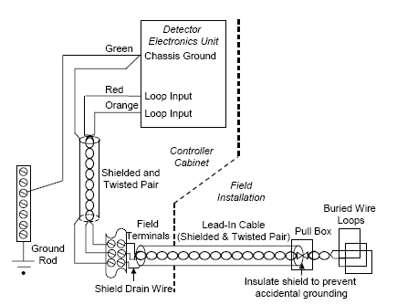
Source (Gibson & David, 2007).
The inductive loop is composed one or more wire loops that are embedded in the pavement which is a sensing element, a splice between the lead-in-wire and the lead-in-cable is connected to the terminal strip and finally to the electronic unit. The terminal strip is what gives the signal to the LED lights in case a vehicle has been detected by the inductive loop.
An induction loop is an electromagnetic communication or detection system which uses a moving magnet to induce an electrical current in a nearby wire.
Cost Analysis
Approximately 100, 000 DHS will be required for the labor and for buying the sensor. The maintenance amount require per annum is about 5, 000 DHS
Time Analysis
Three day will be required for this process to be completed. One day will be required for the installation of the induction loop and the sensors, another day for the installation of the cameras and the sensors. The third day will be used for testing of the functionality of the system.
Advantages
This will help in reducing time spent by vehicles on the road.
The system helps in reducing the average waiting time of all traffic categories at intersections hence ensuring punctuality.
Disadvantages
- Security
The system provides room for hacking as the controllers do not verify the message they receive and therefore a message may be sent to by malicious people who want to put the city on a stand still for criminal reasons. The security threat is even worsened by the fact that the messages are not encrypted opening room for analysis by other users.
- Failure
The induction loops may fail causing unnecessary extension of the green signal or the red signals resulting to traffic mess in the roads (Gibson & David, 2007).

Solution Two: Fixed time control
Here electro-mechanical which consists of movable parts (dials, cams together with the shafts) connected to them. They use the dial timer with fixed time plan with gears that determine the intersections time plans. The timer here ranges from 35 seconds to 25 seconds. A failure of one gear is replaced by another gear (Gibson & David, 2007).
Density Traffic Control
It uses an Infra-Red sensors, microcontroller and Led lights used for controlling traffic signals based on the density of the traffic.
It takes into consideration a four side junction with the traffic flow being just one direction
Figure 3: Density Traffic Control Circuit and Block Diagram.
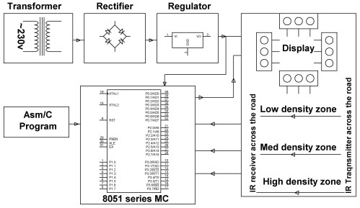
Source (Gibson & David, 2007).
The microcontroller is the heart of this traffic system. IR sensors are connected to microcontroller PORT C (PC0, PC1, PC2, and PC3) of the and traffic lights are connected to microcontroller PORT D and PORT B. If there is traffic on the road then that sensor output becomes logic 0 otherwise if there is no traffic ,logic 1. Receiving these IR outputs, we have to develop the program to control traffic system. If we receive logic 0 from any , we have give the signal green to that path and give red signal red to all paths. Here continuously we have to monitor the IR sensors to check for the traffic. This sytem contains ATmega8 controller, PCB board, IR sensors -4, LED's-12 (4-red,4-green,4-yellow), 12v Battery or adaptor, Serial cable, Connecting wires. This circuit entails 4 traffic lights , atmega8 microcontroller, 4 IR sensors.
IR transmitter looks like LED. This IR transmitter emits IR rays. The operating voltage of the IR transmitter is 2 or 3v. These IR rays are invisible to the naked eye. However we can view them through camera. IR receiver receives rays transmitted by IR transmitter. Normally IR receiver has a very high resistance in the order of mega ohms. When it receives IR rays the resistance is very low. The operating voltage of IR receiver also 2 to 3V. Instead of traffic lights, we can use LEDs ( YELLOW, RED, GREEN). In normal traffic system, we have to glow the LEDs on the basis of time. If the density of traffic is high in any of the road path, then the LED that glows is green LED on that particular path and on the other paths it glows the red LEDs.
.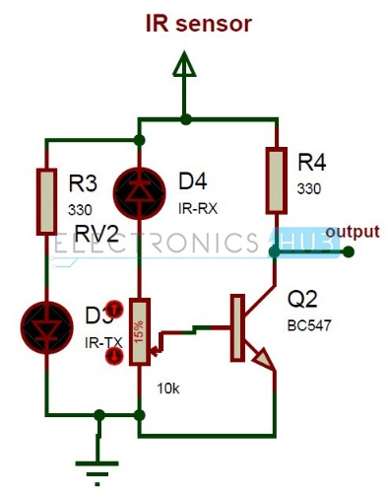
Figure 4 IR transitor 1
Figure 4
The IR sensor circuit is as in figure above shows. 330 ohm resistor is utilised to drop the voltage. IR transmitter may get damaged if it is not used. To chenge the obstacle sensing distance, we have used a potentiometer. We have taken the ouput from transistor collector. This sensor gives the digital output. When the sensor detects a traffic density it will send signals to the IR transmitter which will emit the IR rays to the LED lights which will give the traffic signals. In a case where the traffic density is high on any particular path, the green LEDs glows on the path and Red on the other path..
Cost Analysis
This system is cost effective about only 10,000 DHS is required for the following:
- Open room for migration to the new system as adoption of the new system does not require complete rehabilitation of all the existing system and therefore any expansion or replacement does not require abolishment of the whole system. Hardware replacement may be done after a very long time as a lot of changes are done in the software without changing the hardware.
Time Analysis
Three days will be required for this process to be completed. One day for the installation of the computers,
Advantages
Less prone to failure as the failure of one gear is automatically replaced with another gear.
Less costly as it is not computerized.
Disadvantages
This process does not respond dynamically as they use predetermined time system and therefore it does not respond effectively to changes in traffic patterns overtime.
Cannot be used where the vehicle flows changes overtime.

Solution Three: Dynamic Control.
Dynamic control detector uses an input from detector. Detectors under this control system uses a sensor to detect presence of a vehicle or a pedestrian. When the detector detects a presence of car it the inductance of the coil decreases sending a signal to the control unit to control the switching of traffic light. This system can give more time for intersection in a heavy traffic or even shorten it in a case where the traffic is flowing. This system can also skip a face that has no or little traffic. It can be put built inside the pavement, non-motorized for pedestrians (Gibson &David, 2007).
Traffic Light Controller using Microcomputer.
The main objective of this traffic light controller is to provide control and coordination to ensure that the traffic move smoothly and safely. Here the microprocessor is used for auto changing of signals at specified time intervals. The LED lights are automatically turned on and off by making corresponding port pin of microcontroller.
Figure 5: Circuit and Block diagram for Micro Computer.
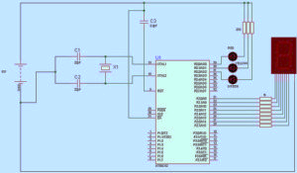
Source (Gibson & David, 2007).
Figure 6: Functionality of the Dynamic Control System.
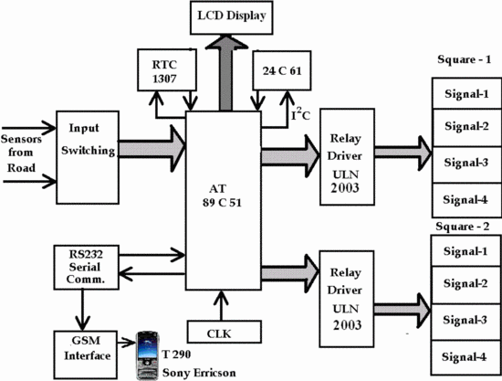
The system uses a seven segment display as a counter display and the LEDs are used for traffic light Control. The microprocessor with a Software has traffic oscillator that generates frequency clock pulses. The LEDs are interfaced in the Port Zero of the micro controller powered with 5V power supply. The microcontroller AT89c51 is this system's heart. multiplexers and additional ports are used for communicating with the external signals. Additional ROM and RAM are used for application program and system program storage. The system consists of the microcontroller, input switching matrix, serial communication interface, Real Time Clock 1307, Clock circuit, LED interfacing circuit, Relay Driver ULN 2003, GSM interface. The signals generated from the sensor assembly will then be applied to the input switching circuit. These input signals will be in digital signals form which corresponds to absence or presence of vehicles.
The digital signals from all lanes will be given to the microcontroller input port , where the microcontroller determines length of vehicles on each lane. This information is then inputted into microcontroller as to determine various timings. The off and on time of the junctions will be estimated or calculated in the microcontroller, in order to keep waiting time minimum. These signals will be applied into two relay drivers that entail ULN 2003. These relay drivers are current amplifiers and level shifters. The output of the relay driver is applied to Green, Red and Orange LED at every junction. IC 24C61 is used for the I2C interface. One LCD Display recieve each signal. LCD Display will then indicate time left for the signal to turn green (it indicates the time each vehicle has to stop at a given junction)
In practice a good contract LED displays are to be used, which will be visible from a longer distance. LED lights get automatically switched on and off by making the corresponding port pins of the microcontroller based on the pins.Only the green light is on at a particular time when other lights are off. After some time the changeover traffic movement changes the LED light from green to yellow then to Red. This system can work automatically based on the traffic density.
Cost Analysis
Requires about 20,000 DHS to purchase the Induction loop and the controllers. Another 5,000DHS will be required for labor. The system will also require 1,000 DHS for annual maintenances.
Time Analysis
Requires about 2 months for an installation process to be complete. This will include the installation of the induction loop that will take 2 weeks, the control system that will take another 2 week as well one month testing period.
Advantages
Requires less time to implement.
Reduces collision of vehicles as the controller only changes color after the vehicle has passed.
Reduces waiting time for both vehicles and pedestrians as it allows for the intersection of the vehicles.
Reduces Driver Frustration.
Disadvantages
Requires stable power supply for the controller to function.
Detectors may fail giving different signals which may result to traffic mess.
Selected Solution
Dynamic Control System.
The selected solution will be to work with the Dynamic model as it is less costly and can be used when the traffic is heavy in one face and when there is no traffic it will therefore be appropriate for use by Sharjah Roads Authority since Sharjah witnesses different Capacity of traffic at different times.
Dynamic model also requires less time to implement and since the project only had 2 months for implement Dynamic System will the more appropriate system for the City.
Dynamic System is also cost effective in terms of maintenance and installation.
Table 2: Specifications of the problem.
Specifications | Discretion
User friendliness | It is easy to understand and maintain
Cost | Allocated budget of 1.2 Million DHS
Level of Accuracy | High level of accuracy as the system will be monitored by the traffic control team.
Reliability of the System | Is less prone to failure.
Time to be taken | Should take a period not more than 2 months to implement.

Table 3: Description of the solution

Figure 7: Human resource required for implementation.
For the project to be implemented the following personnel will be required:
Source: (Gibson & David, 2007).
The software engineer are responsible for coming up with the system, database managers for management of the system maintenance team who will ensure the system is always functional.

Time- Analysis:
After preparation of this proposal the next step will be to carry out a research for problem solution. The project is approximated to take approximately 6 weeks to be completed; it will be commencing on 1st November 2017 to 6th December 2017. The table below gives a summary of the activities involved in the coming up with the problem solution and the allocated time period.
Table 5: Time-based plan for researching problem solutions:

ID | Brief description | Duration (Days) | Start Date | Finish | predecessor | Name of student
A | Formulation of strategies for the research. | 1 | 1st Nov | 1st Nov | -
B | Setting up of equipment required for the research | 2 | 3rd Nov | 5th Nov | A
C | Literatures survey | 4 | 6th Nov | 9th Nov | B
D | Drafting of methodology | 3 | 10th Nov | 12th Nov | C
E | Collection of data. | 5 | 13th Nov | 17th Nov | D
F | Data analysis | 6 | 18th Nov | 23^{trd} Nov | E
G | Discussion of the findings & selection of implementation procedure | 7 | 24th Nov | 30th Dec | F
H | Implementation | 6 | 1st Dec | 6th Dec | G

Conclusion
By adopting the dynamic traffic control system will help in reducing traffic jams in the City of Sharjah by allowing drivers to cross over to the lanes that are not in use at a particular time. The system will work by giving signals to drivers on an empty lane so that it can cross over. Though the system will help in reducing traffic jams it maybe more costly to implement and also the maintenance cost may be high. Of all the analyzed control systems the system was the most appropriate as it is the most cost effective and requires less time for implementation.

Reference
Africon Ltd. Dubai (2006). Derivation of Updated 5-Year Transportation System Implementation Plans for Dubai, 14.
Gibson, David (2007), “A new look at sensors FHWA’s updated traffic Detector Handbook describes in-roadway and over roadway technologies for vehicle detectors as key ITS deployment”
Sharjah overhauls transport services. (2015, September 29). (sharjahupdate) Retrieved from http://www.sharjahupdate.com/2015/09/sharjah-overhauls-transport-services/
PTV AG (2007). Sub-Report “Bus Network Planning”, Appendix C – Present Network Analysis. Dubai Public Transport Bus Master Plan.

