March 2021
DIABETES
(GEORGIA)
Fact Sheet
Figure 1₂
Notes: “Other Counties” is the combined area of Crawford, Jones, Monroe, and Twiggs Counties. *Note that 2012 and 2015 data did not include Baldwin County.
Prevalence of Diabetes in Georgia by county
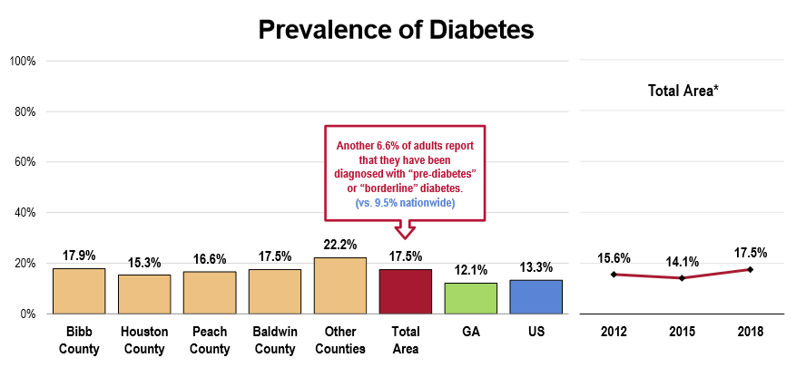
Did you know?
- Diabetes can lower the life expectancy by up to 15%
- Diabetes is the top cause of kidney failure, limb amputation, and adult blindness.
- Diabetes increases the risk of heart-related complications by 2 to 4 times.
What is diabetes?
Diabetes occurs when the body is not able to manufacture insulin or respond abnormally to insulin. Insulin is an essential component of the human body. It is required by the body to absorb and use glucose, which is our primary source of energy. When insulin levels are not at typical levels, other body metabolisms are affected, leading to life-threatening complications. There are three types of diabetes in the world: type 1, type 2, and gestational diabetes.

Diabetes prevalence among specific groups¹
A higher rate of diabetes diagnosis is currently being witnessed among the following:
- Men: 20 percent of all reported cases of diabetes.
- The older adults
- Black residents (21 percent of diagnosis)

- 2018 PRC Community Health Survey, Professional Research Consultants, Inc. [Item 140]
- Health Needs Assessment 2018 PRC Community. https://publicpolicynetwork.net/wp-content/uploads/2018/10/Clay-County-Specific-Survey-Charts_Final.pdf
3. Retrieved from https://www.cdc.gov/diabetes/library/spotlights/diabetes-diagnosis.html
Diagnosed with diabetes? What next³
- Equip yourself with knowledge on how to self-manage diabetes.
- Get into support groups to take care of your mental health.
- Adopt a healthier diet
- Enroll in a gym and get more active
- Aim at getting to a healthy weight and maintain it
- Manage your blood sugar level
- Ask your doctor how to prevent or delay health complications related to your condition.
- Prioritize your health
- Plan to handle medical emergencies
When to get a blood sugar test?
Visit your doctor if you exhibit any of the following symptoms:
- Experience hazy vision
- Urinate often
- If you unintentionally shed weight
- Feel very tired
- Experience tingling sensation in your limbs
- Get thirsty often
- Have parched skin
- You have wounds that heal slowly
Did you know?
Nine out of ten cases of type 2 diabetes in Atlanta could be avoided by making lifestyle changes!
How can you avoid diabetes?
- Get exercising
- Eat lots of fiber
- Include whole grains in your diet
- Shed off that extra weight
- Drink a lot of water
- Quit smoking
- Cut the extra sugar from your diet.

What are the risk factors of diabetes?
Type 1: (pancreas stops producing insulin)
- Family history
- Pancreas diseases
- Infections and illnesses
Type 2: (the body cannot utilize the insulin produced)
- Obesity and overweight
- Insulin resistance by some cells
- Ethnic background
- Inactive lifestyle- you exercise less than thrice a week.
- Family history
- Polycystic ovary syndrome (PSC)
Gestational diabetes (occurs in pregnant women)
- Being obese and overweight
- Glucose intolerance
- Age- older women are at more risk of getting this type of diabetes if they become pregnant.
- Ethnic background- non-white women are at a higher risk.

