Joint Venture Partnership
Varinder Sidhu
Athabasca University
15/01/2020

Executive Summary
Eli Lilly is a leading US company that mostly deals with pharmaceutical operations (Dhanara, 2004). The company has a joint venture with Ranbaxy Laboratories Limited which is situated in India. The two companies have been operating under a joint venture for a long period despite the difference of focus from both of them. Ranbaxy Company has been faced with a financial crisis because its international sales have been on the reduction. The president of Eli Lilly used to determine whether the joint venture business fits its company or not while the India government creating new regulations for businesses. There are two options for Eli Lilly Ranbaxy, they are to either continue with a revised join venture or to part ways. Both these options have benefits for each company. By agreeing on an cordial venture departure Lilly and Ranbaxy both stand to gain more profits per year and continue to reach their separate long term goals.

Problem Statement
A decade after formation of the joint venture, there have been many changes in both the external environment, also the expectation of partners. Dr. Lorenzo Tallarigo must decide to whether continue this joint venture with Ranbaxy or part ways and operate individually.

Analysis
Eli Lilly is one of the leading USA pharmaceutical companies and took part in forming a joint business venture with Ranbaxy Company. This was the right strategy because Ranbaxy was one of the largest companies manufacturing a lot of drugs with a huge market share of 15% in India. Besides, it had formed an elaborate distribution network within the country. This made Eli Lilly come up with an effective joint venture strategy that would also make it make a lot of profits by distributing drugs and chemicals. Ranbaxy Company also was the second-largest exporter of manufactured drugs and chemicals with lower expenses incurred compared to other companies. Therefore, the strategy of Eli Lilly to enter the Indian market was smart and useful for the company to make huge sales of its manufactured drugs (Dhanara, 2004). The first managing director of the joint venture was Andrew Mascarenhas who was involved in positioning the joint venture, building the team and setting operations of the market strategy. He faced some challenges in the management process of the joint venture and they include problems dealing with high turnover rates and government limitations. These problems made it difficult for the director to come up with the best methodology for reducing them. Andrew combatted the problems by introducing a proper human resource management scheme that would create a high turnover rate. Chris Shaw succeeded Andrew and was involved in building strategies as well as processes that would bring about stability in the joint venture. The processes were aligned following the ethical codes of the business. He was then succeeded by Rajiv Gulati in 1999 that enlarged the number of staff members to create a systematic growing company (Dhanaraj, Beamish & Celly, 2011). He also came up with a medical regulatory unit that ensured the approval processes of drugs were done with the government. Under his tenure, he faced the challenges of reviews and evaluation of strategies for the joint venture. The current reviews, as well as their evaluation, were challenging to the creation of reforms in the management of activities in the organization. The JV made a lot of profits for both the two firms within the period of their existence. A lot of sales of chemicals and drugs were made that ensured both the companies create a huge customer base. Moreover, Eli Lilly benefitted in having low-cost clinical trials with a large market of exporting drugs to Russia (Dhanaraj, Beamish & Celly, 2011). This made the companies to have the opportunity to make stable profits that assisted in the creation of adequate firms' growth. Eli Lilly made cooperation with Ranbaxy which led to the increase of sales force in the company with the majority of people purchasing its drugs and chemicals. Ranbaxy also realized a lot of benefits that included the production of more drugs like ARVs and cardiovascular drugs that were purchased in large numbers by people from different parts of the world. Due to the systematic code of ethics that existed between Ranbaxy and Eli Lilly, the former had created a good image within India (Dhanara, 2004). Most people trusted the drugs it produced hence led to high sales volume. The company grew so fast with access to the international market also being on the rise.

Discussion of alternatives
ELR must look at this problem as an opportunity. For many years this JV has benefitted both companies, now the time has come for both companies to consider their future which may or may not include the other half. The most solutions are to either rebuild this joint venture or operate separately.
First options is renegotiate the terms and continue working as a joint venture. This solution allows ELR to remain a single entity. Eli Lilly with continue to use the manufacturing and distribution provide by Ranbaxy, while Ranbaxy can continue growing globally with Eli Lilly on their side.

Secondly ELR can part ways and put an end to the joint venture. Eli Lilly would benefit from this as they would be able to establish themselves as their own company in India. Ranbaxy would benefit from this alternative and they would make huge profits after selling their ELR shares. They can use this money to invest to spread globally in foreign markets.

Recommendation
It is recommended that the two companies take part in reviewing their partnership alliance to prevent any form of confusion. Changing the environment would make the companies have little consumers. The process of reviewing and re-evaluating the joint venture is effective in allowing for best decisions about the location are made. The process of re-evaluation by making sure futuristic development and approval of activities are done on time. The joint venture alliance would be effective in the growing competition for the use of generics amongst the customers (Dhanara, 2004). Proper sales would be made to ensure that every customer is served with the right drug to be used in the process of containing a health problem. The timing of activities of re-evaluation needs to be developed as fast as possible to ensure the company is managed properly.

Exhibits
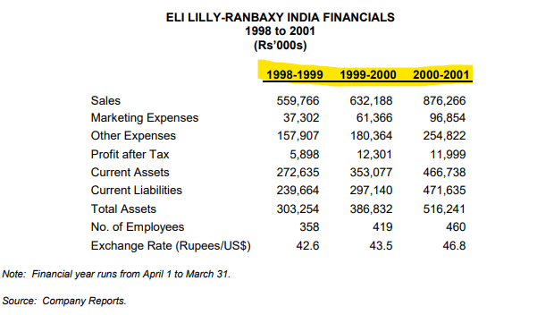

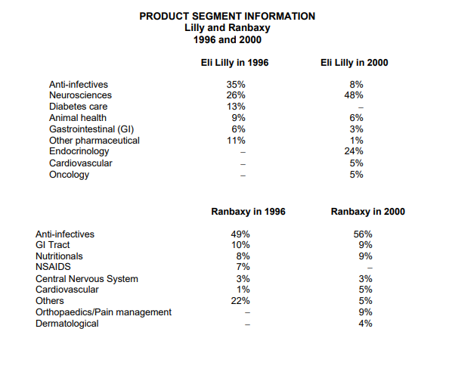

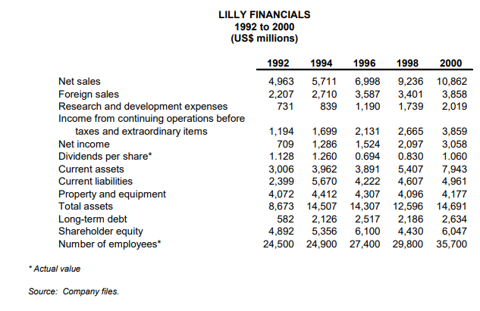

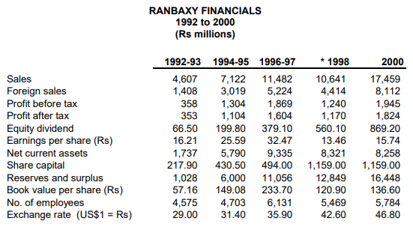

References
Dhanara, B. C. (2004). Eli Lill in India: Rethinking the Joint Venture Strateg.
Dhanaraj, C., Beamish, P. W., & Celly, N. (2011). Eli Lilly in India: Rethinking the joint venture strategy reading. Transnational management: text, cases, and readings in cross-border management.

