Name
Tutor
Course
Date
Silver as an element
Unlike other metals, silver and gold have been known to man since ages. The chemical symbol of silver is Ag, which stands for Argentum in Latin. The atomic number of Silver is 47, and the atomic weight is 107.8682 g/mol. Silver naturally occurs as a pure metal, and it reacts when exposed to ozone (O₃) and hydrogen sulfide (H₂S). This element has 47 protons, 47 electrons, and 61 neutrons. It has two stable isotopes - Ag 107 and Ag 109. In the periodic table, it is positioned in the 5th period, group 11.

Physical Properties of Silver
Physical properties of Silver are the characteristics that can be observed without changing the substance into another substance. They are features which can be observed using our senses such as color, luster, freezing point, boiling point, melting point, density, hardness and odor. The Physical Properties of Silver are as follows.
Physical Properties of Silver
Color | White
Luster | Lustrous shine and is capable of a high degree of polish
Ductility | It can be beaten into extremely thin sheets
Malleability | This refers to the ability of being shaped or bent
Conductivity | Excellent electrical and heat conductor. It has the highest electrical and thermal conductivity of any metal
Solubility | Solubility (ability to be dissolved)
Hardness | A relatively soft metal
Density | It is a dense metal
Melting point | Silver has a melting point of 961.8 °C
Boiling point | Silver has a boiling point of 2,162 °C

Chemical Properties of Silver
These are the characteristics that determine how it will react with other substances or change from one substance to another and are only observable during a chemical reaction. Reactions to substances may be brought about by changes brought about by burning, rusting, heating, exploding, tarnishing etc. The Chemical Properties of Silver are as follows:
Chemical Properties of Silver
Chemical Formula | Ag
Reactivity | Silver does not react with O₂, N₂, or H₂ at normal temperatures
Oxidation | A thin film on the surface of silver as a result of oxygen absorption that increases with temperature and pressure
Compounds | Silver forms complex compounds, most of which are soluble in water
Cyanidation | The extraction from ores requires cyanidation—the dissolution of silver in an alkaline solution of sodium cyanide with an inlet for air

Realistically speaking, there is a controversy regarding the discovery of silver and its applications. The ancient Egyptians and Greeks were probably the first ones to discover this metal according to researchers. It can be deduced that silver is among the first metals discovered by ancient peoples and has a very long history. Its first evidence of silver mining dates back to 3000 B.C., in Turkey and Greece, according to the RSC. However, it can be said that a proper usage of this element started around 5,000 B.C. In terms of silver production, so far Mexico is the largest producer of this element.
Silver has two major isotopes.-Naturally occurring silver is composed of two stable isotopes, ¹⁰⁷Ag and ¹⁰⁹Ag, with ¹⁰⁷Ag being slightly more abundant (51.839% natural abundance). The atomic weight is 107.8682 this value is very important because of the importance of silver compounds, particularly halides, in gravimetric analysis. Both isotopes of silver are produced in stars via the s-process (slow neutron capture), as well as in supernovas via the r-process (rapid neutron capture).
Silver metal will combine with chlorine, bromine, or iodine to form compounds. These compounds include such familiar substances as silver chloride (AgCl), silver bromide (AgBr), and silver iodide (AgI). Each of these salts is used extensively in photography. Silver chloride serves as the light-sensitive material in photographic printing papers and, together with silver bromide, in certain films and plates. The iodide is also used in the manufacture of photographic papers and films, as well as in cloud seeding for artificial rainmaking and in some antiseptics. All three halides are derived from silver nitrate (AgNO₃), which is the most important of the inorganic silver salts. Besides these other salts, silver nitrate is also the starting material for the production of the silver cyanide used in silver plating.
Due to the nature, electrical conductivity, attractiveness and non-reactivity of silver, it has numerous uses as below. It is used for jewelry and silver tableware, where appearance is important. Silver is used to make mirrors, as it is the best reflector of visible light known, although it does tarnish with time. It is also used in dental alloys, solder and brazing alloys, electrical contacts and batteries. Silver is used in chemical production as a catalyst, used in photography can also be used in the energy industry where silver paste is used to make solar panels among other uses. Silver has been known to man since ages, and has played a major role in the development of civilizations. It has some religious significance too. It is often associated with lunar influence, and is considered to denote anything that is creative, flexible, and emotionally centered
On the reactivity with either air or water, Silver is a very inactive metal. It does not react with oxygen in the air under normal circumstances. It does react slowly with sulfur compounds in the air, however forming silver sulfide (Ag ₂ S). Silver is the 68th most abundant element in the Earth's crust and 65th in cosmic abundance. It is found in small quantities in many locations on Earth. The atomic weight of silver is 107.868, and natural silver consists of two stable isotopes: silver-107 (51.82%) and silver-109 (48.18%).
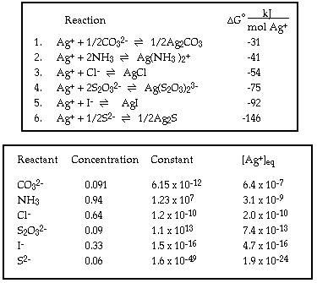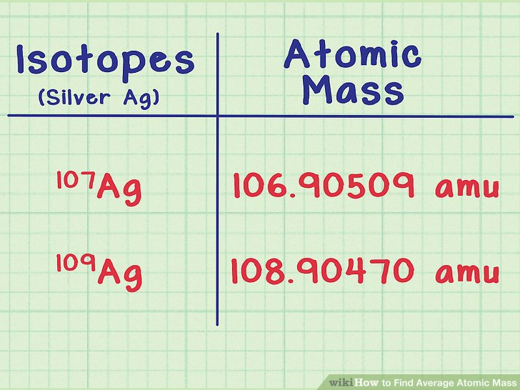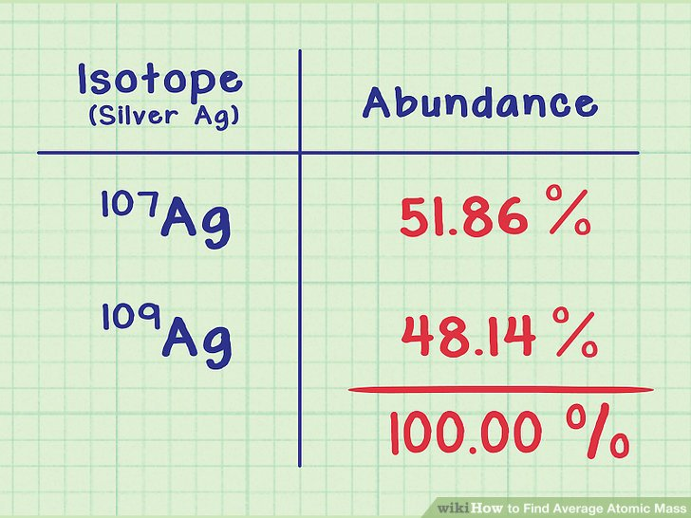

References
- Alexander, J. W. (2009). History of the medical use of silver. Surgical infections, 10(3), 289-292.
- Medici, S., Peana, M., Nurchi, V. M., & Zoroddu, M. A. (2019). Medical uses of silver: history, myths, and scientific evidence. Journal of medicinal chemistry.
- Armistead, W. H., & Stookey, S. D. (1964). Photochromic silicate glasses sensitized by silver halides. Science, 144(3615), 150-154.

- Pillai, V., Kumar, P., Hou, M. J., Ayyub, P., & Shah, D. O. (1995). Preparation of nanoparticles of silver halides, superconductors and magnetic materials using water-in-oil microemulsions as nano-reactors. Advances in Colloid and Interface Science, 55, 241-269.

- Mijnendonckx, K., Leys, N., Mahillon, J., Silver, S., & Van Houdt, R. (2013). Antimicrobial silver: uses, toxicity and potential for resistance. Biometals, 26(4), 609-621.

