Soil
Name
Institution
Date

Soil
What is Soil?
Soil is a non-consolidated mineral or organic substance found on the earth's surface that is a natural medium for the development of land plants. Soil, too, refers to the non-consolidated or organic matter that has been exposed to and has the consequences of genetic and environmental climactic elements such as water, temperature, and macro and relief-conditioned microbes that work on parent material throughout the whole of time and is a non-consolidated mineral or organic matter on the Earth surface. Soil contains both living and non-living components. Some of the specific components of soil include minerals, water, animal matter water, and plant matter. The living components are referred to as biotic, while the non-living components are referred to as abiotic (USDA Natural Resources Conservation Service, 2021). Some of the most common minerals available in soil include nitrogen and phosphorus, and they are essential because they support the growth of plants. Soil ingredients that form the composition of soil vary from one place to another.
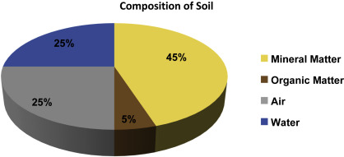
Soil is majorly formed from the breakdown of rocks in a process called weathering. As soil is formed over time, a soil profile is developed from horizons. Soil consists of three horizons, namely A, B, and C horizons. A horizon is topsoil that contains larger percentages of nutrients and organic materials. B horizon is rich in clay and less fertile compared to the topsoil, although it is able to hold more moisture. C horizon comprises the weathered rocks. Some of the factors that affect the formation of soil include parent material, living organisms, climate, topography, and time (Schweizer et al., 2018). Parent material or rocks produce the minerals in the soil through weathering as well as natural erosion. Some of the factors that facilitate the breakdown of parent material include water, living organisms, the interaction of chemicals, and changes in temperature. Organisms such as animals, plants, humans, and insects affect the formation of soil. A drier and cold climate slows the weathering process, while a hot and moist climate makes weathering faster. Topography elements that affect soil formation include slope shape and length. For example, the slope is a determinant of the vegetation type as well as the amount of rainfall.
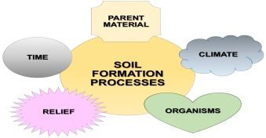
Processes that Cause Soil Erosion
Water, gravity, and wind are among the agents of soil erosion. Some of the processes that cause soil erosion include farming, logging, and mining. Farming is the most significant activity associated with soil erosion. As farmers engage in agricultural activities, native vegetation is removed, and land is plowed to create new land for farming. Farming mostly takes place during the summer and spring seasons, and therefore during winter, most of the land lies fallow. Due to the regular storms during winter, most land is washed away by wind and rain, resulting in soil erosion (Borrelli et al., 2017). Logging entails the removal of trees, which offers protection against soil erosion. As a result of logging, leaf litter is also lost. Essentially, leaf litter safeguards forest soils against erosion. Mining activities also cause land disturbance and make it susceptible to erosion.
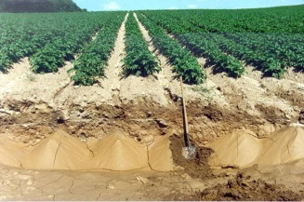
Interventions to Prevent Soil Erosion
Soil is a source of nutrients for most plants that provide food to human beings, and thus soil should be managed properly and soil erosion prevented at all costs. One of the interventions to prevent soil erosion is planting vegetation that acts as ground cover. Notably, planting trees and grass can help in protecting soil from erosion. Specifically, plants cover the soil and bind it with their roots. Some of the plants that can be the best choices for the prevention of soil erosion include herbs, creepers, and wildflowers (Bhat et al., 2019). Another intervention for the prevention of soil erosion is mulching. Mulching entails applying dead leaves to the soil. Essentially, mulching offers plant protection against weathering. In addition, mulching allows slow penetration of water into the soil and thereby reduces soil erosion caused by heavy rainfall.
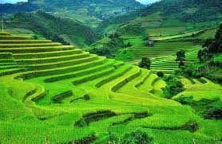

References
Bhat, S. A., Dar, M. U. D., &Meena, R. S. (2019).Soil erosion and management strategies.In Sustainable Management of Soil and Environment (pp. 73-122).Springer, Singapore.
Borrelli, P., Robinson, D. A., Fleischer, L. R., Lugato, E., Ballabio, C., Alewell, C., ...&Panagos, P. (2017). An assessment of the global impact of 21st century land use change on soil erosion. Nature communications, 8(1), 1-13.
Schweizer, S. A., Hoeschen, C., Schlüter, S., Kögel‐Knabner, I., & Mueller, C. W. (2018). Rapid soil formation after glacial retreat shaped by spatial patterns of organic matter accrual in microaggregates.Global change biology, 24(4), 1637-1650.
USDA Natural Resources Conservation Service.(2021). Soils. Retrieved from https://www.nrcs.usda.gov/wps/portal/nrcs/detail/soils/edu/?cid=nrcs142p2_054280

