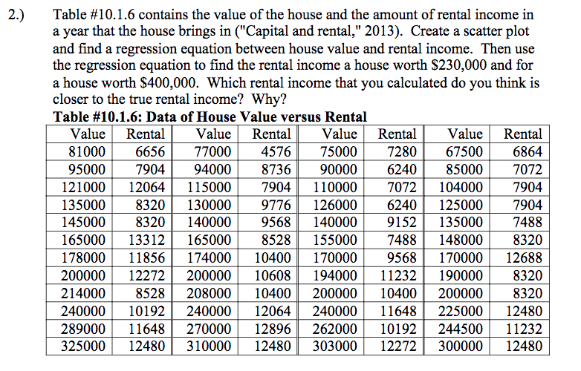

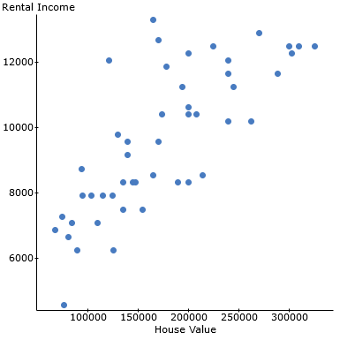
Regression equation: $y=0.024x+5363.86$
If x=230000, $y=0.024\left(230000\right)+5363.86=\$10883.86$
If x=400000, $y=0.024\left(400000\right)+5363.86=\$14963.86$
$10883.86 is closer to the true rental income since house value producing this annual rental income would fall within range of house value data.

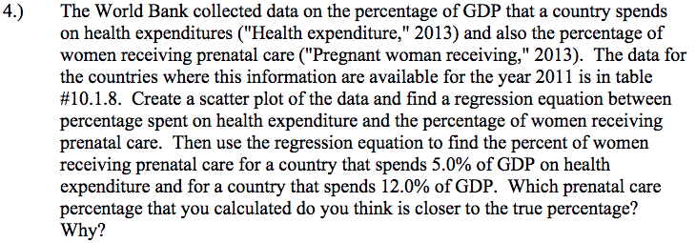
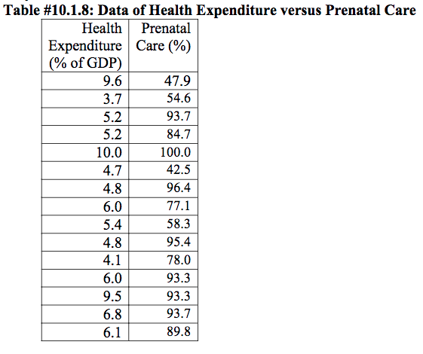

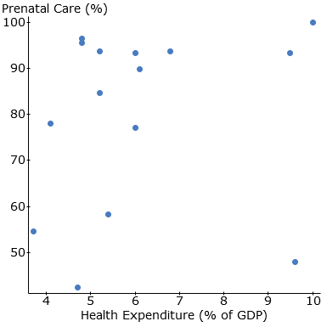

Regression equation: $y=1.661x+69.739$

If x=5.0%, $y=1.661\left(5\right)+69.739=78.044\%$
If x=12.0%, $y=1.661\left(12\right)+69.739=89.671\%$

78.044% since the GDP % spent on healthcare producing this percentage of women receiving prenatal care would fall within range of input data.

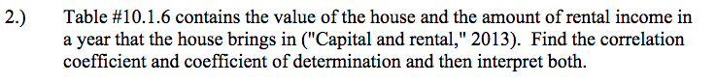
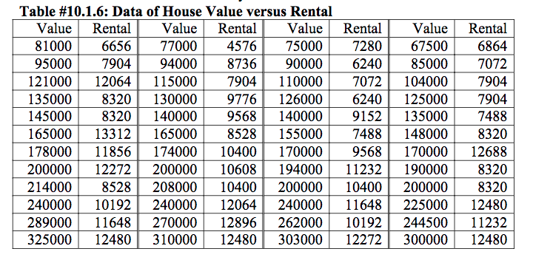
Correlation coefficient: $r=0.76472$. This shows a strong positive relationship between house value and rental income. As the house value increases, the rental income also increases and vice versa.
Coefficient of determination: $R^{2}=0.58479$. This shows that 58.5% variation in rental income is accounted for by the house value.
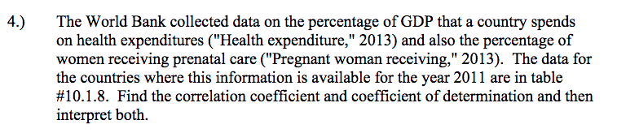
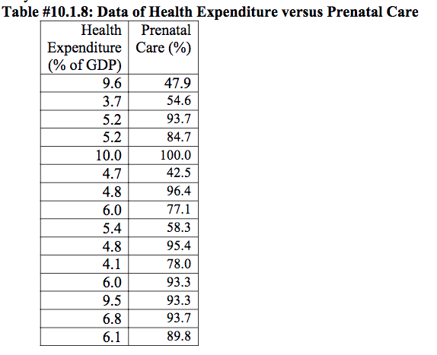
Correlation coefficient: $R=0.1715$. This shows that there is a weak positive relationship between percentage of GDP spent on health expenditure and percentage of women receiving prenatal care.
Correlation of determination: $R^{2}=0.0294$. 2.94% variation in percentage of women receiving prenatal care is caused by percentage of GDP spent on healthcare.
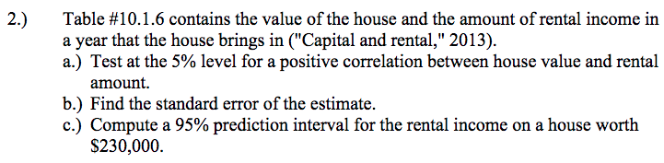

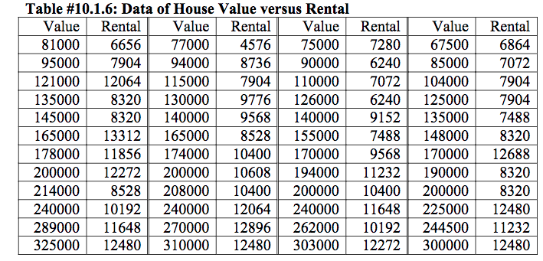
- $H_{O}: ρ=0$
$$H_{A}: ρ>0$$

$$α=0.05$$
$$df=24+24-2=46$$
$$r=0.76472$$
$$Test statistic=\frac{r}{\sqrt{\frac{1-r^{2}}{n-2}}}=\frac{0.76472}{\sqrt{\frac{1-{0.76472}^{2}}{46}}}=8.0492$$
p-value=0
Reject $H_{O}$. There is enough evidence to support the claim that there is a positive correlation between house value and rental income.
- $s_{e}=\sqrt{\frac{\sum{{(y-\hat{y})}^{2}}}{n-2}=}1441.6249$
- $E=t_{c}s_{e}\sqrt{1+\frac{1}{n}+\frac{{\left(x_{e}-\overline{x}\right)}^{2}}{{SS}_{x}}}$
$$t_{c}=2.013$$

$$s_{e}=1441.6249$$
$x_{e}=230000$
$\hat{y}=10883.86$

${SS}_{x}={69486.835}^{2}\left(48-1\right)=226935751200.9096$

$\overline{x}=$174375
$$E=2.013×1441.6249\sqrt{1+\frac{1}{48}+\frac{{\left(230000-174375\right)}^{2}}{226935751200.9096}}=2869.0261$$
Prediction Interval
$\hat{y}-E<y<\hat{y}+E$
$10883.86-2869.0261<y<10883.86+2869.0261$
8014.8339<y<13918.687
There is a 95% chance that the interval 80148339<y<13918.687 contains the true value
for the rental income when the house value 230000.

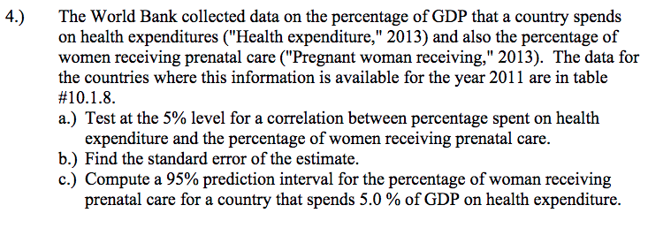

- $H_{O}: ρ=0$
$$H_{A}: ρ≠0$$

$$α=0.05$$
$$df=13$$
$$r=0.171505$$
$Test statistic=\frac{r}{\sqrt{\frac{1-r^{2}}{n-2}}}=\frac{0.171505}{\sqrt{\frac{1-{0.171505}^{2}}{13}}}=$0.62767
p-value=0.5411
Fail to reject $H_{O}$. There is not enough evidence to show that there is correlation between percentage of GDP spent on healthcare and percentage of women receiving prenatal care.
- $s_{e}=\sqrt{\frac{\sum{{(y-\hat{y})}^{2}}}{n-2}=}19.927$
- $E=t_{c}s_{e}\sqrt{1+\frac{1}{n}+\frac{{\left(x_{e}-\overline{x}\right)}^{2}}{{SS}_{x}}}$
$$t_{c}=2.16$$

$$s_{e}=19.927$$
$x_{e}=5$
$\hat{y}=78.044$
${SS}_{x}={2.0129817}^{2}\left(15-1\right)=59.72933$

$\overline{x}=$6.1267
$$E=2.16×19.927\sqrt{1+\frac{1}{15}+\frac{{\left(5-6.1267\right)}^{2}}{59.72933}}=44.89461$$
Predicted interval
78.044-44.89461<y<78.044+44.89461
33.118<y<122.967
There is 95% chance that the interval 33.118<y<122.967 contains the true value for percentage of women receiving prenatal care when the percentage of GDP spent on healthcare is 5%.

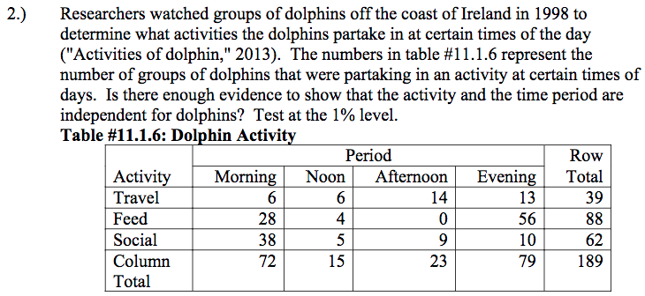
$$H_{O}:Activity and the time period are independent for dolphins$$
$H_{A}:Activity and the time period are dependent for dolphins$
$α=0.01$
Expected frequencies table

 | Morning | Noon | Afternoon | Evening | Total
39 | 6  (14.86) | 6  (3.1) | 14  (4.75) | 13  (16.3) | 39
88 | 28  (33.52) | 4  (6.98) | 0  (10.71) | 56  (36.78) | 88
62 | 38  (23.62) | 5  (4.92) | 9  (7.54) | 10  (25.92) | 62
189 | 72  (72) | 15  (15) | 23  (23) | 79  (79) | 189
Total | 144 | 30 | 46 | 158 | 378

Test statistic=64.465
p-value=0.0001
Reject $H_{O}$. There is sufficient evidence to show that the activity and time period are dependent for dolphins.

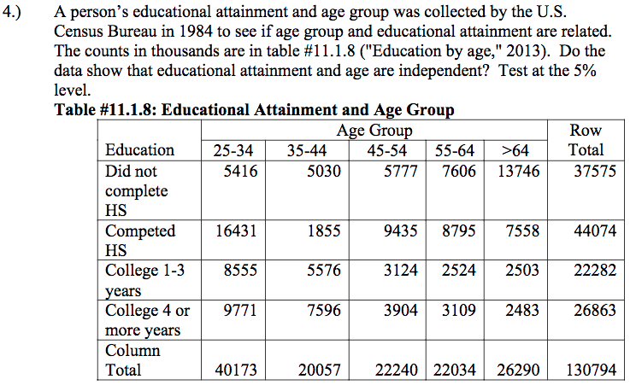$H_{O}:Level of educational atttainment and age are independent.$
$$H_{A}:Level of educational attainment and age are dependent.$$

Expected frequencies table

 | 25-34 | 35-44 | 45-54 | 55-64 | >64 | Total
Did not complete HS | 5416  (11541.05) | 5030  (5762.05) | 5777  (6389.19) | 7606  (6330.01) | 13746  (7552.69) | 37575
Competed HS | 16431  (13537.2) | 1855  (6758.66) | 9435  (7494.27) | 8795  (7424.86) | 7558  (8859.01) | 44074
College 1-3 years | 8555  (6843.85) | 5576  (3416.9) | 3124  (3788.8) | 2524  (3753.7) | 2503  (4478.75) | 22282
College 4 or more years | 9771  (8250.89) | 7596  (4119.39) | 3904  (4567.74) | 3109  (4525.43) | 2483  (5399.55) | 26863
Column Total | 40173  (40173) | 20057  (20057) | 22240  (22240) | 22034  (22034) | 26290  (26290) | 130794
Total | 80346 | 40114 | 44480 | 44068 | 52580 | 261588
Test statistic=22373.566
P-value=0.0001

Reject $H_{O}$. There is sufficient evidence to show that level of educational attainment and age are dependent.

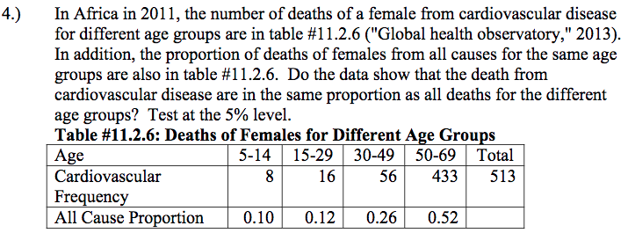$H_{O}:Death from cardiovascular disease are in the same proprtion as all deaths for different age groups.$
$$H_{A}:Death from cardiovascular disease are not in the same proprtion as all deaths for different age grou$$
$$α=0.05$$
Observed | Expected
8 | 51.3
16 | 61.56
56 | 133.38
433 | 266.76
Test statistic=218.756
P-value=0.0001
Reject $H_{O}$. There is sufficient evidence to show that deaths from cardiovascular disease in females are not in the same proportion as all dealths of females of different age groups.

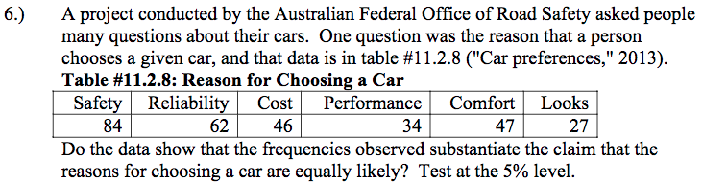
$$H_{O}:The observed frequencies are equal for the reasons for choosing a car.$$
$$H_{A}:The observed frequencies are not equal for the reasons for choosing a car.$$
$$α=0.05$$
Observed | Expected
84 | 50
62 | 50
46 | 50
34 | 50
47 | 50
27 | 50

Test statistic=42.2
P-value=0.0001
Reject $H_{O}$. There is sufficient evidence show that the observed frequencies are not equal for the reasons for buying a car.
1. Correlation: Correlation Does Not Mean Causation
One of the major misconceptions about correlation is that a relationship between two variables means causation; that is, one variable causes changes in the other variable. There is a particular tendency to make this causal error, when the two variables seem to be related to each other.
What is one instance where you have seen correlation misinterpreted as causation? Please describe.
We know that height and weight have a positive correlation. That is, increase in height leads to an increase in weight. However, it is not correct to say that increase in height causes increase in weight. There are other factors that contribute to this such as eating habits.

