The exam has 3 separate parts. Please complete each part. If you have any questions please email me. The exam is due by Saturday 4/18/20

Part 1: Multiple choice and short answer. Please bold or highlight the choose you (20 points total, each question is worth 2 points)

- We perform correlational analyses to determine _______?
Correlation analysis is performed to identify the strength of relationships between a pair of variables.
- What type of data are chi-squares used for?
  - Continuous
  - Categorical
- What type of question do chi-squares answer?
  - Can we predict variable Y from variable X?
  - What is the relationship between two variables? Are these variables associated with one another? Is there a difference in frequencies across groups?
  - Are there significant differences in the outcome variable across groups? Are there significant differences across group means?
- A negative correlation means that________
  - As one measure increases the other also increases
  - As one measure increases the other decreases
  - As one measure decreases the other also decreases
  - Both A and C
- If the analysis is significant, it most usually means________
  - The p-value is more than 0.05
  - The p-value is more than 0.5
  - The p-value is less than 0.05
  - The p-value is less than 0.5
- What type of chi-square test would you use for each of the following questions (test of independence or goodness of fit)?
  - When considering a data set in which we observe frequencies, and we expect those frequencies to reflect what we originally expected to see.

Goodness of fit
  - A dataset with categorical variables in which we want to examine how the observed frequencies are impacted by two variables.

Chi-square test for independence

- Which p-value is significant?
  - P = .07
  - P = .35
  - P = .01
- If I have a positive correlation, that means:
  - As one variable goes up or down, the other variable goes in the same direction
  - As one variable goes up/down, the other variable goes in the opposite direction
  - The two variables are not associated with each other
  - Not enough information
- I can tell the strength of a relationship between two variables by looking at the sign of the correlation coefficient
  - True
  - False
- In a chi-square test if we say that the variables work together as a combined force to influence the observed frequencies, this means that____
  - The variables work independently
  - The variables are not independent
  - There is a relationship between the two variables
  - Both B and C

Part 2: Short Answer (60 points total. Each question is worth 20 points)
1) Lisa is a campus dean and she believes that morning classes are often a great idea in theory, but that many people do not actually attend those classes. Lisa also believes that participation in other social activities, particularly Greek life (fraternities and sororities) may contribute to these student absences in morning classes, as many of their social activities take place on weeknights and may influence whether a student can get up on time. Lisa polls a sample of 200 students, 100 in a fraternity and 100 who are not, asking whether they almost always attend their 8 am classes, or whether they are often late/absent.

 | Attend Classes | Late/Absent
Fraternity | 27 | 73
Non-Fraternity | 84 | 16

Below are the results from SPSS:

 | Value | df | Asymptotic Significance (2-sided) | Exact Sig. (2-sided) | Exact Sig. (1-sided)
Pearson Chi-Square | 65.776ª | 1 | .000
Continuity Correction^{b} | 63.488 | 1 | .000
Likelihood Ratio | 70.248 | 1 | .000
Fisher's Exact Test |  |  |  | .000 | .000
Linear-by-Linear Association | 65.447 | 1 | .000
N of Valid Cases | 200

Symmetric Measures
 |  | Value | Approximate Significance
Nominal by Nominal | Phi | -.573 | .000
Nominal by Nominal | Cramer's V | .573 | .000
N of Valid Cases |  | 200

- What is the independent variable? (3 point)

Participation in other social activities

- What is the dependent variable? (3 point)

Almost always attend their 8 am classes, or whether they are often late/absent

- What test did I use to analyze the data? (3 points)

Chi-Square Test for Independence

- Is the test significant? How do you know? (5 points)

No, P-value is greater significance level (0.000 < 0.05). Fail to reject the null hypothesis

- Report the findings in 1-3 sentences. Make sure to include the independent variable, the dependent variable, and all relevant statistics. (6 points)

Fail to reject the null hypothesis and conclude that there not significant evidence participation in other social activities, particularly Greek life (fraternities and sororities) may contribute to these student absences in morning classes, as many of their social activities take place on weeknights and may influence whether a student can get up on time.

- A professor wants to know if there is a relationship between the hours of sleep a student gets and their performance on the exam. The day of the exam, the professor asks 10 of her students to report how many hours of sleep they got the night before. She then looks at their exam grades. The data are below.
Student | Hours slept | Grade
A | 8 | 90
B | 3 | 56
C | 1 | 68
D | 10 | 92
E | 9 | 90
F | 7 | 94
G | 4 | 48
H | 6 | 88
I | 7 | 87
J | 5 | 75

Below are the results from SPSS:
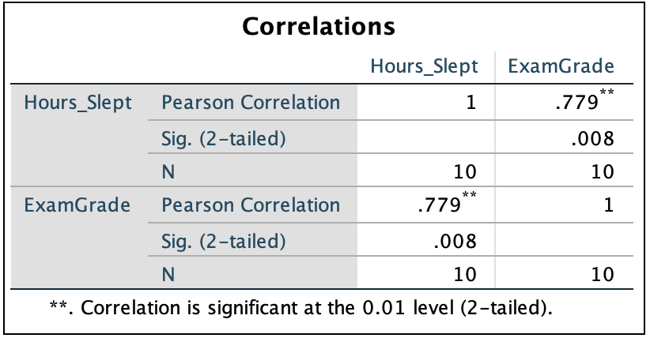

- What is the independent variable? (3 point)

The hours of sleep a student gets.

- What is the dependent variable? (3 point)

Performance on the exam

- What test did I use to analyze the data? (3 points)

Pearson Correlation or Linear regression

- Is the test significant? How do you know? (5 points)

Yes, P-value is less significance level (0.008 < 0.01). Reject the null hypothesis

- Report the findings in 1-3 sentences. Make sure to include the independent variable, the dependent variable, and all relevant statistics. (6 points)

Reject the null hypothesis and conclude that there is significant evidence a relationship between the hours of sleep a student gets and their performance on the exam.

- A candy store owner wants to see which product sells best. He has three categories of products: chocolate, candies, and taffys. He expects that the same amount of all three candies will be sold. He observes the first 60 children come into his store in one week and finds the following sales:
Category | Number of Sales
Chocolate | 19
Candies | 11
Taffys | 31

Below are the results from SPSS:
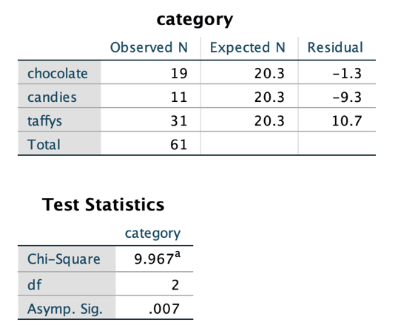

- What is the independent variable? (3 point)

Category of Product

- What is the dependent variable? (3 point)

Number of Sales

- What test did I use to analyze the data? (3 points)

Chi-Square test independence of attributes

- Is the test significant? How do you know? (5 points)

Yes, P-value is less significance level (0.007 < 0.05). Reject the null hypothesis.

- Report the findings in 1-3 sentences. Make sure to include the independent variable, the dependent variable, and all relevant statistics. (6 points)

Reject the null hypothesis and conclude that there is significant evidence of a dependence relationship between the number of sales and category of product.

Extra Credit (5 points):

- For any of the questions above that you used a correlation:Assume you ran a regression and obtained a slope of 10 and a y-intercept of 3. Calculate your predicted y if your x was 5. (5 points)
Y=10X+3
Y=10*5+3=15=3=18

Part 3: Your own study (20 points)

- Make up your own very simple research question (similar to the examples we’ve done in class). Make sure that this is your *own* idea.
  - Describe your research question/study (7 points)
A researcher wants to evaluate whether college students are more stressed during the fall semester or the spring semester of the academic year. During the fall semester, the researcher ask 10 students to report their level of stress (0 = no stress, 10 = extremely stressed). The researcher asks the same 10 students in the spring semester how stressed they are. Data below
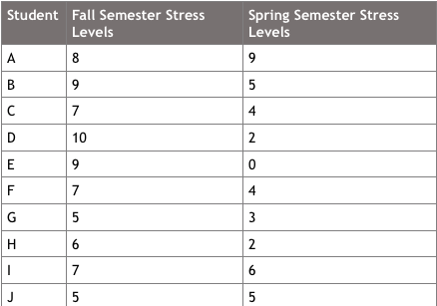

  - State your independent variable (3 points)

Semesters in different seasons (fall and spring)

  - State your dependent variable (3 points)

Stress level

  - Describe the statistical test you would use to analyze your data and why you chose this test. (7 points)

We can run paired t test for analyze this data, because we collect stress level data for same students in two semesters. Hence, data in sample 1 is related to sample 2.

