Spring 2020 Common Portion

1. The data set represents the number of minutes a sample of 25 people exercise each week.
108 139 120 123 120
132 123 131 131 157
150 124 111 101 135
119 116 117 127 128
139 119 118 114 127

- Make a frequency distribution of the data set using five classes and display using relative frequency histogram. Describe the distribution.
Least observation =101
Greatest observation=157
No.of classes=5
Class range=(157-101)/5=11.2
Class | Class Range | Midpoint | Frequency | Relative Frequency | Cumulative Frequency
1 | 101-112.2 | 106.6 | 3 | 0.12 | 0.12
2 | 112.2-125.4 | 117.8 | 10 | 0.4 | 0.52
3 | 123.4-134.6 | 129 | 7 | 0.25 | 0.8
4 | 134.6-145.8 | 140.2 | 3 | 0.12 | 0.95
5 | 145.8-157 | 151.4 | 2 | 0.08 | 1

From histogram the shape of distribution is right skewed.

- Display the data using stem -and leaf plot.
Stem-and-Leaf Display
Stem unit: | 10
10 | 1 8
11 | 1 4 6 7 8 9 9
12 | 0 0 3 3 4 7 7 8
13 | 1 1 2 5 9 9
14
15 | 0 7

- Display the data using box plot.
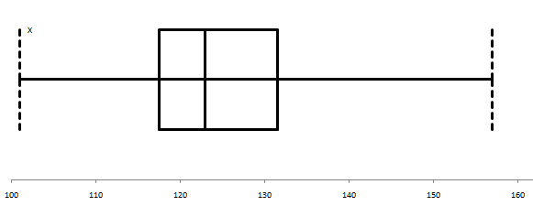
Five-Number Summary
Minimum | 101
First Quartile | 117.5
Median | 123
Third Quartile | 131.5
Maximum | 157

- Compare your graphs from a and d. Make comments on the distributions on your data among these graphs.
The frequencies increases fast and then decrease slow. Therefore, distribution is right skewed

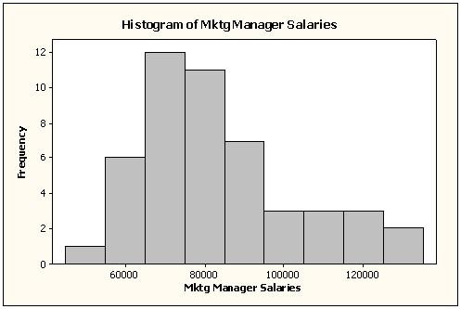
2. A histogram and some summary statistics of
salaries (in $) for a sample of U.S. marketing
managers are shown.
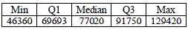

  - Describe the shape of the distribution.

From histogram, it seems there is a right skewed.

  - Would you expect the mean salary for this sample of marketing managers to be higher or lower than the median? Explain.

We would expect the mean salary to be higher than the median because the distribution is skewed right (the sample mean is $82,549).

  - Which would be a more appropriate measure of central tendency for these data, the mean or median?

The median is preferred over the mean when the distribution is skewed.

  - Are there outliers in this sample? Give the lower and upper values where outlier salaries would begin.
IQR=Q₃-Q₁=91750-69693=22057
Upper value=Q₃+1.5IQR=91750+1.5*22057=124835.8
Lower Value=Q₁-1.5IQR=69693-1.5*22057=36607.50

  - Suppose the marketing manager who was earning $129,420 got a raise and now earns $140,000. Indicate how this change affects these summary statistics (increase, decrease, or stay about the same):
i. Mean Increase
ii. Median Stay the same
iii. Range Increase
iv. IQR Stay the same
v. Standard deviation Increase

3. Novel Coronavirus(2019-nCoV)
Among the 37 cases identified outside of China, three were detected without the onset of symptoms, while among the remaining 34 patients, there is information on the date of symptom for 28 individuals.
The epidemic curve for these individuals is shown in the Figure below.

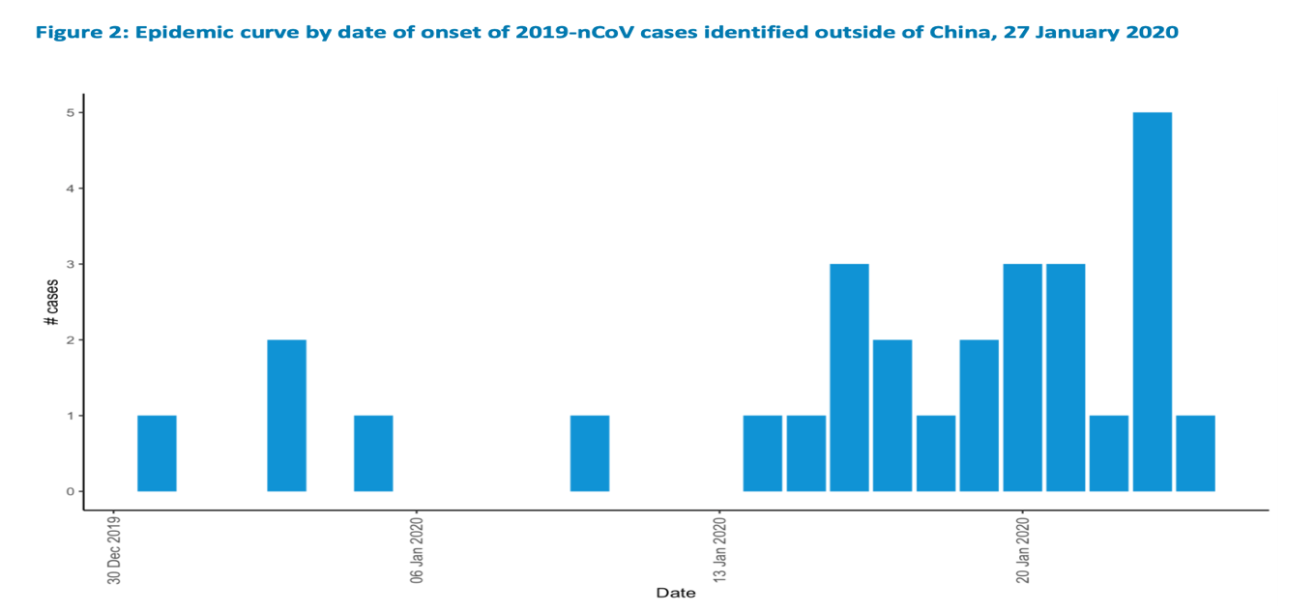
(https://www.who.int/docs/default-source/coronaviruse/situation-reports/20200127-sitrep-7-2019--ncov.pdf )

Describe the distribution​ (shape, center,​ spread, unusual​ features).

The distribution is skewed to the left. The data is uni-modal and has outliers.

4. Office Hours: A college statistics professor has office hours from 9:00 A.M. to 10:30 A.M.
daily. A sample of waiting times to see the professor (in minutes) is
10, 12, 20, 15, 17, 10, 30, 28, 35, 28, 19, 27, 25, 22, 33, 37, 14, 21, 20, and 23.
Assuming σ = 7.84, find the 95% confidence interval for the population mean.

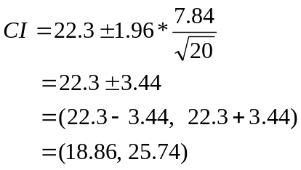
The 95% confidence interval for the population mean between 18.86 and 25.74.

5. A manufacturer of cheese filled ravioli supplies a pizza restaurant chain. The pizza chain
specifies that the ravioli should contain 15 grams of cheese filling. Based on data
collected from its automatic filling process, the amount of cheese inserted into the ravioli
is normally distributed. To make sure that the automatic filling process is on target, quality
control inspectors take a sample of 25 ravioli and measure the weight of cheese filling.
The results of the hypothesis test 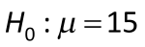grams vs. 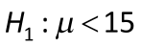grams resulted in a
p-value of 0.142.
  - Which test statistic was used for this scenario? z, t, or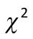?

t-test, because we have sample data given and population standard deviation is un known.

  - Interpret the p-value. In other words, what does the p-value mean?
P value: is the probability of finding observed or extreme result when null hypothesis is true.
  - What is the statistical conclusion at a 5% significance level?

Since p-value=0.142 >0.05, fail to reject the null hypothesis.

  - Is the result of this hypothesis test statistically significant?

There is not statistically significant evidence to claim that µ<15.

  - If this hypothesis test were redone for the alternative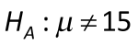, what would be the new p-value?

P-value=2*0.142=0.284

6. A pharmaceutical company makes a pill intended to reduce the chances of seizures
among children. The pill is supposed to contain 20.0 mg of Phenobarbital. A simple
random sample of 20 pills yielded the amounts listed here. Does this sample provide
evidence that the mean amount of Phenobarbital is different than 20.0 mg? Use a 1%
significance level.

27.5 26.0 22.9 23.4 23.0 23.9 32.6 20.9 22.9 24.3
24.8 16.1 24.3 17.3 18.9 20.7 33.0 15.6 24.3 23.3

H_{o}:µ=20
H_{a}:µ≠20
α=0.01
This is two-tailed t-test.
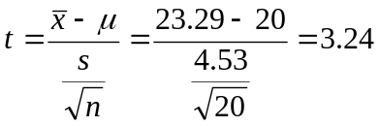
P-value=0.0043
Since 0.0043 < 0.01, it falls in the rejection region. Therefore, reject the null hypothesis and conclude that there is a significant of this sample provide evidence that the mean amount of Phenobarbital is different than 20.0 mg.

7. Dogs and Cats: A pet association claims that the mean annual costs of routine veterinarian visits for dogs and cats are the same. The results for samples of the two types of pets are shown below. At α = 0.10, can you reject the pet association’s claim? Assume the population variance are not equal. (Adapted from American Pet Products Association)

Sample Statistics for Annual Routine Vet Visits

Dogs | Cats
$${\underline{x}}_{1}=\$225$$  s₁ = $28  n₁ = 7 | $${\underline{x}}_{1}=\$203$$  s₁ = $15  n₁ = 10
- State the null and alternative hypothesis.
Discuss the logic of conducting the hypothesis test.
H_{o}:µ₁-µ₂=0 The mean annual costs of routine veterinarian visits for dogs and cats are the same.
H_{a}:µ₁-µ₂≠0 The mean annual costs of routine veterinarian visits for dogs and cats are not the same.
- Decide whether to reject or fail to reject the null hypothesis, and interpret your decision in the context of the original claim.
α=0.10
This is two-tailed Separate-Variances t Test for the Difference Between Two Means.
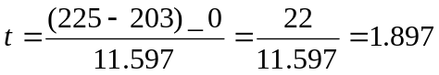
P-value=0.0944
Since 0.0944 <0.10, it falls in the rejection region. Therefore, reject the null hypothesis and conclude that there is not significant evidence to support a pet association claims that the mean annual costs of routine veterinarian visits for dogs and cats are the same.

