Strategic HR Audit
Write a 2,000-word (minimum word count excluding your references section) paper and develop a related 15 slide presentation (you will not actually deliver your presentation live but prepare your slides as though you were going to). Choose any company with 100 or more employees and apply the following Model of Strategic HR Management as a means of investigating and assessing the strategic HR practices of the firm.

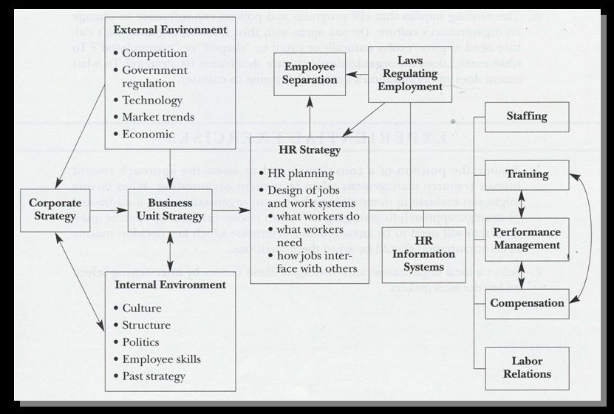

Source: Mello, J. A. (2019). Strategic human resource management (5th ed.). Mason, OH: South-Western.

Provide 3 distinct sections for both your paper and your related presentation.
- Section 1: profile of the subject company (e.g. corporate strategy, revenue base, financial performance, employee base, ownership structure, product/service mix, competitive position, primary locations for operations, etc.).
- Section 2: analysis and assessment of the strategic and theological soundness of the HR practices of the subject company (paying special attention to HR strategy, staffing, training and development, performance management, compensation, and labor relations).
- Section 3: posit 5–7 key recommendations for improving the strategic and theological soundness of the HR practices of the subject company.

Required Sources
Include the following sources in your reference page, and use in-text citations as follows:
- At least 4 citations from Valentine (2020).
- At least 4 citations from Hardy (1990) and/or Keller (2012).
- At least 5 citations from related scholarly journals (e.g. Human Resource Development Quarterly, Human Resource Development Review, Human Resource Management Journal, Journal of Applied Psychology, Journal of Strategic Human Resource Management, Journal of Biblical Integration in Business, Christian Scholars Review).
- At least 3 citations from related trade/practitioner publications (e.g. Harvard Business Review, HR Magazine, T&D Magazine, Business Week, Wall Street Journal).

Submit this assignment by 11:59 p.m. (ET) on Sunday of the assigned module/week.

