Summary 1

Format: MLA
Length: Two pages
Works Cited: one work cited, the Washington Post article, "The right to bury the (online) past". If you bring in any other sources include them in your Works Cited page.

Make sure that you can answer these questions while I read the summary!
- Is there a title to your paper? Does it help your reader?
- Is there an introductory sentence that tells the reader who wrote the article, when they wrote, where it was published and why it was written? If you have an alternative introduction do you also have the "who-what-when-where-how" somewhere in your paper?
- Do you let the reader know the author's main thesis or reason for writing the article?
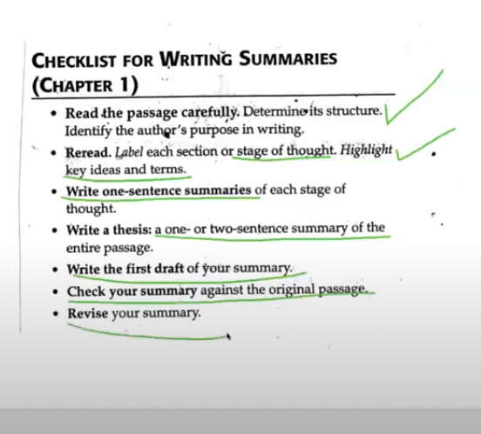
- Can the reader read your summary and not have to read the whole article?

