Strategic management process and Globalization issues of Tesco
Name
Institution Affiliation
Date

1. Strategic Management principles Mariam 4iii of Tesco
According to (Palmer, 2005, p.23-26), Tesco is a drinks and food retail representing the widely spread industry within the United Kingdom.it provides employment for over three Millions persons in the retailing, production and in the primary Manufacturing.
  - Establishment of a robust strategic Management process
On the establishment of robust strategic Management process of Tesco, various issues have to be considered in for the success of Tesco. The various issues include the consideration of the external factors impacting Tesco which could be political, sociological, economical factors, scientific, environmental dimensions and the legal. Among other issues to be considered is the stakeholders’ prospects in Tesco, Analysis of the changes taking place on the outside environment and how it could have an impact when it comes to the strategic decision in Tesco. Also the use of the tools that are appropriate in the analysis of the current plan on the business in Tesco cold be if importance to enhance its robust Management strategy.
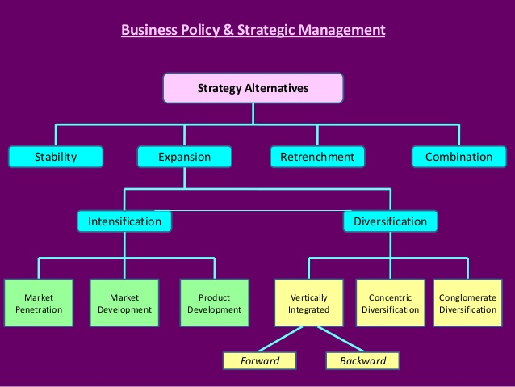
  - Conduct of the sector’s competitive analysis,
Tesco having close to about 700 stores all over the world and a number of them steadily growing. Its great dominance is in the United Kingdom. It has nine competitors which include the following, Sainsbury, Morrison’s.Aldi-6.2 %, Lidl-4.5%, Asda, the cooperative, Waitrose, small retails, Iceland foods-2.1% and other franchise’s.
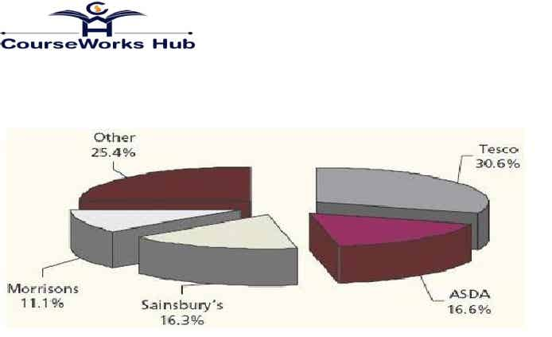 Fig 1: Market grocery stores in UK (Makos, 2014)
  - Introduction of the strategic leadership approach
Reaidy et al, (2015, p.29), stated that, the Tesco’s’ Management headed by Cohen adapted the democratic style of leadership also called the leadership of participation where the voices of the employees are heard when decisions are made. This type of the leadership in Tesco greatly motivates the employees and because of this, the organization provides excellent services to its customers.
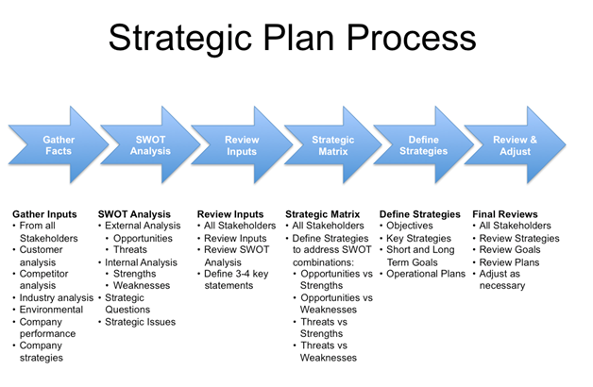
7. Globalization Issues of Tesco
Woods, (2008, p.1074) stated that, globalization being the process of integration and interaction of companies, governments and the people. It has grown with the help of the advanced technology on transport and communication. In the early experience of Tesco organization was not successful with globalization. However, the organization started later to restrict its stores and the Merchandise as per the world’s market.
7.1 Reflection of the organization’s readiness for enter global Market.
On the reflections of Tesco’s readiness for the global market, it is currently operating in the 13 nations. After its gradual expansion to Ireland and unsuccessful expansion into France, in the Year 1990s, it started expanding into the Eastern Europe and the Asian continent rapidly. The area have groceries retail Markets which are undeveloped but those changing rapidly give Tesco more opportunities.

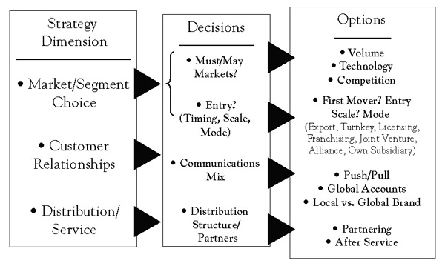Target Market and the Mode of Entry
7.2. Evaluation of the organization’s infrastructure Maturity for globalization
The increased recent collaborative and pooling projects f warehouses, for retailers which include Carrefour, Walmart and also Tesco’s conforms to the trend. Infrastructure maturity for globalization in the organization is evident through the process.
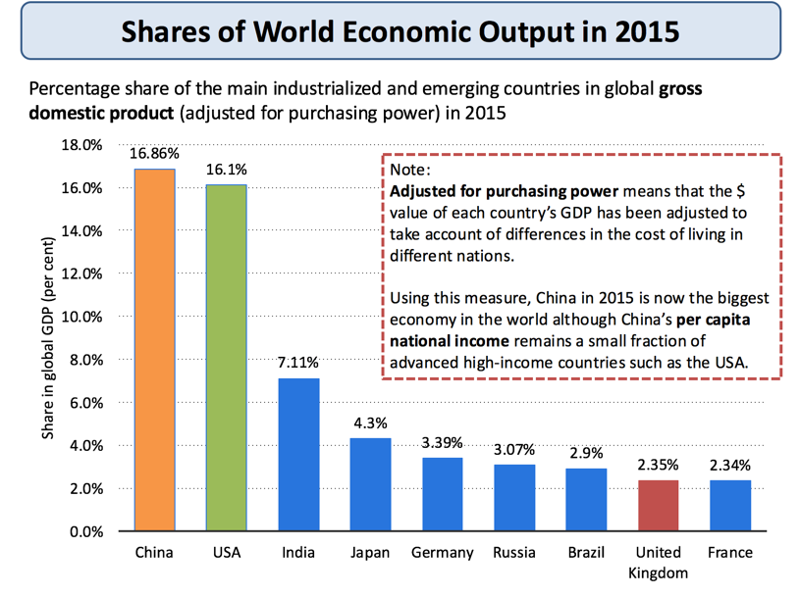
7.3. Review of how the Organisation’s workforce would adapt to globalization.
On how the organization’s workforce would adapt to the globalization, Tesco tries to carefully study the research on the Market and listens more to its customers and considers more on what they are saying. In the 1990s, the organization started to fasten its construction of the superstore which were bigger than the supermarkets they had built before (Barrientos, 2013, p.44). This was to allow for the selection of low prices greatly with an aim of satisfying the upper end shoppers. In all this process of adapting the workforce, there was an introduction of the organic food products by the organization.

References
Palmer, M., 2005. Retail multinational learning: a case study of Tesco. International journal of retail & distribution management, 33(1), pp.23-26.
Reaidy, P.J., Gunasekaran, A. and Spalanzani, A., 2015. Bottom-up approach based on Internet of Things for order fulfillment in a collaborative warehousing environment. International Journal of Production Economics, 159, pp.29-40.
Woods, M., 2008. Linking risk management to strategic controls: a case study of Tesco plc. International Journal of Risk Assessment and Management, 7(8), pp.1074-1088.
Barrientos, S., 2013. Corporate purchasing practices in global production networks: A socially contested terrain. Geoforum, 44, pp.44-51.

