Team A / Week Four: Emerging Technology Plan, Part 2
Alvin Lugo, Corey Nelson, Jesse Conde, Laura Tomlinson, and Rolphsky Jean Gilles
CMGT/557 Emerging Technologies & Issues
Monday, May 07, 2018
Professor: Dr. Gayle Grant

Team A / Week Four: Emerging Technology Plan, Part 2
Intro
In today’s world, with the growing number of connected devices, Amazon Web Services (AWS) needs to ensure they continue to provide and improve upon applications they offer for Internet of Things (IoT). Technologies like AWS IoT cloud services can bring big productivity and flexibility benefits to any organization. To stay ahead of the competition though, AWS needs to understand what their competitors offer for tools, services, and costs.
Industry Analysis
According to Lueth (2014), the Internet of Things (IoT) industry will be become a multi-trillion-dollar market by 2020. In Lueth’s industry analysis, the IoT industry market is driven by certain measures to include the numbered of connected devices, revenue, the economic value, and amount of IP traffic associated with IoT connected devices. By using these indicators, IoT companies can leverage an accurate understanding of the IoT market and enable IoT industry executive decision makers to strategically position their companies to exploit the connected solutions industry.
Because IoT encompasses many different aspects and definitions of connected devices. IoT Analytics firm developed a market segmentation to help identify the IoT ecosystem. The IoT ecosystem segmentation helps companies understand the difference between different aspects of the IoT industry in order to better focus marketing and efforts. Figure (1) breaks down IoT industry differences between two market segments; Consumer-facing and Business facing. These two differences are important because it helps companies determine where their IoT service fits in and where their efforts need to be concentered in.
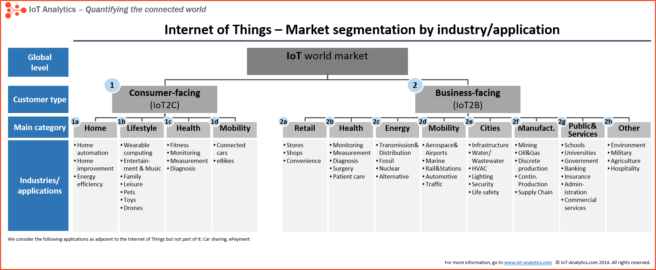 Figure (1)
Competitor Analysis
Amazon Web Services (AWS) launched their Internet of Things (IoT) services because they recognized the potential of integrated their top of the line cloud standards with the ever growing popularity of connected devices. AWS’s cloud services is a huge network conduit perfectly suited for existing AWS customers to ingrate their IoT infrastructure to AWS’s cloud infrastructure. Because IoT requires a huge amount of storage and information processing, the ideal competitor platform and infrastructure for AWS IoT is other commercial cloud providers.
The Crisp Research company conducted an AWS IoT competitor analysis which included 16 different IoT providers that could be comparable to AWS IoT service offerings. Figure (2) depicts Crisp Research’s findings. In order to be fair and have consistent standards, the analysis was broken down into two categories; product value creation and vendor performance. By averaging product value creation and vendor performance, a percentage is created to better determine a clear IoT competitor analysis. The higher average indicates the strong relationship to competition to Aws IoT.
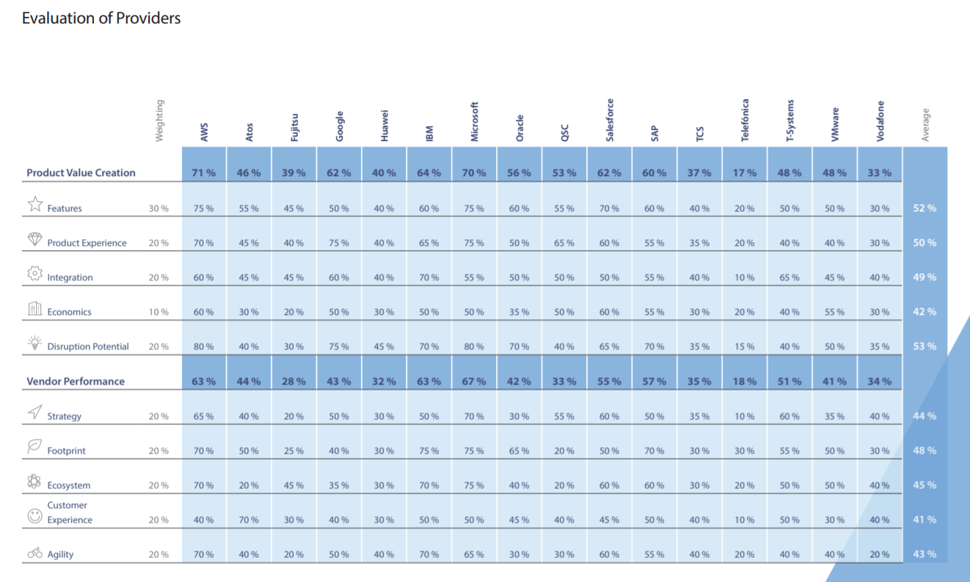Figure (2)
Development and Implementation
The development and implementation process will start immediately after decision-makers’ approval. All tasks will start and complete during the weekdays, which will give the team one month to finish the process.
Tasks
- Staff/Stakeholders’ meeting.  - Gathering Information to identify project’s purpose, goals, and target audience | 2 days
- Planning: Website map and Wireframe Creation  - Identifying functional and non-functional requirements | 3 days
- Design: page layouts, review, and approval cycle  3.1 Discussing design concepts of server-less (Lambda) and server-based (EC2) AWS services | 3 days
- Validation of AWS Services  - Find sample codes  - Test and validate AWS services for the needs of the web application | 4 days
- Selecting file services with cost considerations on location, redundancy, archiving compression, and security | 2 days
- Selecting data service (licensed or open source) | 1 day
- Testing | 1 day
- End users’ training (if necessary) | 3 days
Total Days | 19 days

Marketing- Target Markets
Anyone who uses any type of internet-connected devices, which is really everyone, this includes really all ages and classes of people. Today there are over 3.8 billion users connected in the world. EC is responsible for around 2 Trillion dollars in sales last year.
Marketing-Data Analytics
One of the biggest issues with data from IoT is that it is highly unstructured which can make analysis difficult utilizing traditional tools. Data from these devices need to be cleaned before analysis is performed which can be a lengthy and time-consuming process. One of the biggest strengths of AWS IoT analytics is in the automation of many processes which can save the customer time and improve business efficiency. The analytic filters that are utilized can filter, transform and enrich data before storing it in for analysis.
According to AWS IoT Analytics Overview - Amazon Web Services, (n.d.), You can build a scalable analytics pipeline on AWS to consistently track data and make data-informed decisions to optimize the performance of your products (ex. targeting algorithms). This robust system delivers the right message to the right audience at the right time. Amazon Athena is a serverless interactive query service that simplifies data analysis which provides ad targeting algorithms.

References
AWS IoT Services Overview - Amazon Web Services. (n.d.). Retrieved April 21, 2018, from https://aws.amazon.com/iot/
Crisp Vendor Universe (2016). Evaluation of IoT Backend Providers. Retrieved May 3, 2018 from https://d1.awsstatic.com/analyst-reports/CVU_Evaluation-of-IoT-Backend-Providers_shortversion_AWS_LogoNew.pdf.
Digital Marketing - Amazon Web Services (AWS). (n.d.). Retrieved from https://aws.amazon.com/digital-marketing/
Hunt, R. (2018, May 1). AWS IoT Analytics Overview - Amazon Web Services. Retrieved from https://aws.amazon.com/iot-analytics/
John Stevens(2017 Aug 17) Internet Stats & Facts for 2017, Retrieved from https://hostingfacts.com/internet-facts-stats-2016/
Lueth, K. (2014, October 17). IoT Market – Forecasts at a glance. Retrieved May 2, 2018, from https://iot-analytics.com/iot-market-forecasts-overview/
Lueth, K. (2014, October 31). IoT market segments – Biggest opportunities in industrial manufacturing. Retrieved May 3, 2018, from https://iot-analytics.com/iot-market-segments-analysis/
Valacich, J. & Schneider, C. (2018). Information Systems Today: Managing in the Digital World (8th Edition). New York: Pearson.

