1.
Temperature | Expansion
10 | 2.1
20 | 2.8
30 | 3.5
40 | 4
50 | 4.8
60 | 5.7
a)

b)
i) y = 14.197x - 19.187 Y=Temperature x=Expansion
Find T when E=1.5
Y=14.197(1.5)-19.187
=2.11
ii) Find E when T=65
65=14.197(E)-19.187
84.187=14.197E
E=5.93
2. 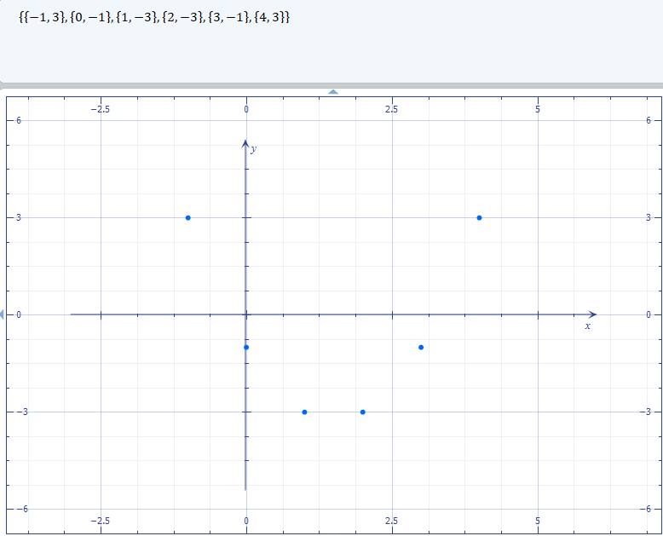

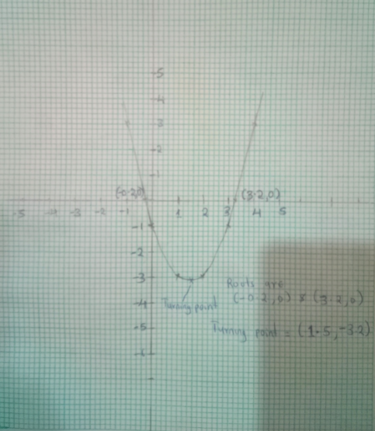

From the graph the roots are -0.2 and 3.2
The turning point coordinate (1.5,-3.2)

3)
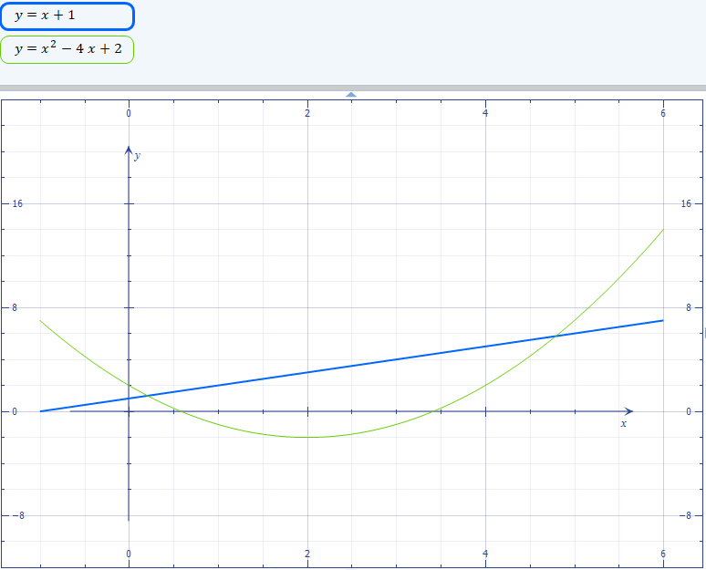
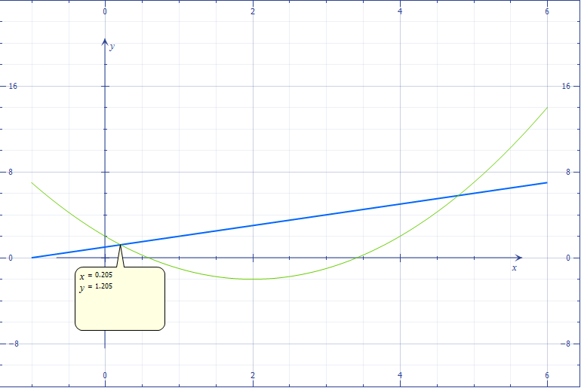

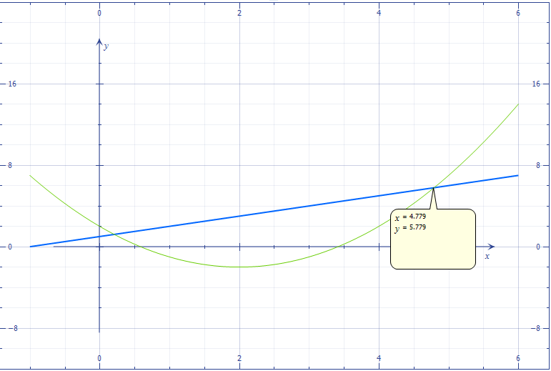

From the graph the values of x are
X=0.2
X=4.8

