Emerging Technologies Management
Name
Instructor
Course
Date

Table of Content
No. Title Page Number
- Cover Page …………………………………………………………………... 1
- Table of Contents ……..……………………………………………………... 2
- Emergies Technologies Management ……………………………………….. 3
- Introduction ………………………………………………………………….. 3
- Body …………………………………………………………………………. 4
- Diagram 1.0 ………………………………………………………………….. 5
- The assimilation and Fusion of Technology Lineages-Convergence …….…. 5
- The Technology Evaluaton Procedure …………………………………….… 6
- Learning and Information Confinement ……………………………………... 7
- Technologies Assessment ……………………………………………………. 7
- Diagram 1.1 ………………………………………………………………….. 8
- The Strategy Building Ability ……………………………………………….. 8
- Taught Imagination ………………………………………………………….. 9
- Technology Difficulties ……………………………………………………... 9
- Situation Development ………………………………………………………. 9
- References …………………………………………………………………… 11

Emerging Technologies Management
Introduction
Different areas of expertise in regard to instruction, business, and therapeutic fields are focusing to team up following self-education hence benefiting from the emerging technology in intensifying correspondence improvement, enhance management, and monetarily booster their items. Each field encounters particular input positioning events to select the technology efficiently possible. The dependent determination procedure on the company provides the assessment and quantifiable analysis regarding the quality of the new technology. It also focuses towards the technology surveillance for the shareholder and client associations, the management and company items. Within the duration of time, ultimately, the emerging technology builds up innovation amongst the internal desires of an organization and the operational methodology through which it depicts the organization’s future diagram (Garrison, Kim, & Wakefield, 2012). The issue of time sufficiency in the association marks another essential aspect to be considered during emerging technology management. In addition, the time aspect regard trials, investigation, advancement, and evaluation whether there is a depiction of sufficient time that can be allocated for the growth of the emerging technology. New generation technologies are the college and open educational system’s hope that an individual taking into account experience in mind keeps focusing the eventual objectives hence building security measures, obtaining the system control, expansion of the academic tasks, and different levels correspondence expansion. Accord to Kevin Doss (2012), his article Emerging Technology depicts that "a developing technology called adjacent field correspondence (NFC) empowers cell phones to do everything an ability contactless card can do—to say the very least" (pg. 20). Its surveillance on the college foundation focuses on the improved locks and keys hence its wellbeing, (there was the indented advancement of the locks and keys to automated keycards where eventually saw the shrewd cards implementation, "give a large group of on-and off-grounds management's past security" (pg. 20). Similar to security access, the shrewd cards are able to process and keep data. Some of the data type stored and processed include individuals data while can guarantee access to the library information inclusion of other great staffs and understudy.
Among the initial aspects regarding this particular situation, generally, the college and individuals, the educational systems seek upon the quality lead to enhancement of the management setup of on-and-off grounds aiming understudies, staff, and personnel. Unfortunately, many of the local associations’ projects do not obtain such improvement management set up and therefore, as a result, it indispensably shows a mono-directorate umbrella hence highlighting the end goals as per acquisition of the innovative novel technology accomplishing the access control and security objective.
Body
During the initial determination of the above condition, understand that setting up implementation technique would possibly appear feasible whenever a benefit way probably obtains a quick to fast rate innovation regarding the monetarily influential technology. The achievement of the influential enhancement of a fresh technology, first within a circumstance that is officially settled, the company experiences a motion in consideration of, speaking manner (Anderson, & McGreal, 2012). In addition, an excursion is necessary as it explores new efficient ends having in mind that the influence of the end goal is effective leading to the rise of the innovative truth that the current company performance should intact keep. Seeing the augmented and evaluation studies according to George et al., (2000), Managing Emerging Technologies article further depicts additional proof under which a surveillance and dissection of the details will be more discussed in the paper mainly focusing on the foundational leadership, pretence, and created dreams that the emerging new technology open organization perseverance.
The chart below helps better understanding of the emerging technologies management.
Diagram 1.0
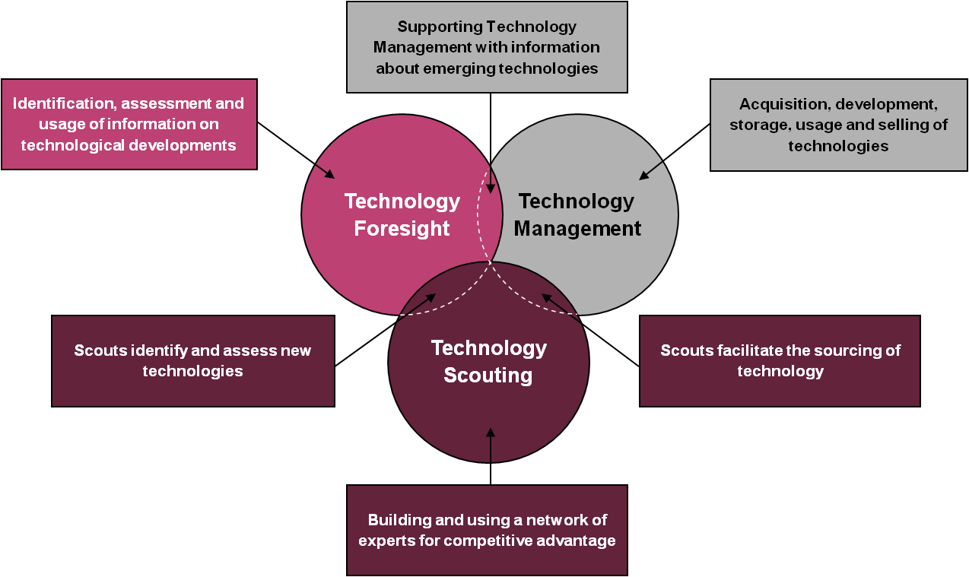
The assimilation and Fusion of Technology Lineages-Convergence
The earth connection of a technology leads to its maturity. However, the particular sort of numerous can be implemented for the application. According to the Schoemaker & Gunther, 2000, Creator and Editors Day; highlights that combination is the aftereffect of the meeting, “two particular advancements into a typical application field,” consequently, the collection creates a motion in call of new technology claim outline. However, combination involves interlock of two identical technologies that craves for innovation regarding both the technology mind kept end goal and creation of the entire new entry (Day, Schoemaker and Gunther, 2000).

The Technology Evaluation Procedure
In order to appear in a competitive business, it is fundamental for the company to retain knowledge improvement of the generational technology. Creation of the selected technology arrangement for an association leads to expansion of the benefits following the deepened age group and prosperity. Essentially, assessment and dissection is the best practice implemented in hunt of technical surveillance and distinguish. With particular end goal, the new technology results anticipation is also expected. The quick implication for the new technology with clarification of the way of the technology spearhead ability empowering the organization to rise ahead of the competitors as, "itself for more noteworthy financial return… and can yield transient point of interest over contenders," (Schoemaker& Gunther, 2000). The new technology evaluation procedure can be analyzed through a methodological four essential practice partitioning. The practices involve of the conferring, assessing, looking, and checking practices. Reading carefully as the fundamental application aspect, basically, it pertains spotlight elements characterizing the organization’s capacities and objectives and additionally pave the way to a broadened capability to read a compass; also, it creates a restriction concerning the company’s assets for the emerging new technology prospects (Sofia Empel, 2012). The chances and wellbeing of an association rely upon the discoveries and bearing inferred upon the looking aspect. The persuasion of the technology potential is perceived through the organization’s internal peer, space exchange, specialization, and open foundation. In regard to the opportunities, it grants the technology hopeful scrutiny or analysis condition. Lastly, the new technology mechanical development signs observation together with move making is a guaranteed role for any technology quest. Ultimately, it is then unavoidable for the issues of disappointment or achievement, yet "mechanical change is a progressing and basic procedure" (Schoemaker, & Gunther, 2000).
Learning and Information Confinement
Further, in the elaboration of the previous part regarding the effective way to raise technology into an organization, a consistent methodology is essential. Wherever there is a constant are headways and upgrades innovation, technology is vitally considered as a developmental instrument (Schoemaker, &Gunther, 2000).
Technologies Assessment
In the dissection of the systems evaluation, assessment of the potential technology emerges an attempt leading the controllers "to create technology arranges that rough the way to technology commercialization, required speculations, hierarchical ramifications, and possible money related prizes" (Schoemaker, & Gunther, 2000). To enforce that, Sofia Empel, 2012 highlights that every technology should portray instructions based records and information management (RIM) capabilities that are additionally widened and reliable goals.

The diagram below shows technologies assessments process.
Diagram 1.1
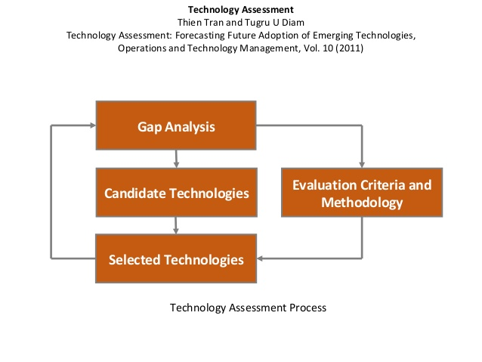
The Strategy Building Ability
The organization inference creates an environmental figure in regard to the previous experience, the current association position, and the anticipated development as well as competence (Schoemaker, & Gunther, 2000). The ability of technique creation focuses ending of issue solver as it similarly encourages tests and trials of the emerging development. The technique creation further approaches the unanticipated outcomes of the defenseless response and production of main methodologies paving the way through the previous victory and opportunity potential. The lessons learned are essential on methodology settling and improve replacement assessments that reflect as a development following the actual discipline effectiveness.
Taught Imagination
Technique creation depends on the main ideological ability of order and creativity (Day, Schoemaker and Gunther, 2000). The order revelation is through the standard acquisitions, ways of data and information arrangement, appraisal perspective, and the acquisition of the highest appraisal endorsement from the top ranking management (Doss, 2012).
Technology Difficulties
It is obligatory for the organizations to ideologically manage new thoughts during the start of the creative and control ability. Essentially, it further observes the previous association predicament practices bearing in mind the ending objectives on the advancement of the new technology (Schoemaker, & Gunther, 2000). Budgetary strategic action, previous errors, vulnerability, questions, and anxiety of ineffective improvement depicting "the reason that most firms stand deadened notwithstanding innovative change backs this viewpoint in their article Disruptive Pedagogies and Technologies in Universities, by affirming the thought of" system advancements and coming about social and financial development present interruptions to all associations" and "commercial ventures have been compelled to definitely re-engineer their procedures and items keeping in mind the end goal to survive" yet, after some time "an equivalent or better item is accessible at lower cost through utilization of the problematic technology."
Situation Development
During the troublesome development control occasion, organizations ought to thoroughly anticipate addressing the predicaments that are amid, the conceived process of emerging technology through the implementation of a portion of the condition arranging (Day, Schoemaker and Gunther, 2000). Situation arranging is a technique implemented in aid of changes outlook, multifaceted nature, and instabilities in the life road of the organization. In affirmation of that, according to Day, Schoemaker and Gunther, 2000 asserts; "situations recount an account of how different components may connect under an assortment of various suppositions."

References
Anderson, T., &McGreal, R. (2012). Disruptive Pedagogies and Technologies in
Universities. Educational Technology & Society, 15(4), 380-389.
Day, G. S., Schoemaker, P. J., & Gunther, R. E. (2004). Wharton on managing emerging
technologies. John Wiley & Sons.
Doss, K. (2012). Emerging technologies. American School & University, 84(11), 20-22.
Garrison, G., Kim, S., & Wakefield, R. L. (2012). Success factors for deploying cloud
computing. Communications of the ACM, 55(9), 62-68.
Sofia Empel CRM, C. D. I. A. (2012). Next Best Technology or Next RIM Headache? How to
Evaluate New Technologies for RIM Impact. Information Management, 46(6), 36.

