Test2 What to expect
You can/should use my written notes, our text book, graphing calculator (Desmos or TI-84) or Khan Academy. However, if you fail to provide details in your work that clearly leads to your final answer, then I may consider that as violation of PoH. Please upload the test on Google Drive as described below. Make sure to "Share" and "allow comment" to sc623@email.vccs.edu. As a plan B, IF nothing else works email your test to suchatt
On the top righ
Right click on your document and use the Share option
Expect no more than 8 problems from concepts covering 3.3, 4.1, 4.2, 4.3, 4.5, 4.6, 5.1. Every problem in the test will have at least one example somewhere on my class notes. So, study and use my notes.
You should know how to …
- Quadratic function section 3.3:
- from a graph of a quadratic find the standard and general forms like 3.3#52; solving application problems like 3.3#93
- 4.1: from description or graph find the polynomial like Q#4 on Quiz 1 or 4.1#56; behavior at end-points and at zero;
- 4.2, 4.3: - Given all zeros find the polynomial; given some zeros find the polynomial, given the polynomial find all complex zeros. "May 28 4.2,4.3 notes" and "June 2 notes" 4.3p1, 4.3p2, Try this
- 4.5: Any one of these two types: follow steps to sketch neat labeled graphs of rational functions (either n = m+1 or n = m); An application problems like 4.5#62 or #58.
- 4.6: Solve a polynomial or rational inequality following detailed steps ("testing" with signs important)
- 5.1: -Given several functions find the composition of functions and write the domain.
- Given graphs of functions or a table, find values of composition of functions "June 4" notes
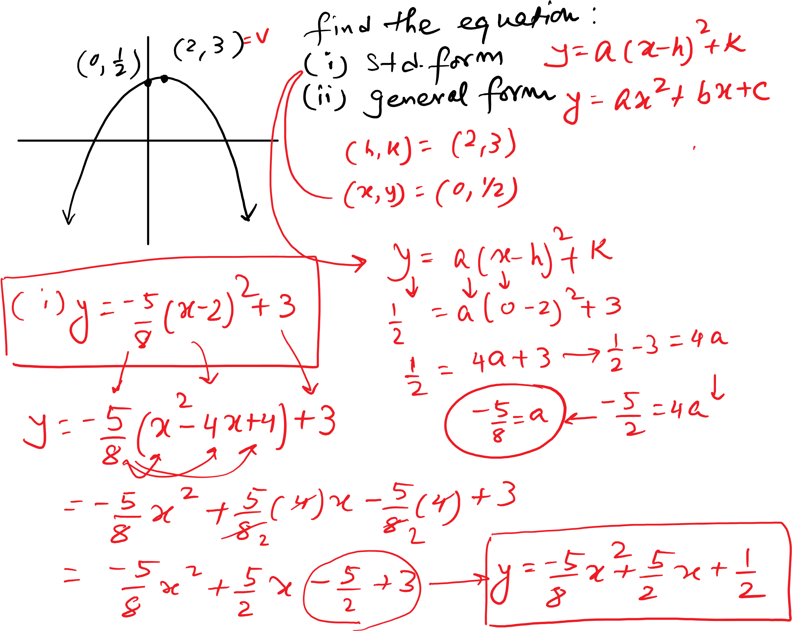
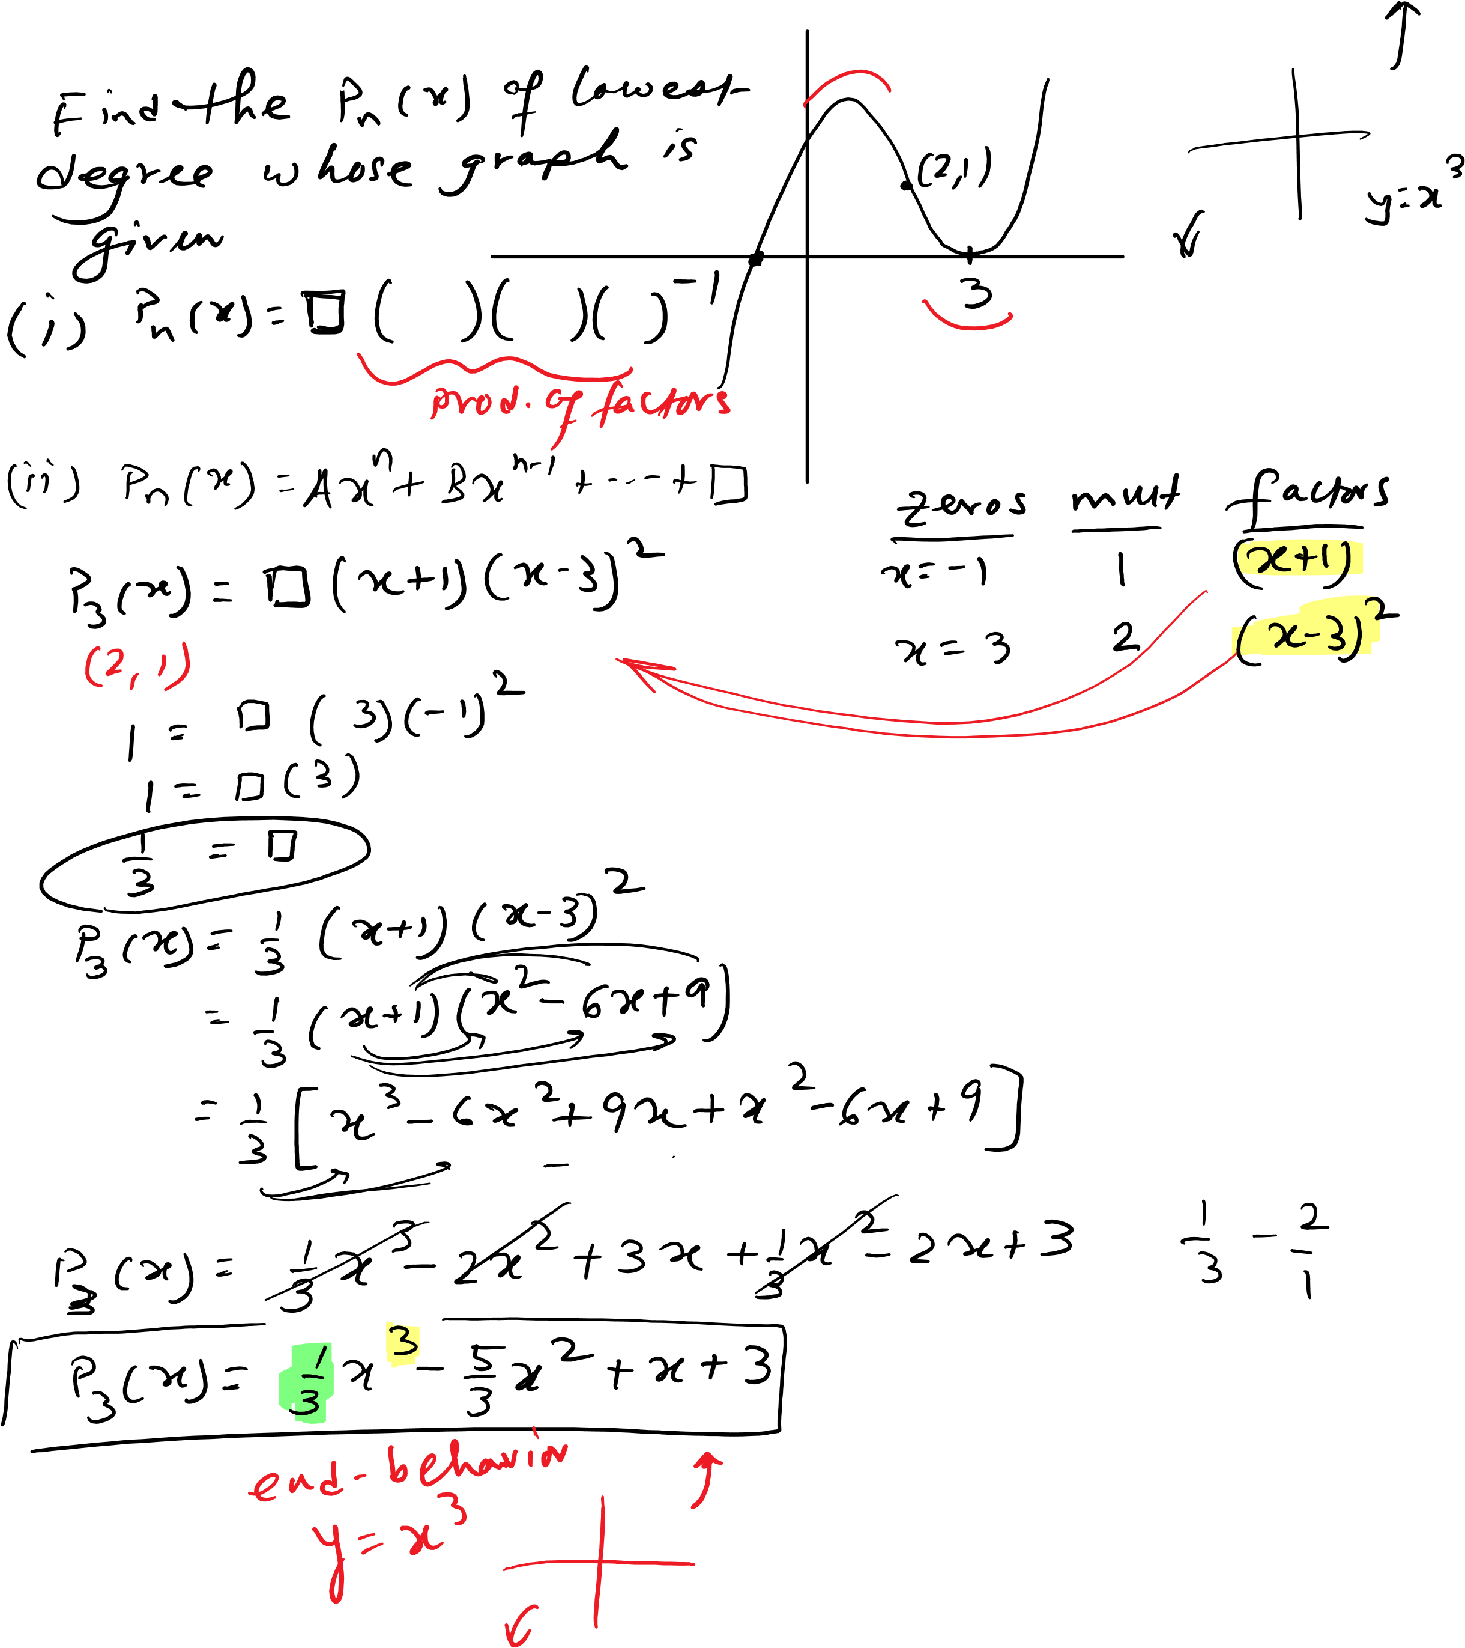

Test2Prep Page 5
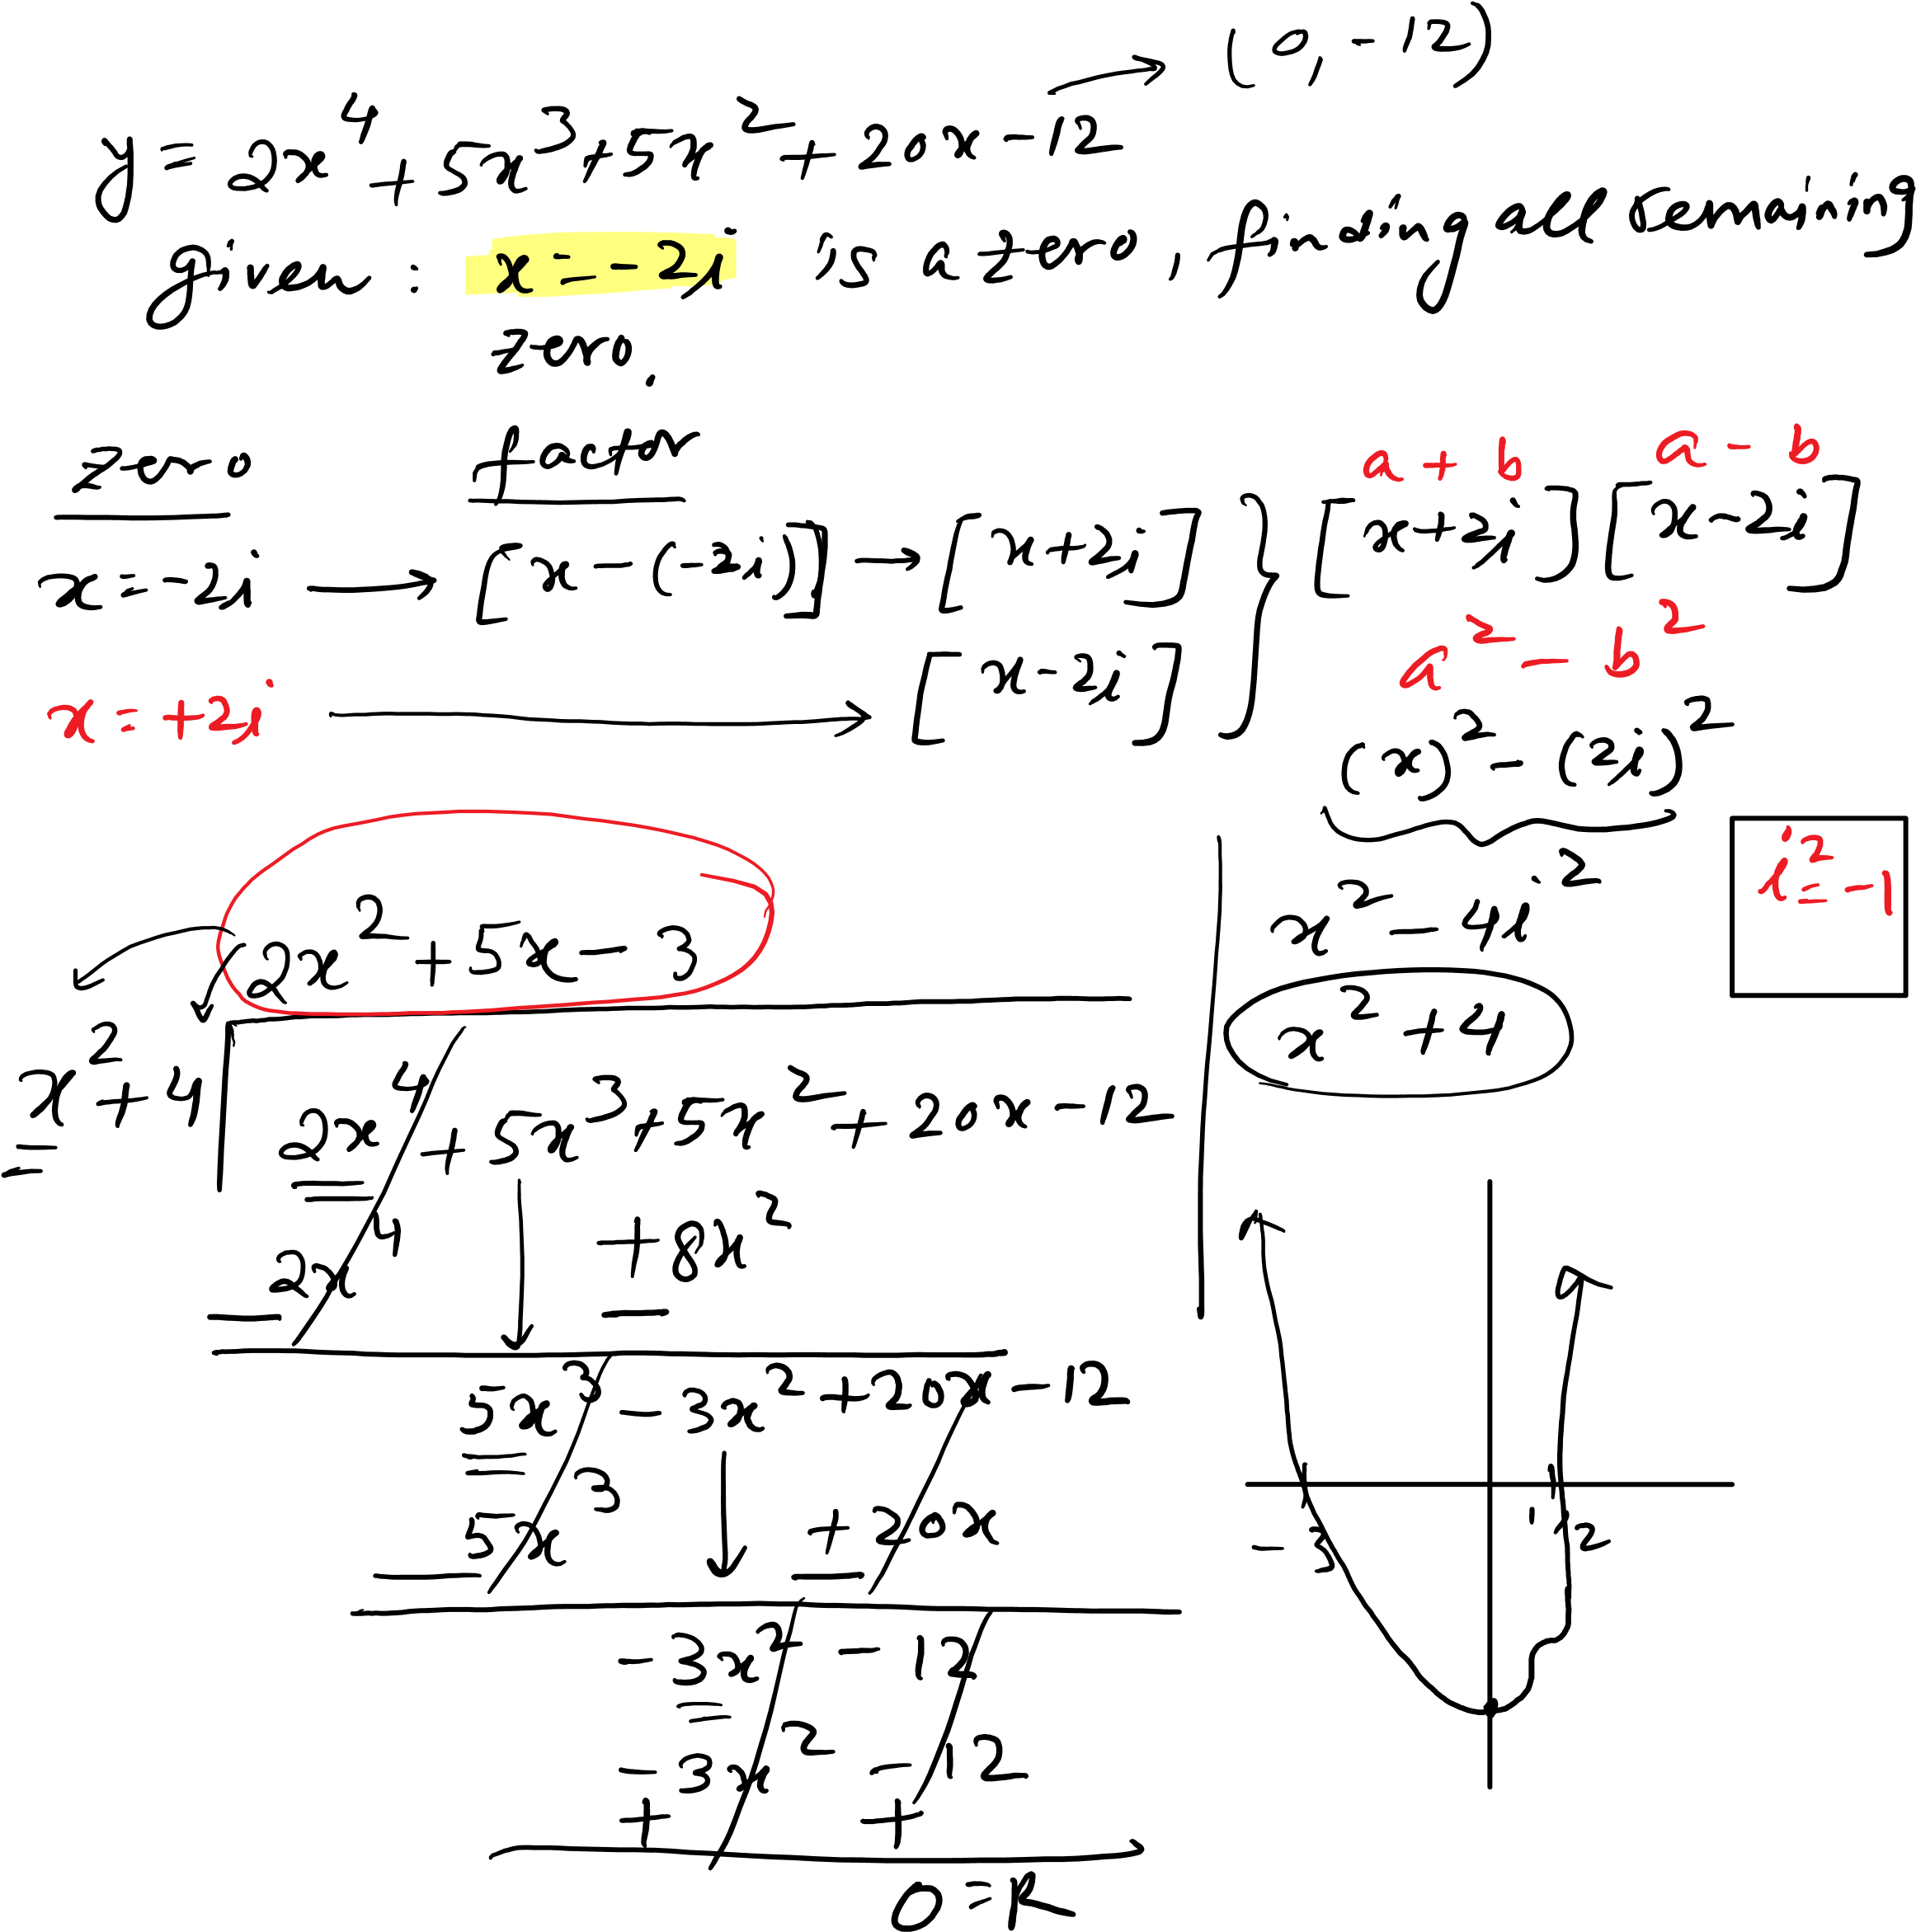

Test2Prep Page 6
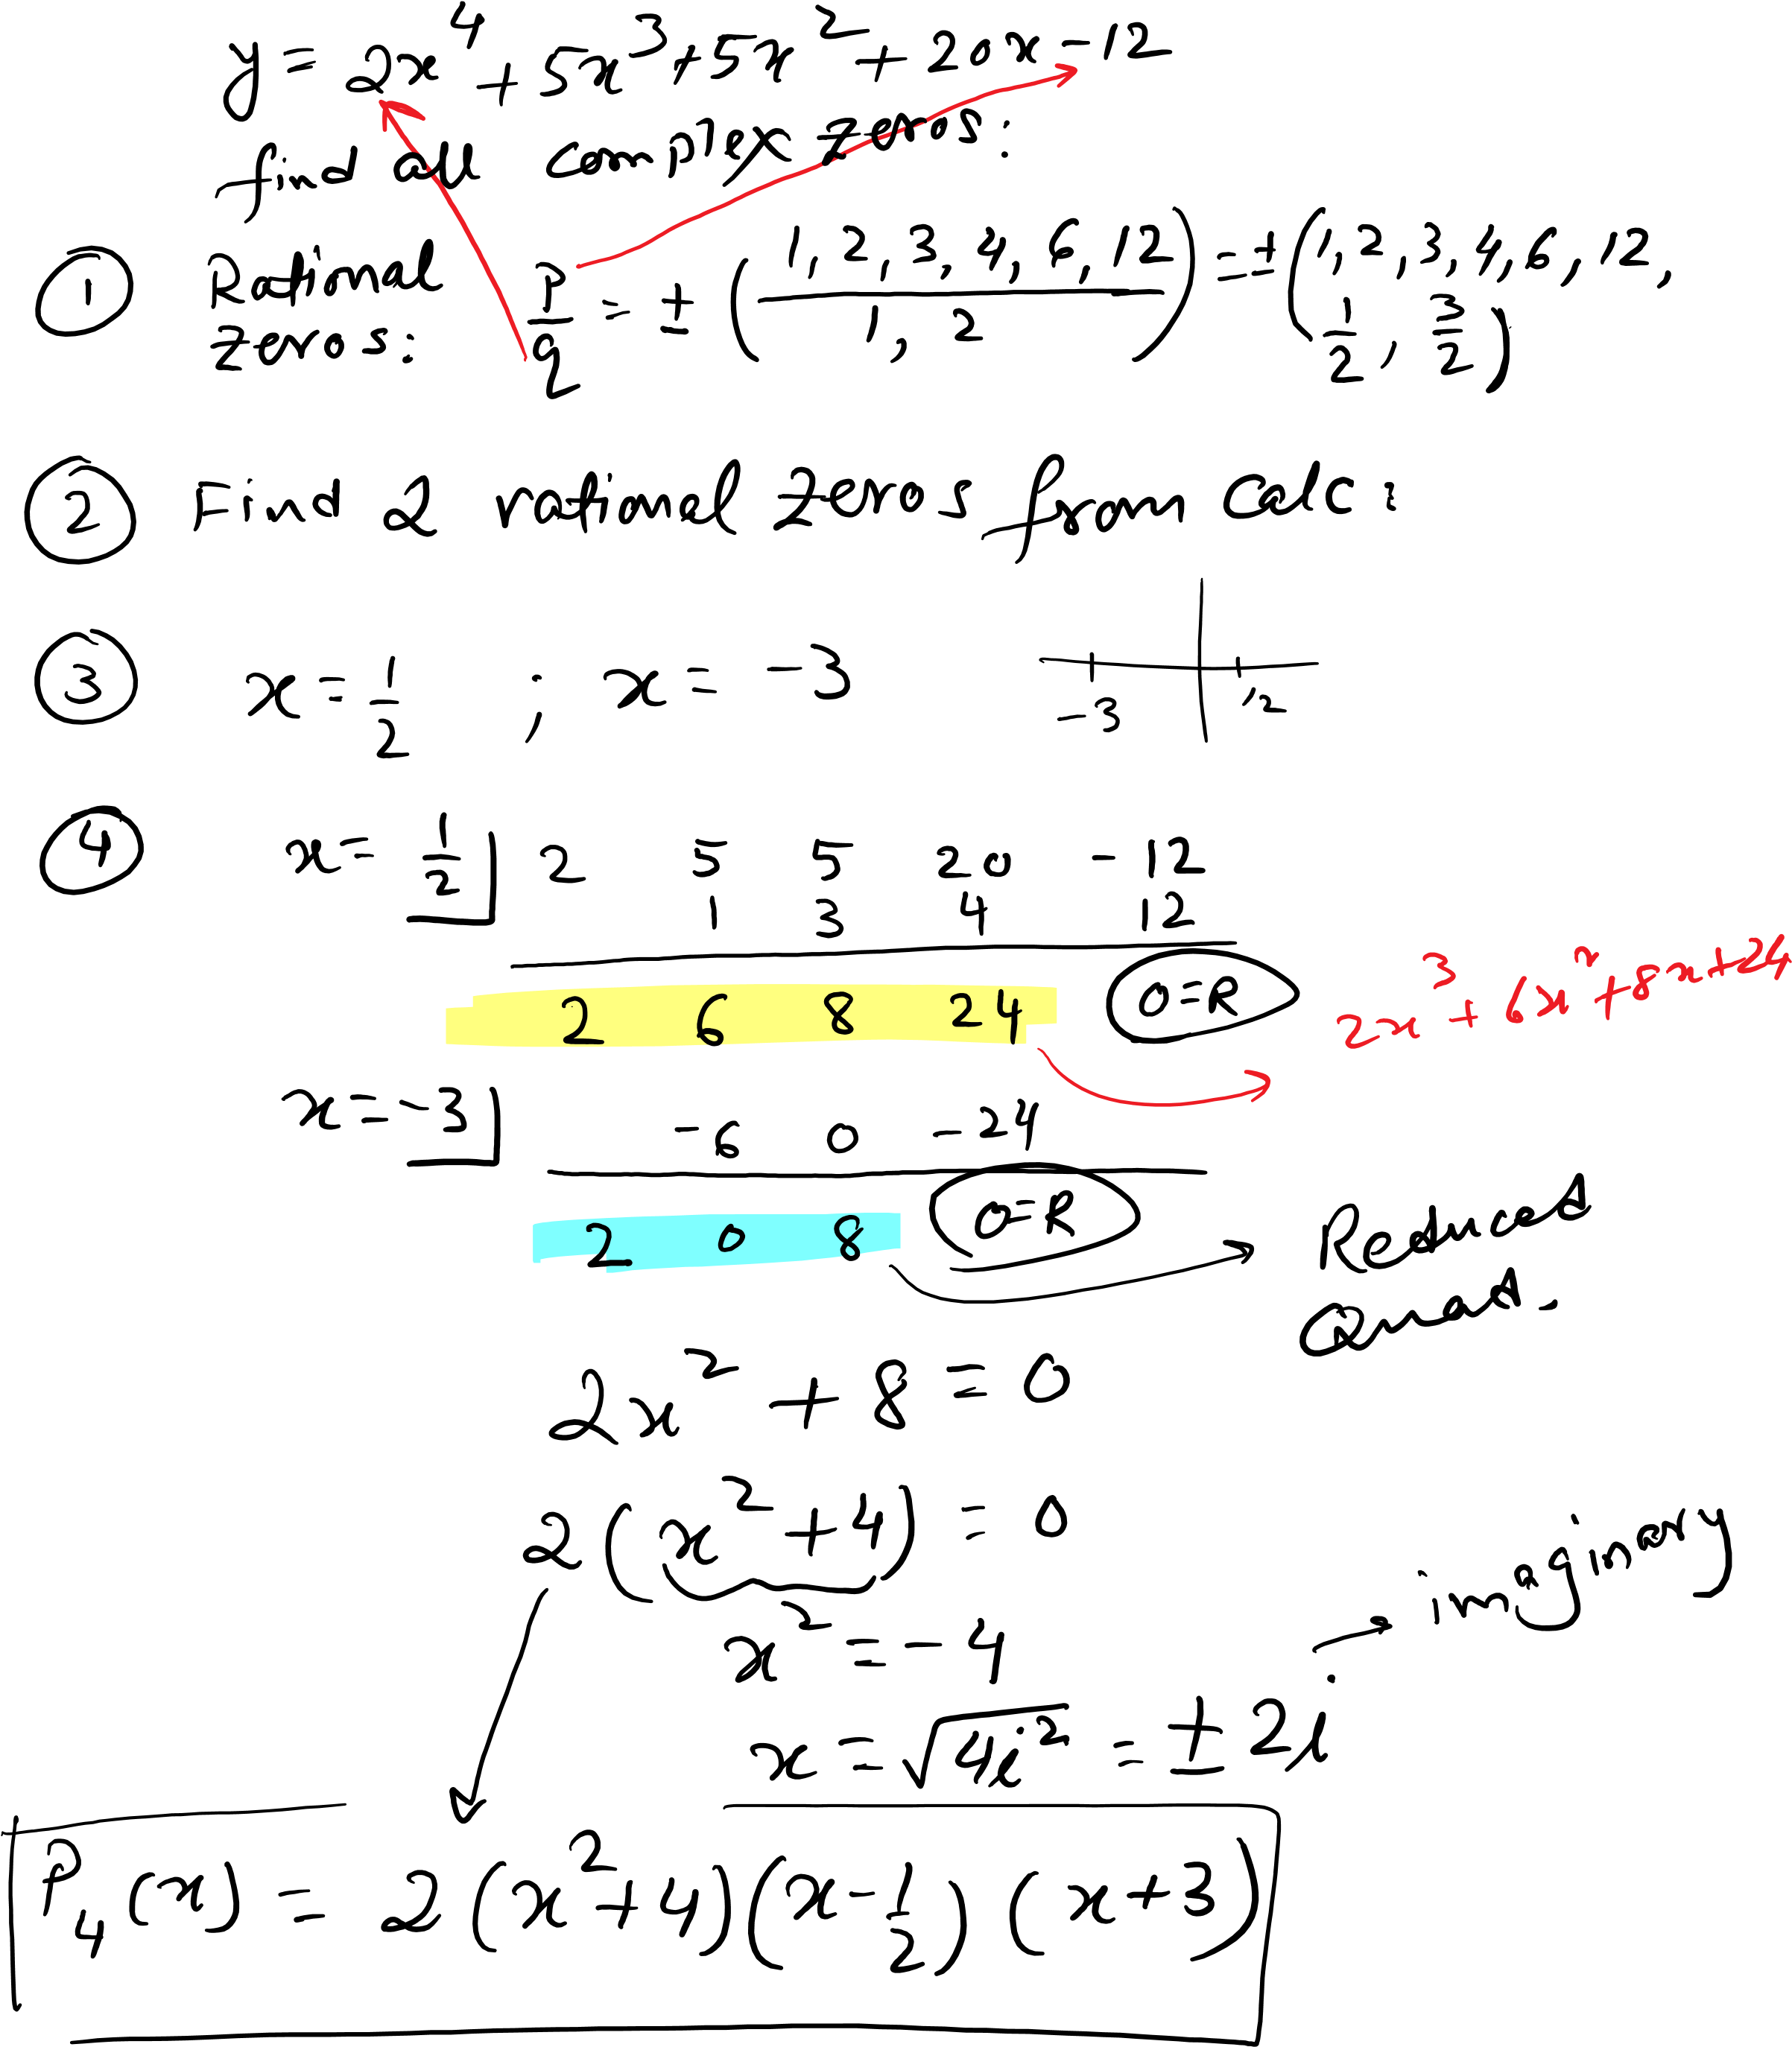

5.1
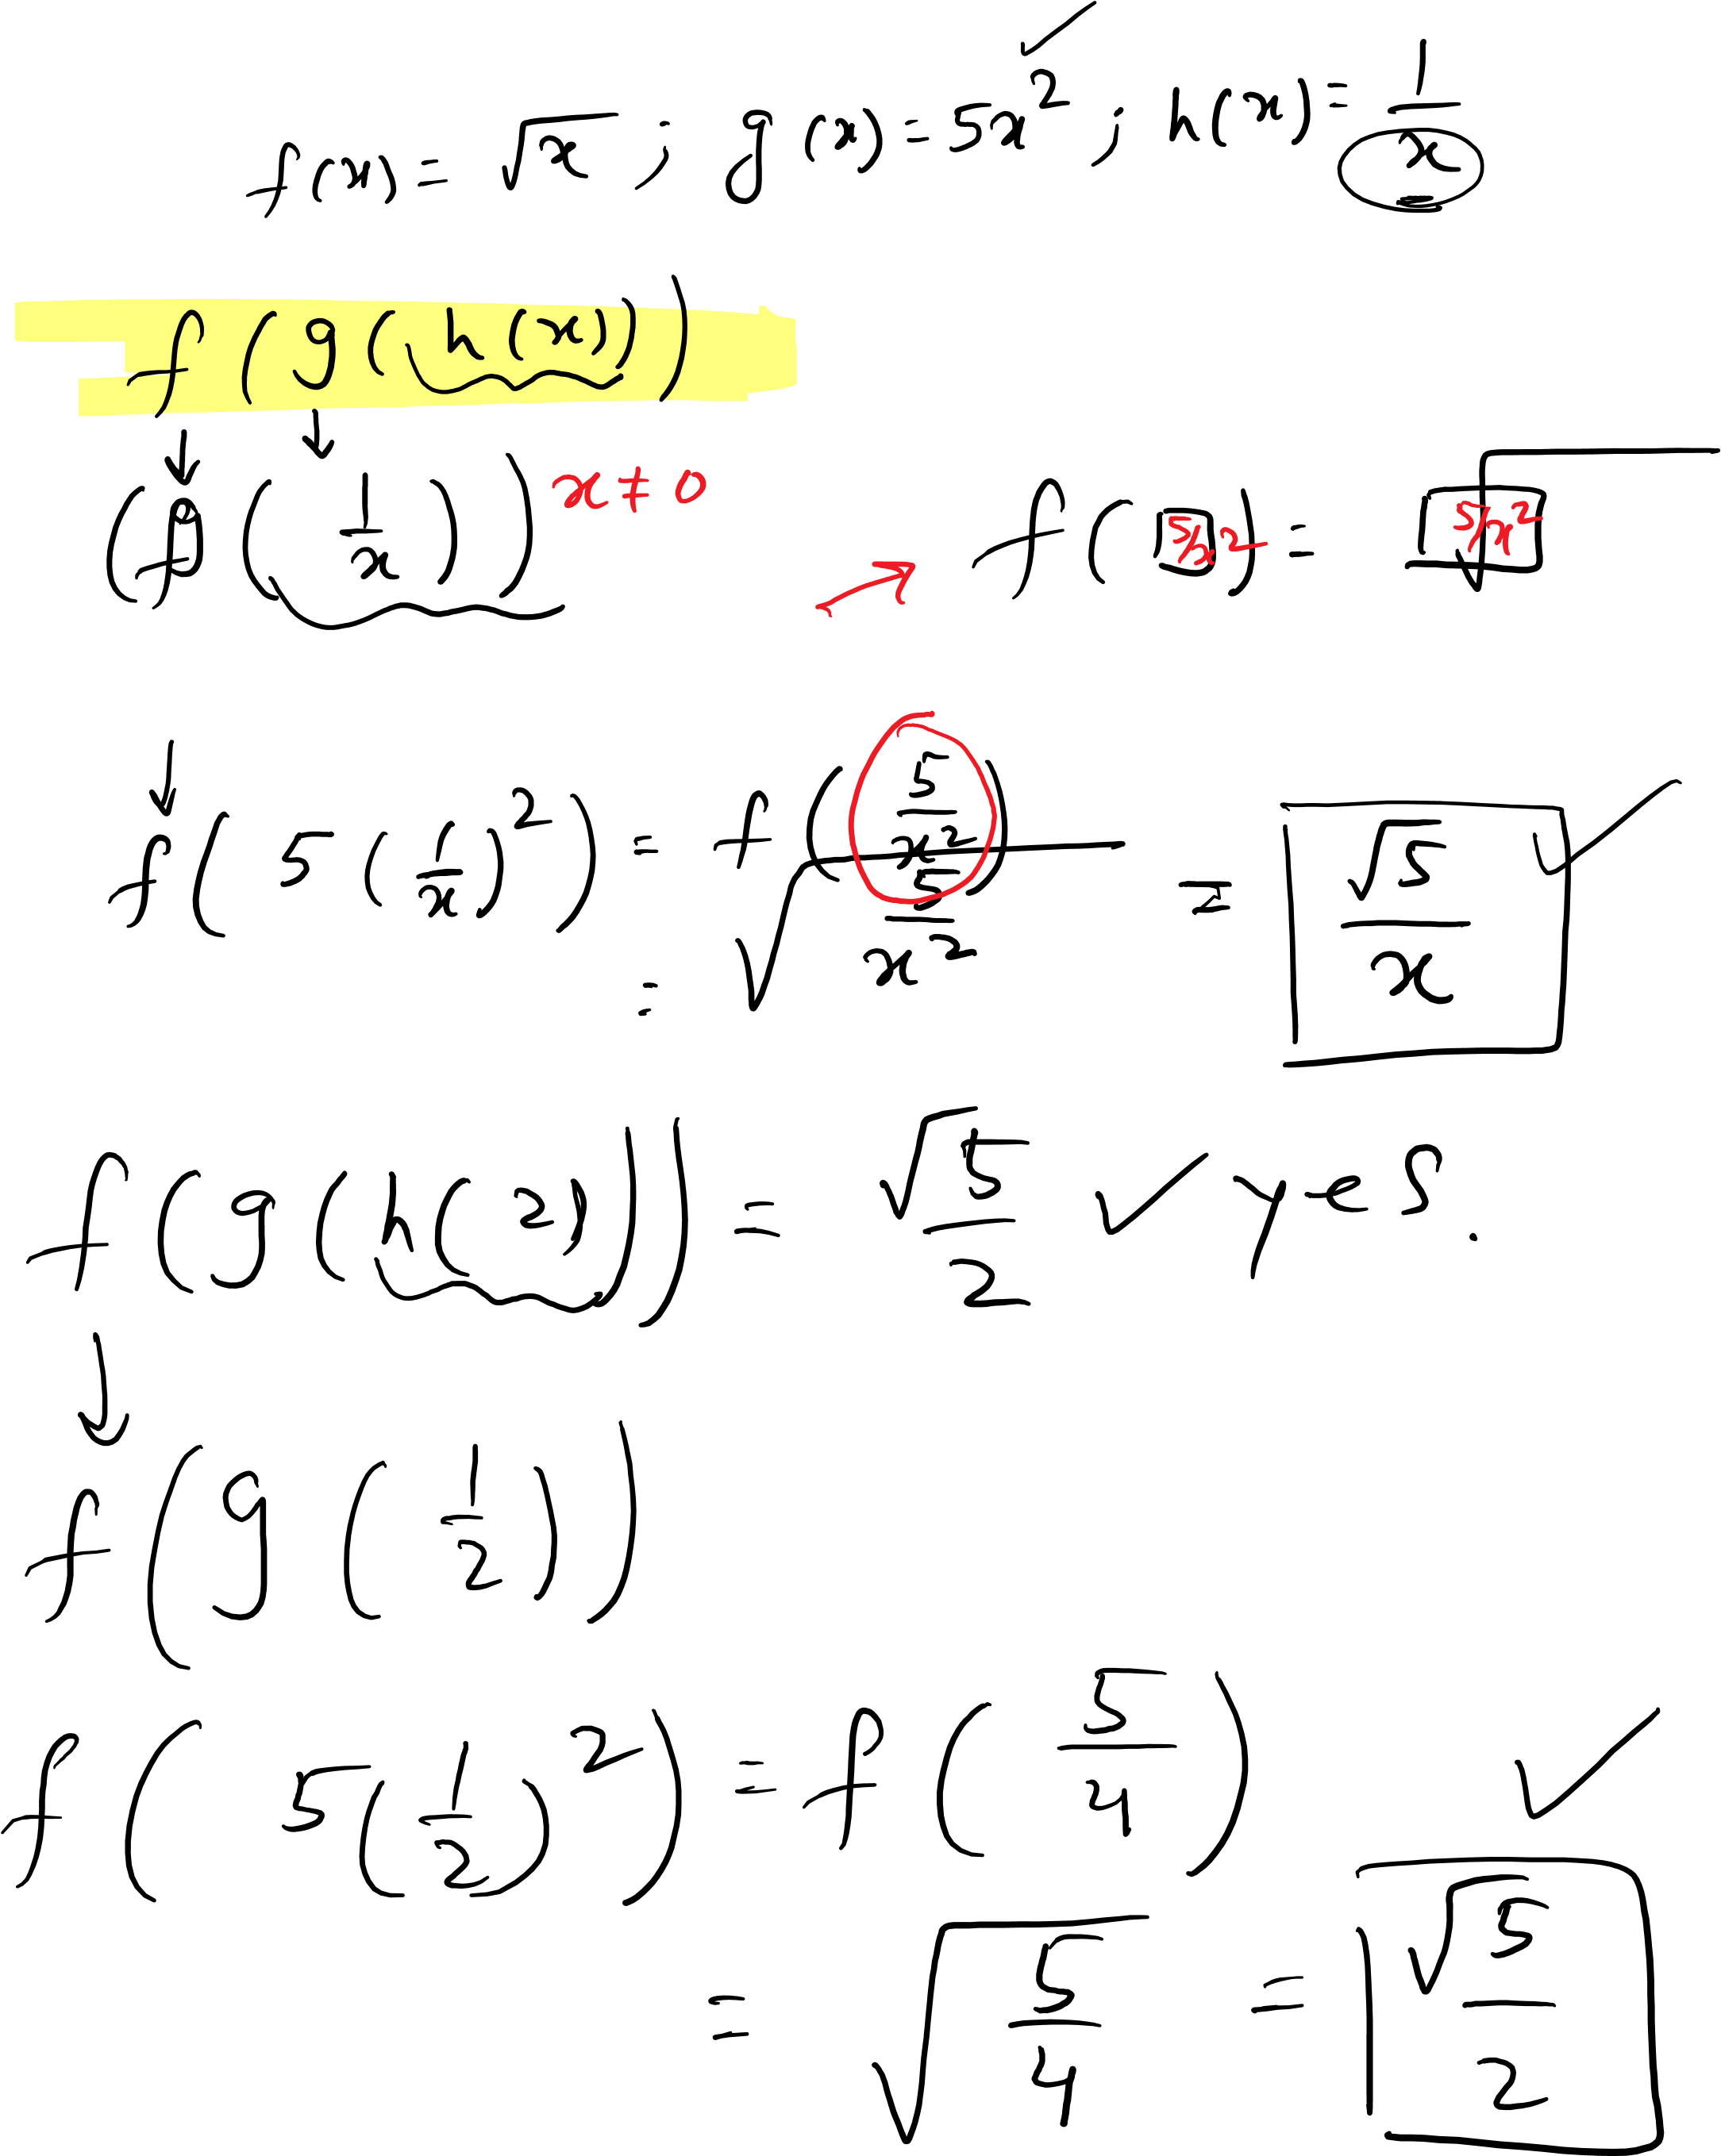

5.1 composition

