- (24%) We use a processor with CPIs for the following classes of instructions to execute the given C-code. For array B[N], 20% of its elements are NOT zeros. For array C[N], 30% of its elements are NOT zeros. For the execution of each IF statement, 1 branch instruction is execution, regardless of the branch condition. Every array reference needs a load or store instruction. Answer in the table 1) the number of instructions to be executed for each of the classes, 2) the total number of cycles used for executing each class’s instructions, 3) the percentage of total cycles by each class with respect to the overall total cycles. Also answer after the table 4) the overall total number of instructions of all classes that are executed, 5) the overall total cycles spent for all classes, and 6) average CPI (cycles per instruction in average). Addition used for calculating memory effective address for load and store instructions should NOT be considered. But loop count increment is considered as addition.

Instruction class | CPI
add | 5.6
load/store | 20
branch | 4

int N = 1000;
int A[N], B[N], C[N]
int i;
for (i=0; i < N; i++) {
A[i] += 3.14;

if (B[i] != 0) A[i] += B[i];

if (C[i] != 0) A[i] += C[i];
}

Instruction class | CPI | # instructions x10³ | # Cycles x10³ | Cycles Percentage
Add/sub | 5.6
load/store | 20
branch | 4

4) Overall Total instructions =
5) Overall Total cycles =
6) Average CPI =

- (10%) The following diagram shows the data path and control signals of a standard 5-stage CPU design for load, store, and arithmetic/logic instructions. We will introduce a memory access instruction called exchange, which is in the form of “exchange RS2, #imm(RS1)”. The instruction exchanges the value in register RS2 with the value in memory address #imm2 + Reg[RS1]. If you implement the instruction using the provided CPU in the diagram, highlight the data path used for the exchange instruction. Hint: considering the exchange operation does load and then store. To draw from MS Word, using the draw feature of the Word application, see below screen shot of the menu: 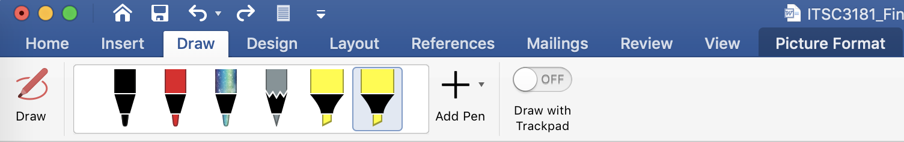

- (36%) Given the following CPU diagram that you use for your Homework 4, you are asked in the same way as the question 2 of HW4. Given instructions to be executed on the CPU, fill in a table with values for selected datapath for each instruction when being executed on CPU.

Your answer should be in the given table. Instructions are independently executed, i.e. instruction will not change register or memory after being executed. Datapath whose values are not used for the instruction can be marked X, even if they may have valid values. Branch target address is calculated by PC + #label * 2

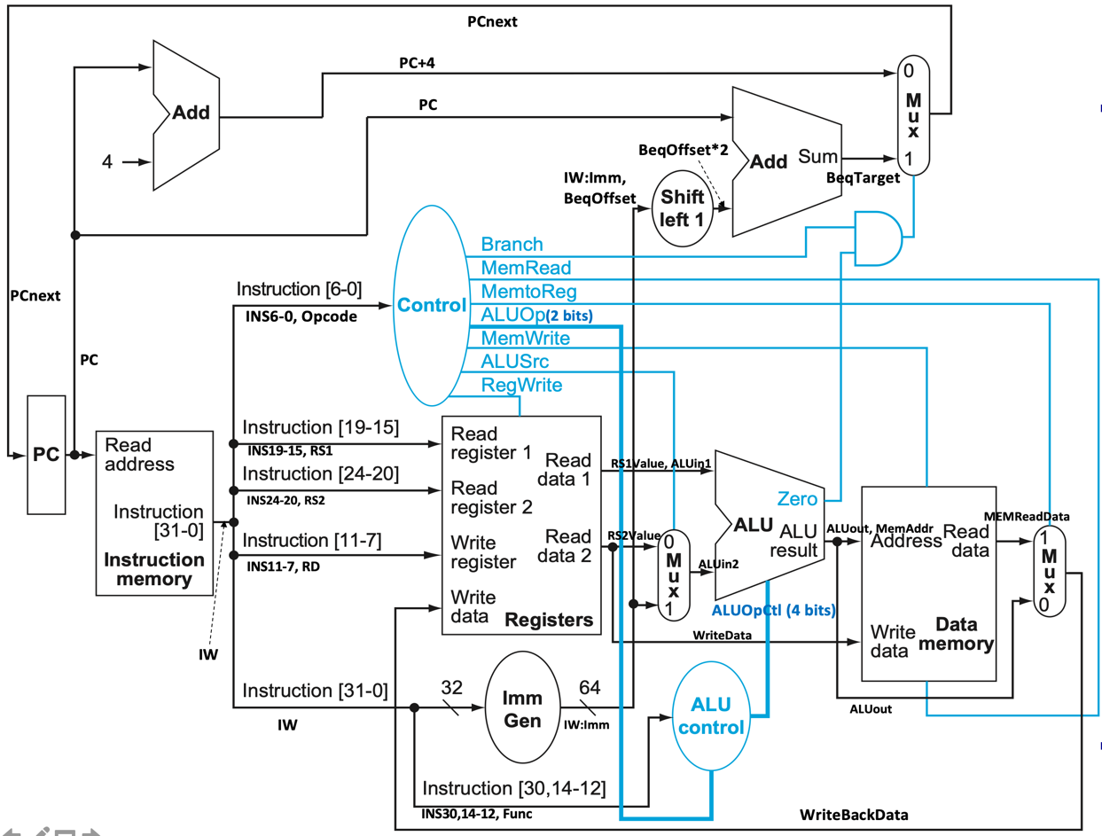
Register # | value
0 | 0
1 | 12
2 | 10
3 | 16
4 | 18
5 | 22
6 | 8
7 | 64
8 | 18

Memory Address | value
16 | 20
20 | 24
24 | 26
30 | 32
34 | 48
38 | 72

Instr Address |  | INS19-15, RS1 | INS24-20, RS2 | INS11-7, RD | RS1Value, ALUin1 | RS2Value | ALUin2 | ALUout | MEMReadData | WriteBackData | PCnext
4 | add x3, x2, x1 | 2 | 1 | 3 | 10 | 12 | 12 | 24 | X | 24 | 8
16 | sub x2, x2, x5
22 | addi x3, x1, 16
28 | lw x6, 16(x4)
32 | sw x4, 14(x2)
40 | bne x3, x1, 16
56 | beq x4, x8, 8

- (30%) Pipeline execution and RAW (Read-After-Write) data hazard. For the following RISC-V style instruction sequence,

addi x1, x0, 4
lw x2, 0(x1)
add x3, x2, x1
lw x4, 4(x3)
add x5, x4, x10
lw x6, 4(x1)
add x7, x1, x6

- Fill in the following table about RAW dependency between two consecutive instructions and also mark those RAW dependencies that are load-use.
Instruction that writes the register | Instruction that reads the register | The register
addi x1, x0, 4 | lw x2, 0(x1) | X1

- Draw the 5-stage pipeline execution using stage labels (IF, ID, EX, ME, and WB). CPU has no any forwarding, register files can be read/written in the same cycle, and instruction memory and data memory are separated. Use X to indicate a stalled cycle.
- Draw the 5-stage pipeline execution using stage labels on the same CPU but with fully forwarding.
- For the CPU with fully data forwarding, rearrange instructions to eliminate the stall(s) from load-use hazard and then draw the 5-stage pipeline execution of the rearranged instruction sequence.

 | Cycles
b) No Forwarding | 1 | 2 | 3 | 4 | 5 | 6 | 7 | 8 | 9 | 10 | 11 | 12 | 13 | 14 | 15 | 16 | 17 | 18 | 19 | 20 | 21 | 22
addi x1, x0, 4
lw x2, 0(x1)
add x3, x2, x1
lw x4, 4(x3)
add x5, x4, x10
lw x6, 4(x1)
add x7, x1, x6
c) Full Forwarding
addi x1, x0, 4
lw x2, 0(x1)
add x3, x2, x1
lw x4, 4(x3)
add x5, x4, x10
lw x6, 4(x1)
add x7, x1, x6
d) Rescheduling

