The Old Guitarist
Name of Student
Institutional Affiliation
Date

The Old Guitarist, 1903 by Pablo Picasso
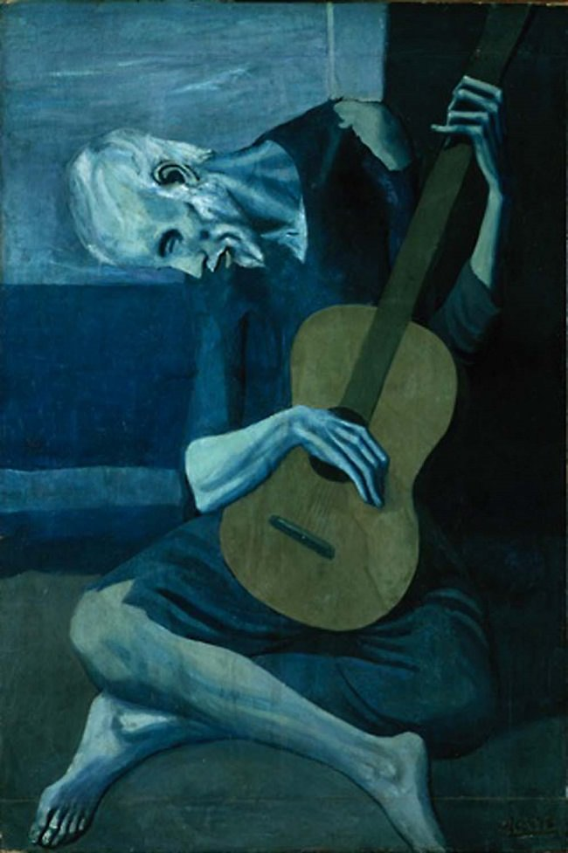
Pablo Picasso is among the greatest artists of the 20th century, and he was a Spanish printmaker, sculpture, and most importantly a painter. His father was Don Jose Ruiz Blasco, and he was also a painter, and a teacher of art. Picasso who was born in 1881 displayed a great talent for drawing at a very young age probably influenced by his father. (Fatović-Ferenčić, 2016) Picasso to this day remains known for endlessly reinventing himself by switching through different styles that were very diverse. Historians, as well as art critics, divided Picasso’s adult career into different distinct periods.
The blue period only lasted from 1901 to 1904, and during this time most of his paintings were mostly dominated by the color blue, and it is during this time that he completed his famous painting The Old Guitarist. (Defeyt, 2018) It was painted just after the death of one of Picasso’s close friends, Carles Casagemas and during this time the artist was living in poverty after being almost penniless in 1902 hence he was sympathetic to the plight of the downtrodden. It was the death of his dear friend that acted as a catalyst to make Picasso start painting blue.
The painting was created using a distorted style as can be seen in the way the upper torso of the guitarist seems to be reclining while the bottom half, on the other hand, is sitting cross-legged. The old guitarist was presented by Pablo as a timeless expression of the human suffering, and it represents the emotional turmoil and poverty that Picasso experienced during his ‘Blue period.’ (Ravin, 2015) Everything in the painting is blue except for the guitar, which could mean that Picasso viewed his own art as a ray of hope even in his darkest of moments. The painting is related directly to the artist El Greco, as it is reminiscent of his works and Picasso, is known to have been fond of the artist.
The painting had inspired poetry as witnessed by the lengthy poem ‘the man with the blue guitar’ which was written by American modernist Wallace Stevens and despite the seemingly evident link between the poem and Picasso’s painting, Wallace claimed to have not had the painting in mind when he created the poem. The painting has to it a gut-wrenching misery with only the guitar acting as a ray of hope to the older man.

The Blind guitarist
I see him in the streets beaten down by life
Like a rose trampled on the ground
He goes unnoticed
His guitar like hope enables him to see a better tomorrow
A tomorrow without poverty or blindness
I look at him, the blind guitarist
And a thousand words fill my mind
Words depicting misery, illness, poverty
And just like a picture, he paints a thousand words
He has seen the darkest of moments
Clinging to his only friend; the guitar
He plays his misery away
And for a moment forgets he is blind
The little things in life that mean the most
His guitar.
What is worse than loneliness- than blindness?
The blind guitarist has led his life
He has endured it all
He is glorious
Not hideous
For with age comes inner sight
And in his sorry state, he sees what many men do not see
The sad reality of life.

Reference
Defeyt, C., Walter, P., Rousselière, H., Vandenabeele, P., Vekemans, B., Samain, L., & Strivay, D. (2018). New Insights on Picasso’s Blue Period Painting La famille Soler. Studies in Conservation, 63(1), 24-35.
Fatović-Ferenčić, S., Kardum, D., & Kardum, Ž. (2016). Pablo Picasso’s sfumato. Arhiv za higijenu rada i toksikologiju, 67(1), 67-68.
Ravin, J. G., & Perkins, J. (2015). Representations of blindness in Picasso's Blue Period. Archives of Ophthalmology, 122(4), 636-639.

