Thermochemistry Lab
Written by: Nancy Manikas, 2017

Part 1 The Basics: Change of State
Label change of state diagram below.
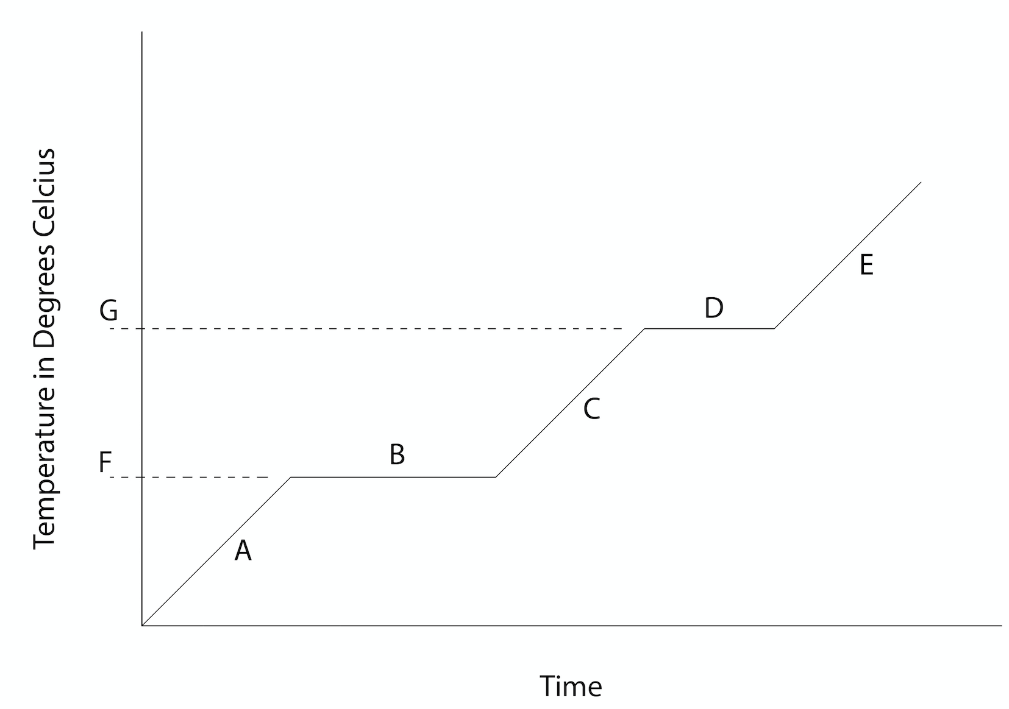
A: ________________________

B: ________________________

C: ________________________

D: ________________________

E: ________________________

F: ________________________

G: ________________________

Part 2 Change of State Lab

- Place 2 cups of water (measure it!) into a small cooking pot. Take the starting temperature. Place in the data table (see next page).
- Turn on one burner of the stove to a medium setting. If using an electric stove, you will need to let it heat up for a little bit before starting the experiment.
- Place the pot of water on the stove, and start your timer. Leave the thermometer in the pot with the water. Hold it so that the tip of the thermometer is in the middle of the water, not resting on the bottom. Stir the water frequently as it heats. Record the temperature every minute until it reaches boiling. You may need to add rows to the data table if there are not enough provided. Continue to boil for 4 minutes, taking the temperature each minute. BE CAREFUL! The steam can burn you even worse than the boiling water.
- Keep the boiling water for part 3 of this lab. You may want to do the graphing later and jump down to do the part 3 procedure while you have boiling water. If the water is running low, add more and get it to boiling temperature. Do not let the pot run dry.

Part 2 Data Table
Time (minutes) | Temperature
0
1
2
3
4
5
6
7
8
9
10
11
12
13
14
15

Part 2 Analysis and Questions:
- Graph the data from the chart above on the graph below, or insert a photo of your graph of your data here.



Time (minutes)
- What seems to happen to the temperature as the water boils? Does this agree with your graph you labelled in the introduction at the beginning of this lab?

- Calculate how much energy (in Joules) it took to heat the cool water up to the point at which it started to boil.
  - Remember, while we say waters boils at 100ºC, that is only at sea level, so your water will probably boil at a lower temperature. Don’t think your thermometer is wrong if your water is boiling at 97ºC. It depends on your elevation and the weather on the day you are doing the experiment (high or low pressure system in place).
  - Two cups of water have a mass of 473.18g, and the specific heat of water is 4.184 J/gºC. If your thermometer measured in Fahrenheit or Kelvin, be sure to convert to Celsius. Show your work.

- Once you have your 473.18g of water up to the boiling temperature, how much energy (in Joules) would it take to completely convert all the water into steam? Do NOT do this, just do the calculation! The heat of vaporization of water is 2260 J/g. Show your work.

Part 3 Transfer of Heat Lab
Materials Required: Thermometer, boiling water from part 2, 10 pennies (or other copper currency), scale or balance, tweezers or tongs to fish pennies out of boiling water.
- Record the temperature of the boiling water. Remove the thermometer from the boiling water and let it cool down. Keep the water boiling. If the volume is very small, add more water and get it up to boiling again.
- Get 10 pennies (or other copper currency) and weigh them all together, and record the mass.
- Get a SMALL amount of cool tap water in a separate cup. You need enough to cover the pennies, but not much more. Record the mass of the cup empty, the mass of the cup with water, and subtract to get the mass of the cool water.
- Place all 10 pennies into the boiling water and boil for one minute.
- Place the cup of cool water into a ceramic mug or something sturdy so that it won’t tip over, and put in thermometer. Record the temperature of the cool water; this is the beginning temp of the water. Keep the thermometer in this water until the end of the experiment.
- Begin transferring pennies from the boiling water to the cup of cool water. Be as efficient as possible; try not to lose time between the boiling water and cool water. If you drop one during the transfer, put it back in the boiling water to heat up again and transfer the other pennies first. This works better with lab partner – one person to stir the cool cup of water and watch the temperature after adding each new penny, the other to do the transfer.
- After all 10 pennies are in the cool water cup, keep stirring and watching the temperature until it reaches its maximum. Record the highest temperature reached. This is the final temperature of both the water and the pennies; final temperature of the system.
Part 3 Data Table

Temperature of Boiling Water (Celsius)
(Metal Starting Temperature)
Mass of 10 pennies (grams)

Mass of cup + cool water (g)

Mass of empty cup (g)

Mass of cool water (g)

Temperature of Cool Water (Celsius)
(Water Starting Temperature)
Maximum temperature reached in cool water cup (Celsius)
(Final temperature of the System)
Specific Heat of Water | 4.184 J/gºC

Part 3 Analysis and Questions (show your work):
- Calculate the amount of heat the cool water gained as it was heated by the pennies.

- This is the same as the amount of energy the pennies lost. Therefore, calculate the experimental value of specific heat for your pennies.
- The specific heat for copper is 0.385J/gºC. Why is your penny value not equal to this number? If this question confuses you, go to the next question and come back to this one.

- Take a piece of sand paper or a nail file (emery board) and scratch off a little of the copper on the side of the penny*. What do you see? Use the internet to find out what metal this is. Look up its specific heat. _______. Is this closer to your value?

*If you are not using US currency, you may have to research this part online. If you are using US currency, be sure your penny is newer than 1982.

Note: if your answer to #2 above is VERY different from what #3 and #4 suggest it should be, check your conversions and calculations!

