Design with UML

Name
Affiliations
Instructor
Date

………. Page break ...…….

Question 1: Introduction
UML is a Unified Language Modeling acronym. UML is basically a modern method of modeling and reporting programming. Currently, it is one of the most popular approaches of business process modeling.
It focuses on diagrammatic representations of the computer component. "There are thousands of words worth a picture," as the old proverb suggests. By using visual pictures, we understand possible flaws or defects in program or business processes.
A 1,000-word image, this language perfectly suits the UML definition. Object-oriented principles have been implemented far before UML. There were no standard methodologies at the time to coordinate and consolidate object-oriented growth. It was then that UML was photographed.
There are different UML goals, but the most relevant is to define a general modeling language that can be used by all modelers and it must be simple to understand and use.
UML diagrams are intended for creators as well as enterprise customers, everyday citizens and anybody involved in learning the framework. The system may be a non-machine framework or software. It must also be explicit that UML is not a creation tool nor accompanies procedures for making it a good framework.

To conclude, UML can be described as a simple modeling framework for modeling all functional structures in today's complex world.

Question 2: Classes in structure model
Structural diagrams display the modeled machine material. In a more scientific word, various artifacts are displayed in a device.
- Class Diagram
The core building block of every object-orientated solution is class diagrams. It displays the classes in each class and the interaction between each class in a scheme.
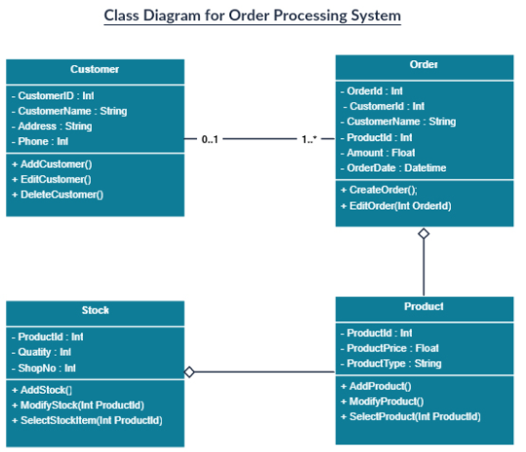
- Component Diagram
A component diagram illustrates the hierarchical interaction between information device elements. These are primarily found in dynamic structures with multiple components. Components interact by interfaces with each other. Connectors link the interfaces. The picture below shows a diagram of the component.
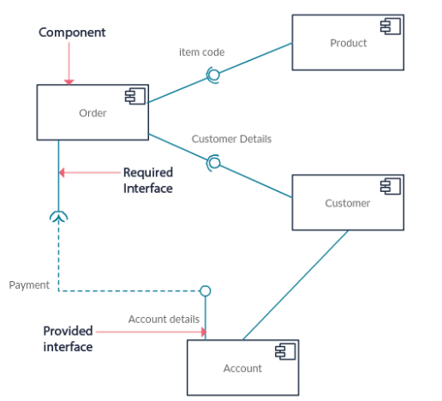
- Deployment Diagram
A deployment diagram displays the hardware and software of your device. When the tech solution is used on many devices and each one has a special setup, implementation diagrams are helpful. This is an example diagram for implementation.
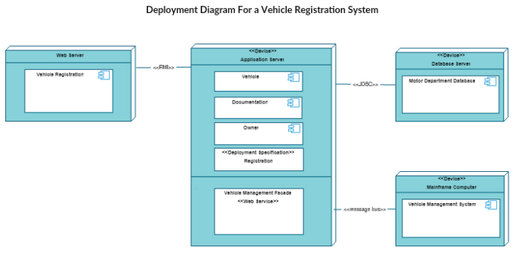

- Object Diagram
Object diagrams are somewhat close to class diagrams, often referred to as instance diagrams. They often demonstrate connections between things, including class diagrams, but use real-world examples.

Question 4: Steps of Design Modelling with UML and validation walk through the package diagram (Activity Class picked for explanation purposes)
Stage 1: Identify the mechanism
First of all, we must select a particular method. Let's assume that we want to plan out the car recruiting process.

Stage 2: Actor Recognition
There are three players in this case: the buyer, the distribution office and the recruit office.
Stage 3: List all activities/tasks needed
Create a summary of all actions / projects that must be done to obtain the intended result at the conclusion of the process. This can as well be accomplished while you work on the model, but preferably list it in advance as you can find ways to ease the method.
Stage 4: Call the start node and position it in the diagram's top left corner.
The starting node must be called and located at the upper left corner of the model.
Stage 5: Insert operation first
After the first actor begins the process, what is the first role or action to complete? For our case, the mission is checking availability and the sales desk is to be completed.
Stage 6: Start connecting activities with connector arrows, position forks and link nodes if required
The model continues to take form here. Place an arrow connector between activities. Insert a fork node that enables operations to be separated along multiple directions. Please insert a node when two or more routes cross in the same path.
Stage 7: Combine decisions and, if possible, merge symbols
After the operation such as check availability, a determination has to be taken as a car may or may not be available. The method can adjust based on the outcome
Stage 8: Incorporate inbound/outbound symbols, where applicable
These symbols are often called transmitting and receiving symbols. Add an outgoing sign in which an operation produces an occurrence where the effect is beyond the diagram's reach. In the case of our example, an excellent sign named "Stock Manager notify" is generated if a car is inaccessible, since it is an operation to be carried out but the manner in which it is done is unrelated to the method of hiring vehicles.
An incoming symbol can be added anytime an occurrence arrives from another method that is beyond the framework of the diagram.
Stage 9: Apply annotations if necessary
Conservatively, annotations should be included. In an effort to explain operations, it might be tenting to attach a series of annotations, however these may trigger uncertainty and establish a messy scheme. Only add them to reflect sensitive knowledge
Stage 10: Ensure sure the end operation finishes the loop and link it to the end node
Check the final operation to confirm the phase is completed and apply a connector arrow to the end node. All done! All done! This is the time to check the diagram to make sure no steps have been taken.

The package diagram of ABC company (Case provided in the question)
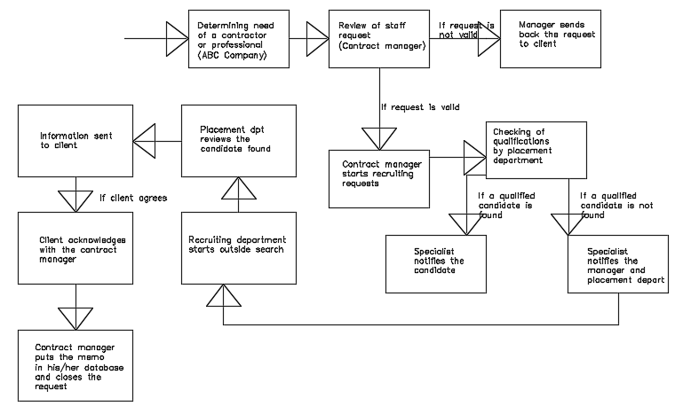

REFERENCES
UML Tutorial: How to Model any Process or Structure in Your Business | Process Street | Checklist, Workflow and SOP Software. (2021). Retrieved 26 February 2021, from https://www.process.st/uml-tutorial/
UML Tutorial: How to Model any Process or Structure in Your Business | Process Street | Checklist, Workflow and SOP Software. (2021). Retrieved 26 February 2021, from https://www.process.st/uml-tutorial/
Andreas Zendler (1997) Advanced Concepts, Life Cycle Models and Tools for Object-Oriented Software Development. p. 122

