United Nations Human Rights Council
Student’s Name
Institution

United Nations Human Rights Council
Goals of Human Rights Council
The Human Rights Council (HRC) is one of the major bodies that form the United Nations. The HRC is the new version of the United Nations Commission on Human Rights. The Council was initiated in 2006 to replace the Commission of Human Rights due to the accusations of its members’ abominable records (Chilton & Golan-Vilella, 2016). The new HRC began its tasks the same year after a three month period upon establishment. The HRC performed its role guided by the institution-building package that laid down the procedures that have to be adopted. This guiding document is an illustration of the present-day relevance of mechanisms laid down by building blocks such as the organizational structure. The intergovernmental body has the potential of handling any theme on human rights issues that are brought to its attention. The members of the HRC meet to address such situations at Geneva in their UN office.
The main goal of HRC is the promotion of human right standards across the globe. The body further protects these rights by addressing any violations through the proposal of recommendations. As a result, the body will have accomplished its goal of ensuring that the fundamental freedom granted to all is fostered. Additionally, the body strives to ensure that all people are aware of their rights and the various ways they can practice these privileges. The council will spread awareness through promotion of human rights education. On a similar note, the HRC focuses on the development of international laws to guide human rights practices around the world. The HRC is further responsible for handling emergency issues on human rights as they emerge. Lastly, the HRC focuses on upholding its international task of providing a forum to debate on important thematic issues on human rights.
Structure of HRC and Goal Accomplishment
The Human Rights Council is comprised of 47 states that are a part of the body by virtue of election by the General Assembly. The Council conducts its significant works and prepared reports are directed to the General Assembly. The body’s organizational structure led by the High Commissioner is made up of different sections to ensure all important activities of HRC are addressed. The HRC performs its duties based on a package of elements that contains the procedures and work methods that should be adopted by the members of its organizational structure. These rules were formulated to foster transparency, impartiality, and predictability in the accomplishment of HRC’s objectives. On that note, the result-oriented body is better positioned to accomplish its tasks.
All the positions in figure 1 below are occupied after an electoral process that is guided by the regional principle of the United Nations. The Office of the High Commissioner is deputized by the Deputy High Commissioner and works towards achieving HRC goals by ensuring that project implementation obstacles are eliminated. As a result, coordination and cooperation are enhanced amongst the Council members in the quest of addressing human rights-related activities. The Assistant Secretary heads the New York office and is responsible for leading the UN’s effort aimed at promoting human rights (United Nations Human Rights, n.d). Four sections are categorized under the leadership of the Deputy Commissioner. These sections are tasked with duties such as policy formulation, security planning, and management including program evaluation amongst others. These departments play a critical role in providing supplemental material to ensure fundamental freedoms are realized internationally.
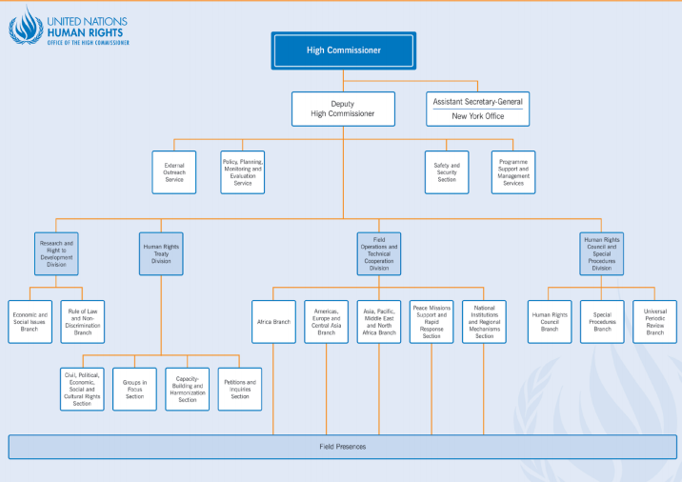
Figure 1: Organizational Structure of HRC
Besides the main two human rights division, the fields operation and research divisions are structured to ensure no nation is left behind in the goal of harnessing equal human rights internationally. The benefits of these divisions can be articulated through the HRC and special procedures. The UN special procedures have been established to facilitate the roles of the members of the HRC organizational structure. The UN special procedures are comprised of the special rapporteurs, representatives, groups, and hired experts expected to oversee human right issues. This role is made possible through activities such as monitoring, examination, issuance of advice, and make public reports on the situation.
Are HRC Goals Achievable?
The HRC’s organizational structure is well-suited to accomplish its goals which are evident through its numerous projects and reports. The High-Level Meeting that occurred in December 2018 to discuss ways to foster sustainable development for the middle-income countries based its concepts on the 2030 Agenda (Garces, 2018). HRC is meeting its objectives evident through some of the key facts the body addresses such as the high inequality and the effects of unplanned urbanization on residents of MIC. The HRC through divisions such as the research entity conduct intense investigations to address the challenge of data availability. Such actions ensure that the HRC has full control of the universal rights of all individual across the world. Additionally, initiatives such as the review of each HRC member state as a measure of eliminating potential abuses on the freedom and rights of people are a significant contributive effort towards achieving the body’s goals. On that note, it is recommendable that HRC maintains its procedures and mechanisms that guide its organizational structure.

References
Chilton, A., & Golan-Vilella, R. (2016). Did the Creation of the United Nations Human Rights Council Produce a Better “Jury”? Havard International Law Journal. 58, 7-15.
Garces, M. (2018). Concept Note: High-Level Meeting on “Development cooperation in middle- income countries” December 4, 2018, Trusteeship Council Chamber, UN Headquarters, New York. Retrieved from https://www.un.org/pga/73/wp- content/uploads/sites/53/2018/11/HLM-MICS-CONCEPT-NOTE-draft-November-2.pdf
United Nations Human Rights. (n.d). Andrew Gilmour. Retrieved from https://www.ohchr.org/EN/AboutUs/Pages/AndrewGilmour.aspx

