
Assessment Guide

Course | Mathematics and Mechanics eLearning course (NCME Year 1, Night/Correspondence)
Units | 21905 v2 | Demonstrate knowledge of trade calculations and units for mechanical engineering trades | Level 2 | 6 credits

Assessment Evidence
Successful completion of nine (9) short answer question assessment books in the Mathematics and Mechanics eLearning course. All these books are marked by the system.
- Basic Maths
- Quantities and Units of Measurement (Q & M)
- Shapes and Angles 1 (S & A 1)
- Shapes and Angles 2 (S & A 2)
- Shapes and Angles 3 (S & A 3)
- Tables and Graphs (T & G)

Conditions
For assessments, formulae and conversion factors to be supplied, and use of calculator is permitted.

Definitions
Basic trigonometry refers to the relationship between angles and sides of triangles. It covers the use of sine, cosine and tangent.
Quantities refers to properties ascribed to phenomena, bodies, or substances that can be quantified; e.g. force, length, pressure.
Value of a quantity refers to the quantitative expression of a particular quantity, expressed as a numerical value with unit; e.g. 1.7 m, 1700 mm, 0.75 kPa, 30 lb/in².

Reference
The International System of Units (SI), 8th edition (France: Bureau International des Poids et Mesures, 2006). Available at http://www.bipm.org/utils/common/pdf/si_brochure_8_en.pdf

AG 21905 v2 Ed 5 © January 2013 Page 1

Questions
Basic Maths (Module 1)

Introduction
- This assessment will use a scenario. In the scenario, you need to calculate and prepare a cutting plan for 40 pieces of bar that will be machined into shafts.
- The shafts are 780 mm long and will be cut from 6000 mm lengths of stock bar.
- As the ends of the stock are often damaged, you need to cut off the first 10 mm before you start cutting the actual bars.
- Work through the assessment exercises to develop your cutting plan.
You may need a scrap piece of paper to write down answers that will be used for later questions.

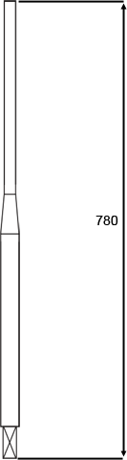
- The bar used to make the shafts comes in lengths of 6000 mm.
How many whole 780 mm shafts can you make from one bar?
(Choose the best answer)
  - Four shafts
  - Five shafts
  - Six shafts
  - Seven shafts

Note down this answer as you will need it for the next question.

- The bar used to make the shafts comes in lengths of 6000 mm.
How many bars will you need to make 40 shafts of 780 mm?
(Choose the best answer)
  - Four bars
  - Five bars
  - Six bars
  - Seven bars

Note down this answer as you will need it for the next question.

The bar is 6000 mm long. Each saw cut is 2.5 mm wide. 10 mm is trimmed off each bar to tidy up one end.
Each shaft needs to be 780 mm long.

- How many offcuts are left over and what are their lengths? (Choose the best answer)
Formula:
Offcut = Original Length – (Trim) - (Cuts) – (Shafts)
Full length bars (6000 mm):
Cuts: 8 x 2.5 mm
Shafts: 7 x 780 mm Offcuts: 1 x ? mm Trim: 1 x 10 mm One bar (6000 mm):
Cuts: 6 x 2.5 mm
Shafts: 5 x 780 mm Offcuts: 1 x ? mm Trim: 1 x 10 mm

  - 6 x 10 mm pieces, and 5 x 510 mm pieces.
  - 5 x 10 mm pieces, 5 x 510 mm pieces, and 1 x 2075 mm piece.
  - 6 x 510 mm pieces, and 1 x 2075 mm piece.
  - 5 x 510 mm pieces, and 1 x 2075 mm piece.

- Consider the entire job of 40 shafts, and all the lengths of bar. What is the total % waste for the job?
Include all off cuts as waste. Round your answer to 2 decimal places.
Formula:
% waste = (𝑇𝑜𝑡𝑎𝑙 𝑙𝑒𝑛𝑙𝑙𝑡ℎ 𝑜𝑜𝑜 𝑚𝑎𝑡𝑒𝑟𝑚𝑚𝑎𝑙−𝑡𝑜𝑡𝑎𝑙 𝑙𝑒𝑛𝑙𝑙𝑡ℎ 𝑜𝑜𝑜 𝑎𝑙𝑙 𝑡ℎ𝑒 𝑠ℎ𝑎𝑜𝑜𝑡𝑠) 𝑥 100
Total length of material

Percentage waste after cutting = 0.47%

- You have been asked to look in the store for any bars that are 1.25 inches in diameter and have been given a ruler that measures in fractions of an inch.
Convert the decimal number to a whole number so you can use the ruler.
Formula:
Decimal to fraction: Multiply by whole numbers until the result is a whole number. Multiplier becomes the denominator and result becomes the numerator.

Fraction =5/4inches

- Your supervisor has asked you to let him know when ⁴/5 of the 40 bars have been cut.
How many bars is that?
Formula: Decimal = 𝑁𝑢𝑚𝑏𝑒𝑟 𝑜𝑜𝑜 𝑏𝑎𝑟𝑠 𝑥 𝑛𝑢𝑚𝑒𝑟𝑎𝑡𝑜𝑟
𝑑𝑒𝑛𝑜𝑚𝑚𝑚𝑛𝑎𝑡𝑜𝑟
Number of bars = 32

- What percentage of the total number of bars is 4/5?
Formula:
% = 𝑛𝑢𝑚𝑒𝑟𝑎𝑡𝑜𝑟 𝑥 100
𝑑𝑒𝑛𝑜𝑚𝑚𝑚𝑛𝑎𝑡𝑜𝑟
0.32%
8. You have been told that there is a maximum 5% reject allowance.
How many of the 40 bars can be rejects?
Formula:
Decimal = 𝑁𝑢𝑚𝑏𝑒𝑟 𝑥 𝑝𝑒𝑟𝑐𝑒𝑛𝑡𝑎𝑙𝑙𝑒
100
Maximum number of rejects = 2 bars

Note down this answer as you will need it for the next question.

9. Express the maximum 5% reject allowance as a fraction.
Formula:
Percentage to fraction = ^{𝑒𝑟𝑐𝑒𝑛𝑡𝑎𝑙𝑙𝑒}
100
Then divide both numerator and denominator by whole numbers to the lowest possible whole number is achieved.
Fraction =1/9

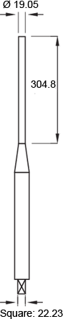
Questions – Quantities & Units of Measurement (Module 2)

- The lathe in your workshop is an imperial machine that is graduated in inches.
Using your calculator, convert the following dimensions into imperial metric.
Provide all answers to 3 decimal places.
Formula: 1 inch = 25.4 mm.

  - 19.05mm =483.87inches
  - 22.23mm =564.642inches
  - 304.8mm =7741.92inches
11. The overall length of the shaft is 780mm. Convert this length to inches.
Provide the answer to 3 decimal places.
Formula: 1 inch = 25.4 mm.
Length =19,812inches

- Complete the table below by dragging the units and symbols into the empty spaces.

Unit
Cubic metre, Joule, Metre per second squared, Metres per second, Millimetre Newton, Newton metre, Second, Square metre, Watt

Symbol
J, m/s, m/s², m², m³, mm, N, Nm, s, W

Quantity | Unit | Symbol
Time | Seconds | s
Area | Square Metre | m²
Work | Joule | J
Power | Watt | W
Volume | Cubic metre | m³
Speed | Metre per second | m/s
Force | Newton | N
Acceleration | Metre per second squared | m/s²
Torque | Newton metre | Nm
Length | Millimetre | mm

- Define the following quantities, including their SI base unit(s).

Force, Torque, Velocity, Volume, Work
Drag the quantity into the box next to its definition.

Quantity | Definition, including SI unit(s)
Torque | The measure of a force (N) applied at a distance (m) from a pivot, producing rotation about the pivot.
Work | Work done on the body when a force (N) is applied to a body and the body moves (m) in the direction the force is applied.
Volume | The measure of how much space an object occupies or can contain (m³).
Force | A push or pull on a body (mass in kg, acceleration in m/s²).
Velocity | The speed (m/s) travelled in a particular direction.
- Define the following quantities, including their SI base unit(s).

Area, Power, Pressure, Speed
Drag the quantity into the box next to its definition.

Quantity | Definition, including SI unit(s)
Pressure | Measured in kPa. The force (N) per unit area (m²) acting on a surface in a direction perpendicular to the surface.
Power | The rate(s) of doing work (J).
Area | Measurement of the size of a surface (m²).
Speed | The distance travelled (m) in a unit of time (s).

Case Study

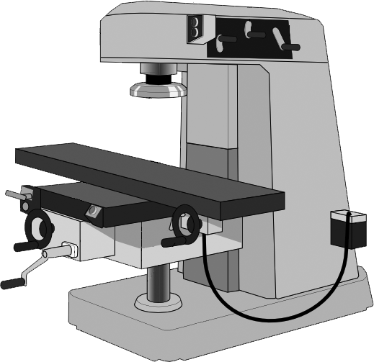
Your company has bought a new machine from the U.S.A. and all the units in the manual are in imperial units.
The width of the machine is 12 feet and it requires at least 11 inches clearance from the back wall.
The machine has a mass of 28,500 lb. It requires 300 lb/in² air pressure, and it should not operate at temperatures above 110°F.
It has a maximum feed rate of 2,362 inches per minute and a positional accuracy of 0.001” (inches).

- To help with correct installation, your supervisor has asked you to calculate the width of the machine then measure the opening of the main factory door to see if it will fit through it. The width of the machine is 12 feet. Convert this to mm.

Provide all answers to 1 decimal place.
Formula:
You have found the following conversion factors in your machinery handbook:
1 inch = 25.4 mm 1 foot = 12 inches
12 feet = 3657.6mm

- You measured the door at 3.85 metres. Convert this to millimeters.

Provide your answer to this question as a whole number.
Formula:
You have found the following conversion factor in your machinery handbook: 1 m = 1000 mm
3.85 m =3850mm

- Your supervisor has asked you to calculate the clearance from the back wall in millimeters to make sure the installers leave enough room for future maintenance.
The machine requires at least 11 inches clearance from the back wall. Convert this to mm.

Provide all answers to 1 decimal place.
Formula:
You have found the following conversion factor in your machinery handbook: 1 inch = 25.4 mm
11 inches =279.4mm

- To ensure he orders the right lifting equipment, your supervisor has asked you to calculate the mass of the machine.
The machine has a mass of 28,500 lb. convert this to kilograms. Provide all answers to 1 decimal place.
Formula:
You have found the following conversion factors in your machinery handbook: 1 lb. = 0.4536 kg
28,500 lb. =12,927.6kg
Note down this answer as you will need it for the next question.

- The machine has a mass of 28,500 lb. convert this to tonnes. Round your answer to the nearest whole number.
Formulae:
You have found the following conversion factors in your machinery handbook:
1 lb. = 0.4536 kg
1000 kg = 1 tonne
28,500 lb. = 13tonnes

- Your supervisor has asked you to find a suitable hydraulic jack that is capable of lifting the entire mass of the machine. You have found a company that hires a jack that is rated to a force of 147 kN.
Convert 147 kN. to Newtons.
Formulae:
You have found the following conversion factors in your machinery handbook:
1 kN. = 1000 N
1 kg = 9.81 N
1 tonne = 1000 kg
147 kN. =147000N
Note down this answer as you will need it for the next question.

- Convert the Newtons (N) you calculated in previous question to kilograms (kg)

Round your answer to the nearest whole number
Formulae:
You have found the following conversion factors in your machinery handbook:
1 kN. = 1000 N
1 kg = 9.81 N
1 tonne = 1000 kg
147 kN. =14,985kg
Note down this answer as you will need it for the next question.

- Convert the mass you calculated in previous question to tonnes.

Round your answer to the nearest whole number
Formulae:
You have found the following conversion factors in your machinery handbook:
1 kN. = 1000 N
1 kg = 9.81 N
1 tonne = 1000 kg
15tonnes

- Your supervisor has asked you to see if the workshop compressor, rated to 1.55 MPa, has enough pressure to allow the machine to operate.
The machine requires 300 lb. /in² air pressure. Convert this to Pascals.

Round your answer to the nearest whole number
Formula:
You have found the following conversion factors in your machinery handbook:
1 lb. /in2 = 6895 Pa
1000 Pa = 1 kPa
1000 kPa = 1 MPa
300 lb. /in² = 2068500Pa
Note down this answer as you will need it for the next question.

- Convert your answer to previous question to MPa.

Round your answer to one decimal place.
Formula:
You have found the following conversion factors in your machinery handbook:
1 lb/in2 = 6895 Pa
1000 Pa = 1 kPa
1000 kPa = 1 MPa
300 lb/in² =2.1MPa

- The rated operating pressure of the workshop compressor is 1.55 MPa. This figure could also be described as..?
a. 155 kPa
b. 1.55 x 10⁶ Pa
c. 15,500 Pa
d. 1.55 x 10⁶ kPa

- You have a job that requires holes to be positioned to an accuracy of +/- 0.25 mm. The new machine’s manual states that positional accuracy is +/- 0.001” (inches). Convert the imperial measurement to metric.

Round your answer to three decimal places.
Formula:
You have found the following conversion factors in your machinery handbook: 1 in = 25.4 mm
0.001” =0.0254mm

- How would you express the required accuracy of +/- 0.25 mm in microns (µm)?
a. +/- 0.025 µm
b. +/- 0.25 µm
c. +/- 25 µm
d. +/- 250 µm

- Your supervisor has asked you to take some temperature measurements around where the machine is to be sited.
The machine’s maximum allowable temperature is 110°F. Convert this to °C to help with your records.

Round your answer to one decimal place.
Formula:
You have found the following conversion factors in your machinery handbook: Fahrenheit to Celsius = subtract 32, multiply by 5 and divide by 9
110°F =43.3°C

- Your friend who works for another company reckons their machine has a faster maximum feed rate at 0.8 m/sec.
Your new machine has a maximum feed rate of 2,362 in/min. Calculate the feed rate in m/sec to see if your machine is faster.

Round your answer to one decimal place.
Formulae:
You have found the following conversion factors in your machinery handbook:
1 in = 25.4 mm
1 metre = 1000 mm
1 minute = 60 seconds
Max feed rate =1.0m/s

- Drag the prefix to the correct Power of 10.

Centi, Deci, Kilo, Mega, Micro, Milli, Unit

Kilo x 10³
Unit x 1
Micro x 10⁻⁶
Milli x 10⁻³
Mega x 10⁶
Centi x 10⁻²
Deci x 10⁻¹

- Drag the term onto the correct definition. (Use each definition only once)

Mass, Newton, Weight

Term | Definition
Weight | The mass of an object multiplied by the force of gravity.
Mass | The amount of matter contained in an object.
Newton | The unit of measurement describing the force that accelerates a mass of 1 kg at a rate of 1 m/s².

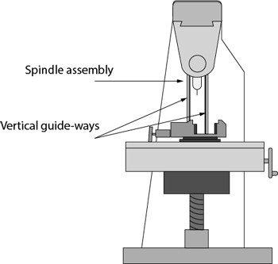
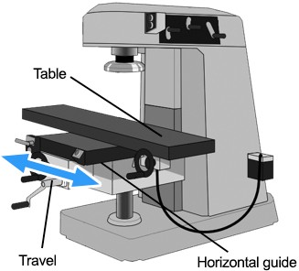
32. The spindle assembly of this machine has a mass of 120 kg and slides on vertical guide-ways.
The gravitational acceleration exerted on it is
9.81 m/s²
Calculate the weight of the spindle assembly.
This is the force required to prevent the spindle falling if unsupported.
Round your answer to the nearest whole number.
Formula:
Weight = mass x gravitational acceleration
1,177N
33. The table of this machining centre has a mass of 280 kg and is sitting on friction-free guide-ways.
How much force is required to accelerate the bed at 4 m/s²?
Round your answer to the nearest whole number.
Formula:
Force = mass x acceleration
10,987N

Questions – Shapes and Angles 1: Area (Module 4)

Introduction
This steel wedge block needs to be zinc plated to be used in a mildly corrosive atmosphere.
The price of zinc plating is based on the surface area. You need to calculate the total area, excluding the inside faces of the holes, to work out the cost of plating.
To do this, you need to calculate the surface area of each face, and then add them together to find the total area. As you move through the assessment, write down your answer for each surface.
At the end, we will give you the total surface area you should have. You will be able to add up your answers to see if you got them all correct.
For the exercises in this assessment, always use π = 3.14.

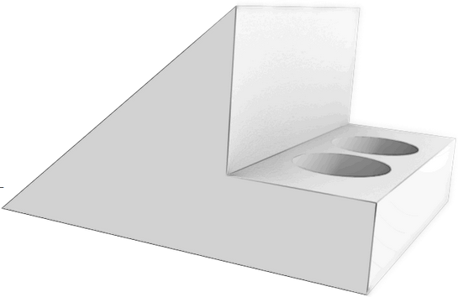

Surface A and B (view 1) | - Find the area of surface A.  Provide your answers to the nearest whole number.  Formula:  Area of a rectangle: Height x Width  Area of a triangle:  Height x Width 2  Area of triangle =230mm²  Area of rectangle =84mm²  Total area of surface A =314mm²  Note down this answer, as you will need it for the next question.  - Surface B is the same as Surface A. Multiply the total area of Surface A by 2 to account for surface B.  Area of surfaces A & B =628mm²  Note down this answer, as you will need it for the next question.
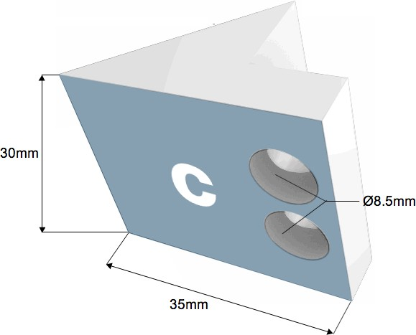  Surface C (view 2) | 36. Find the area of Surface C.  Provide your answers to one decimal place.  Formula:  Area of a rectangle: Height x Width Area of a circle:  πd2 OR πr2  4  π = 3.14  Total surface area = rectangle – (circle x 2)  Area of rectangle:1050mm²  Area of 1 circle:113.4mm² Area of surface C =936.6mm²  Note down this answer, as you will need it for the next question.
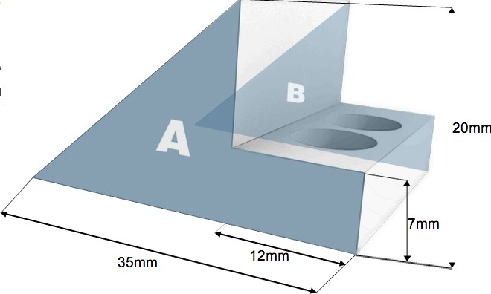

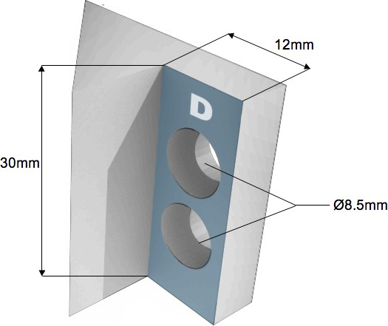
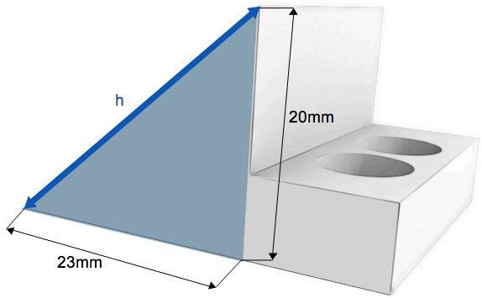
Surface D (view 3) | 37. Find the area of surface D.  Provide your answers to one decimal place.  Formula:  Area of a rectangle: Height x Width Area of a circle:  πd2 OR πr2  4  π = 3.14  Total surface area = rectangle – (circle x 2)  Area of rectangle:360mm²  Area of 1 circle:113.4mm² Area of surface D =246.6mm²  Note down this answer, as you will need it for the next question.
Surface A showing triangle only | 38. Use Pythagoras’ Theorem to calculate the length of the hypotenuse (h).  Provide your answer to two decimal places.  Formula:  Pythagoras’ Theorem: a2 + b2 = c2  Length of h =30.48mm  Note this answer, as you will need it for the next question.
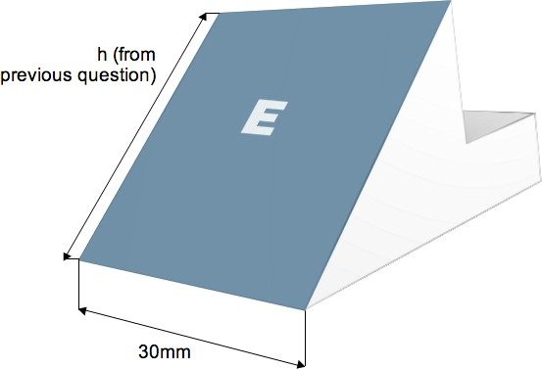  Surface E (view 4) | 39. Use your answer from question 38 to find the area of Surface E.  Provide your answers to one decimal place.  Formula:  Area of a rectangle: Height x Width  Area of Surface E =914.4mm²  Note this answer as you will need it for the next question.

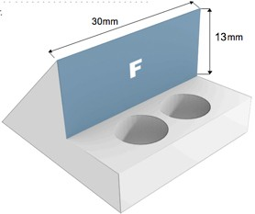
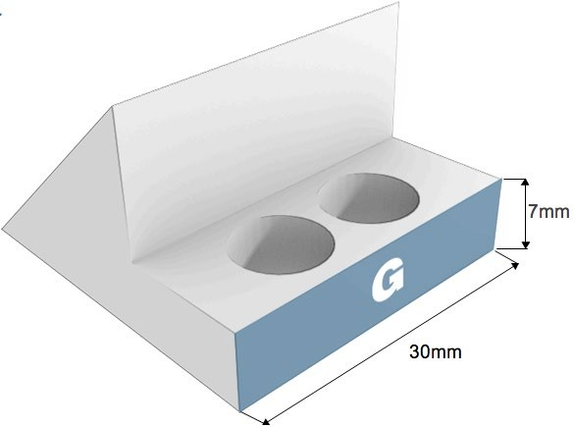
Surface F (view 5) | 40. Find the area of surface F.  Provide your answer to the nearest whole number.  Formula:  Area of a rectangle: Height x Width  Area of Surface F =390mm²  Note this answer, as you will need it for the next question.
41. Find the area of surface G.
Provide your answer to the nearest whole number.
Formula:
Area of a rectangle: Height x Width

Area of Surface G =210mm²
Surface G (view 6)
Double Check

Add together your answers for surfaces A - G.

If you forgot to note them down, you can go back into each question on the questions list for Shapes and Angles: Area assessment book.

The total area for this object is 3325.6 mm²

If your answers did not add up to this, go back over the assessment questions and re-do your calculations.
Just remember, once you’ve selected the ‘I’m Done’ button, you’ve locked in your answers for the whole Shapes and Angles: Area assessment book.

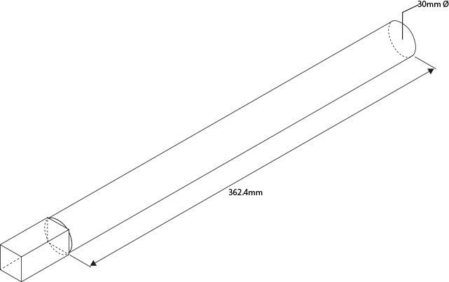
Questions – Shapes and Angles 2: Volume (Module 4)

Introduction

For this assessment, you will be finding the total volume of this shaft.
To do this, you will be finding the volume of each of the four sections, then add them together for the total volume.
Keep a track of your answers on paper as you complete each question. At the end, you’ll be able to compare your total volume to the correct total volume of the component.
Make sure you use the number 3.14 for Pi.

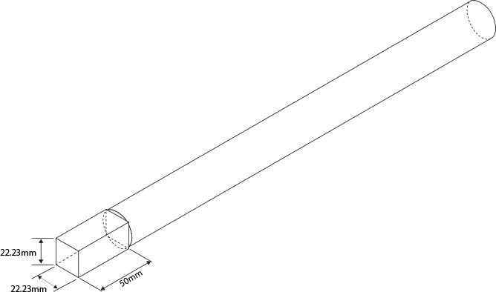
42. Find the volume of this box.
Provide your answers to two decimal places.
Formula:
Volume of a box: Height x Width x Depth
24,708.65mm³
Note this answer, as you will need it for the next question.
43. Find the volume of this cylinder.
Provide your answers to one decimal place.
Formula:
Volume of a cylinder:
𝜋𝑑^{𝟐}
𝟒 × 𝐿𝑒𝑛𝑔𝑡ℎ
or πr² x Length
π = 3.14
256,035.6mm³
Note this answer, as you will need it for the next question.

44. Use the image to calculate the volume of the whole cone.
Provide your answers to the nearest whole number.
Formula:
Volume of a cone:
πr² x Length 3
π = 3.14
40376mm3
Note this answer as you will need it for the next question.
45. Use the image to calculate the volume of the smaller cone (shaded).
Provide your answers to the nearest whole number.
Formula:
Volume of a cone:
πr² x Length 3
π = 3.14
10338mm³
Note this answer as you will need it for the next question.
46. Subtract the volume of the smaller cone in question 4 from the volume of the larger cone in question 3 to find the volume of the frustum.
Provide your answers to the nearest whole number.
30038mm³
Note this answer as you will need it for the next question.
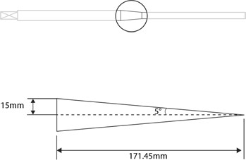
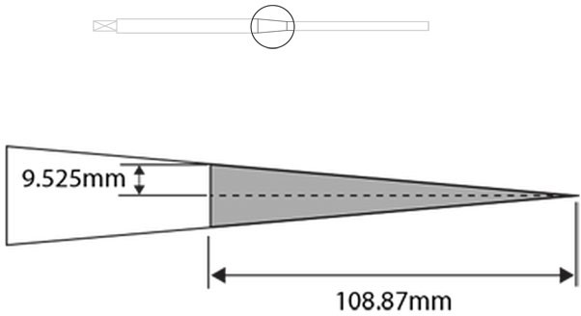
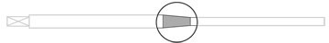

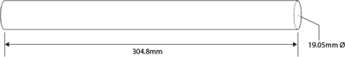
47. Find the volume of this cylinder.

Provide your answer to two decimal places.
Formula:
Volume of a cylinder: ^{𝜋𝑑}𝟐𝟐 × 𝐿𝑒𝑛𝑔𝑡ℎ
𝟒𝟒
OR πr² x Length
π = 3.14

86830.95mm³
Note this answer, as you will need it for the next question.

Double Check
Add together your answers for the box, the two cylinders and the frustum.
If you forgot to note them down, you can go back into each question on the questions list for Shapes and Angles: Volume assessment book.

The total volume for this object is 397613.21 mm³

If your answers did not add up to this, go back over the assessment questions and re-do your calculations.
Just remember, once you’ve selected the ‘I’m Done’ button, you’ve locked in your answers for the whole Shapes and Angles: Volume assessment book

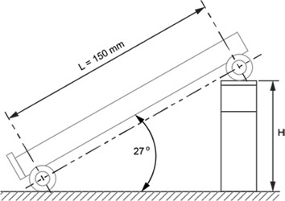
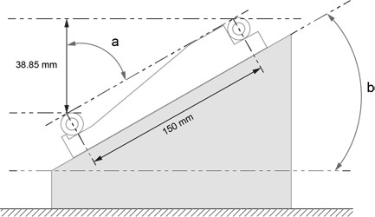
Questions – Shapes and Angles 3: Trigonometry (Module 4)

Introduction
This assessment involves trigonometry. We will use the example of a sine bar.
A sine bar is an engineering tool used to create or measure precise angles by packing up one end of the bar to the height calculated using trigonometry.
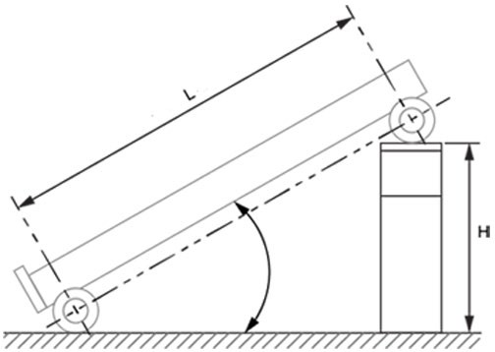
You have been asked to grind an accurate 27° angle on a blade using a 150 mm long sine bar and gauge blocks to set up the jig.

48. Calculate the height (H) of the gauge blocks needed to create this angle.
Sin 27⁰ = 0.454
Round your answer to two decimal places.
Formula:
𝑂𝑝𝑝𝑜𝑠𝑂𝑂𝑡𝑒 = 𝑆𝑂𝑂𝑛 𝑎 𝑥 ℎ𝑦𝑝𝑜𝑡𝑒𝑛𝑢𝑠𝑒
H =68.1mm
You have a steel block with a tapered face that you need to reproduce precisely. Placing the block on a surface table and a 150 mm long sine bar upside down on top of it, you measure a
difference in height between the two cylinders of

38.85 mm. Calculate the angle from the vertical (a).
49. Calculate the angle of the tapered face from the vertical. Round your answer to the nearest degree.

Formula:
𝐶𝑜𝑠𝑂𝑂𝑛𝑒 = 𝐴𝑑𝐴𝐴𝑎𝑐𝑒𝑛𝑡
𝐻𝑦𝑝𝑜𝑡𝑒𝑛𝑢𝑠𝑒
a =75º
50. Calculate the angle of the face (b). Subtract this result from 90 degrees to get the angle of the face.
b =15º
51. There are two vertical posts that have a 300mm difference in height. You want to join them with a beam.
Calculate the length of the beam required using Pythagoras’ theorem.
Round your answer to the nearest millimetre.
Formula: Pythagoras’ Theorem a2 + b2 = c2
beam =1334.17mm
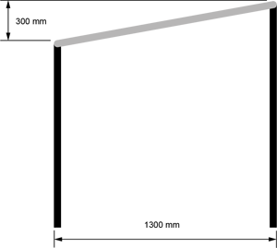

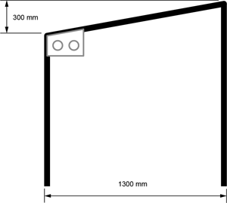
- You now need to make a plate to brace the beam. Use trigonometry to calculate the angle to cut the top side of the plate.

Round the angle to the nearest degree.
Formula:
𝑇𝑎𝑛𝑔𝑒𝑛𝑡 = 𝑂𝑝𝑝𝑜𝑠𝑂𝑂𝑡𝑒
𝐴𝑑𝐴𝐴𝑎𝑐𝑒𝑛𝑡
Angle =13°

Questions – Tables and Graphs (Module 6)

Introduction
In this assessment you will need to read tables and graphs.
You will need to demonstrate that you understand the connection between the two.
The graphs we will look at first are used to illustrate the variation in sizes of machined parts within a tolerance band.

Sample | Time | Outside diameter | Bore size
Sample | Time | Size 28.3 ± 0.05 | Size 20.00 ± 0.05
1 | 8.00 am | 28.31 | 19.99
2 | 8.30 | 28.33 | 19.98
3 | 9.00 | 28.32 | 19.99
4 | 9.30 | 28.34 | 19.95
5 | 10.00 | 28.33 | 19.96
6 | 10.30 | 28.35 | 20.02
7 | 11.00 | 28.34 | 20.03
8 | 11.30 | 28.28 | 20.01
9 | 12.00 | 28.27 | 20.01
10 | 12.30 pm | 28.30 | 20.00
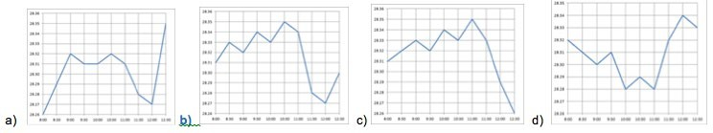
- Select the line graph that accurately represents the outside diameter of the machined parts as shown in the table.

Click on a graph to enlarge or reduce it.

Answer = Graph (b)
- Select the line graph that accurately represents the bore size of the machined parts as shown in the table.

Click on a graph to enlarge or reduce it.

Answer = Graph (d)
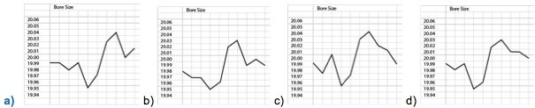

- Use the data from the graph to the right to fill in the table below. Fill in the meters per minute for each RPM and each diameter.
Click the graph to enlarge or reduce it.
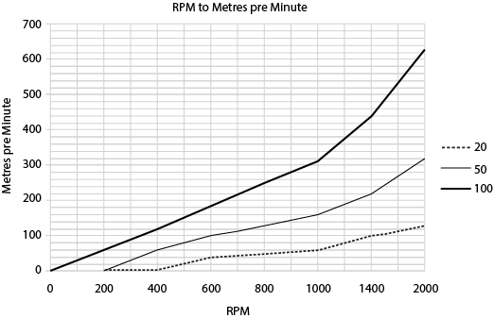

Diameter | RPM
 | 200 | 400 | 600 | 800 | 1000 | 1400 | 2000
20 | NA | NA | 40 | 50 | 60 | 100 | 130
50 | NA | 60 | 100 | 130 | 160 | 220 | 320
100 | 60 | 120 | 180 | 250 | 310 | 440 | 630

Candidate evidence check

Required evidence
Use this checklist to make sure you finished the assessment tasks in full. Clearly name and label all attachments.
I have completed and/or attached:
- The questions in this guide.
Additional supporting evidence
If you have any other evidence which helps prove your skills and knowledge in this unit (such as completed documents, photos, videos or voice recordings), attach it and record it below.
Clearly name and label all attachments.
I have attached the following as additional supporting evidence:

Assessor final judgement
After reviewing the candidate’s evidence for Unit Standard 21905 v2, it is clear that the candidate can competently:
- Carry out arithmetic and algebraic operations for mechanical engineering.
- Carry out trigonometric operations for mechanical engineering.
- Use tables and graphs for mechanical engineering.
- Define and apply quantities and units of measure in a mechanical engineering environment.

Assessor feedback to the candidate
Assessor |  | Date

