The State of the American Dream

Jake Bai
Period D
Mrs. Salter
March 30, 2021

The State of the American Dream
The existence of the “American Dream” has long been an important aspect of the country’s national identity. America, along with the New World more broadly, was a place of hope and wealth in the eyes of those who risked their lives to relocate across the Atlantic Ocean. Stories of vast, cheap land and resources available for all enticed many Europeans living in crowded conditions and held down by feudalism to make the journey and colonize this New World. Originally, the perspective of the American Dream had a “distinctly male cast” in which often landless white men sought economic success, a nice marriage, and a happy family on their own plot of land that they could thrive off of (Fuchsman 289). These goals were owed to them, they felt; once settlers had colonized the east, the American Dream slowly morphed into a fervour that overtook the settlers in the form of “Manifest Destiny.” The mantra of Manifest Destiny stated that these settlers had the right to move westward and colonise all the way to the Pacific Ocean, regardless of the wishes of the Native Americans already living in these lands. After this conquest succeeded, and the United States of America was founded, the prospect of property and riches caught the eyes of potential immigrants, evolving the concept of the American Dream further. Nowadays, the definition of the American Dream has changed into a more general perspective on attaining quality education and a stable career with less of a “gendered focus” (Fuchsman 289). In addition, for a time, this dream was deemed attainable, such as the rise of the middle class. In recent years, however, many in younger generations see this dream as just that: a dream, one that is unrealistic, or at least more difficult than their parents’ generation, to achieve. Increasing economic inequality has led some to claim that the American Dream is “dying,” though there is no consensus on solutions, or even universal acknowledgment of a problem. The American Dream has changed over time and its viability going forward has been called into question, but it can also be argued that it continues to persist in the minds of most Americans to this day, even if in decline, and will continue to survive into the future.
The most basic tenant of the modern American Dream is also the one that now seems the most volatile to the uncertain, younger generation; income mobility. This is the idea that someone from one economic class can move up to a higher income category (Chetty 398). In other words, children grow up with the expectation that they will live better lives, by making more money, than their parents. This particularly held true for Americans in the economic boom after World War II and during America’s prosperity in the following decades in which the white middle class grew in numbers. Tired from the war effort and tired from living with so few amenities, the American soldiers were granted the ability to purchase housing upon coming home via the GI Bill and Federal Housing Administration loans (Pruitt). New car sales quadrupled between 1945 and 1955, and new houses were sold and promptly furnished with new furniture and appliances at a whopping rate of 30 houses per day (Pruitt). This was a time of plenty, with many Americans, including immigrants, being able to attain the stereotypical American Dream that persists to this day; white picket fences, wealth, increased job opportunities, and room for upward economic mobility.

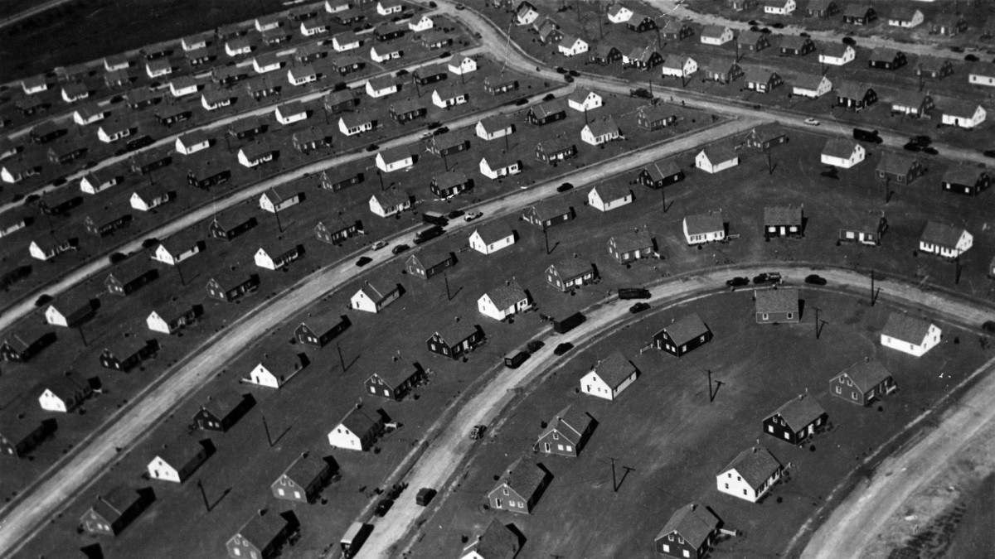
Aerial photo taken in 1947 of the new Levittown, New York homes built by William Levitt and Sons (Pruitt).
Sadly, this economic boom did not last forever. Today, it is projected that less than half of recent generations have been able to achieve this goal of generational progress economically (Chetty 399). Furthermore, public belief in the American Dream sits at just below half of Americans (Wolak and Peterson 973). In a survey conducted by OnePoll of 2,000 Americans, over 62 percent felt that the American Dream as they know it was much more achievable 30 years ago than it is today (Mansfield). In this survey, every six in ten Millennials, as well as 42 percent of Generation Z believed that the American Dream is unattainable, contrasting sharply with the less than one in three baby boomers who shared the opinion (Mansfield). With so many Americans believing that this core aspect of the American Dream is unattainable, the ideology of the American Dream appears to be on the decline.
In recent years, the attainment of higher education has become synonymous with the American Dream, due to higher education being associated with better job opportunities and a higher social status. Americans have continuously increased their educational expectations over successive generations (Mortimer et al. 1428). Furthermore, recent students have succeeded in achieving record levels of higher educational attainment (Mortimer et al. 1424). And yet, higher education is also seen as a major barrier to achieving the American Dream today. According to the aforementioned OnePoll survey, 56 percent of respondents stated that affording higher education was a critical part of the American Dream, and yet over six in ten respondents claimed that the rising cost of education prevents the true accomplishment of the American Dream (Mansfield). The majority of respondents went on to elaborate that, despite being exposed to different post-high school career paths, they were often pushed towards the most expensive options (Mansfield). In reference to the survey results, the survey requisitioner Bharani Rajakumar, CEO of a company that provides skills-based training to candidates, stated, “Education is a huge component of the American dream, but a four-year university degree is not necessarily the best path for everybody immediately after high school” (Mansfield). In addition to different inherent skill sets and personality types making higher education not applicable for everyone, globalisation and other factors that flood markets with certain majors have made holding a higher degree no longer as beneficial as it used to be, and students who lack resources are hard pressed to keep up. Students are also saddled with enormous levels of debt, constraining their future economic prospects and holding them back from purchasing homes and starting families; ironically blocking the original goals of the American Dream. Americans have progressed in educational attainment, even as education has become more expensive and less valuable, seemingly cheapening the results of the American Dream for students across the country.
The American Dream has guided American ambitions for numerous generations, and yet current popular opinion among the younger generations reveals a declining hope in attaining it. In the past, the American Dream drove colonialization and progress in the United States ever onward, and was a beacon of hope and a promise of success. Even after world wars, the American Dream persisted, overcoming economic downturns and global upheaval. Though the American Dream appears to be nothing more than a pipe dream amongst those of the younger generations, especially now with a global pandemic still ongoing, the concept of the American Dream will continue on for generations to come, though whether in a hopeful or derisive context remains to be seen.

Works Cited
Chetty, Raj, et al. “The Fading American Dream: Trends in Absolute Income Mobility Since 1940.” Science, vol. 356, no. 6336, 2017, pp. 398–406., doi:10.1126/science.aal4617.
Fuchsman, Ken. “The Age of Miracle and Wonders: Paul Simon and the Changing American Dream.” The Journal of Psychohistory, vol. 43, no. 4, 2016, pp. 288–301.
Mansfield, Mollie. “DREAM IS OVER: Most in US Say ‘the American Dream’ is Dead.” The Sun, 12 Nov. 2020, www.thesun.co.uk/news/13181876/american-dream-over-survey/. Accessed 7 May 2021.
Mortimer, Jeylan T, et al. “Decline of ‘the American Dream’? Outlook Toward the Future Across Three Generations of Midwest Families.” Social Forces, vol. 98, no. 4, 2019, pp. 1403–1435., doi:10.1093/sf/soz130.
Pruitt, Sarah. The Post World War II Boom: How America Got into Gear. 14 May 2020, www.history.com/news/post-world-war-ii-boom-economy. Accessed 7 May 2021.
Wolak, Jennifer, and David A. M. Peterson. “The Dynamic American Dream.” American Journal of Political Science, vol. 64, no. 4, 21 Apr. 2020, pp. 968–981., doi:10.1111/ajps.12522.

