SOFTWARE DEVELEOPEMNT
Student’s Name
Code + Course Name
Professor’s Name
University Name
City, State
Date

Table of Contents
Introduction 3
Stage 1 3
Unified Process Model 3
Phases in the Unified Process Model 3
Comparing Traditional Development Methodologies and Unified Process Model 5
Stage 2 8
Rational Unified Process 8
Best Practices, Building Blocks, and Phases 8
Artifacts in the Rational Unified Process 9
Conclusion 10
References and Bibliography 12

Introduction

Stage 1

Unified Process Model
The unified process is software that is used in developing systems. It can also be defined as incremental, use-case driven and iterative approach used in the development of the system. The iterative ad incremental approach of the model means that each iteration is considered to be a mini-project, and that does not change even if a new system is developed. The use-case approach is the study of the interaction of two or more entities, that is, customers and the system. The approach, Alvarez (2018) describes the operation of the software in the system, which results in a measurable return. The company will have benefit from the implementation of the unified process model. The software of the Blanchardstown Inc. will be unified within the organization, which will fit the business needs of individual hence boost the performance of the company. The unified process model using the acronym of UPM has four different phases that ensure that a system is developed in a meaningful and functional manner. These phases include inception, elaboration, construction, and transition.

Phases in the Unified Process Model
In inception phase requirements from customers are collected and cost-benefit analysis is done on projects presented. In other words, this phase is known to be the collection and analysis stage. The common goals in this phase are to establish, prepare a project, and estimate its costs, test the feasibility and lastly buy or develop the system. The phase should not be long because it causes excessive up-front specification, Ochs (2016) which contradicts to the unified process model. Generally, the phase is about developing a functional system, making the business case, defining the scope, and determining the cost-benefits analysis f the system developed.
The second phase is an elaboration and in this phase business case documents are prepared and activities done in phase ones are expanded. The requirements collected in the first phase are created to be meaningful in the second stage. The main goals in this phase are addressing risk factors and establishing ad validating system architecture. The system architecture is validated through the process of implementing an architecture baseline. The baseline implements the system which includes significant components. It is the function of the baseline to demonstrate and support the system functionality which examines the right behavior in terms of cost estimation and feasibility. After the implementation of the system, risk factors are addressed, and the system is brand new.
Construction being the third stage is important since codes of every iteration are written and implemented in this phase. The use-cases approach, the system developed makes the core functionalities in the software system. The code writing and implementation determines the functionality of the software developed. Being the largest phase of the development process, it includes building the system on the foundation of the projects after implementation in phase there. The phase involves the unified modeling language, which consists of activity, sequences, interaction overview, and state transition diagrams. Implementation of lower risks and elements are done at this stage; then the software is ready to be deployed in the next phase.
In the transition phase, bugs are fixed for previous releases hence building software to customers. System conversions and training of users are incorporated in the final phase. After the development of systems, the systems are deployed to target users outside the company. Feedback from the initial releases is important because it results in refinements that should be included in this phase.

Comparing Traditional Development Methodologies and Unified Process Model
Generally, traditional software development methodologies have undirected flow from requirements to development to maintenance. For a traditional approach to be effective and efficient, Kaushik (2017) requirements collected need to be well understood to avoid an increase in known risk factors. For instance, construction industries require everyone to understand the final product, whereas, in the IT industries, these traditional approaches may fail in achieving the goals of the company. In these methodologies, documentation is assumed to be a high priority hence becomes expensive and time-consuming.
When the user of the system gets to understand the system through the developer’s eyes, the user’s need will be met. In the traditional approaches, Ahimbisibwe (2017) there is a low percentage of creating and implementing re-usable components. The components used are new which reduces the probability of the factors hindering the development of the system. The primary variables of the projects are Matharu (2015) costs, time, quality, and features. These variables are suitable when requirements collected for analysis are precise. These approaches are suitable for a short project to make maintenance of projects moderate and great modifications.
Similarly to traditional methodologies, unified process’s main project variables are costs, time, features, and quality. Unlike the traditional methodologies, unified approaches are very precise, customer-friendly, and suitable for changes in the business. In this approach, DaSilva (2015) users of the system have the chance to modify projects through the development phases. Unlike the traditional method, the unified process allows flexibility in the changes made after a project has started. The other reason why the unified process model is suitable and efficient in the development of systems is when there is unplanned development of software, the process is cheaper than the traditional methodologies.
Although traditional methodologies have their advantages, it also has disadvantages. The two main disadvantages are the business statements have to be defined in advance and hence cannot be changed or modified, and all the requirements collected need to be given in the initial phase without making any changes or modifications. These disadvantages hinder the variables of the projects having a great impact on customer relationships. Scrapped project leads to inefficiency, Kaushik (2017), and results are wasted in efforts and expenses. The final stage in the traditional approaches is testing, which can only be done after the development process is over. The projects cannot go back to be edited after the testing process has already begun.
The advantages of a unified process over the traditional approaches include, it is possible to create and implement re-usable components, Mittal (2018) which are suitable to changes in the business environment. Business needs and problem statements are modified and changed at any time, unlike traditional, where they cannot be modified. Less priority is put on documentation; hence, less time in expenses is used, and solutions are estimated by separating projects and classifying them in mini-projects. The main difference between traditional and unified models is the arrangement of the phases Liefooghe (2011), which includes, requirement analysis, design, planning, developing, and testing. The traditional approach is arranged in linear form while the unified process is in iterative form.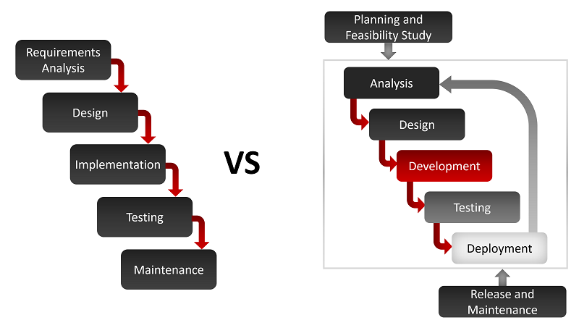
The common variables of the projects for both methods include:
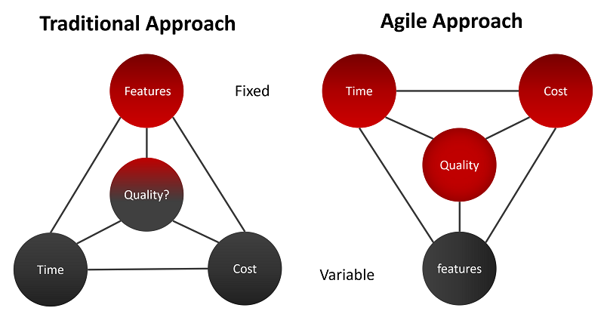

Stage 2

Rational Unified Process
The rational unified process known as RUP is among the modern software development process that is suitable for any business changes. Similarly to the unified process, the rational unified process has four distinctive phases into the development of systems. The phases involve the processes of, modeling business, analysis, and designing, implementation, testing, and deployment of phases to the next phases. This model provides software developers with the guidelines, templates of stages of development of software systems. The rational unified process was created by Rational Software Corporation Solomon (219) and was introduced by the IBM in 2003. The process is adaptive and modified to the needs of customers. Apart from the phases of development, the process also builds blocks which defines who, when, how, and what is to be developed. The model has three common features that need to be available during the development process they include, best practices, building block, and phases. These features determine the cost-benefit analysis of the project presented and enhances the development of the software.

Best Practices, Building Blocks, and Phases
There are six best Practices of Rational Unified Process, and they include developing iterative, managing requirements, use of components architectures, visual model, verify quality continuously, and managing change. Developing software iteratively, Kruchten (2004) involves encouraging the development team and establishing high-risk elements in every phase of software developed. Technical risks are handled when a system is developed iteratively. When the risks are handled to create an opportunity to reach a rhythm that makes intelligent correction which is relative to both technical and business risks. Management of requirements is defined to be changing user’s needs and artifacts of the process intentionally. This practices also describes the methods an organization use to keep track of functionality requirements and documentation. The component-based architectures, Mohd (2016) emphasizes on the development that is based on components of the software. Components-based software, Galster (2015) is used in both current and future projects. This practice determines the risks that could hinder the progress of software development. Visual modeling allows the projects teams to construct, visualize, and be creative on the artifacts used in the rational unified process. The approach that visual modeling is based on is to control the reasons why elements cannot be known to a certain level of code.
Similar to the unified process, the rational unified process uses the unified model language to visualize models. The visualization practice involves analyzing software components and the relationship with each other. Testing the quality of the software is vital because it tests all the phases of software development and determines any factor that may hinder the completion of the process. Verifying represents a baseline that is against the final product. Managing change is the final practice, and it includes tracking and managing forms that are necessary for making the software development process successful. Building blocks basically involve the workers, activities, artifacts, and workflows, Solomon (2019) of software development. In other words, building block answers the WHO question such as, what will be produced, who will produce, how will it be produced and when should it be produced. The life cycle phases of the model include the inception, elaboration, construction, and the transition phase.

Artifacts in the Rational Unified Process
An artifact is a tangible output that, as involved in the process with code functions and additional phase’s models. The person who is responsible for the production system works on activities that will produce the artifacts to be deployed to the target users. In RUP, artifacts are classified into management or technical artifacts which are further categorized into four sets, requirements, analysis and design, test implementation and deployment sets. The requirement sets describe what the systems do, analyze and design test and illustrates the construction of the system, Solomon (2019) test sets explains how the system is verified, implementation sets portray how software comments are assembled. Lastly, deployments sets provide the necessary data used in the configuration of the software process. These sets can be explained in terms of models used in the development of software.
Models are considered to be artifacts which create a better understanding of a system being created. There are eight models that are considered to be artifacts used in the RUP model. Business use case model established the concept of a company, business analysis models set up the context used n the system, and use case model creates a functional requirement of the systems. Analysis model, which is optional conceptual designs, design model stats problem vocabulary and finds its solution, Mohd (2016) and data model, which is also options create data representation and some repositories. Deployment model sets up hardware topology where systems are executed, and the implementation models institute some parts used in releasing and assembling of the physics system.

Conclusion
The unique characteristics of the unified process are iterative, incremental, risk-focused, and architecture based. Iterative and incremental characteristic improves the functionality of software because an iteration leads to an increment. For architecture based executable baseline implements and validates the foundation of software development. Risk focused feature in the model address most technical risk in the project and tackled carefully to avoid the risks from repeating itself. The rational unified process is efficient and effective because it emphasizes the accuracy of documentation and requires less help on the integration process. The other advantage of the model is it resolves projects risks that are related to customers. The disadvantage of the process is that the software developer needs to be an expert, and the development process is very complex and unorganized. The complexity of the model makes it difficult to understand. Implementing a unified process in Blanchardstown Inc. will be a good step since the organization will be prepared in the presents and future of the company. The President of the company, after implementing the UP mode, he will have better control over the company’s system and will be able to monitor all the activities in or out of the company. The unified model creates teamwork among staff, even in distances. Since the software will be used n every computer, interaction with one another will be cheaper and easier.

References and Bibliography
Ahimbisibwe, A., Daellenbach, U. and Cavana, R.Y., 2017. Empirical comparison of traditional plan-based and agile methodologies: Critical success factors for outsourced software development projects from vendors’ perspective. Journal of Enterprise Informatio Management, 30(3), pp.400-453.
Alvarez, J. and Hurtado, J., 2018, September. UP-VSE: A Unified Process-Based Lifecycle Model for Very Small Entities. In Colombian Conference on Computing (pp. 260-275). Springer, Cham.
DaSilva, A.R., 2015. Model-driven engineering: A survey supported by the unified conceptual model. Computer Languages, Systems & Structures, 43, pp.139-155.
Galster, M., 2015, May. Software reference architectures: related architectural concepts and challenges. In 2015 1st International Workshop on Exploring Component-based Techniques for Constructing Reference Architectures (CobRA) (pp. 1-4). IEEE.
Kaushik, S., Bharadwaj, A., Awasthi, V. and Sharma, R., 2017. Applicability and issues in traditional model of ERP implementations: an industry perspective. International Journal of Advanced Computer Research, 7(30), p.88.
Kruchten, P., 2004. The rational unified process: an introduction. Addison-Wesley Professional.
Liefooghe, A., Jourdan, L. and Talbi, E.G., 2011. A software framework based on a conceptual unified model for evolutionary multiobjective optimization: ParadisEO MOEO. European Journal of Operational Research, 209(2), pp.104-112.
Matharu, G.S., Mishra, A., Singh, H. and Upadhyay, P., 2015. Empirical study of agile software development methodologies: A comparative analysis. ACM SIGSOFT Software Engineering Notes, 40(1), pp.1-6.
Mittal, S. and Martín, J.L.R., 2018. Netcentric system of systems engineering with DEVS unified process. CRC Press.
Mohd, H., Baharom, F., Darus, N.M., Saip, M.A., Marzuki, Z., Yasin, A. and Robie, M.A.M., 2016. A secured e-tendering model based on rational unified process (RUP) approach: Inception and elaboration phases. International Journal of Supply Chain Management, 5(4), pp.114-120.
Ochs, C., Geller, J., Perl, Y. and Musen, M.A., 2016. A unified software framework for deriving, visualizing, and exploring abstraction networks for ontologies. Journal of biomedical informatics, 62, pp.90-105.
Solomon, V., Anderson, L., Bates, S. and Herrera, T., 2019. A Methodology for the Deployment of Rational Unified Process. Systems and Software Engineering Publication, 7(2).

