Math 61 Learning Unit 2 Hand-In Assignment for Section 3.5
© Problems copyright Stefan Waner 2015 All rights reserved

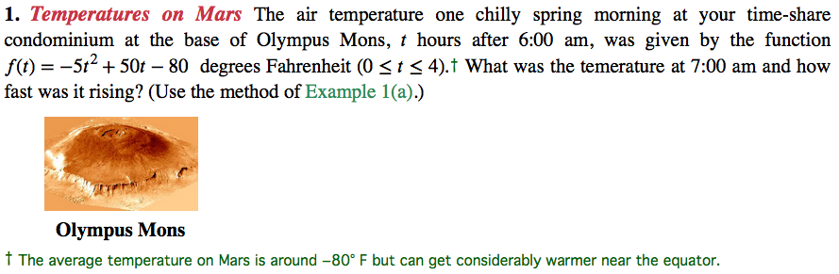
Hint: Use a balanced difference quotient. See Section 3.5 Exercise 85 for a similar problem in the book.

f(t) = -5t²+50t -80
$f'(t)$= -25t +50
When t =1 then -25(1) +50
= 25degrees Fahrenheit the temperature was rising with rate of -25 degrees Fahrenheit.

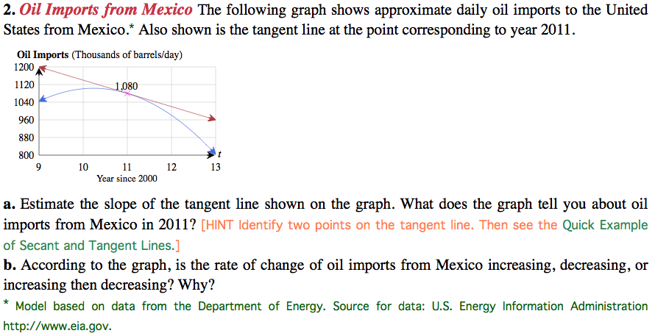
‡ 1980 data estimated. Source: http://www.sciencewatch.com
Hint: Similar to Section 3.5 Exercise 79 in the book.

- Slope of tangent (9, 1200) (11, 1080)
(1080-1200)/ (11-9) = -120/2 = -60
The slope is negative meaning that the oil from Mexico decrease with increase in time.
- The rate of change from Mexico is decreasing because the oil exploitation increase through time thus decreasing oil volume.
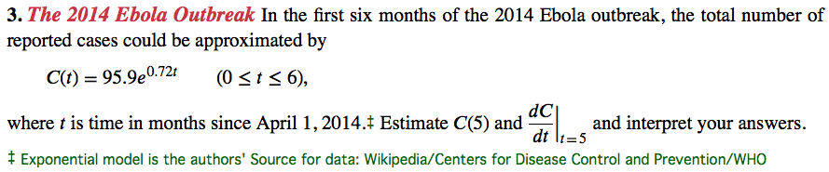
Hint: Similar to Section 3.5 Exercise 87 in the book.
$c^{'}$(t)= 95.9 x 0.72 e^{0.72t}
$c^{'}$(t)=69.04 e^{0.72 x5}
$c^{'}$(t)=69.04e^{3.6}
$c^{'}$(5)= 2527.034

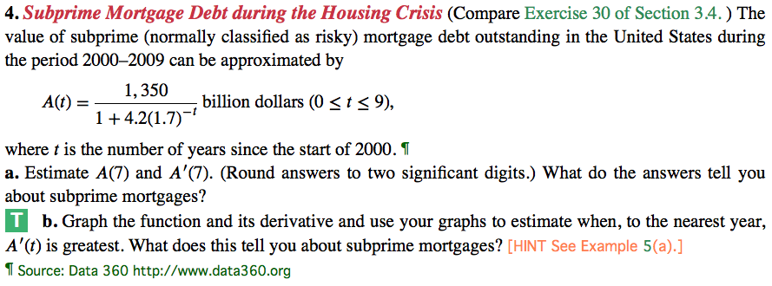
Hint: This is Section 3.5 Exercise 96, similar to Exercise 95 in the book.
- A(7) = $\frac{1350}{1+4.2(1.7)^{-7}}$ = $\frac{1350}{1.1024}$ = 1224.60
A^{’ (7)} = $\frac{1350}{-7x4.2(1.7)^{-8}}$ = $\frac{1350}{-0.42}$= -32,142.86

5. Sketch the graph of a function whose derivative decreases from 0 to -1 and then increases back to 0.

6. If two functions have the same derivative at every point, how do their graphs compare? Their graph are parallel and they share the same point .

