Unit 3 Dropbox Assignment Answers by (Insert your name here)
In the summary tables below, insert only the answers. You will show work after the summary section.

Question 1 answer
1 | Z=0.0228

Question 2 answers
2a | P=0.8413
2b | P=0.928

Question 3 answers
3a | P=0.2160
3b | P=0.5679

Question 4 answer
Make sure you use full sentences for the null and alternative hypotheses.. Do not simply say something like “x1<x2” “or “reject null” without a description and explanation of how you arrived at your conclusion.
Null hypothesis: μ = 3.16
Alternative hypothesis: μ > 3.16
Calculated t value: 2.492
Conclusion (justify using the metrics): For this one tailed test, we reject Ho if t₀ > t_{α/n-1}. In this case 1.687 > 2.492 is false, so we fail to reject H0. The data doesn't provide enough evidence to test the claim.

Question 5 answer
Make sure you use full sentences for the null and alternative hypotheses. Do not simply say something like “x1<x2” “or “reject null” without a description and explanation of how you arrived at your conclusion.
Null hypothesis: Proportion of CFOs that get their money from newspapers is 0.47 (47%). Ho:P=0.47
Alternative hypothesis: Proportion of CFOs that get their money from newspapers is not 0.47 (47%).H1:P≠0.47

Calculated z value: 0.984
Conclusion (justify using the metrics): null hypothesis Ho is not rejected. Therefore, there is not enough evidence to claim that the population proportion p is different than Po, at the 0.05 significance level.

Question 6 answer
Make sure you use full sentences for the null and alternative hypotheses. Do not simply say something like “x1<x2” “or “reject null” without a description and explanation of how you arrived at your conclusion.
Null hypothesis: There is no difference in the mean spending of men and women on Valentine's Day
Alternative hypothesis: The mean spending of men is greater than the mean spending of women on Valentine's Day
Calculated p or t value: 0.051537
Conclusion (justify using the metrics): At 0.05 significance level, there is not enough evidence to claim that the average spending of men is higher than women on Valentine's day.

Work
Show all your work for the questions below.

Question 1
Show your work here.
Let X= score of a randomly picked student
Give mean score μ=75
Standard deviation σ = 15
Z score = (X - μ)/σ = (105-75)/15 = 30/15 = 2
Therefore z score = 2
The probability of randomly picked student has scored 105 or above is
P(Z ≥ 2) = 1 - P(Z < 2) = 1 - 0.9772 = 0.0228

Question 2
Show your work here.
The following information is provided:
mean = 73 , s.d = 22. We need to compute Pr(X < 95)
The corresponding z-value needed to be computed:
z = (95 - 73)/22 = 1
Therefore, Pr(X < 95) = Pr ( Z < (95 - 73)/22 ) = Pr(Z< 1) = 0.8413
b) The corresponding z-values needed to be computed:
z₁ = (62 - 73)/22 = -0.5
z₂ = (84 - 73)/22 = 0.5
Therefore, we get:
Pr (62 < X < 84) = Pr( (62 - 73)/22 < Z < (84-73)/22 ) = Pr(-0.5 < Z < 0.5)
= 0.6914 –0.2366 = 0.928

Question 3
Show your work here.
P (p > 0.20)
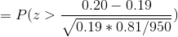
= P (z > 0.79)
= 0.2160

B) P (Between 18% and 20%)
= P (0.18 < p < 0.20)
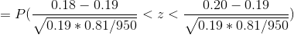
= P (-0.79 < z < 0.79)
= 0.5679

Question 4
Show your work here
Sample mean = xbar = 3.19
Sample Std Dev = s = 0.0889
Ho: μ = 3.16
Ha: μ > 3.16
Test Statistic = t₀ = (xbar - μ)/(s/sqrt(n))
t₀ = (3.19 - 3.16)/(0.0889/5)
t₀ = 1.687
t_{α/n-1} = t_{0.01/25-1} = t_{0.01,24} = 2.492
For this one tailed test, we reject Ho if t₀ > t_{α/n-1}. In this case 1.687 > 2.492 is false, so we fail to reject H0. The data doesn't provide enough evidence to test the claim.

Question 5
Show your work here
Null Hypothesis: Proportion of CFOs that get their money from newspapers is 0.47 (47%).
Alternate Hypothesis: Proportion of CFOs that get their money from newspapers is not 0.47 (47%).
Z value calculation:
The sample size is N = 76, the number of favorable cases is X = 40, and the sample proportion is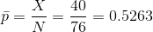, and the significance level is 0.05
Rejection Region
Based on the information provided, the significance level is 0.05, and the critical value for a two-tailed test is 1.96.
The rejection region for this two-tailed test is R={z:∣z∣>1.96}
Test Statistics
The z-statistic is computed as follows:
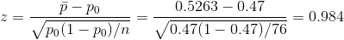
Conclusion
Since it is observed that, it is then concluded that the null hypothesis is not rejected.
Using the P-value approach: The p-value is p = 0.3253, and since, it is concluded that the null hypothesis is not rejected.
It is concluded that the null hypothesis Ho is not rejected. Therefore, there is not enough evidence to claim that the population proportion p is different than Po, at the 0.05 significance level.

Question 6
Copy/paste the output table from the data analysis tool here and explain how you arrived at your conclusion.
Null and alternative hypothesis are as follows:
Null Hypothesis Ho: There is no difference in the mean spending of men and women on Valentine's Day
Alternative Hypothesis Ha: The mean spending of men is greater than the mean spending of women on Valentine's Day
This is a right tailed test as the research aims to find whether mean spending of men is higher in comparison to women. So for testing hypothesis we need to look for one tailed p value from t-Test output provided.
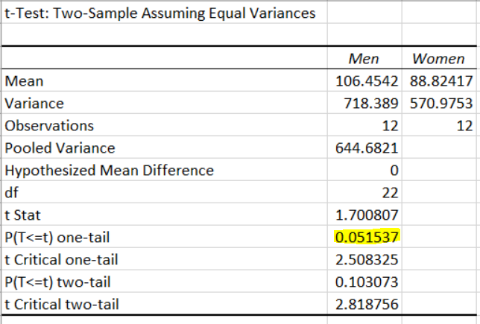

From the t-Test output, it can be seen that p value for one tailed test is 0.051537. Since p value is greater than 0.05, so we fail to reject null hypothesis.
Conclusion
At 0.05 significance level, there is not enough evidence to claim that the average spending of men is higher than women on Valentine's Day.

