Acid-Base Solutions

Note: You must be logged into Blackboard to access the simulation

- Open the Acid-Base Solutions Interactive Simulation found in the syllabus under the Unit II Lab Assignment.

- Click on “Introduction,” and then in the “Solution” menu, click on “Water.” Observe the graphic of the beaker. The equation can be seen below the beaker. Record this chemical equation.

- From the “Tools” menu (lower right), select pH paper and dip it in each solution provided in the “Solution” menu, recording the color of the paper. From the corresponding key, record the pH.

- From the “Tools” menu (lower right), change to the pH meter and dip it in the solution. Record the pH for each solution provided in the “Solution” menu. Note: You might record a slightly different pH with the meter than with the pH paper.

- From the “Tools” menu (lower right), select the light bulb and dip the electrode probes in each solution provided in the “Solution” menu. Record the strength of conductivity based on if the light bulb glows (strong bulb = strong electrolyte, weak bulb = weak electrolyte, no glow = nonelectrolyte).

- Take a screenshot of each of your completed collections, and insert it into the table below. You can do this by selecting the three horizontal lines in the bottom right hand corner of the simulation screen and then selecting “Screenshot.” A screenshot will be downloaded to your browser which you can save to your computer.

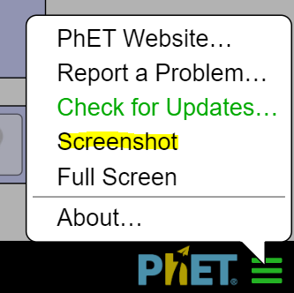

Solutions | View  (screenshots) | Equation | Color of pH paper & pH from color key | pH from Meter | Strength of Conductivity (light bulb)
Water  EXAMPLE IN VIDEO | 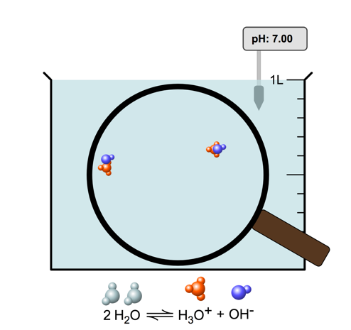 | 2 H₂O ⇔ H₃O⁺ + OH⁻ | Yellow (6.0) | 7.00 | WEAK
Strong acid
Weak acid
Strong base
Weak base

