  - Upgrade the HVAC System
  - at Ras Tanura Terminal Sea Island
  - 28/09/2021

Project Background and Description
Every year Eastern Region Terminal Department at Saudi Aramco wasting a large amount of money at Sea Island to repair the frequent refrigerant leaks of the A/C units which are caused by the harsh corrosive environment. In case of failures, the A/C unit can`t be repaired while the ship is present for loading. Therefore, the downtime of the A/C unit increased, and the area affected. The project scope of work is to replace the HVAC system at RT Terminal Sea Island #4. The existing HVAC system are working in low efficiency, they exceed their life expectancy and don’t meet the minimum energy efficiency requirement according to Saudi Aramco standard SAES-K-001. According to CSD HVAC smart tool matrix these units are due for replacement. The information of existing HVAC system is listed below:
AREA | LOCATION | TYPES | COMPANY | MODEL # | CAPACITY | VOLTAGE | QTY.
S.I# 4 | SUBSTATION | FREE STAND UNIT | CARRIER | 50BB008530/ 09AZH008-3 | 8 TR | 208-3-60 HZ | 3
S.I# 4 | C/R | PACKAGE TYPE | TRANE | TSC102A3E0AIY00000000000 | 8.5 TR | 208-3-60 HZ | 2
S.I# 4 | SUBSTATIONS, ENGINE ROOM | FREE STAND UNIT | CARRIER | 50BZN00851/09HZH008-3 | 8 TR | 208-3-60 HZ | 7
S.I# 4 | TRANSFORMER ROOM | FREE STAND UNIT | CARRIER | 50BU-008---520/09AZH00083 | 8 TR | 208-3-60 HZ | 4
S.I# 4 | BACKUP A/C | FREE STAND UNIT | CARRIER | 50BU006500/09HZH003--3 | 6 TR | 208-3-60 HZ | 1

This project will be conducted for Ras Tanura sea island 4 which is located almost 5 KM from the Ras Tanura Tank Farm.
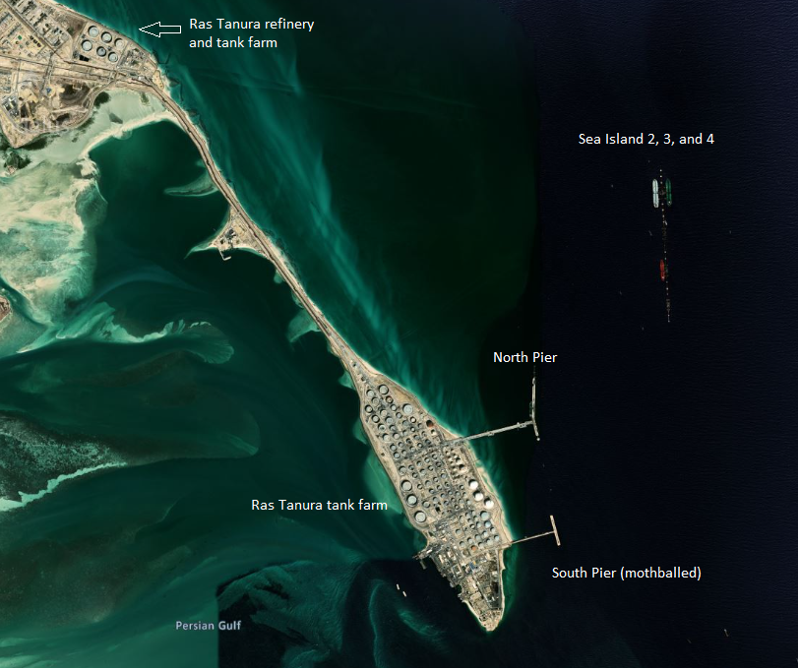

Figure 1 Sea Island 4

Project Classification
The team has identified the classification of the above project by using Shenhar & Wideman classification. After using the basic classification method, the team has found that the selected project is classified as tangible craft project. The reason for selecting this approach is because of the tangibility of the project in terms of building a new HVAC system consist of infrastructure and utility. Also, for the craft part, in order we install HVAC system we need a trained worker in every task.
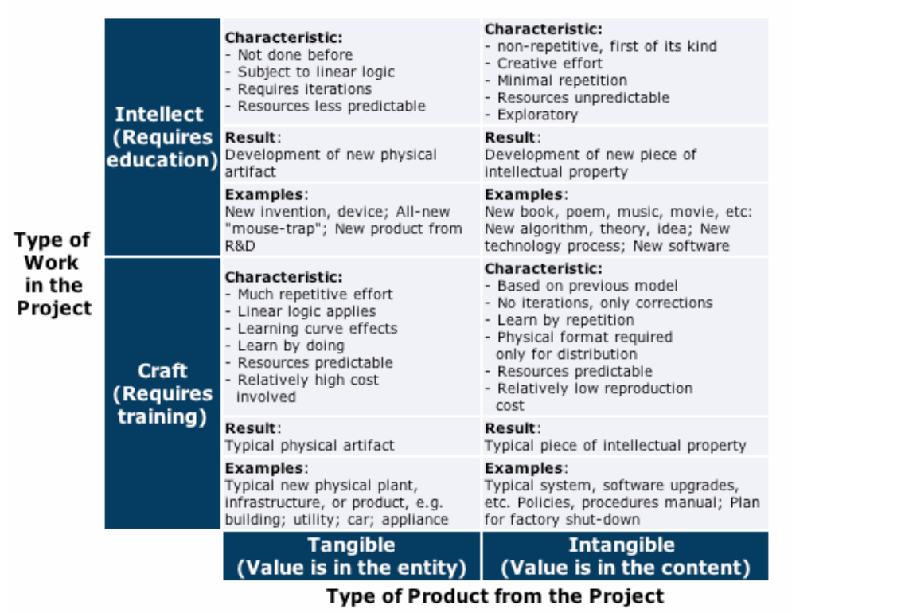

Project Lifecycle
As a technical support group, we have developed a study that illustrate the need of this project. Since the system can`t be repaired while the ship is present for loading, we have to schedule it during the upcoming T&I which will be during the last quarter of 2022. We are working with the planning division to do a feasibility study to analysis project scope and budget to get the management approval and include it on the upcoming business plan. The lifecycle of this project will have a total of 5 phases following the PMI standard for project management as follows:
- The initiation phase (one week): We are currently in this phase, where proposals are being evaluated to start up the project. At this stage we define the project`s problem statement, the objectives of the project, deliverables, and stockholders are taking place in this phase.

- The planning phase (two weeks): At this phase we will prepare the plan to guide us through project. At this phase we will ensure the planned budget and time will within limits
- Execution (25 weeks): This phase is most critical phase and it will take the majority of the project time and recourses. At this phase we will complete the defined work
- Monitor and control: This phase is undertaken from the initiation until the closing phase to ensure the project is within the scope, on time and within the budget.
- Close out phase (2 weeks): At this phase we ensure that all work has been completed withing the scope, budget and time. Also, we receive final approval from all concern stakeholders.

Project Goal
The main goal is to provide a reliable HVAC system which will satisfy the employees, protect the assets and facilities, to ensure the continuity of operation to one of the biggest exporting facilities at the Kingdom.

Project Objective
- Increase HVAC system reliability.
- Enhance area safety.
- Reduce maintenance cost (material & Labor).
- Reduce failures caused by corrosion.
- Reduce lifecycle cost.
- Reduce electric power consumption.
- Minimize outage
- Comply with Saudi Aramco safety standards, procedure and regulations.

Project Sponsor
The sponsor of this project is the Eastern Region Terminal Department Manager.

