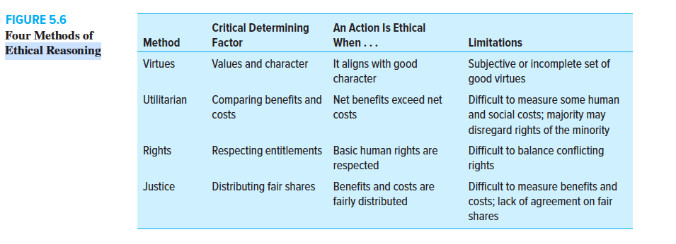 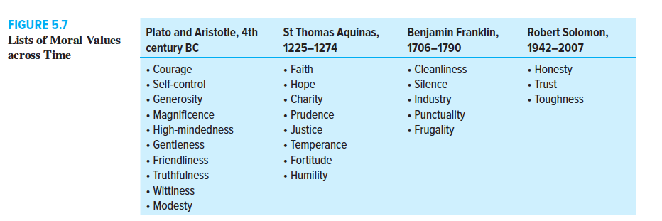Utility: Comparing Benefits and Costs
Another approach to ethics emphasizes utility, or the overall amount of good that can be
produced by an action or a decision. This ethical approach is called utilitarian reasoning. It
is often referred to as cost–benefit analysis because it compares the costs and benefits of
a decision, a policy, or an action, as shown in Figure 5.6. These costs and benefits can be
economic (expressed in dollar amounts), social (the effect on society at large), or human
(usually a psychological or an emotional impact). After business managers add up all the
costs and benefits and compare them with one another, the net cost or the net benefit
should be apparent. For a utilitarian, the alternative where the benefits most outweigh the
costs is the ethically preferred action because it produces the greatest good for the greatest
number of people in society.
The main drawback to utilitarian reasoning is the difficulty of accurately measuring
both costs and benefits. Some things can be measured in monetary terms—goods produced,
sales, payrolls, and profits—but others that are less tangible, such as employee morale, psychological satisfaction, or the worth of a human life, are trickier. Human and
social costs are particularly difficult to measure with precision. But unless they can be
measured, the cost–benefit calculations will be incomplete, and it will be difficult to know
whether the overall result is good or bad, ethical or unethical. Another limitation of utilitarian
reasoning is that the majority may override the rights of those in the minority. Since
utilitarian reasoning is primarily concerned with the end results of an action, managers
using this reasoning process often fail to consider the means taken to reach the end. Some
of these challenges are evident in Exhibit 5.B.
Despite these drawbacks, cost–benefit analysis is widely used in business. Because
this method works well when used to measure economic and financial outcomes, business
managers sometimes are tempted to rely on it to decide important ethical questions without
being fully aware of its limitations or the availability of still other methods that may
improve the ethical quality of their decisions.

Rights: Determining and Protecting Entitlements
Human rights are another basis for making ethical judgments. A right means that a person
or group is entitled to something or is entitled to be treated in a certain way, as shown in
Figure 5.6. The most basic human rights are the rights to life, safety, free speech, freedom,
being informed, due process, and property, among others. Denying those rights or failing
to protect them for other persons and groups is normally considered to be unethical and
is the core of the debate over the “Right to Try” controversy profiled in Exhibit 5.B. This approach to ethical reasoning holds that individuals are to be treated as valuable ends in
themselves just because they are human beings. Using others for your own purposes is
unethical if, at the same time, you deny them their goals and purposes.
The main limitation of using rights as a basis of ethical reasoning is the difficulty of
balancing conflicting rights. For example, an employee’s right to privacy may be at odds
with an employer’s right to protect the firm’s assets by testing the employee’s honesty.
Rights also clash when U.S. multinational corporations move production to a foreign
nation, causing job losses at home but creating new jobs abroad. In such cases, whose job
rights should be respected?33
Despite this kind of problem, the protection and promotion of human rights is an important
ethical benchmark for judging the behavior of individuals and organizations. Surely most
people would agree that it is unethical to deny a person’s fundamental right to life, freedom,
privacy, growth, and human dignity. By defining the human condition and pointing the way
to a realization of human potentialities, such rights become a kind of common denominator
of ethical reasoning, setting forth the essential conditions for ethical actions and decisions.

Justice: Is It Fair?
A fourth method of ethical reasoning concerns justice. As shown in Figure 5.6, a common
question in human affairs is, Is it fair or just? Employees want to know if pay scales are fair.
Consumers are interested in fair prices when they shop. When new tax laws are proposed,
there is much debate about their fairness—where will the burden fall, and who will escape
paying their fair share?34 After the U.S. government bailed out several big banks and insurance
companies in 2008–09, many people wondered if it was fair that some of their top executives
continued to receive big bonuses while their employees, shareholders, and bondholders
suffered—and taxpayers absorbed the cost. The Occupy Wall Street protests, which began in
2010, called attention to the perceived lack of fairness in the distribution of income and assets
between wealthy bankers and ordinary Americans. (This topic is also taken up in Chapter 15.)
Justice, or fairness, exists when benefits and burdens are distributed equitably and
according to some accepted rule. For society as a whole, social justice means that a society’s
income and wealth are distributed among the people in fair proportions. A fair distribution
does not necessarily mean an equal distribution. Most societies try to consider people’s
needs, abilities, efforts, and the contributions they make to society’s welfare. Since these
factors are seldom equal, fair shares will vary from person to person and group to group.
Justice reasoning is not the same as utilitarian reasoning. A person using utilitarian
reasoning adds up costs and benefits to see if one is greater than the other; if benefits
exceed costs, then the action would probably be considered ethical. A person using justice
reasoning considers who pays the costs and who gets the benefits; if the shares seem fair
(according to society’s rules), then the action is probably just.

Applying Ethical Reasoning to Business Activities
Anyone in the business world can use these four methods of ethical reasoning to gain a
better understanding of ethical issues that arise at work. Usually, all four can be applied at
the same time. Using only one of the four methods is risky and may lead to an incomplete
understanding of all the ethical complexities that may be present. It also may produce a
lopsided ethical result that will be unacceptable to others. Once the ethical analysis is complete, the decision maker should ask this question: Do
all of the ethics approaches lead to the same decision? If so, then the decision, policy, or
activity is probably ethical. If the application of all ethics theories result in a “no, this is not
ethical,” then it is probably unethical. The reason you cannot be absolutely certain is that
different people and groups (1) may honestly and genuinely use different sources of information,
(2) may rely on different values or definitions of what is a virtuous character, (3)
may measure costs and benefits differently, (4) may not share the same meaning of justice,
or (5) may rank various rights in different ways. Nevertheless, any time an analyst obtains
a consistent result when using all of the approaches, it indicates that a strong case can be
made for either an ethical or an unethical conclusion.
What happens when the application of the four ethical approaches does not lead to the
same conclusion? A corporate manager or an employee then has to assign priorities to each
method of ethical reasoning. What is most important to the manager, to the employee, or
to the organization—virtue, utility, rights, or justice? What ranking should they be given?
A judgment must be made, and priorities must be determined. These judgments and priorities
will be strongly influenced by a company’s culture and ethical climate. Some will be
sensitive to people’s needs and rights; others will put themselves or their company ahead
of all other considerations.
The importance of being attentive to ethical issues at work and the ability to reason to
an ethical resolution of these knotty dilemmas have always been important but today are
essential given the increasing ethical scrutiny of business and the grave consequences for
unethical behavior in the workplace. Employees do not work in a vacuum. The organization
where they work and the culture that exists within any organization exert significant
influence on the individual as an ethical decision maker. Businesses are making significant
efforts to improve the ethical work climates in their organizations and are providing
safeguards to encourage ethical behavior by their employees, as the next chapter discusses.

