Impacts of Vaccination on the Human Condition
Name
Institution Affiliation

Introduction
Vaccination was first introduced in public health care by Edward Jenner in 1796 as a tool for handling coxpox and soon gaining popularity with the UK making it compulsory under the Vaccination Act in 1871 (Greenwood, 2014). Following the success of vaccination, the World Health Organization extended the Program of Immunization in 1974 and other organizations that funded global vaccination such as the Global Alliance for Vaccination and Immunization also boosted the procedure in 2000 (Greenwood, 2014). However, despite the success of this program in improving public health questions have been raised among the public concerning the safety of this program. Also, there are the questions being raised among the public as to why has the research on vaccines not provided the solutions to some of the disease that remain to be chronic and claim the lives of many human being. Therefore this paper takes a look at the scientific explanations of why there are no vaccines for some infections and why there are there is a certain surfacing of public criticism of the procedures.
The Scientific Process

Why There Is No Vaccine for Various Disease
The early technology used in vaccination was called variolation and was developed by Edward Jenner. This idea was based on the principle that injecting a mild form of a virus or an infection would trigger the individual to form immunity against the pathogen (Bustreo Okwo-Bele & Kamara, 2015). Failures that the In 1885 Pasteur developed a more improve procedure of developing vaccines with involved attenuation this new technique improved public health.
Despite the success of vaccinations, there are still other infections that this procedure has not provided the solution. An example of such high profile disease is malaria which infects more than 250 million people and claims the lives of 863, 000 people every year across the globe. Malaria is the reason for the death of one out of every child in Africa. Vaccination succeeded in the much eradication of measles from about four and a half million infections in 1980 to only 157,000 cases in 2012 especially in Africa as shown in Figure 1 (Greenwood, 2014).
The reason for the failure of developing a vaccine against malaria lies behind the genetic makeup of the parasite. The malaria parasite is said to have a complex life cycle which makes it hard for scientists keep the parasite in check. Also, the parasite has a complex genetic composition which produces a different type of antigens. So, the vaccines that have been developed so far cannot offer lifelong protection to the recipients (van der Burg et al., 2016). Another infection which a vaccine has not been established is the Dengue fever which is similar to malaria and can be transmitted through mosquito’s bites.
There are also viruses whose vaccines have not yet been established. The success of vaccines in the eradication of viruses was evident in the elimination of polio in the world. So far only a few countries have recorded cases of polio attacks with vaccinations campaigns being promoted as indicated in Figure 2
However, the vaccine for the HIV virus is yet to be discovered. According to WHO, 36.7 million people worldwide are reported to live within 2016. The only preventive measure for HIV is the use of ARVs that prevented about 13.1 million deaths in 2016. According to science, what has made the journey of discovering the vaccine for HIV is the nature of the virus. The virus also has a complex genetic makeup that makes its mutation easy. For this same reason, the establishment of the treatment of this virus has been a major global challenges.

Supporting Evidence
By 1960, a large population of the people in Europe and other developed countries of the world had received the vaccination, and most of the infections were completely eradicated. A good example of such diseases is smallpox which is estimated to have claimed the lives of over eight million people across the world during its epidemic before 1950 (Bustreo Okwo-Bele & Kamara, 2015). However, the infection was completely wiped out of Europe and most developed countries and the disease no longer considered a threat. However, during the same period, developing countries were still under the threat of communicable diseases such as polio and measles. These conditions mostly affected the children under the age of five making it difficult for most of them to attain the age of five years. However, ever since the establishment of the Expanded Program on Vaccination (EPI) by the World Health Organization in 1974 the improvements observed have been tremendous as presented in Figure 3

Why Other People Think Vaccination is Bad
The success of vaccination in improving the health status of the entire globe has not come without its critics. As much as there are figures to back the importance of vaccination and a lot of people support this, procedure, there is still a group of individual that are skeptical about this process (MacNeil, 2016). Recent research involving the parent in Australia indicates that there are rising cases of parents that prefer not to have their children vaccinated (Ward et al., 2017). The reports indicated that most of the parents that parent opt not to take their children for vaccination because of cognitive reasons and the information they read from different media. Furthermore, other parents believe that vaccination is a more traditional method and therefore new approaches should be introduced. Another research also indicates that the reason most of the parents fail to take their children for vaccination is as a result of fear of the possible side effects of the procedure (King & Leask, 2017). This fear was a result of the cases reported in 2010 of convulsions among the children below the age of five who had received influenza vaccination. These cases resulted in the suspension of all influenza vaccination by the Australian National Immunization Program (NIP). It is such cases that reduced the confidence that the public has on vaccinations as an effective way of preventing the spread of infections.

Conclusion
The introduction vaccination by Jenner in the 18th century was a significant milestone that improved healthcare. The idea developed a basic method of activating the immunity of an individual by injecting a mild form of the pathogen to the individual. The introduction of this procedure improved the health of many individuals tremendously with measles, polio, and smallpox being eradicated in most parts of the world. However, the few reported cases of side effect that were brought by using this cases resulted in most parents especially in developed countries rejecting that procedure. Nevertheless, statistics released by WHO about the importance of this procedure shows that despite the minor glitches, vaccination is still significant when it comes to improving public health.

References
Bustreo, F., Okwo-Bele, J. M., & Kamara, L. (2015). World Health Organization perspectives on the contribution of the Global Alliance for Vaccines and Immunization on reducing child mortality. Archives of disease in childhood, 100(Suppl 1), S34-S37.
Greenwood, B. (2014). The contribution of vaccination to global health: past, present, and future. Phil. Trans. R. Soc. B, 369(1645), 20130433.
King, C., & Leask, J. (2017). The impact of a vaccine scare on parental views, trust and information needs: a qualitative study in Sydney, Australia. BMC public health, 17(1), 106.
MacNeil, J. R. (2016). Recommendations for use of meningococcal conjugate vaccines in HIV-infected persons—Advisory Committee on Immunization Practices, 2016. MMWR. Morbidity and mortality weekly report, 65.
Pfaller, C. K., Cattaneo, R., & Schnell, M. J. (2015). Reverse genetics of Mononegavirales: How they work, new vaccines, and new cancer therapeutics. Virology, 479, 331-344.
van der Burg, S. H., Arens, R., Ossendorp, F., van Hall, T., & Melief, C. J. (2016). Vaccines for established cancer: overcoming the challenges posed by immune evasion. Nature Reviews Cancer, 16(4), 219.
Ward, P. R., Attwell, K., Meyer, S. B., Rokkas, P., & Leask, J. (2017). Understanding the perceived logic of care by vaccine-hesitant and vaccine-refusing parents: A qualitative study in Australia. PloS one, 12(10), e0185955.

Appendices
Figure 1show the impact that vaccination brought in the eradication of measles between 1980 and 2012 (Greenwood, 2014)
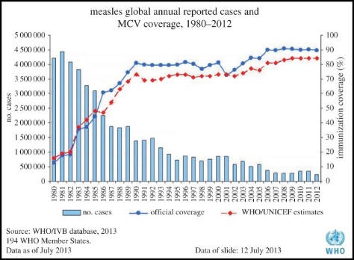
Figure 2 shows the current global distribution of the polio virus (Greenwood, 2014)
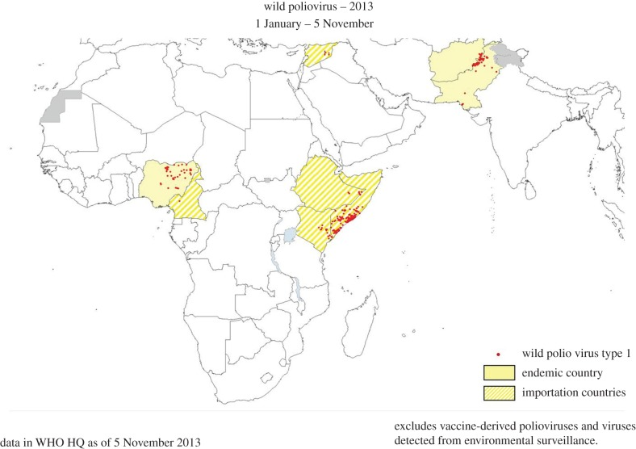
Figure 3 show how vaccination has changes the distribution of infection disease that are preventable yet that result to child mortality child mortality in 2012 (Bustreo, Okwo-Bele & Kamara, 2015)
