Volcanoes
What is a Volcano?
A volcano refers to a mountain, which opens downward towards a molten rock pool below the earth’s surface. Once pressure builds up, there emerges eruptions. Rock and gases shoot up via the opening and get spilled over or lava fragments fill the air. The eruptions have the potential of causing:
- Lava flows
- Lateral blasts
- Avalanches
- Hot ash flows
- Falling ash
- Avalanches
- Floods
The pictorial representation of a volcano is as shown below:
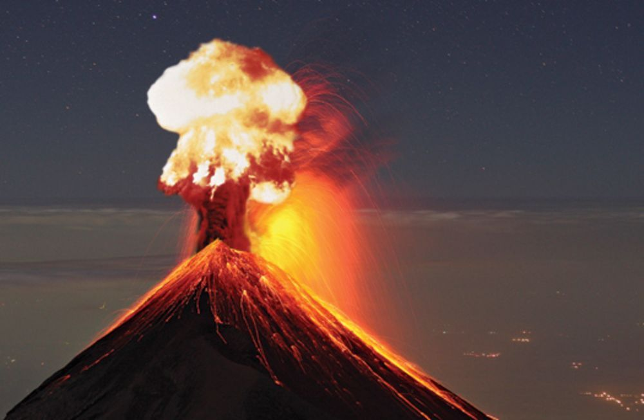
How are Volcanoes Formed?
Volcanoes are formed once magma from the earth’s upper mantle finds its way to the top surface. Within the surface, eruption occurs resulting to the formation of lava flows, as well as, ash deposits. In the course of time, the eruption of the volcano continues, getting bigger and bigger.
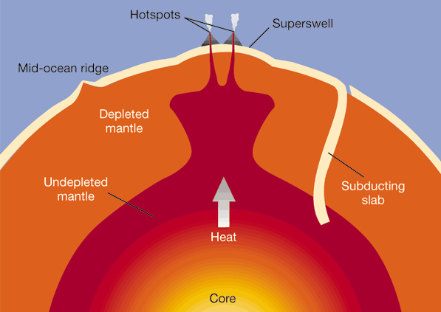

Different Categories of Volcanoes
Scientists have classified volcanoes into three major categories,
- Active volcanoes
- Dormant Volcanoes
- Extinct Volcanoes
Active volcanoes are the ones that have erupted in the recent times and are likely to erupt in the near future. On the other hand, dormant volcanoes are the ones that for a quite long time have not erupted but are likely to erupt within the future. Lastly, extinct volcanoes are the ones that erupted numerous years ago and are not likely to erupt in future.
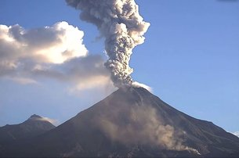Pictorial representation of an active volcano
A dormant volcano appears as shown below:
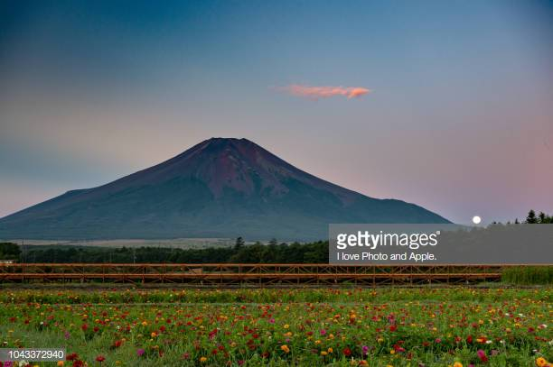
On the other side, extinct volcanoes are as presented below:
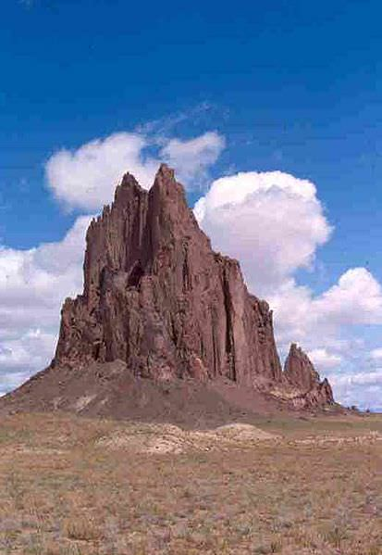

Why Do Volcanoes Erupt?
The crust of the earth is composed of huge slabs that are termed as plates. The plates fit together in a similar way as jigsaw puzzle. At sometimes, the plates move. The friction results to earthquakes together with volcanic eruptions within the plates’ edges. The theory which explains the aforementioned process is termed as plate tectonics.
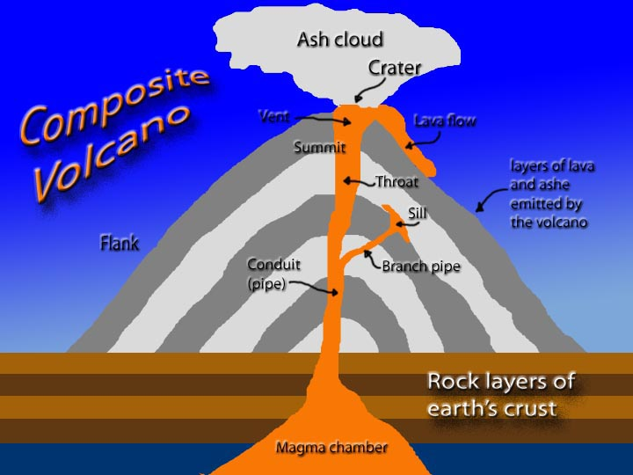
What are Plate Tectonics?
The plate tectonics theory is an interesting theory about continents drifting from one place to another, grinding and colliding against one another. The theory is supported by substantial amount of evidence which considers the crust of the earth and the upper mantle to be made up of diverse large, thin, considerably rigid plates which move relative to each other. The plates usually move in diverse directions and within different speeds. In some cases, the plates crash together, sideswipe one another or pull apart. Once this occurs, it basically results in earthquakes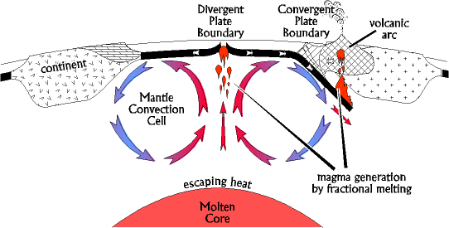

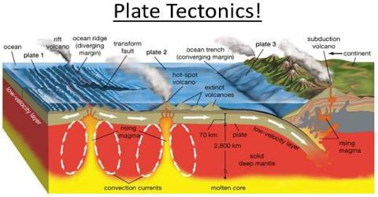.

What are the Number of Volcanoes on Earth?
The number of active volcanoes within the earth exceed 1500. As at present, it has been established that 80 or even more are under the oceans. Within the United States, the active volcanoes are mainly found in California, Hawaii, Washington, Alaska and Oregon.
Mount Cleveland, Alaska
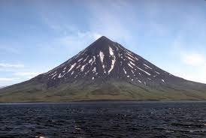
Kilauea Hawaii Volcanoes
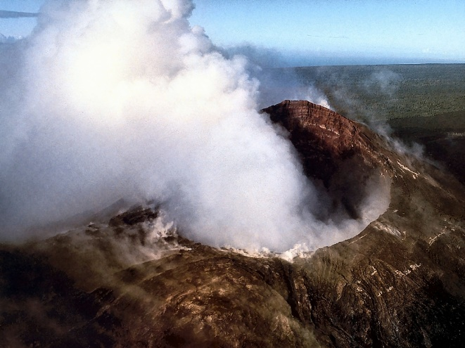The Different Types of Volcanoes
Volcanoes are categorized into four types. These are,
- Cinder cones
- Composite volcanoes
- Shield volcanoes
- Lava volcanoes
Cinder Cones
They are oval or circular cones composed of small lava fragments from a single vent which has been blown within the air, cooled before falling around the vent.

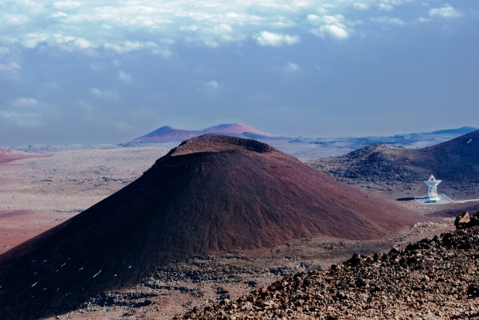
Composite Volcanoes
These are steep-sided volcanoes made up of several volcanic rocks layers, mostly originating from high-viscosity lava, rock debris and ash. Examples of such types of volcanoes are Mt. Rainier, as well as, Mt. St. Helens.
Mt. St. Helens
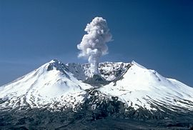

Mt. Rainier
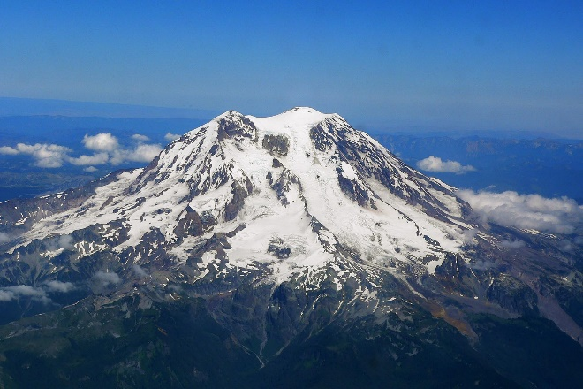
Shield Volcanoes
These are volcanoes that are shaped like a shield or bowl within the middle with slopes that are long and gentle that are made by the basaltic lava flows. The basalt lava flows that are from the shield volcanoes are termed as flood basalts. The volcanoes which led to the formation of the Columbia Plateau basalt were shield volcanoes.
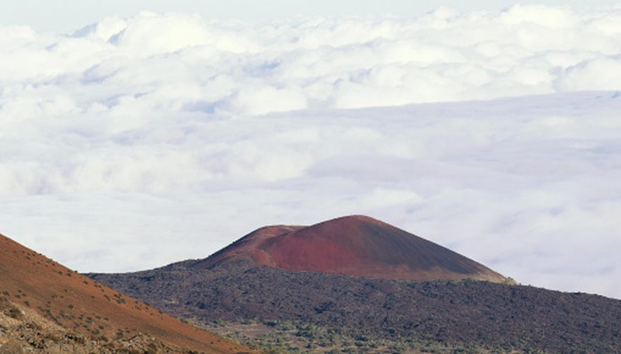Lava Volcanoes
These emerge after the formation of lava domes once erupting lava turn out to be too thick such that it cannot flow, thus piling up near the volcanic vent making a steep-sided mound. Mt. St. Helens eruption in 1980 was partly as a result of the shifting of a lava dome that allowed explosive gas, as well as, steam to emerge from the mountain.
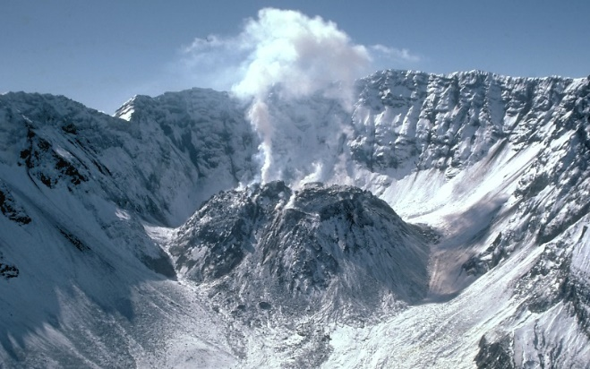

Reference
Sigurdsson, H., Houghton, B. F., McNutt, S. R., Rymer, H., & Stix, J. (2015). Encyclopedia of volcanoes. London, UK: Academic Press

