Name: World History - B
Date:
Name and date are required! You will lose points if you leave them off!
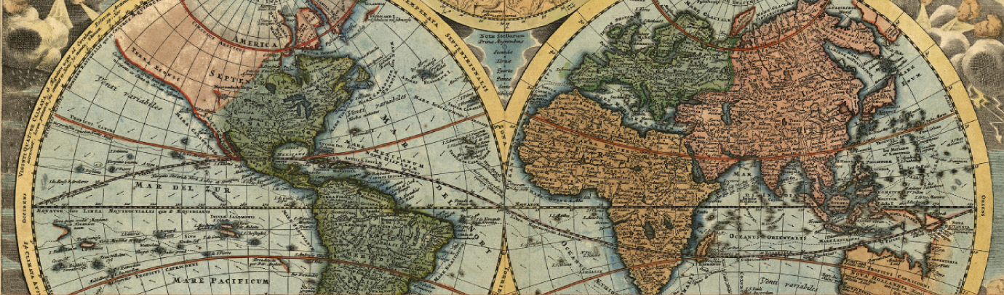
Unit 9 Section 1
Course overview: World History is a survey course covering from early civilizations to modern times, with emphasis on the political and philosophical roots of western democracy. Topics include: the rise of democratic governments; political, social and economic developments of the Middle Ages; the Renaissance and era of discovery; the growth of democracy and nationalism; the industrial revolution; and the two world wars. Postwar problems and recent developments are also studied.
CA State Standard:

10.10 Students analyze instances of nation-building in the contemporary world in at least two of the following regions or countries: The Middle East, Africa, Mexico and other parts of Latin America, and China. 1. Understand the challenges in the regions, including their geopolitical, cultural, military, and economic significance and the international relationships in which they are involved. 2. Describe the recent history of the regions, including political divisions and systems, key leaders, religious issues, natural features, resources, and population patterns. 3. Discuss the important trends in the regions today and whether they appear to serve the cause of individual freedom and democracy.

Assignments:
Chapter 29 Lesson 1: Nationalism in the Middle East
Worksheet: The Balfour Declaration
Worksheet: Redrawing the World
Chapter 29 Lesson 2: Nationalism in Africa and Asia
Worksheet: Gandhi and the Nonviolent Movement
Worksheet: Jawaharlal Nehru
Chapter 29 Lesson 3: Revolutionary Chaos in China
Worksheet: Chiang Kai-shek and China's Banking System
Worksheet: China's New Life Movement
Chapter 29 Lesson 4: Nationalism in Latin America
Worksheet: Political Cartoon
Worksheet: Diego Rivera, Pan American Fusion
Check-in 9.1

Packet Directions
- These packets are assessed coursework.
- You will be scored based upon completion, effort, and accuracy.
- All short answer questions are to be completed IN YOUR OWN WORDS! Answers copied from online sources will not receive credit
Unless a question specifically asks you to cite or quote from the text, answers copied word for word or cut and pasted from the online text (even with quotations) will be treated as copied and marked down. (See Inspire’s plagiarism policy in your course syllabus)
- When typing your responses please keep your answers in red font (when red font is provided)
- Packets are required to be uploaded as one whole unit and as one file (see the syllabus for details)
- Name and date are required! You will lose points if you leave them off!

-Content Vocabulary-
Directions: Use the textbook’s glossary to complete vocabulary words as you complete the unit. Looking them up online often gets you the wrong definition!
Genocide
Caliphate
Pan-Africanism
Civil disobedience
Redistribution of wealth

-Don’t forget to complete Key Assignment #9 due by 5/15-

-Chapter 29 Lesson 1: Nationalism in the Middle East-
Directions: Read each main idea. Use your textbook to supply the details that support or explain each main idea.

A. Main Idea: World War I had a devastating effect on the Ottoman Empire, which had already been in decline for more than a century.
1. Detail: In __________________ , the Ottoman Empire adopted a new constitution and placed __________________ on the throne.

2. Detail: However, the new sultan quickly __________________ the new constitution.

3. Detail: In 1908, the __________________ restored the Ottoman Empire’s __________________ but lacked strong support for their government.

4. Detail: The British, including adventurer __________________, encouraged nationalist __________________ to revolt against Ottoman rule.

5. Detail: As part of a policy to rid the Ottoman Empire of Christian Armenians and other minorities, the Armenians became the victims of __________________ at the hands of the Ottoman __________________ . An estimated one million Armenians died.

B. Main Idea: Turkey, Iran, and Saudi Arabia became modern states, while in Palestine, tensions mounted between Jewish and Muslim inhabitants.

1. Detail: The Turkish war hero __________________ , who became the first president of the __________________ of Turkey, abolished the __________________ and developed a modern Western state.

2. Detail: Persian Army officer __________________ led a military mutiny that seized control of Tehran, established himself as __________________ , and modernized the government, army, and economy of the nation that became __________________ .

3. Detail: Ottoman territories became League of Nations __________________ .

4. Detail: Reform leader __________________ united Arabs in the northern part of the Arabian Peninsula, which was free of European influence, and created the kingdom of __________________ .

5. Detail: The __________________ Declaration supported the creation of a Jewish homeland in __________________ .

Summary & Reflection

Directions: Using ideas from throughout the entire lesson, summarize the main ideas by answering the question below. Answers must be IN YOUR OWN WORDS. DO NOT RESEARCH ANSWERS ONLINE! Points awarded based on accuracy and effort.

How did nationalism affect political developments in the Ottoman Empire, Iran, Saudi Arabia, and Palestine?
Provide several examples from the textbook – the facts are from your book but the way you construct an answer with those facts needs to be your own unique style and word choice
Answer: __________

-Worksheet: The Balfour Declaration-
Arthur James Balfour, “The Balfour Declaration” (1917)
Background In 1897, Zionists held the First Zionist Congress in Basel, Switzerland. At that meeting, the congress members established a context for the Zionist movement and created a plan for a “Jewish State” in Palestine. Twenty years later, 117 words in a brief note from a British diplomat to the leader of British Jews became the basis of a major change in the Middle East and in world politics. The note, known as the Balfour Declaration, led Jews to believe that the demands for a Jewish state would be fulfilled. In fact, the Balfour Declaration is often cited as the first step in creating the modern state of Israel.
The area desired for the Jewish homeland was in the hands of the Ottoman Empire, which was at war with Britain in World War I. Although there were Jews living in Palestine, the majority of the population was Arab and Muslim. Arab nationalism in the area raised hopes of an Arab state in Palestine; however, the Arab Palestinians were not consulted about a possible homeland. The potential for clashes was great. It was not until 1948 that the modern state of Israel was established.

Directions: The following selections are from the Zionist Congress and the Balfour Declaration. Read the selections. Then, using information from these excerpts, answer the questions that follow.

Zionism seeks to establish a home for the Jewish people in Eretz Israel secured under public law. The Congress contemplates the following means to the attainment of this end: 1. T he promotion by appropriate means of the settlement in Eretz Israel of Jewish farmers, artisans, and manufacturers. 2. O rganizing and uniting all Jewry by means of appropriate institutions, both local and international, in accordance with the laws of each country. 3. S trengthening and fostering of Jewish national sentiment and national consciousness. 4. P reparatory steps toward obtaining the consent of governments, where necessary, in order to reach the goals of Zionism.
—The First Zionist Congress and the Basel Program, 1897

Foreign Office November 2nd, 1917
Dear Lord Rothschild:
I have much pleasure in conveying to you, on behalf of His Majesty's Government, the following declaration of sympathy with Jewish Zionist aspirations which has been submitted to, and approved by, the Cabinet:
His Majesty's Government view with favor the establishment in Palestine of a national home for the Jewish people, and will use their best endeavors to facilitate the achievement of this object, it being clearly understood that nothing shall be done which may prejudice the civil and religious rights of existing non Jewish communities in Palestine, or the rights and political status enjoyed by Jews in any other country.
I should be grateful if you would bring this declaration to the knowledge of the Zionist Federation.
Yours, Arthur James Balfour
—Arthur James Balfour, “The Balfour Declaration,” 1917

Questions for: Worksheet on The Balfour Declaration

1. Identifying Central Issues
What is the basic issue being addressed in these selections?
Answer: __________

2. Understanding Relationships
Among Events Why do you think the First Zionist Congress mentioned other institutions and governments in its goals?
Answer: __________

3. Drawing Conclusions
In what way did the Balfour Declaration fall short of Zionist desires?
Answer: __________

4. Identifying Perspectives
How do you think Arabs reacted to the Balfour Declaration?
Answer: __________

5. Drawing Conclusions
What role did nationalism play in the events surrounding the Balfour Declaration?
Answer: __________

6. Identifying Cause and Effect
How did the Balfour Declaration affect events in the Middle East?
Answer: __________

-Worksheet: Redrawing the World-
Following the end of World War I, the Ottoman Empire broke apart, resulting in the creation of many new nation-states. In order to monitor these new Middle Eastern territories, the League of Nations authorized the creation of a mandate system. A mandate was a territory that was judged not to be ready for self-government. The victorious Allied powers divided up the Asian and African possessions of the former Ottoman Empire as well as Germany into three classes. Middle Eastern areas were classified as Class A, or territories that were more “advanced.” The former Turkish provinces of Iraq and Palestine (including modern Israel and Jordan) became British mandates while Syria and Lebanon were accorded to France. The map and legend below indicate the status of these nations and the dates of their eventual independence.

Widespread resentment of outside rule inspired nationalistic movements. As a result, three powerful nations—Turkey, Iran, and Saudi Arabia—emerged as independent states without passing through the intermediate stage of the mandate system.

Under the leadership of Kemal Atatürk, Turkey became a secular republic in 1923, rejecting Islamic religious influences. He also greatly boosted literacy, replacing Arabic script with the Latin alphabet for the writing of Turkish.

In Iran, then known as Persia, nationalistic sentiments were inflamed by the presence of British advisors and foreign oil investors. In 1925, Reza Shah Pahlavi was proclaimed the king, or shah. Like Atatürk, he undertook sweeping reforms, emancipating women, establishing the country’s first university, and building roads, schools, and hospitals.

Finally, in Saudi Arabia, Ibn Sa‘ūd exploited religion to unify his country. In 1932, after 30 years of conflict, he formally consolidated most of the Arabian Peninsula as the Kingdom of Saudi Arabia, with himself as monarch.
Despite their differences, all three leaders used modernization and, in the case of Iran and Saudi Arabia, abundant oil deposits to benefit their nations.

Questions for: Worksheet: Redrawing the World
Understanding Concepts
1. Reading Maps
Which countries were British mandates (colonies) after World War I?
Answer: __________

2. Analyzing
Why might the mandate system have led to resentment and instability and hastened the development of nationalist movements after the breakup of the Ottoman Empire?
Answer: __________

3. Comparing and Contrasting
On the chart, list two important similarities shared by these three countries: Turkey, Iran, and Saudi Arabia. Then list two significant differences among these countries.
Similarities: | Differences

Applying Concepts
4. Drawing Conclusions Did modernization have an overall positive impact on the development of the Middle East after World War I, or did it have an overall negative impact? Briefly explain, providing support for your answer from the article.
Answer: __________

5. Making Connections
How do religion, politics, economics, and geography continue to cause tensions in the Middle East? Briefly explain your answer.
Answer: __________

-Chapter 29 Lesson 2: Nationalism in Africa and Asia-
Directions: Read the lesson and complete the outline below. Refer to your textbook to fill in the blanks.

I. African Independence Movements
A. After World War I, leaders throughout Africa such as Omar Mukhtar of __________________ and Jomo Kenyatta of __________________ sought to end colonial rule.

B. The ideas of __________________ and __________________ influenced young African leaders educated in the United States.

II. Revolution in Southeast Asia
A. In 1920, Lenin established a new organization aimed at societies outside the Western world known as the _______________ to spread the philosophy of ________________ and advance the cause of world revolution.

B. As a result of Lenin's efforts, by the end of the __________________ , almost every Asian society had a __________________ party.

III. Indian Independence
A. Led by __________________, the Indian National Congress employed nonviolent __________________ to seek Indian self-rule and independence from Britain.

B. In response to nonviolent protests such as the __________________ March, the British Government in 1935 passed the __________________ and expanded the role of Indians in government.

C. The branch of the independence movement associated with __________________ was religious, anti-Western, and traditional, while the branch associated with __________________ was secular, Pro-Western, and modern. IV.

IV. Militarist Japan
A. The __________________ controlled major segments of the Japanese industrial sector.

B. Economic hardships led some to call for a return to traditional Japanese values and some to call for Japan to use its strength to dominate __________________.

C. Western governments opposed Japan’s policy of __________________ territory to obtain raw materials and supported the territorial integrity of __________________.

D. During the 1930s, Japan conquered all of __________________. By 1938, Japan had merged all __________________ into the Imperial Rule Assistance Association, which called for further expansion abroad.

Summary & Reflection

Directions: Using ideas from throughout the entire lesson, summarize the main ideas by answering the question below. Answers must be IN YOUR OWN WORDS. DO NOT RESEARCH ANSWERS ONLINE! Points awarded based on accuracy and effort.

What forms did twentieth-century nationalism take in Africa and Asia?
Provide several examples from the textbook – the facts are from your book but the way you construct an answer with those facts needs to be your own unique style and word choice

Answer: __________

-Worksheet: Gandhi and the Nonviolent Movement-
Background Most people generally think of independence movements as being violent revolutions. Yet the leader of the Indian nationalist movement, Mohandas K. Gandhi, used a nonviolent approach to protest British rule in India. Inspired by his religious beliefs—which included respect and tolerance for all living things—Gandhi encouraged the people to practice satyagraha, or nonviolent resistance to British injustice. Gandhi’s methods included fasting (giving up food), peaceful marches, and boycotts of British schools, courts, and businesses.
One of Gandhi’s most famous nonviolent demonstrations was the Salt March. The British Salt Acts made it illegal for Indians to produce or sell their own salt; instead, they were required to buy expensive, heavily taxed salt from British merchants. In March of 1930, Gandhi led a group of protesters on a march to the coast, where they broke the law by picking up salt from the shore. The demonstration inspired thousands of Indians to practice civil disobedience and led to the arrest of around 60,000 people (including Gandhi himself) by the end of the year.
Gandhi’s methods of nonviolent resistance had a powerful impact on the British—and on leaders around the world. In 1931, he was invited to negotiate a truce with the British. His efforts would later inspire world leaders such as Martin Luther King Jr. to practice nonviolence in their own political struggles.

Directions: Analyze the photographs and read the selection from Gandhi’s Non-Violent Resistance. Then answer the questions that follow.
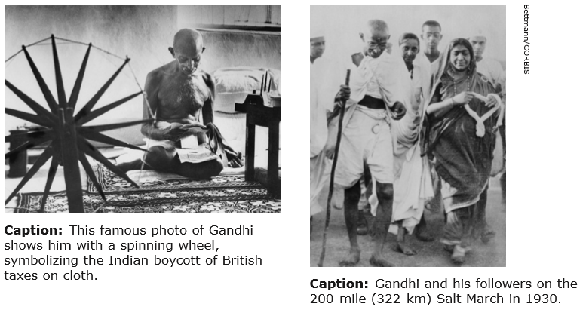
Passive resistance is a method of securing rights by personal suffering; it is the reverse of resistance by arms. When I refuse to do a thing that is repugnant to my conscience, I use soul-force. For instance, the Government of the day has passed a law which is applicable to me. I do not like it. If by using violence I force the Government to repeal the law, I am employing what may be termed body-force. If I do not obey the law and accept the penalty for its breach, I use soul-force. It involves sacrifice of self.
—Mohandas K. Gandhi, Non-Violent Resistance (Satyagraha), 19

Questions for: Worksheet on Gandhi and the Nonviolent Movement
1. Explaining
How does each photograph shows an example of nonviolent resistance?
Answer: __________

2. Summarizing
According to Gandhi, what is the difference between passive resistance and resistance by arms?
Answer: __________

3. Synthesizing
Do you think Gandhi would have considered the protest methods shown in the photographs to use body-force or soul-force? Explain.
Answer: __________

4. Analyzing
In what ways was Gandhi’s Indian nationalist movement a turning point in history?
Answer: __________

-Person Profile: Jawaharlal Nehru-
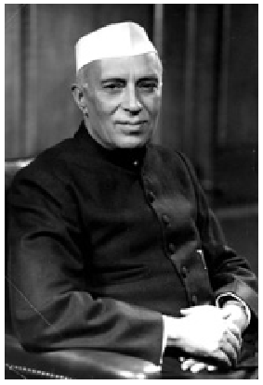
Jawaharlal Nehru (1889–1964)
Jawaharlal Nehru was the first prime minister of independent India. He was born into a Brahmin (upper-class) family and was educated by English tutors. His father was a well-known lawyer who worked closely with Mahatma Gandhi. Nehru met Gandhi, who was 20 years older, for the first time in 1916. Over the next 30 years, Nehru worked alongside Gandhi for Indian independence. As a fellow member of the Indian National Congress and a political activist, Nehru was jailed nine times between 1921 and 1945 for noncooperation with the British government. He played a leading role in the three way negotiations with the British that led to independence for India and Pakistan in 1947. Nehru served as India’s prime minister from 1947 until his death in 1964.
As India’s leader, Nehru’s foreign policy included a principle of nonalignment, or refusal to take sides in the Cold War. He also tried to develop India’s economy and adapt modern ways of thinking to Indian traditions. Under Nehru’s leadership, India’s industrial production almost tripled between 1950 and 1965.
More About the Image: This photograph of Indian Prime Minister Jawaharlal Nehru was taken on January 1, 1955.

Please use the information above to answer the questions below – answers taken from other sources will not receive credit
1. Making Inferences
Nehru was educated in England. How might this have helped him in his political life?
Answer: __________

2. Analyzing
How might the age difference between Nehru and Gandhi have affected their work together?
Answer: __________

3. Interpreting Significance
Why was it important for a newly independent India to have a leader like Nehru? Explain.
Answer: __________

-Chapter 29 Lesson 3: Revolutionary Chaos in China-
Directions: Locate each heading below in your textbook. Then use the information under the correct heading and subheading to help you write each answer.

I. Nationalists and Communists
A. What was the purpose of the alliance between the Nationalists and the Communists?
Answer: __________

B. a) When did the Nationalist-Communist alliance split? b) What did the Communists do after the split?
Answer a): __________

Answer b): __________

C. What was the reaction of the Nationalists to Communist activities in China?
Answer: __________

D. How did Mao Zedong and his followers avoid defeat at the hands of the larger Nationalist forces?
Answer: __________

E. What was the Long March?
Answer: __________

II. The New China
A. How did Chiang Kai-shek plan to ease the Chinese people into a Republican form of government?
Answer: __________

B. What problems did China need to overcome before creating a new China?
Answer: __________

C. What was the goal of the New Life Movement?
Answer: __________

D. What successes did Chiang Kai-shek have in shaping a new China?
Answer: __________

Summary & Reflection

Directions: Using ideas from throughout the entire lesson, summarize the main ideas by answering the question below. Answers must be IN YOUR OWN WORDS. DO NOT RESEARCH ANSWERS ONLINE! Points awarded based on accuracy and effort.

What struggles did Mao Zedong and Chiang Kai-shek face as they each tried to advance their ideas of a new Chinese state?
Provide several examples from the textbook – the facts are from your book but the way you construct an answer with those facts needs to be your own unique style and word choice

Answer: __________

-Worksheet: Chiang Kai-shek and China’s Banking System-
Central banks can play a highly significant role in the economic and monetary policies of nations. Prominent examples include the Federal Reserve System in the United States (established in 1913) and the Bank of England in the United Kingdom (established in 1694).

Because Chiang Kai-shek wished to reunify China and put the new Chinese republic on a more solid economic footing, he vigorously supported the creation of a central bank. Chiang Kai-shek reportedly said, “The establishment and function of the central bank is the base for the consolidation of central government and China’s political construction.”

In October 1928, Chiang Kai-shek succeeded in establishing the new Central Bank of China. However, there was substantial disagreement between Chiang Kai-shek and leading Chinese bankers over several important issues. These included the allowance of private shares and the nature of the new bank’s relationship to the government.
When domestic debt was reorganized in 1932 and 1936 due to rising loan service costs, monetary policies included the reduction of interest rates and more time for clients to pay back debts. This restructuring also increased profits for the lenders who loaned money to the Chinese government.

In addition, individual tycoons dominated the four most important, preexisting banks and used these banks for their political and personal profit. These pre-existing banks and their tycoons hindered the success of Chiang Kai-shek’s Central Bank because modern banking facilities were spread unevenly throughout the country, and the Central Bank found itself continually bailing out a debt-ridden government.
Please use the information above to answer the questions below – answers taken from other sources will not receive credit
1. Explaining Why is a central bank often an important force in a nation’s economic and monetary policies?
Answer: __________

2. Analyzing Why did Chiang Kai-shek energetically support the creation of a central bank in China in the late 1920s?
Answer: __________

3. Making Generalizations Based on the information provided, what generalization might you make about the success (or lack thereof) of Chiang Kai-shek’s Central Bank of China? Cite two supporting details for your generalization.
Answer: __________

-Worksheet: China’s New Life Movement-
Background The New Life Movement created by Chiang Kai-shek and his wife, Soong Mei-ling, represented a combination of ancient Confucian values and Christian teachings. It was based on the principles of Li (propriety or correct behavior), Yi (justice or right conduct), Lien (integrity), and Ch’ih (honor). Using those principles as a foundation, the couple launched a program of rules and regulations for the Chinese people to follow.
The rules ranged from the trivial and mundane (for example, prohibiting spitting, smoking, gambling, and vulgar behavior; prescribing appropriate dress and hairstyles) to the practical and serious (for example, promoting basic hygiene, birth control, and infant care; prohibiting bribery, extortion, and other corrupt business practices). To implement the program, the couple recruited thousands of volunteers throughout China. A corps of trusted army officers known as Blue Shirts, aided by the police and the Boy Scouts, enforced the program and reported any serious wrongdoing to the central government.

Though Chiang and Mei-Ling’s attempts to unify and mobilize the Chinese people were undoubtedly sincere, the methods they employed to enforce the program severely undermined its effectiveness. Intellectuals were critical of the superficiality and hypocrisy of the program. Many individuals, from ordinary citizens to the business and political elite, resented the enforcement practices and simply ignored the rules or found ways to get around them. Finally, most of the rural peasants, who made up over 80 percent of the population, did not understand the program, knowing only that nothing was being done to meet their needs. The inability or unwillingness of the Nationalist government to address the problems of this segment of the population would eventually prove fatal to Chiang Kai-shek and Mei-Ling’s plans for a modern China under Nationalist rule.

Directions: The selection is from the January 3, 1938 issue of Time magazine about Time’s Man & Wife of the Year for 1937. Read the selection. Then answer the questions that follow.

In China no great moral stigma had commonly attached to graft. It was the custom of nearly every official who could to collect it. For the colossal purchases Chiang had to make, he could not afford the normal luxury of graft. To find someone he could trust to purchase war planes the Generalissimo turned at last in desperation to his own wife. She it was who pored over aircraft catalogs, dickered with hard-boiled white salesmen, and is reputed to have had several Chinese officials of her Air Ministry shot to reduce thieving. What Chinese officialdom needed, the Generalissimo & Mme Chiang had decided, was a big dose of the castor oil of Puritanism. The tablespoon with which they dished this out they called the New Life Movement, and with every ounce of Nanking’s authority they dosed all China. Batch after batch of local mayors and magistrates were ordered to Nanking, drilled and exhorted there in the primary decencies—to stop wiping noses on sleeves, to stop taking bribes from litigants. They were warned that he who did not practice the new Puritanism might expect the worst—and this was no empty threat. . . . [Thus] the New Life Movement . . . was successfully enforced. The Generalissimo & Mme Chiang had individuals whom they trusted planted unobtrusively in all branches of the Government. These spies for Puritanism reported direct, and in Nanking not a few errant officials’ careers were mysteriously broken.
—Time magazine, “Man & Wife of the Year,” 1938

Questions for: Worksheet on China’s New Life Movement
1. Identifying
What are your impressions of Chiang Kai-shek and Mei-Ling in the Time article?
Answer: __________

2. Interpreting
Explain the meaning of the extended metaphor in the second paragraph. a) What was the “big dose of castor oil”? b) What was the “tablespoon”? c) To what did “every ounce of Nanking authority” refer? d) How were these items connected or related to one another?
Answer a): __________
Answer b): __________
Answer c): __________
Answer d): __________

3. Analyzing Secondary Sources
What did Chiang Kai-shek and Mei-Ling hope to achieve by creating and implementing the New Life Movement? Use what you have learned to answer this question.
Answer: __________

4. Evaluating
To what degree do you think the couple succeeded in achieving their goals for the New Life Movement? Use what you have learned to answer this question.
Answer: __________

-Chapter 29 Lesson 4: Nationalisms in Latin America-
Directions: Read the lesson and complete the outline below. Refer to your textbook to fill in the blanks.
I. The Latin American Economy
A. American investors in __________________ , unlike the British, put their funds directly into __________________ facilities and ran companies themselves.

B. President __________________ Good Neighbor policy called for an end to U.S. military involvement in Latin America.

C. Due to a reduced demand for Latin American __________________ and raw materials during the Great Depression, Latin American nations began to encourage the development of new industries to produce __________________ goods.

II. Authoritarian Rule
A. In most Latin American countries, an elite group ruled the country with the help of the military behind the guise of a __________________ form of government.

B. The __________________ that ruled Argentina and Brazil failed to grasp the importance of industry and the working class that came with it.

C. Getulio __________________ made himself __________________ of Brazil in 1937. While silencing his opponents and restricting civil rights, he stimulated new industries in Brazil.

D. The __________________ government, basically democratic in form, was controlled by party bosses of the Institutional __________________ Party, or PRI, which was formed during the __________________ revolution.

E. After President __________________ paved the way for large investments by foreign companies in Mexico, he seized control of the oil fields and eventually set up a national oil company called __________________ .

III. Culture in Latin America
A. Latin American artists incorporated __________________ modern art techniques into their work while expressing their own __________________ and native roots.

B. Diego __________________ in Mexico is an example of the artists and writers who used their work to promote a new national spirit. He sought to create a national art that would portray Mexico’s __________________ as well as festivals and __________________ customs.

C. His work also focused on __________________ and __________________ themes such as the Spanish conquest of the Aztecs and the Mexican Revolution.

Summary & Reflection

Directions: Using ideas from throughout the entire lesson, summarize the main ideas by answering the question below. Answers must be IN YOUR OWN WORDS. DO NOT RESEARCH ANSWERS ONLINE! Points awarded based on accuracy and effort.

How did the Great Depression influence politics in Latin America?
Provide several examples from the textbook – the facts are from your book but the way you construct an answer with those facts needs to be your own unique style and word choice
Answer: __________

-Worksheet: Political Cartoon-
When analyzing a political cartoon, it is important to pay close attention to all the visual details the cartoonist provides. Political cartoonists use specific graphic features to aid interpretation. Look for a title, if one is given, and notice any labels, captions, or commentary that explain parts of the cartoon. Note any dialogue: Who is saying what to whom? Next, observe the way the cartoon is composed, or arranged, so that you can tell what the cartoonist wants you to focus on: What is exaggerated, or caricatured, in the characters’ expressions, postures, or actions? What do you notice about the setting, characters’ clothing, and other details? Finally, ask yourself what the cartoonist’s point of view toward his or her subject seems to be. What evidence of a positive or negative bias do you see?

Directions: The political cartoon below depicts one cartoonist’s view of President Franklin Roosevelt’s Good Neighbor Policy. Look closely at the cartoon, analyze it, and answer the questions below.

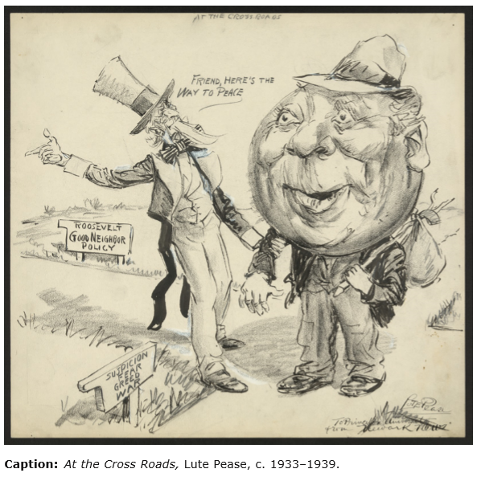
Background In the decades before the 1930s, the United States practiced a much-resented military and economic interventionist policy in Central and South America. This changed when President Franklin D. Roosevelt took office and decided to change the world’s view of the United States. In his inaugural speech of 1933, Roosevelt announced, “In the field of world policy, I would dedicate this Nation to the policy of the good neighbor—the neighbor who resolutely respects himself and because he does so respects the rights of others—the neighbor who respects his obligations and respects the sanctity of his agreements in and with a world of neighbors.” Although this announcement of the Good Neighbor Policy was directed to the whole world, it soon became focused on U.S. relations with Latin America.

In response to Latin America’s economic hardships, the policy included various aid programs. This aid enabled the continued growth of native industries to supply Latin America’s needs, a growth that had begun out of necessity during the Great Depression and continued through World War II. As a result of the popular Good Neighbor Policy, relations between the United States and Latin America greatly improved, and Latin American nations cooperated fully with the United States against the Axis powers during World War II.

The political cartoon “At the Cross Roads” was created sometime between 1933 and 1939. The cartoon shows Uncle Sam, a traditional symbol of the United States, trying to direct a hobo-like man with a huge, round head (possibly representing the world, as the bulbous head resembles a globe) toward Roosevelt’s “Good Neighbor Policy” and away from “Suspicion, Fear, Greed, War.” Lucius (Lute) Curtis Pease (1869–1963) worked as a political cartoonist for the Newark Evening News in New Jersey from 1914–1954. In 1949 he won the Pulitzer Prize for one of his political cartoons.

Questions for: Worksheet on Political Cartoon

1. Interpreting
A crossroad is often used as a metaphor for a “turning point,” or a moment that calls for a crucial choice to be made. What does the crossroad in this cartoon stand for?
Answer: __________

2. Interpreting
Using what you have learned about Roosevelt’s Good Neighbor Policy, explain the meaning of this cartoon.
Answer: __________

3. Drawing Conclusions
Do you think that the cartoonist has a positive or negative bias toward Roosevelt’s Good Neighbor Policy? What evidence makes you say so?
Answer: __________

4. Synthesizing
Even today, political cartoonists use established symbols such as elephants (Republicans) and donkeys (Democrats) to convey political messages. Why are such symbols important tools of political cartoonists?
Answer: __________

-Worksheet: Diego Rivera, Pan American Fusion-
Background Mexican painter Diego Rivera (1886–1957) helped create a unique national art by combining European painting styles with Mexican themes. As a young man, Rivera studied art in Europe and was particularly inspired by the fresco paintings found on walls throughout Italy. When he returned to Mexico in 1921, Rivera was commissioned to paint murals on the walls of several important public buildings in Mexico City. Although he used techniques he learned in Europe, the themes of his murals reflected the history and culture of his native country. Using bright, bold colors, Rivera painted scenes that depicted Mexican industry and agriculture, as well as the diverse cultural traditions of the Mexican people.

In the early 1930s, Rivera spent time traveling and painting in cities throughout the United States, including San Francisco. In 1940, architect Timothy L. Pflueger invited Rivera to return to San Francisco to participate in a new exhibit at the Golden Gate International Exposition (G.G.I.E.). The exhibit, called “Art in Action,” would give visitors to the exposition a chance to watch famous painters, sculptors, and other artists while they worked. Rivera accepted his friend’s invitation, and he decided to paint a mural that depicted the fusion of cultures between North and South America. Rivera named the artwork Marriage of the Artistic Expression of the North and South on this Continent, or more simply Pan American Fusion. When completed, it covered ten steel-framed panels and was one of the most popular works of the exhibit.

Directions: Read the letter from Diego Rivera to Timothy L. Pflueger. Then answer the questions that follow.

I am most happy to accept your kind invitation to participate in the G.G.I.E. and paint a fresco in the Palace of Fine Arts, on the condition that I be [permitted] to make this my personal contribution toward the promotion of good will between our countries and because of my great affection for my friends in San Francisco who made my [previous] stay in San Francisco such a pleasant one. For years I have felt that the real art of the Americas most came as a result of the fusion of the machinism and new creative power of the [north] with the tradition rooted in the soil of the south, the Toltecs, Tarascans, Mayas, Incas, etc., and would like to choose that as the subject of my mural. I am enthusiastic about this project and shall look forward eagerly to the pleasure of again seeing and being with you and my many other friends in San Francisco.
—Letter from Diego Rivera to Timothy L. Pflueger, April 15, 1940

In this mural I projected the idea of the fusion of the genius of the South (Mexico), with its religious ardor and its gift for plastic expression, and the genius of the North (the United States), with its gift for creative mechanical impression. Symbolizing this union—and focal point of the whole composition—was a colossal Goddess of Life, half Indian, half machine. She would be to the American civilization of my vision what Quetzacóatl, the great mother [sic] of Mexico, was to the Aztec people. I depicted the South in the period before Cortés. The outstanding physical landmarks were the massive and beautiful snow-crowned Popocatépetl and Ixtaccíhuatl. Nearby were the temples of Náhuatl [sic] and Quetzacóatl and the temple of the plumed serpent. Also portrayed were the Yaqui Deer Dancers, pottery makers, and Netzahualcóyotl, the Aztec poet-king of Texcoco who designed a flying machine.
—Diego Rivera, from My Art, My Life: An Autobiography, 1960

Questions for: Worksheet on Diego Rivera, Pan American Fusion

1. Analyzing Primary Sources
What are Rivera’s motivations for accepting Pflueger’s invitation?
Answer: __________

2. Identifying Central Issues
a) What does Rivera choose to be the subject of his mural? b) How does this reflect his beliefs about the nature of American art?
Answer a): __________

Answer b): __________

3. Drawing Conclusions
Rivera mentions “the Toltecs, Tarascans, Mayas, Incas, etc.” when he explains the subject of his mural. Why would Rivera include these groups in a mural about the fusion of North and South American artistic traditions?
Answer: __________

4. Comparing and Contrasting
a) How is Rivera’s original intent in his letter similar to his recollections in his autobiography? b) How do the two sources differ?
Answer a): __________

Answer b): __________

-STOP!-
Do not move on to Unit 9 Section 2 until you have completed the Check-in 9.1.

-STOP!-
Key Assignment is due prior to taking the Unit Test and before moving to the next Unit.

