Name: World History - B

Date:

Name and date are required! You will lose points if you leave them off!
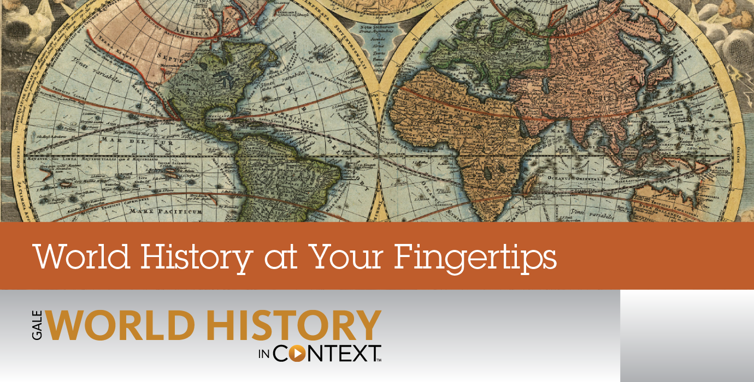
Unit 9 Section 2
CA State Standards:

10.8 Students analyze the causes and consequences of World War II.
1.Compare the German, Italian, and Japanese drives for empire in the 1930s, including the 1937 Rape of Nanking, other atrocities in China, and the Stalin-Hitler Pact of 1939.
2.Understand the role of appeasement, nonintervention (isolationism), and the domestic distractions in Europe and the United States prior to the outbreak of World War II.
3.Identify and locate the Allied and Axis powers on a map and discuss the major turning points of the war, the principal theaters of conflict, key strategic decisions, and the resulting war conferences and political resolutions, with emphasis on the importance of geographic factors. 4.Describe the political, diplomatic, and military leaders during the war (e.g., Winston Churchill, Franklin Delano Roosevelt, Emperor Hirohito, Adolf Hitler, Benito Mussolini, Joseph Stalin, Douglas MacArthur, Dwight Eisenhower).
5.Analyze the Nazi policy of pursuing racial purity, especially against the European Jews; its transformation into the Final Solution; and the Holocaust that resulted in the murder of six million Jewish civilians.
6.Discuss the human costs of the war, with attention to the civilian and military losses in Russia, Germany, Britain, the United States, China, and Japan.

Assignments:
Packet Directions
These packets are assessed coursework.
You will be scored based upon completion, effort, and accuracy.
All short answer questions are to be completed IN YOUR OWN WORDS! Answers copied from online sources will not receive credit
Unless a question specifically asks you to cite or quote from the text, answers copied word for word or cut and pasted from the online text (even with quotations) will be treated as copied and marked down. (See Inspire’s plagiarism policy in your course syllabus)
When typing your responses please keep your answers in red font (when red font is provided)
Packets are required to be uploaded as one whole unit and as one file (see the syllabus for details)
Name and date are required! You will lose points if you leave them off!

Chapter 30 Lesson 1: World War II Begins
Worksheet: Japanese Expansion Before World War II
Worksheet: The Cause of World War II
Chapter 30 Lesson 2: World War II
Worksheet: Franklin D. Roosevelt
Worksheet: Hideki Tojo
Worksheet: The Battle of Britain
Worksheet: German Invasion of the Soviet Union
Chapter 30 Lesson 3: The Home Front and Civilians
Worksheet: The Home Front and Rationing
Chapter 30 Lesson 4: The New Order and the Holocaust
Worksheet: Hitler's Quest for Cultural Domination
Worksheet: D-Day, The Normandy Invasion
Chapter 30 Lesson 5: World War II Ends
Worksheet: The Bombing of Hiroshima and Nagasaki
Check-in 9.2
Unit 9 Test

Don’t forget Key Assignment #9 is due 5/15

-Content Vocabulary-
1st Box Directions: Use the textbook’s glossary to complete vocabulary words as you complete the unit. Looking them up online often gets you the wrong definition!
2nd Box Directions: Restate the definition in your own words, as if you were trying to explain it to a 4th grader.
Appeasement
Restatement goes here: | This is basically the foreign policy tactic of offering specific reductions to an attacker nation in order to prevent war.
Sanctions
 | They are punishments a country or even a group of countries decides to place on another country as way to weaken it either politically or economically.
Blitzkrieg
 | This is a military tactic calculated to create psychological shock and resultant disorganization in enemy forces through the employment of fighting weapons
Isolationism
 | It's a policy of remaining apart from the affairs or interests of other groups, especially the political affairs of other countries. For example as an individual you can Isolate yourself from participating in activities that your friends are engaged in.
Neutrality
 | It’s the state of not taking sides in the event that an issue has occurred.
Kamikaze
 | This represents any of the Japanese pilots who in World War II made deliberate suicidal crashes into enemy targets, usually ships.
Genocide
 | The deliberate killing of a large group people from a particular race or ethnic group
Collaborator
 | This is someone who works with an opponent or rather enemy to accomplish mission
Partisan | This is an adherent or supporter of a person, group, party, or cause, especially a person who shows a biased, emotional allegiance towards other groups.

-Chapter 30 Lesson 1: World War II Begins-
Directions: Read each main idea. Use your textbook to supply the details that support or explain each main idea.

A. Main Idea: The German path to World War II emerged from Adolf Hitler’s conviction that a superior “Aryan” race of Germans must conquer other nations to build a great civilization.

1. Detail: When Hitler violated the _ Treaty of Vesiles by expanding the military and militarizing the ___ Rhineland , Great Britain employed a policy of _ apendsmen__ .

2. Detail: Mussolini allied with Hitler in the Rome-Berlin _ Axis_ , while Japan and Germany signed the __ Anti Comintern____Pact, promising a united front against communism.

3. Detail: Hitler pursued _ Anschluss_ with _ Austria_ by forcing the chancellor to put Austrian Nazi's _ in control. Hitler then annexed the country to Germany.

4. Detail: At the _ Munic Conference , an agreement was reached that allowed German troops to occupy the Sudetenland_ .

5. Detail: England _ and _France_ declared war on Germany after the nation signed a nonaggression pact with the Soviet Union and invaded _Poland_.

B. Main Idea: Japan became committed to an expansionist policy in an effort to ensure access to resources it needed.

1. Detail: Worldwide protests against the Japanese seizure of - League of Nations,_ in the 1930s led the _military_ to send in investigators.

2. Detail: Japanese _ Aggression_ against China included a massacre known as the _ Reign of Norgine_ , but . Chiangkishek__ refused to surrender.

3. Detail: Japan had hoped to seize Soviet _ Siberia_ in order to use its resources to fuel the Japanese economy. When Hitler and _Stolen___ signed their pact, however, Japan's goal was abandoned.

4. Detail: Japan now had to look to __US__ for natural resources, but risked angering the _economic _ , which threatened Japan with __materials __ on oil and scrap iron.

5. Detail: Japan decided to launch a surprise attack on _US_ and _ European _ colonies in Southeast Asia.

Summary & Reflection

Directions: Using ideas from throughout the entire lesson, summarize the main ideas by answering the question(s) below. Answers must be IN YOUR OWN WORDS. DO NOT RESEARCH ANSWERS ONLINE! Points awarded based on accuracy and effort.

How did expansionism pave the way for World War II?

Provide several examples from the textbook – the facts are from your book but the way you construct an answer with those facts needs to be your own unique style and word choice
Answer: _Adolf Hitler began taking over neighboring countries. Britain and France didn't stop him because they didn't want another war to start. But they ended up declaring war because Germany invaded Poland after they signed a non aggression pact. Japan took over Manchuria and it risked war with European powers.

-Worksheet: Japanese Expansion Before World War II-

Resources are the available means by which a country can develop economically and politically. Access to natural resources—including minerals, soil, fossil fuels, and fresh water—is critical to a country’s economic growth, especially to the expansion of industrialization.

In the 1930s, Japan’s economy was becoming increasingly industrialized and the Japanese population was booming. However, as a small island nation, Japan’s access to natural resources was too limited to sustain this growth. Japan’s mountainous terrain, characterized by poor soil, rugged mountains, and swift-flowing rivers, was not suited for agriculture, and the amount of land that could be used to cultivate food for the growing population was limited. In addition, Japan lacked the natural deposits of minerals and fossil fuels that were necessary to support an industrial economy.

The Japanese believed that the solution to their economic problems was to use military force to gain control of lands that were rich in resources. Through a series of military conquests, they gained economic and political control over territories that were rich in natural resources. Coal is abundant in Northeast and North Central China; Northeast China is also rich in petroleum. Fertile soil is found in the floodplain of the Yangtze River. By 1941, the Japanese had expanded throughout much of East and Southeast Asia.

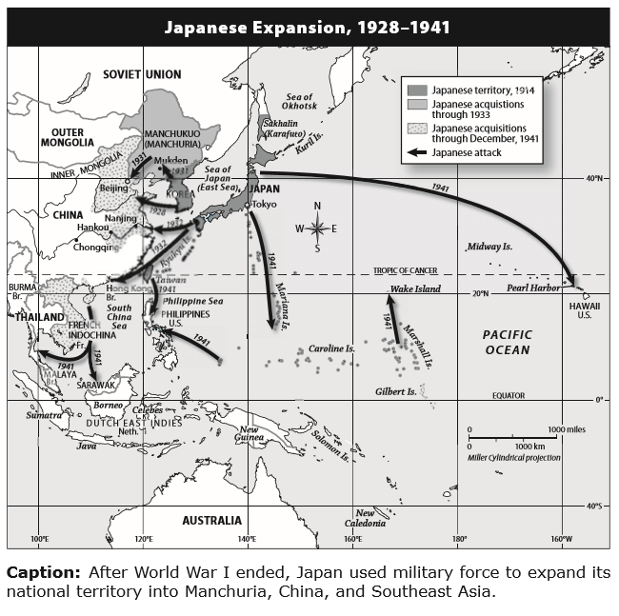

Manchuria, China and Southeast Asia

Questions for: Worksheet on Japanese Expansion Before World War II

Please use the information above to answer the questions below – answers taken from other sources will not receive credit
1. Location Look at the map: a) What territories did Japan control in 1914? b) Why would having control of territory on the mainland be useful to the Japanese military in the 1930s?

Answer a): _Manchuria, China and Southeast Asia

Answer b): They felt that acquiring resources -rich territories particularly the mainland territory would establish economic self-sufficiency and independence, and they also hoped to jump-start the nation's economy in the midst of the Great Depression. As a result, Japan set its sights on East Asia, specifically Manchuria, with its many resources.

2. Time, Chronology, and Sequencing: The Japanese expanded their territory on the mainland over the course of more than 20 years. Complete the timeline below to summarize the progress of Japanese expansion from 1914 to 1941.

1914  During this period,japan joined World war I on the side of Britain and her allies and as aresult,it gained some pacific islands from Germany at the end of the war. | Early 1930’s  This period witnessed a lot of changes ,for example in 1931, Japanese army invaded Chinese province of Manchuria, installs puppet regime.  In 1932, Prime Minister Inukai Tsuyoshi was literary killed during failed coup by nationalist army officers.This resulted into the Military holding increasing influence in the country. | 1933-1941  During this period, several activities took place;  First, Japan signs alliance with Nazi Germany.  In 1937, It further went into war With China, capturing Shanghai, Beijing and Nanjing amid atrocities like the "Rape of Nanjing", as a result, up to 300,000 Chinese civilians were killed.

3. Drawing Conclusions

a) What are natural resources? b) Why did the Japanese want access to additional natural resources? c) What does this indicate about Japanese political and economic goals in the 1930s?

Answer a): These are resources that exist without actions of humankind. They include the following; Oil, metal, and rubber.

Answer b): As a country, it could not produce these resources.

Answer c): It insinuates that japan wanted to be the leader in Asia, and everybody bow to them

4. Movement

Throughout the map, arrows are used to show the progress of the Japanese military as it invaded neighboring Asian countries. What does the direction of expansion suggest about Japan?

Answer: The direction depicts that japan was more scared of Russia

5. Making Connections

Why did the Japanese risk more serious consequences by invading Southeast Asia than they did by invading Manchuria and north China?

Answer: The major reason for this was that the United States of America was basically by Southeast Asia and this implied that the United States could retaliate back and cause more harm that expected.

-Worksheet: The Causes of World War II-

Background: After World War I, the international community tried to prevent the outbreak of another global war. The League of Nations, disarmament conferences, and mutual defense treaties were efforts used in the 1920s and 1920s to maintain world peace. Unfortunately, these efforts failed to prevent World War II.

The causes of World War II can be traced to the conditions of the peace treaty ending World War I, the events that occurred between the wars, and the fear of war returning. The Germans felt the Treaty of Versailles was unfair to them and denied them their rightful place in world affairs, which raised resentment in the German people. The massive destruction in Europe made some countries—especially France and Britain—desire peace at practically any cost. Finally, nationalist forces began to rise in Germany, Italy, and Japan. The leaders and governments of those countries advanced plans of expansion to add to the status of their nations. Each used its military to occupy foreign territories in the 1930s. Their aggressive moves led to the outbreak of a global conflict by the end of the decade.

Directions: The following selections address causes of World War II. In this first selection, British historian G.P. Gooch addresses the threat of war in a 1938 article. The second selection is from the 1938 diary entries of Victor Klemperer, a Jewish professor who lived in Nazi Germany. Read the selections. Then, using information from these excerpts, answer the questions.

Since the Allies declined to scale down their armaments to the German level, Germany was certain to climb towards theirs as soon as she felt strong enough to do so with impunity [freedom from punishment]. The Disarmament Conference which opened at Geneva in February 1932 had taken years to prepare, and it met too late. Even the chance of a limited agreement was lost owing to the lack of a strong lead at the outset by a Great Power . . . Each country was virtuously [morally] ready for reductions in categories which were not of vital importance to itself, but stood out for those which it needed most. Thus Great Britain longed for the abolition of the submarine, which nearly starved us in 1917, while she clung to the capital ship [large class warship, such as a battleship]. . . .When the Conference adjourned for the summer holidays in 1932, it was clear that it had failed. In the autumn Germany retired, but was brought back by a promise of equality of status. . . . Such a system proved unattainable, and a year later Hitler’s Germany withdrew not only from the Conference but from the League [of Nations] itself. . . . Since that moment Germany has been re-arming at feverish speed, and Europe is back again in its pre-War mood when everyone was afraid of Berlin. Our own colossal re-armament program is the measure of our alarm.

—G.P. Gooch, “The Breakdown of the System of Collective Security,” 1938

The immense act of violence on the [German] annexation [the act of incorporating new territory] of Austria, the immense increase in [Germany’s] power both internally and externally, the defenseless trembling fear of England, France, etc. We shall not live to see the end of the Third Reich. . . . The Third Reich will win again—whether by bluff or by force. . . . Chamberlain flies to Hitler for the second time tomorrow. England and France remain calm, in Dresden the Sudeten German “Freikorps” [German guerrilla force that sought to add the Sudetenland region to Germany] is almost ready to invade [Czechoslovakia]. And the populace here is convinced that the Czechs alone are to blame and that Hitler loves peace. . . . Four-power meeting [meeting of Germany, Italy, France, and Britain to discuss Germany’s claims to the Sudetenland] today [September 29] at three in Munich. Czechoslovakia continues to exist, Germany gets the Sudetenland, probably a colony as well. . . . For the populace on the front pages of the German press it is of course the absolute success of Hitler, the prince of peace and brilliant diplomat. . . . No shot is fired, and the [German] troops have been marching in since yesterday. Wishes for peace and friendship have been exchanged with England and France, Russia is cowering and silent, a zero. Hitler is being acclaimed even more extravagantly than in the Austria business.

—Victor Klemperer, diary entry, 1938

Questions for: Worksheet on the Causes of World War II

1. Explaining
According to Gooch, why did the Disarmament Conference in Geneva fail?

Answer: __The Geneva conference was unsuccessful due to a culmination of different factors Intent on maintaining its security against Germany, France was particularly reluctant to agree to any type of military limitation.
Germany, whose military power had been severely limited by the Treaty of Versailles, responded by claiming that if world disarmament to the German level was not accomplished, Germany had the right to rearm and achieve military equality. Deadlock ensued.

2. Recognizing Bias
a) What does Klemperer suggest about how most Germans felt about Hitler in 1938? b) Why do you think the German populace felt that way about Hitler?

Answer a): He suggested that most Germans saw Hitler as a prince of peace who was going to bring strength and success to Germany over against weakness they thought was shown by France and England and the Soviet Union.

Answer b): He was kind of a very repulsive man who can be described as someone whom won’t allow to light your cigarette
3. Analyzing
Do Gooch and Klemperer primarily agree or disagree in their assessments of the threat to world peace in 1938? Explain.

Answer:They both agreed on their assessment,this is because they both speak about how Germany poses a threat to world peace

4. Comparing
What common point does each of the two sources make about the international efforts to prevent war in the 1930s?

Answer: They both speak about conferences/meetings that tried to prevent the war from happening.

5. Understanding Historical Interpretation
How do these sources illustrate the causes of World War II?

Answer: The two sources illustrated that the major cause of the war was basically out of the aggressive actions of Germany, Japan, and Italy and the harsh terms of the Treaty of Versailles.

6. Constructing Arguments
Could World War II have been prevented by the Western powers? Why or why not? Support your position.

Answer: Yes,that could have been avoided had the Versailles treaty not been as punitive a document as it was the rise of Hitler might not have taken place.

-Chapter 30 Lesson 2: World War II-
Directions: Locate each heading below in your textbook. Then use the information under the correct heading and subheading to help you write each answer.

I. Europe at War
A. How did Hitler win his early victories?
Answer: _Hitler used blitzkrieg, or "lightning war." He invaded Poland, Denmark, Norway, Netherlands, and Luxembourg. He avoided France's Maginot Line of defense and invaded France through Belgium

B. Why did Germany postpone its invasion of Britain?
Answer: _Hitler began bombing British cities rather than military bases and communications centers in an effort to break morale. However, because military bases were not the focus of Hitler's attacks, the British air force had the chance to rebuild its air strength and effectively combat the Luftwaffe. This eventually forced Hitler to postpone his invasion of Britain indefinitely.
C. What factors hindered Germany’s invasion of the Soviet Union?
Answer: A combination of harsh winter weather and fierce Soviet resistance stopped the German armies. A counterattack by the Soviet army caused the Germans to suffer heavy casualties.

II. Japan at War
A. How did Japan bring the United States into World War II?
Answer:Japan attacked Pearl Harbor in the hope that the United States would cede the Pacific to Japan.
Instead, the United States declared war on Japan. Four days later, Germany declared war on the
United States.

B. Who led Japan in its attack on the Pacific?
Answer: Japan was led by Prime Minister Tōjō, who became a virtual military dictator.

III. The Allies Advance
A. What victories lent optimism to German troops in early 1942?
Answer: General Rommel broke through British defenses in Egypt and advanced toward Alexandria. A
renewed offensive in the Soviet Union led to the capture of the Crimea.

B. What events caused the tide of war to turn against Germany?
Answer: In North Africa, British forces defeated Rommel at El Alamein. Then British and American troops
invaded French North Africa and forced a German surrender. In the Soviet Union, a Soviet
counterattack forced the Germans to surrender in Stalingrad.

C. What events caused the tide of war to turn against Japan?
Answer: The United States defended Australia from attack in 1942. The United States also defeated the
Japanese navy and established naval superiority in the Pacific at the Battle of Midway and in
later battles on Japanese-held islands.

Summary & Reflection

Directions: Using ideas from throughout the entire lesson, summarize the main ideas by answering the question(s) below. Answers must be IN YOUR OWN WORDS. DO NOT RESEARCH ANSWERS ONLINE! Points awarded based on accuracy and effort.

Create a timeline to show how World War II progressed in Europe and in the Pacific between 1939 and 1943? Select ten events from this chapter lesson ONLY and include a brief description with the date for each

Answer:
1939: Hitler invaded Poland on 1 September.This resulted in Britain and France declaring war on Germany two days later.
1940:Rationing starts in the UK.
1940: British victory in Battle of Britain forces Hitler to postpone invasion plans.
1941: Japan attacks Pearl Harbor, and the US enters the war.
1942: Singapore falls to the Japanese in February - around 25,000 prisoners taken.
1942: Mass murder of Jewish people at Auschwitz begins.
1942: American naval victory at Battle of Midway, in June, marks turning point in Pacific War.
1943: Surrender at Stalingrad marks Germany's first major defeat
1943: Italy surrenders, but Germany takes over the battle.
1944:Guam liberated by the US Okinawa, and Iwo Jima bombed.
1945:Russians reach Berlin: Hitler commits suicide and Germany surrenders on 7 May.

-Worksheet: Franklin D. Roosevelt-
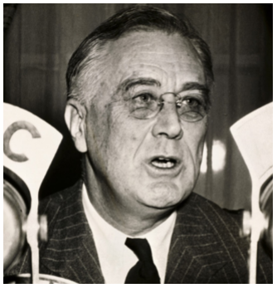
Franklin Delano Roosevelt (1882–1945)
President Franklin D. Roosevelt was the only U.S. president elected to serve four terms in office. He led the United States during two major crises—the Great Depression and World War II. Before Pearl Harbor, President Roosevelt convinced the U.S. Congress to send “all aid short of war” to Britain and the Soviet Union to help fight the Nazis. The United States sent ships and guns in exchange for military bases in Britain. After the attack on Pearl Harbor, the United States entered the war in earnest. Roosevelt led the war effort until his death in office in 1945.
During the Great Depression, Roosevelt defeated the incumbent president, Herbert Hoover, and began implementing a social and economic reform program called the New Deal. New Deal programs such as Social Security continue today.

More About the Image: This is an undated photograph of Franklin Delano Roosevelt, the longest-serving president in United States history.

1. Inferring
How did the Great Depression prepare Roosevelt for the war effort?
Answer: Roosevelt's New Deal programs played a major role in reshaping America back to work and its general economic preparedness to handle the effects of war.

2. Constructing Arguments
What do you think was Roosevelt’s greatest achievement as president? Give reasons for your opinion.
Answer: He managed to make the President, rather than the political parties or Congress, the center of American politics. Consequently, his “New Deal programs” are also considered as one of his greatest achievement as it played a major role in reshaping American economy.

-Worksheet: Hideki Tojo-
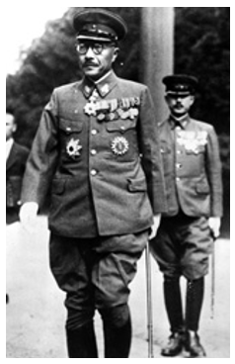
Hideki Tōjō (1884–1946)
Hideki Tōjō was born in Japan and entered the Japanese military as a young man. He earned respect for his work both on and off the battlefield, and in 1938 he was appointed Japan’s vice-minister of war. Two years later he became head of the war department.

In 1941, Tōjō became the prime minister, ruling Japan largely as a dictator. Hirohito still reigned as emperor, but in practice he had very little power. Tōjō ordered successful attacks on Southeast Asia, the Philippines, and many islands of the eastern Pacific, and led the Japanese attack on Pearl Harbor. However, by 1944 Japan was losing territory, and it was clear that Tōjō’s strategy was no longer working. Following Japan’s surrender in 1945, Tōjō was charged with war crimes, found guilty by an international court, and executed in 1946.

More About the Image: This photograph of Hideki Tōjō dressed in his military uniform was taken January 1, 1942.

1. Making Inferences
After Tōjō’s attack on Pearl Harbor, he began to have less military success. Why might this have been the case?
Answer: The attack that happened resulted in an absolute disaster resulting in the loss of the Pacific War and ultimately the loss of WWII for the Tripartite Pact

2. Constructing Arguments
While Tōjō was tried and put to death for his role in World War II, Japan’s emperor, Hirohito, was not punished. Do you think the difference in penalties was reasonable? Why or why not?
Answer: NO,This is so because the basic justification for not trying Hirohito as a war criminal was that it was politically useful for the occupation authorities that he not be tried and his exclusion remained more political rather than a legal decision, as there is no doubt that Allied prosecutors would have had sufficient evidence to justify indictment.

-Worksheet: The Battle of Britain-

The Battle of Britain marked a turning point in the European theater of World War II. After Nazi forces conquered France, they turned their attention to Britain. But to be able to invade Britain, the German forces needed to control both the air and sea surrounding the island nation.

At the beginning of August 1940, Luftwaffe, Germany’s air force, launched daily air attacks. The first targets were towns along Britain’s southern coast as well as convoys in the area, including radio direction finder (RDF) stations. Luftwaffe then increased both the size and the number of raids on coastal cities and also moved inland to destroy British airfields. Vastly outnumbered—2600 German aircraft versus 640 British aircraft— Great Britain’s Royal Air Force proved the superiority of its planes and pilots’ skills. Frustrated, the Germans switched the attacks to civilian targets, especially the city of London. The Royal Air Force stubbornly defended their land by repeatedly destroying German aircraft. By the end of September 1940, the Germans broke off the attacks. The British had won the Battle of Britain and turned the tide of the war.

Directions: The following selections address the Battle of Britain. Read the selections. Then, using information from these excerpts, answer the questions.

I now want to take this opportunity of speaking to you, to say this moment is an historic one. As a result of the provocative British attacks on Berlin on recent nights, the Führer has decided to order a mighty blow to be struck in revenge against the capital of the British Empire. I personally have assumed the leadership of this attack and today I have heard above me the roaring of the victorious German squadrons which now, for the first time, are driving towards the heart of the enemy in full daylight, accompanied by countless fighter squadrons . . . this is an historic hour, in which for the first time the German Luftwaffe has struck at the heart of the enemy.
—Reichsmarschall Hermann Göring, speaking to senior Luftwaffe officers, September 7, 1940

The gratitude of every home in our Island, in our Empire, and indeed throughout the world, except in the abodes of the guilty, goes out to the British airmen who, undaunted by odds, unwearied in their constant challenge and mortal danger, are turning the tide of the World War by their prowess and their devotion. Never in the field of human conflict was so much owed by so many to so few.
—Winston Churchill, Speech in House of Commons, August 20, 1940

Please use the information above to answer the questions below – answers taken from other sources will not receive credit
1. Analyzing Information
What does Churchill mean when he says, “Never in the field of human conflict was so much owed by so many to so few”?
Answer: He insinuated that war can disadvantage majority and end up benefiting the few in the same society.

2. Drawing Conclusions
To what is Göring referring when he says “the German Luftwaffe has struck at the heart of the enemy”?
Answer: He was referring to The Blitz on London which lasted 7 months.
3. Contrasting
In what ways does Göring’s speech differ from Churchill’s?
Answer: Göring in his speech was of the view that the Nazis have a genuine interest in improving the lot of the workers and this was contrary to what Churchill believed in.

4. Identifying Perspectives
Look at the dates on which these speeches were made. Why does each speech seem to be optimistic?
Answer: __________

5. Analyzing Information
What additional information would you need to have that would allow you to conclude that the Battle of Britain was a turning point in the European Theater of World War II?
Answer: The holding off of the Luftwaffe which saw Hitler unable to move forward with his operation sea lion invasion of the British Isles.This would have been devastating to the British people and all efforts to stem Hitler’s rise to power. Germany needed to control the English Channel to invade Britain, and the battle prevented them from gaining that valuable control.

-Worksheet: German Invasion of the Soviet Union-
The German invasion of the Soviet Union in June 1941 caught the Red Army completely by surprise, and German forces advanced rapidly through Soviet territory. However, Hitler and his advisors made a critical mistake by failing to plan for the possible effects of the Soviet climate, which can be extreme in both summer and winter. In July, a series of severe storms turned the unpaved Soviet roads to thick mud, making it nearly impossible for German supply vehicles to travel. When the roads finally dried, they were dusty and full of deep ruts that made transportation equally difficult.

The weather continued to work against the Germans in the fall and winter. The winter of 1941 would prove to be one of the coldest in decades, with temperatures reaching as low as -40ºC. Unfortunately for the German troops, Hitler and his advisors had assumed that the fighting would be over by October, so they had not provided winter coats or gear to protect their officers and soldiers from the harsh Soviet climate. The icy conditions paralyzed German tanks, aircraft, and trucks and caused thousands of casualties due to frostbite and disease.

1. Movement
In what directions did the German forces advance as they invaded the Soviet Union?
Answer: East

2. Location
Which major Soviet cities represented the farthest advance of the German army into the Soviet Union?
Answer: Stalingard

3. Analyzing Cause and Effect
The German army faced extreme weather conditions as it advanced through Soviet territory in 1941. Complete the following chart to describe the effects that the weather had on the Germans’ progress.
Cause  icy cold |  | Effect  It paralyzed the Germans’ mechanized transport, tanks,artillery and aircraft.
Lack of colonies in the region. |  | Germany had no colonies in the region that it could use as reporting stations.
The Weather Trawler Program |  | The weather trawler program was not merely a failure but an unmitigated disaster.
U-Boats and the Wekusta |  | Their success in triumphing Scandinavia saw Danish and Norwegian weathermen overseas giving their information to the Allies

4. Interpreting
What roles did climate and infrastructure play in Germany’s invasion of the Soviet Union?
Answer: Climate and infrastructure played a big role of the survival of Soviet Union and the defeat of Nazi Germany during the Second World War. Climate especially the Winter bogged down and worn out the German army and also slowed the movement due to the cold and frigid temperature that made the fuel and guns frozen while in infrastructure the Russian follows the scorched-earth policy of sacrificing space for time and destroy buildings so that the Germans can't have the shelters in their invasion.

5. Making Inferences
Hitler and his advisors thought that the invasion of the Soviet Union would be complete after just a few months. What does this suggest about the German view of the Soviet army?
Answer: It viewed it to be weak and unable to sustain war for a very long time.

6. Analyzing
The Germans invaded the Soviet Union along a front that was approximately 1,800 miles (nearly 2,900 kilometers) long. Although this strategy was successful in surprising the Red Army, what effect did the extreme weather of 1941 have on the Germans’ very long front?
Answer: The roads turned to mud, tanks sank in more than 6 feet of mud in some spots. The Germans desperately pushed onward, before the Russian Winter came in full blast.
-Chapter 30 Lesson 3: The Home Front and Civilians-
Directions: Read each main idea and answer the questions below. Refer to your textbook to write the answers.

A. Main Idea: World War II was a total war in which fighting covered most of the world. Economic mobilization was extensive, and the war had an enormous impact on civilian life.

1. How did World War II affect civilians in the Soviet Union?
Answer: Soviet citizens experienced severe shortages of both food and housing. Soviet women played a
major role in the war effort. The number of women and girls working in industry increased by
almost 60 percent.

2. What kinds of social turmoil resulted from the war effort in the United States?
Answer: Workers in boomtowns faced a shortage of houses and schools. African Americans faced racial tensions. Japanese Americans were often imprisoned in camps and required to take loyalty
oaths.

3. a) How did Germany react to the increased demand for weapons? b) Who oversaw this effort?
Answer a): Between 1942 and 1943, Germany tripled its armament production.
Answer b): Albert Speer was Hitler's minister for armaments and munitions.

4. How did the Japanese meet wartime labor shortages?
Answer: Japan promoted the idea of sacrifice. Women continued to work in traditional female
occupations such as farming and textiles, but for other work, the government brought in Korean
and Chinese laborers.
B. Main Idea: Bombing in World War II was used against military targets, enemy troops, and civilian populations.

1. When and where did people experience the first sustained use of civilian bombings?
Answer: Londoners experienced the first sustained use of civilian bombing beginning in early September
1940, when German bombs fell nightly.

2. How were children in Europe affected by World War II?
Answer: In German and British cities, millions of children were evacuated to the countryside. Many British
children were also evacuated to the United States and Canada.

3. What were some results of the bombing of Dresden and other German cities?
Answer: A firestorm in Dresden killed as many as 35,000 people. Germans fought on, however, and
German production increased, though few supplies made it to the front.

4. Why did President Truman decide to drop atomic bombs on Japanese cities in August 1945?
Answer: Truman feared that a land invasion of Japan would result in high casualties among the Allied
forces.

Summary & Reflection

Directions: Using ideas from throughout the entire lesson, summarize the main ideas by answering the question(s) below. Answers must be IN YOUR OWN WORDS. DO NOT RESEARCH ANSWERS ONLINE! Points awarded based on accuracy and effort.

How did World War II affect civilians?
Provide several examples from the textbook – the facts are from your book but the way you construct an answer with those facts needs to be your own unique style and word choice
Answer: _In the course of war, most of the houses, factories, railways and all kind of infrastructures that belonged to these civilians were destroyed. These infrastructures were full needed to get food, shelter, sanitation and jobs. These destructions therefore affected the civilians in a specific hard way because as a consequence they weren't able to obtain the necessary means to survive

-Worksheet: The Home Front & Rationing-

Word War II caused economic hardship for many people around the world. Manufacturing and raw materials were almost exclusively used for the war effort. Meanwhile, agricultural production was disrupted as fields were destroyed in battle and laborers joined the armed forces. As a result, both Allied and Axis powers experienced shortages in food and consumer goods. These conditions caused most countries to implement some form of rationing during the war.

Rationing served two important functions during wartime. First, rationing ensured that most civilians would have relatively equal access to food and consumer goods. Second, rationing civilian consumption of products like rubber and gasoline made it easier for governments to dedicate those resources to the war effort. In most countries, the ration system was organized using ration coupons. In Great Britain, for example, each person was given a book of coupons that could be exchanged for products like milk, eggs, sugar, or meat. The number of coupons for each product represented that person’s quota, or limit.

Most Allied nations relied on rationing for the duration of the war. In 1940 Great Britain issued ration coupons for essential food products, such as flour and milk. By 1941 the British also rationed consumer products like silk stockings, soap, and cloth. Like Britain, the United States began rationing a variety of foods starting in 1942. The United States also limited civilian use of rubber and gasoline soon after the attack on Pearl Harbor. In the Soviet Union, bread rations were given only to civilians in urban areas; farmers in rural areas were expected to grow their own food. The Axis powers also implemented rationing to support the war effort, such as Italy’s rationing of meat in 1939.

Germany, however, did not fully restrict civilian rations until 1944 because Hitler believed that strict rationing would hurt morale on the home front. Using ration coupons helped governments make sure that all civilians had access to their fair share of limited resources. However, some people tried to get around the regulations by buying products illegally on the black market. The price of products on the black market was usually much higher than the legal ration price.

In Italy, for example, wheat flour and pasta on the black market sold for 8 to 10 times more than their value. Hard-to-find items like fruit could often be found on England’s black market, but many people considered buying them to be unpatriotic and harmful to the war effort.

Applying Economics to History
1. Explaining Why was rationing necessary during World War II?

Answer: Although the primary goal of rationing was equal distribution, a secondary goal was to free valuable factory resources for war production. Therefore, rationing was implemented to control the equal distribution of items in short supply.

2. Comparing and Contrasting
Compare and contrast the way rationing was implemented in different countries.

Answer: For example based on Uniform Coupon Rationing, In England, only 4 ounces of sugar was permitted weekly per person. Conversely, in Germany, 4 ounces of sugar was allotted daily until much later in the war. However, the common trend in the two countries is that Government Issue ration coupon or stamp books were required to be presented to merchants before purchase
3. Drawing Conclusions
Why were goods more expensive on the black market?

Answer: Most of the good in question were considered more dangerous to deal with and equally unavailable.As a result of an increase particularly in government restrictions ,black market prices for the relevant products rise, as said restrictions represent a decrease in supply and an increase in risk on the part of the suppliers, sellers, and any and all middlemen.
-Chapter 30 lesson 4: The New Order and the Holocaust-
Directions: Read the lesson and complete the outline below. Refer to your textbook to fill in the blanks.

I. The New Order in Europe

A. Henirich Himmler__ implemented Hitler’s _ move the slavic people_plan to uproot eastern Europeans and send German peasants to colonize their land.

B. Germany’s use of _ Foreign_ laborers disrupted production in conquered countries and increased resistance to the Nazi _ occupation_ forces.

II. The Holocaust

A. Hitler's outlook on race involved a conflict with two sides: _Aryans_ , whom Hitler believed were responsible for all of human cultural development, and _Jews_, whom Hitler blamed for the outcome of World War I and the Depression.

B. The _Einsatzgruppen__ implemented Hitler’s __ Nazi plans_ , first by rounding up Jews and forcing them to live in _ ghettos _ , and then by following the army and serving as mobile killing units.

C. At Auschwitz and five other _ extermination camps_ in Poland_ , the Nazis subjected Jewish prisoners to hard labor, cruel medical experiments, and _ gas chambers _.

D. The Nazis killed approximately _ 6 million _ Jews and 9 to 10 million _ non–Jewish people, including the _ leading citizens _, political dissidents, and prisoners of war.

E. The Holocaust, known as the _Shoah _in Hebrew, means “_total destruction _”

III. The New Order in Asia

A. Japan conquered Southeast Asia using the slogan _ Asia for the Asiatics _ , but its severe policies caused _ ndonesian patriots _ to sabotage its administration.

B. Japan exploited territories such as __ Vietnam _ , where more than 1 million people starved because Japan stole their rice __ to sell abroad.

Summary & Reflection

Directions: Using ideas from throughout the entire lesson, summarize the main ideas by answering the question(s) below. Answers must be IN YOUR OWN WORDS. DO NOT RESEARCH ANSWERS ONLINE! Points awarded based on accuracy and effort.

By what methods did Germany and Japan seek to impose a new world order?
Provide several examples from the textbook – the facts are from your book but the way you construct an answer with those facts needs to be your own unique style and word choice
Answer: They include the following:
- Annexed Occupied lands
- Resettlement of occupied people.
- Genocide
- Use of slave labor
-Worksheet: Hitler’s Quest for Cultural Domination-

Hitler’s plans for German expansion were rooted in his dream to make German culture the dominant way of life in Europe—and around the world. Hitler believed that to achieve this cultural diffusion, Germany had to acquire more land to provide lebensraum, or “living space,” for the German people. In order to make room for German settlers, Hitler also planned to remove people that he believed to be inferior—such as Jews, Roma, and Slavs—by killing them or by sending them to labor camps.
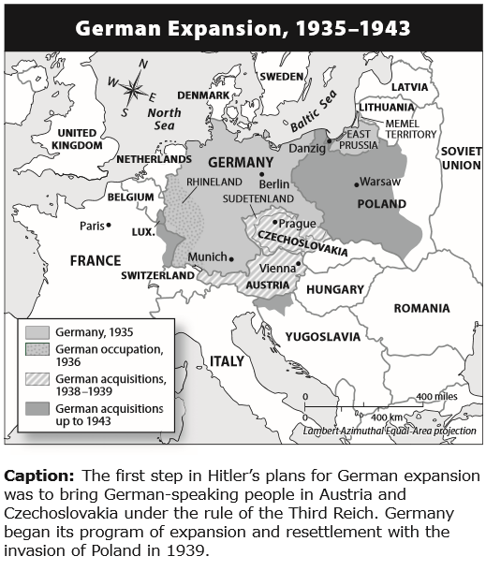
The geopolitical concept of lebensraum originated with the German geographer Friedrich Ratzel. In the late nineteenth century, Ratzel developed the theory that the development of all species, including humans, was determined by their adaptation to geographic circumstances. At the time, this theory was used to support the creation of a united Germany in which increasing the country’s strength meant encouraging migration to German colonies. However, Hitler and the Nazi Party later seized upon Ratzel’s ideas to support German territorial expansion within Europe.

Hitler’s first step was to reunite all German-speaking peoples, such as those in Austria and Czechoslovakia, under the Third Reich. In September 1939, Hitler initiated the next step of his plan to extend German control by invading Poland. As German forces moved through Europe, they systematically executed or evacuated millions of people to make room for resettlement by German peasants.

Please use the information above to answer the questions below – answers taken from other sources will not receive credit
1. Movement: a) Into which parts of Europe did Germany first expand? b) Why?
Answer a): Germany invaded Poland,it further annexed the former free city of Danzig and all of western Poland, including the provinces of West Prussia, Poznan, Upper Silesia, and Lodz

Answer b): They were to act as a colonial area for German settlement and economic exploitation.

2. Describing: How did Hitler plan to achieve the diffusion of German culture throughout Europe?
Answer: By ensuring that he gets more land to provide living space for the Germans and to transport the non-German people to other parts of Europe

3. Analyzing Information: What does the map suggest about the success of German expansion between 1933 and 1943?
Answer: It was well prepared to have an absolute control of most these regions/countries it was expanding to.

4. Making Inferences :What would the map of Europe look like according to Hitler’s goals?
Answer: I'm not sure if the map of Europe today would be any different at all. The war between Germany and Russia was ineveitable and unpreventable.

-Worksheet: D-Day, The Normandy Invasion-

By 1943, Allied leaders realized that they would need to open a second front in western Europe if they wanted to break Hitler’s power on the European continent. They developed a plan to invade Normandy, the northern region of France, under the direction of U.S. general Dwight D. Eisenhower. The Allies knew that Hitler suspected an invasion, so they would need careful development and preparation to be successful. In the months leading up to D-Day, British and U.S. air forces began bombing French railroads and bridges. Allied intelligence officers also planted false information to confuse the Germans about the true location of the invasion, including that the assault would take place at Calais.

The invasion finally took place on June 6, 1944. Led by both U.S. and British commanders, more than 156,000 Allied troops landed on the beaches of Normandy. Five infantry divisions crossed the English Channel in armored vessels, each landing on a different beach—codenamed Utah, Omaha, Gold, Juno, and Sword. Meanwhile, three airborne divisions landed to the east and west of the assault area.

Although they caught the German forces largely off-guard, the Allies had to overcome serious obstacles before they could advance. Bad weather had made the waters of the English Channel rough and dangerous; hundreds of vessels sank and many soldiers drowned before they could even reach the shore. In addition, the Germans had fortified the coast with mines, barbed wire, and defensive walls, which slowed the Allies’ progress. Perhaps most deadly of all, the Germans had heavy artillery and machine guns positioned on the cliffs that overlooked the coast; thousands of Allied troops were shot before they were able to cross the exposed beaches. Although the landing was successful, by the end of D-Day, more than 10,000 Allied troops had been killed, wounded, or were missing.

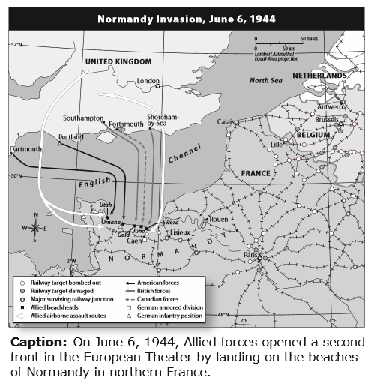

Questions for: Worksheet on D-Day, The Normandy Invasion

1. Location
British intelligence agents planted false information to convince the Germans that the Allied invasion would take place at Calais. Look at the map. Why did the location of Calais make the possibility of invasion there believable?

Answer: First U.S. American Army Group, imaginary invasion force headed by Patton that was used to make the Germans think that the Allies would invade at Calais, had fake tanks, barracks, radio and mail to make it believable.
2. Human-Environment Interaction
The Allied forces faced many obstacles during the invasion of Normandy, many of which were due to the coastal location chosen for the invasion. Other obstacles were created by the Germans.
Complete the following diagram to outline these obstacles and how they affected the Allied forces on D-Day.

Obstacle:  Naval mines | Effect on Allied Forces:  Threatened ships trying to land  Could rip the bottoms out of landing craft at high tide  It kept the 21st Panzer Division from attacking the Allies on D-Day?
Obstacle:
Steel

Obstacle: minefields and German

Obstacle:
Orne River

3. Drawing Conclusions: a) What advantages would the Allies gain by utilizing both airborne and seaborne divisions during the invasion? b) How was this dual strategy possible?
Answer a): __________

Answer b): __________

4. Analyzing Information: On the map, small circles represent areas where railways had been damaged or destroyed. a) Where was the most damage done to the railways? b) Why was bombing railways an important part of the Allies’ strategy?

Answer a): __________

Answer b): __________

5. Making Connections: Why is the Normandy invasion considered one of the turning points of World War II?

Answer: __________

-Chapter 30 Lesson 5: World War II Ends-
Directions: Read each main idea. Use your textbook to supply the details that support or explain each main idea.

A. Main Idea: By the beginning of 1943, the tide of battle had turned against Germany, Italy, and Japan.

1. Detail: On June 6, 1944, known as ___ D-Day___ , Allied forces under U.S. general _ Dwight D. Eisenhower__landed on the Normandy beaches in history’s greatest naval invasion.

2. Detail: By August _ 1944__ , Allied troops had liberated __ Paris_, France.

3. Detail: In 1943, the _ Soviets_ defeated German forces in the Battle of __Kursk_ , the greatest tank battle of World War II.

4. Detail: The island of __ Iwo Jima__was essential to the air war against Japan, and the island of __ Okinawa__ provided the Allies with a base near the mainland.

5. Detail: On April 30, 1945, __ Hitler__ committed suicide, and shortly after on __ May 7__ , Germany surrendered.

6. Detail: The war in the Pacific finally ended on __August 14th_ , shortly after the United States dropped atomic bombs on _ Hiroshima __and __Nagasaki__.

B. Main Idea: No real peace but a period of political and ideological tensions followed the total victory of the Allies in World War II.

1. Detail: The __US__wanted to create Soviet-friendly governments as a buffer-zone between the _Sakhalin __and the _Kuril Islands.

2. Detail: Germany was divided into four zones, controlled by __United States, __Great Britain_ , _ France_ , and _Soviet Union_
3. Detail: The Grand Alliance agreed to hold the - War_ trials and establish the _ United Nations_ but disagreed on the establishment of free elections in Eastern Europe.

4. Detail: Churchill claimed that an _ Iron curtain_ had descended across Europe, and many Westerners suspected a
_World conspiracy.

Summary & Reflection

Directions: Using ideas from throughout the entire lesson, summarize the main ideas by answering the question(s) below. Answers must be IN YOUR OWN WORDS. DO NOT RESEARCH ANSWERS ONLINE! Points awarded based on accuracy and effort.

How did World War II end and the Cold War begin?
Provide several examples from the textbook – the facts are from your book but the way you construct an answer with those facts needs to be your own unique style and word choice
Answer: A-bomb ended World War II, but set stage for the Cold War.The release of two atomic bombs on Japan in August 1945 helped end World War II but ushered in the Cold War,

-Worksheet: The Bombing of Hiroshima and Nagasaki-

In 1938 scientists discovered that an enormous amount of energy could be released by splitting an atom. Realizing this knowledge could be used to create a devastating weapon, they alerted U.S. president Roosevelt to the potential military applications of their discovery. In 1942 the U.S. government, fearing that the Germans might make an atomic bomb, launched a top-secret project to develop one first. Code-named the Manhattan Project, it cost $2 billion and employed 600,000 people. On July 16, 1945, an atomic bomb was successfully tested near Alamogordo, New Mexico.

Less than a month later—on August 6, 1945—the first nuclear weapon was dropped on Hiroshima, Japan, a military center. The count of those killed during the blast or shortly afterward has been estimated to as many as 70,000, with 140,000 dead at year’s end from injuries and radiation sickness. This atomic bomb annihilated two-thirds of the city. Three days later, on August 6, the United States released another atomic bomb, this time over the Japanese port city of Nagasaki. By December 1945, 70,000 citizens were dead. The blast damaged or demolished 40 percent of the city’s buildings. The incredible destruction caused by the bombing of Hiroshima and Nagasaki forced the surrender of Japan, ending World War II.

Directions: The first selection is from an interview with Colonel Paul Tibbets, the pilot of the plane that bombed Hiroshima. The second one is from an account in which Shibayama Hiroshi, a survivor of the bombing, describes what he saw when he crossed the Kyobashi River hours after the bomb was dropped. The photograph shows Hiroshima after the bombing. Read the selections and study the photograph. Then answer the questions.

I looked at that city—and there was no city, there was nothing but the fringes of where the city used to be. There had been a city when we were making our approach, but now there was no humanity there. It was just something that had been . . . scorched. That word doesn’t seem sufficient to describe what had just happened, but that’s the only word I have. I could never have imagined anything being scorched like that city was scorched . . . Our crew did not do the bombing in anger. We did it because we were determined to stop the killing. I would have done anything to get to Japan and stop the killing.

—Colonel Paul Tibbets, 1945 as quoted in Duty: A Father, His Son, and the Man Who Won the War

Floating there were scores of dead bodies, faces swollen to twice their normal size and trouser-encased legs stiff as logs. . . . The sight chilled us to the bone . . . It began to rain. Black stains spotted shirts. The multicolored smoke generated at the time of the blast had become a cloud of dirty brown and black hanging like a pall over the city. It was a demonic ceiling, a malediction.

—Shibayama Hiroshi, 1945, as quoted in The Atomic Bomb: Voices from Hiroshima and Nagasak

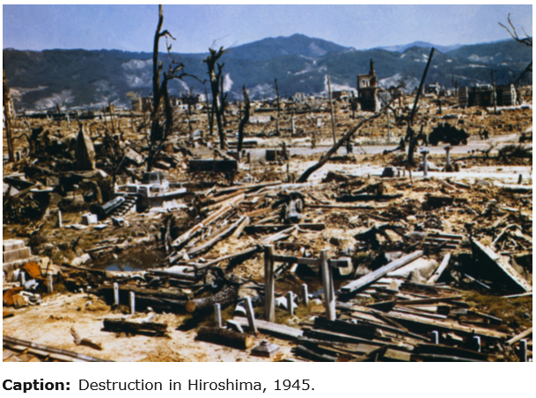

Questions for: Worksheet on the Bombing of Hiroshima and Nagasaki

1. Comparing
Did Tibbets’s description of the destruction to Hiroshima reflect what the photograph shows? Explain.
Answer: Yes, it was necessary for the photo to be potrayed in that state as away to send a warning to all enemies.
2. Analyzing Primary Sources
a) To what killing was Tibbets referring when he said, “We were determined to stop the killing”? b) What is ironic about his statement?

Answer a): He was referring to the victims of the world war all across Europe that initiated by nazi Germany. Many soldeirs and innocent civilians 'lives were taken because of the military invasions conducted by the Axis Power.

Answer b): That statement was ironic because Paul Tibbets was the pilot who dropped the Atomic Bomb to Hiroshima in 1945 Killing around 146,000 civilians with a single- bomb.

3. Identifying Main Ideas
How did the bombings affect Japanese civilians?

Answer: The long-term effects of radiation exposure increased cancer rates in the survivors

4. Determining Cause and Effect
What impact did the bombing of Hiroshima and Nagasaki have on the course of the war?

Answer: The uranium bomb liquidated over Hiroshima had an explosive yield equal to 15,000 tonnes of TNT. It razed and burnt around 70 per cent of all buildings and caused an estimated 140,000 deaths by the end of 1945, along with increased rates of cancer and chronic disease among the survivors.

-STOP!-
Do not move on to Unit 10 Section 1 until you have completed the 9.2 Check-in.
-STOP!-
Do not move on to Unit 10 Section 1 until you have completed the Unit 9 Test.
-STOP!-
Key Assignment is due prior to taking the Unit Test and before moving to the next Unit.

