A Change Team Initiative occurs in three continuous phases:

Phase I – Assessment;

Phase II – Planning, Training, & Implementation; and Phase
III – Sustainment.

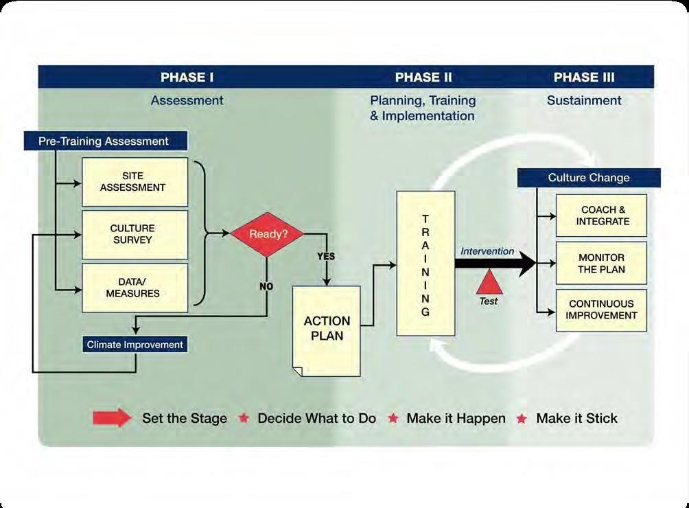For example: Shift Toward a Culture of Safety

Change Team Action Plan

The Change Team Action Plan:

Is a detailed written report of exactly what an organization intends to do during their Change Team Initiative.

- Identification of the Change Team

- Identification of the specific problem

- Stated aims of the Change Team Intervention

- Detailed description of the Change Team Intervention

- A plan for testing the effectiveness of the Intervention Change Team

- An implementation plan for the Change Team Intervention

- A monitoring plan for ongoing assessment of the effectiveness of the Change Team Intervention

- A communication plan to generate support for the Change Team Initiative

Timeline

  - Create a Change Team.

  - Define the problem, challenge, or opportunity for improvement.

  - Define the aim(s) of your Change Team Intervention. 4.Design a Change Team Intervention.
- Develop a plan for testing the effectiveness of your Change Team Intervention.

- Develop an implementation plan and training program for the Intervention.

- Develop a plan for Sustained Continuous Improvement. 8.Develop a Communication Plan.
- Putting it all together - Write the Change Team Action Plan.

- Review the Change Team Action Plan with key personnel, and modify according to input.

Key Actions:
- Select a multidisciplinary Change Team.

- Ensure representation from three different leadership levels: Senior
Leadership, Clinical/Technical Expertise, and Front-line Leadership.

- Ensure at least one member is very knowledgeable of team strategies,
tools, and training techniques.

- Ensure at least one member has experience in process improvement including performance trending techniques. Relevant skills include data collection, analysis, and presentation.

- Key Actions:
  - Identify a problem, challenge, or opportunity for improvement that you feel could be bettered with enhanced teamwork.

  - Identify the process during which the problem, challenge, or opportunity occurs by stating:

what the process is? What happened? who is involved?
when it occurs? where it occurs?

Example 1 of a Problem Definition

    - Identify the problem: Suboptimal telephone communication of patient information from staff labor and delivery (L&D) nurses to staff L&D physicians.

What happened? Who is involved? When it occurs?
Where it occurs?

Example 1 of a Problem Definition

1. Identify the problem: Suboptimal telephone communication of patient information from staff labor and delivery (L&D) nurses to staff L&D physicians.

What happened? Suboptimal Telephone communication of patient information
who is involved? Staff L&D nurses and staff L&D physicians
when it occurs? During the working hours
where it occurs? labor and delivery unit

Example 2 of a Problem Definition

1. Identify the problem: Suboptimal communication between surgical team members in the operating room.

What happened? who is involved? when it occurs? where it occurs?

Example 2 of a Problem Definition

- Identify the problem: Suboptimal communication between surgical team members in the operating room.
What happened? Suboptimal communication
who is involved? surgical team members when it occurs? During the working hours where it occurs? In the operating room

Key Actions:

  - Develop one to three measurable aims for your Change Team Intervention, and state in one or two sentences.

- The team process aims to focus on how well or often your staff carries out your Change Team Intervention.

- Outcome aims to focus on changes that occur because your staff carries out the intervention. These aims can be directed at changes in team performance (team outcome aims) or in clinical results (clinical outcome aims).

Example 1 of Process and Outcome Aims:

The Problem: Suboptimal preoperative communication between surgical teams in General Surgery Service

Team Process Aims:
Increase the percentage of unit staff who has received training to at least 80% within 2 months of team training implementation.

Example 1 of Process and Outcome Aims:
The Problem: Suboptimal preoperative communication between surgical teams in General Surgery Service Team Outcome Aim:
Increase the perception among General Surgery Service staff of good team behavior, as assessed by the
Change Team Teamwork Perceptions Questionnaire, within 6 months of the Change Team Intervention implementation.

Clinical Outcome Aim:
Increase the percentage of surgical patients who receive prophylactic antibiotics at appropriately time prior to the incision from the current 85% to 100% within 4 months of the Change Team Intervention implementation.

Example 2 of Process and Outcome Aims:

The Problem: Suboptimal telephone communication of patient information from staff labor and
delivery (L&D) nurses to staff L&D physicians.

Team Process Aims:
- Increase the percentage of L&D nurses and physicians who receive training on SBAR (Situation-Background-Assessment-Recommendation) technique to at least 80% within one month of medical team training implementation.

- Increase the use of SBAR (Situation-Background-Assessment-Recommendation) technique by L&D nurses during telephone communications to L&D physicians by at least 60% within 2 months of Change Team Intervention implementation.

Example 1 of Process and Outcome Aims:

The Problem: Suboptimal telephone communication of patient information from staff labor and
delivery (L&D) nurses to staff L&D physicians.

Team Outcome Aim:
Increase the perception among all L&D staff of good team behavior, as assessed by the Change Team Teamwork Perceptions Questionnaire, within 6 months of Change Team Intervention implementation.

Clinical Outcome Aim:
Increase L&D physicians’ average rating of the quality of L&D nurses’ telephone communication of patient information by at least 50% within 3 months of Change Team Intervention implementation.

Key Actions:

To design your Change Team Intervention you will use process improvement techniques and systems-based strategies for human error reduction. The following key actions should be performed in the order they appear:

  - Flowchart or map the process during which the target problem occurs. Write down the process steps as they currently occur and identify who is doing what, when, with what tools.

  - Study the process to identify risk points where things could go wrong.

  - Identify where in your process team strategies and tools might eliminate or mitigate the risk points.

  - Determine which team tools and strategies would work best to eliminate
the process risk points.

  - Draft your Change Team Intervention. State what team tools and strategies
will be implemented; who will use them, when and where.

  - Evaluate your Change Team Intervention for potential benefits and negative effects.

  - Evaluate your Change Team Intervention using the Change Team Intervention Checklist, and modify your intervention based on the results.

  - Write a detailed description of your final Change Team Intervention. State what team tools and strategies will be implemented; who will use them, when and where.

Key Actions

- Identify who on your Change Team will be responsible for data collection, analysis, and presentation (generation of graphs and charts).

- Identify a measure and define target ranges for that measure.

- Create a study design

- Select “test subjects” and data source.

- Identify a comparison and “control” group.

- 6. Determine methods for data collection.

- Determine methods for data analysis and interpretation.



Step 5. Develop a Plan for Testing the Effectiveness of Your Change Team Intervention

- Determine data presentation method.

- Determine resources required (time, equipment, personnel, expertise).

- Determine timelines for the test
For baseline data: When will you collect it, analyze it, and display it?
For post-implementation data: When will you collect it, analyze it, and display it?

Part A: Develop a Plan for Medical Team Training

- Identify your trainee audience(s) and their training requirements.

- Identify the instructors for each audience.

- Develop a training plan for each audience,

- Create your training timelines.

Part B: Develop an Implementation Plan for the Change Team Intervention Key

- Identify individual(s) responsible for implementation.

- Determine how you will implement Change Team Intervention in order to achieve.

- Develop an implementation timeline.

- Develop a plan for monitoring over time the effectiveness of your Change Team Intervention.

- Determine how data from your monitoring plan will be used to continually improve processes and performance.

- Develop a plan for sustaining and spreading positive changes

- Identify your stakeholders.

- For each of your identified stakeholder groups, develop a communication plan

- Identify a person on the Change Team who will be responsible for implementation and oversight of the communication plan

- Identification of the Change Team

- Identification of the problem, challenge, or opportunity for improvement that will be the focus of the Change Team Initiative

- Stated aims of the Change Team Intervention 4.Detailed description of the Change Team Intervention
5.A plan for testing the effectiveness of the Change Team Intervention

6.An implementation plan for both medical team training and for the Change Team Intervention.

7.A monitoring plan for ongoing assessment of the effectiveness of the Change Team Intervention

- A communication plan to generate support for the Change Team Initiative, to keep major stakeholders informed of progress, and to maintain and spread positive changes.

- Timelines 10.Resources required

  - Identify stakeholders who could contribute significantly to the Action Plan.

  - Ask key stakeholders to review your Action Plan and identify any potential problem areas and offer solutions.

  - Modify your Action Plan based on their input, if needed.

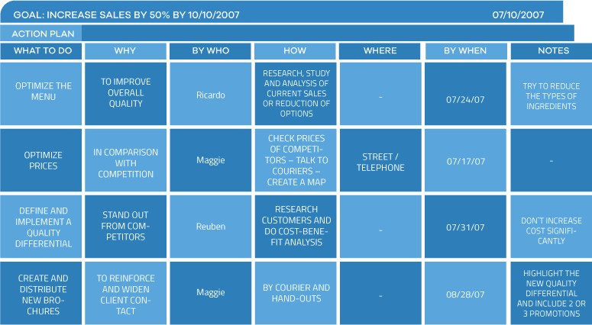

Example of an Action plan summary

https://www.youtube.com/watc h?v=Pai4IcoVsNc

The End

