Muda Scavenger Hunt
Student’s Name
Student ID
Professor’s Name
Course Title
Date of Submission

The 7 Wastes
There has been an increase in the waste production.
- Overproduction
Overproduction can be regarded as producing more than the customer is requesting or even before they request what is enough for them. For instance, many restaurants around and food joints have been producing overproduction waste whereby foods ends up getting thrown away because the firm did not reach the planned level of orders.
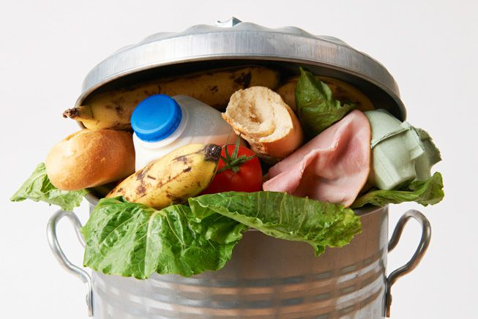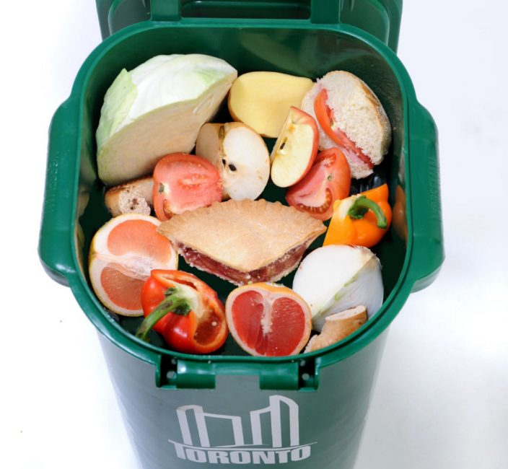

- Waiting
Waiting is another form of waste and productivity killer and it frustrates most of the customers. Waiting for copies transaction to be printed can be tiresome and hence end reducing the level of productivity.
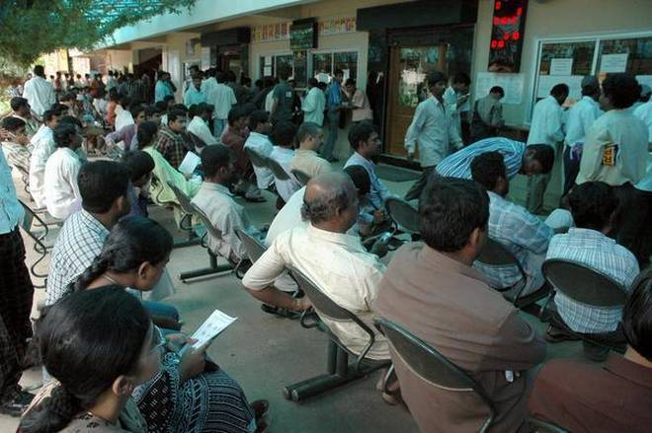

- Transporting
Transporting is another form of waste whereby products, equipment, information, or other materials are needlessly moved from one place to another. The waste of transportation may be as a result of non-Lean layout. For instance, in a busy warehouse, the movement of forklifts may be viewed as an increased inefficiency in the facility and they are also non-value added operations.
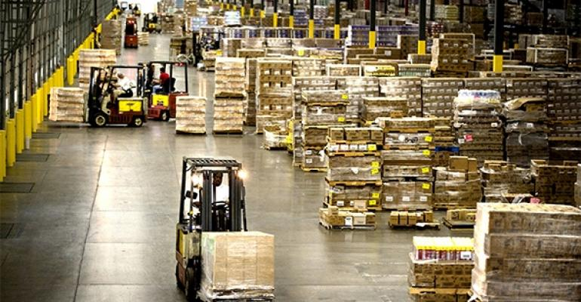

- Over processing
Over processing is a kind of waste that is caused by process and operations that are not necessary and one that do not add any value. The major causes are not identifying the needs of the customers correctly and lack of attention on the requirements among other factors. For example, a firm may produce reports that are not used because the whole information is already in the systems.
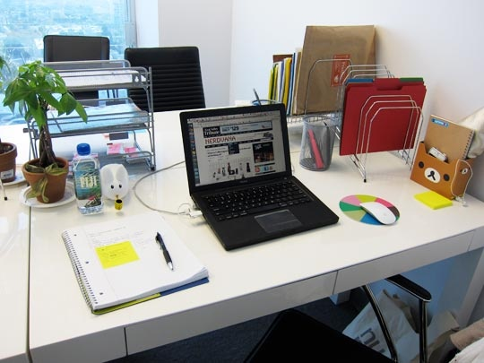

- Inventory
Waste as a result of inventory can be termed as unnecessary storage of materials or information more than is needed. For example, firms involved in the manufacturing of nonperishable commodities such as the building tiles tend to store a lot of unnecessary inventory hence consuming productive floor/space.
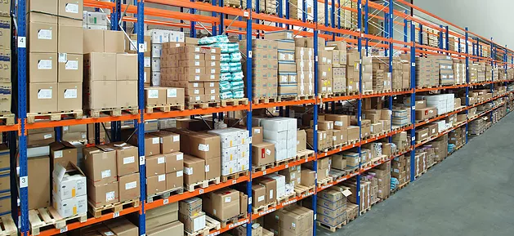

- Motion/Movement
Motion or movement is a form of waste that entails movement of people that does not add any value to the service or product. It is a high productivity killer. For example, the office workers are in most cases forced to get up from their desks and walk for some distance to a printer that is shared in the office.
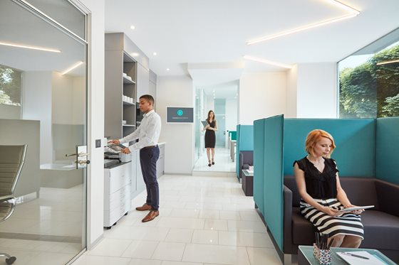
- Defects
Defects are said to be any work/services that are less than the level that has been requested by the customer. Defects can result to a rework and mostly occur products fails to conform to the proper specification. For instance, during the production of Led Floodlights, a percentage of them may fail to work and are regarded as defects. Reworking them again is quite costly for firm.
