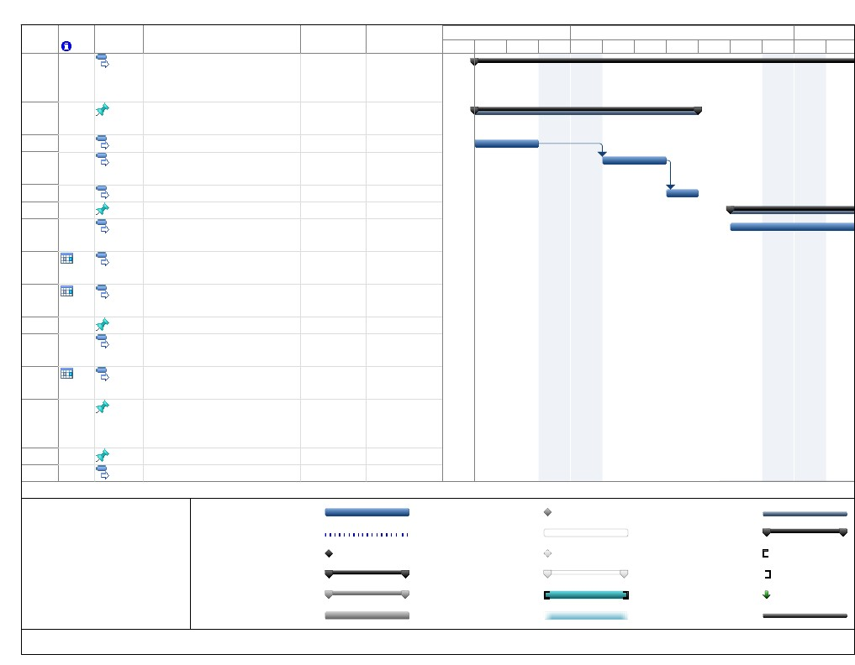
ID
1
Task
Mode
Task Name
Duration Mar 3, '19Start
W
T
F
S
Mar 10, '19
SM
T
W
T
F
S
Mar 17, '19
SM
1.0 Upgrade OMOP common 38 days?
data model software
1.1 Requirement
gathering
1.1.1 Site Survey
1.1.2 Create office
groupings
1.1.3 Analysis report
1.2 Selection and Design
1.2.1 Purchase
computers
1.2.2 Purchase software
1.2.3 Purchase Cabling
Accessories
1.3 Implementation
1.3.1 Back-up shared
Drives
1.3.2 Back-up Local user
drives
1.4 Installation, operation
and configuration
1.4.1 Set-up Network
1.4.1.1 Run Cables
Task
Split
Thu 3/7/19
2
3
4
5
6
7
8
9
10
11
12
13
5 days
2 days
2 days
1 day
7 days
3 days
2 days
2 days
4 days
3 days
1 day?
1 day?
Thu 3/7/19
Thu 3/7/19
Mon 3/11/19
Wed 3/13/19
Fri 3/15/19
Fri 3/15/19
Wed 3/20/19
Fri 3/22/19
Fri 3/29/19
Fri 3/29/19
Mon 4/1/19
Tue 4/2/19
14
15
2 days
2 days
Tue 4/2/19
Tue 4/2/19
External Milestone
Inactive Task
Inactive Milestone
Inactive Summary
Manual Task
Duration-only
Page 1
Manual Summary Rollup
Manual Summary
Start-only
Finish-only
Deadline
Progress
Project: WBS
Date: Thu 3/7/19
Milestone
Summary
Project Summary
External Tasks

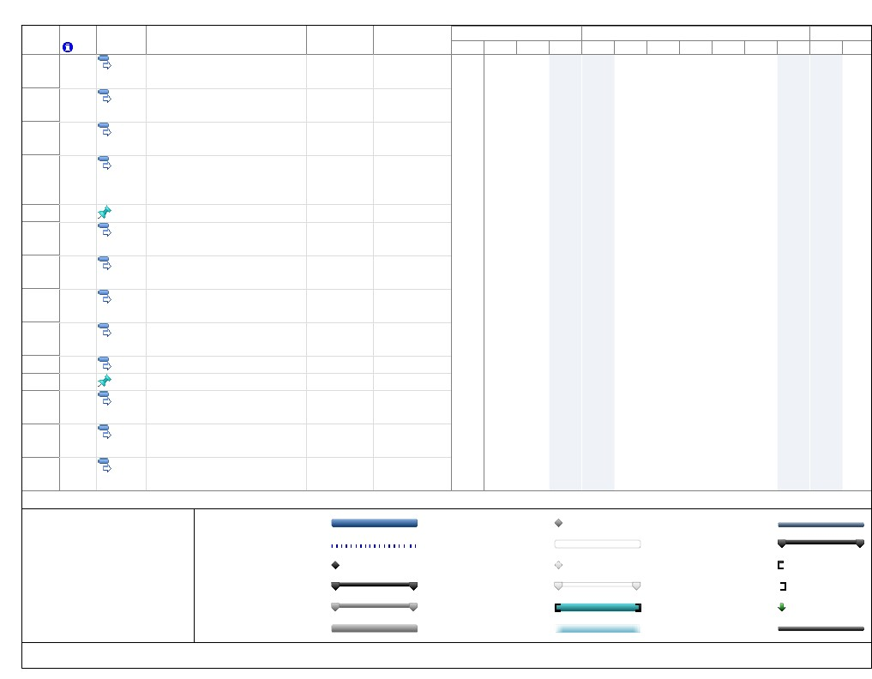
ID
16
17
18
19
Task
Mode
Task Name
Duration Mar 3, '19Start
W
T
F
S
Mar 10, '19
SM
T
W
T
F
S
Mar 17, '19
SM
20
21
22
23
24
25
26
27
28
29
1.4.1.2 Set-up2 days
Routers
1.4.1.2.1 Configure 2 days
Firewall
1.4.1.2.2 Set-up static 2 days
ip's
1.4.1.2.3 Create2 days
passwords and access
rules
1.4.2 Set-up Users1 day?
1.4.2.1 Set-up2 days
computer
1.4.2.2 Install2 days
software
1.4.2.3 Configure2 days
settings for network
1.4.2.4 Configure2 days
Printer
1.4.2.5 Restore Data 2 days
1.5 Train Staff1 day?
1.5.1 Create user2 days
reference materials
1.5.2 Facilitate Lunch and 2 days
learns
1.5.3 Deliver one on one 2 days
trouble shooting
Task
Split
Thu 4/4/19
Mon 4/8/19
Wed 4/10/19
Fri 4/12/19
Tue 4/16/19
Tue 4/16/19
Thu 4/18/19
Mon 4/22/19
Wed 4/24/19
Fri 4/26/19
Tue 4/30/19
Tue 4/30/19
Thu 5/2/19
Mon 5/6/19
External Milestone
Inactive Task
Inactive Milestone
Inactive Summary
Manual Task
Duration-only
Page 2
Manual Summary Rollup
Manual Summary
Start-only
Finish-only
Deadline
Progress
Project: WBS
Date: Thu 3/7/19
Milestone
Summary
Project Summary
External Tasks

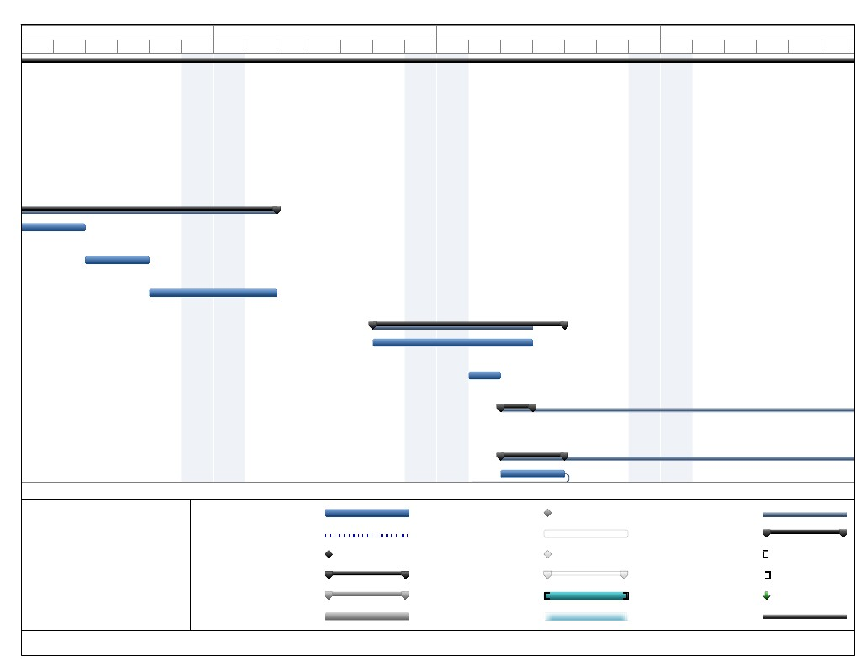
Mar 17, '19
M
T
W
T
F
S
Mar 24, '19
SM
T
W
T
F
S
Mar 31, '19
SM
T
W
T
F
S
Apr 7, '19
SM
T
W
T
F
Task
Split
Project: WBS
Date: Thu 3/7/19
Milestone
Summary
Project Summary
External Tasks
External Milestone
Inactive Task
Inactive Milestone
Inactive Summary
Manual Task
Duration-only
Page 3
Manual Summary Rollup
Manual Summary
Start-only
Finish-only
Deadline
Progress

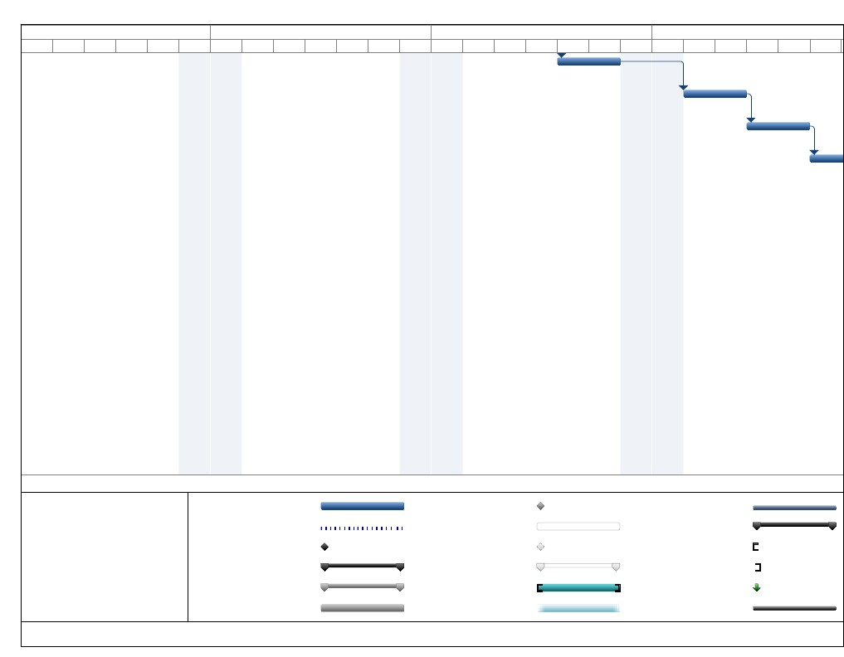
Mar 17, '19
M
T
W
T
F
S
Mar 24, '19
SM
T
W
T
F
S
Mar 31, '19
SM
T
W
T
F
S
Apr 7, '19
SM
T
W
T
F
Task
Split
Project: WBS
Date: Thu 3/7/19
Milestone
Summary
Project Summary
External Tasks
External Milestone
Inactive Task
Inactive Milestone
Inactive Summary
Manual Task
Duration-only
Page 4
Manual Summary Rollup
Manual Summary
Start-only
Finish-only
Deadline
Progress

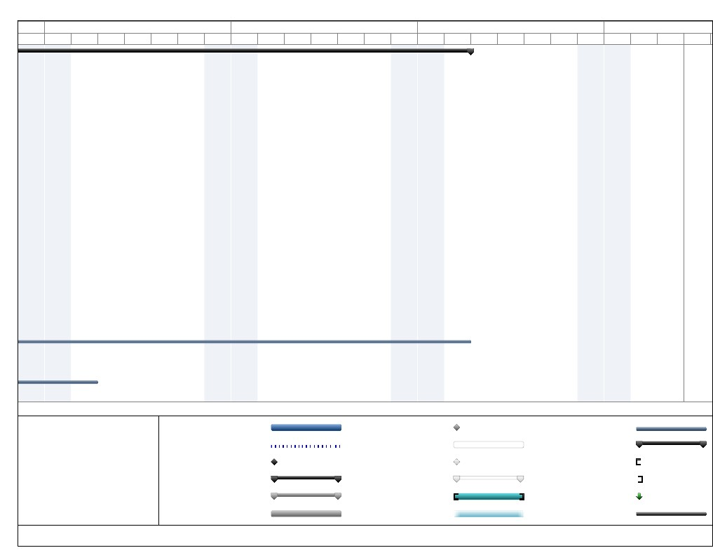
S
Apr 14, '19
SM
T
W
T
F
S
Apr 21, '19
SM
T
W
T
F
S
Apr 28, '19
SM
T
W
T
F
S
May 5, '19
SM
T
W
Task
Split
Project: WBS
Date: Thu 3/7/19
Milestone
Summary
Project Summary
External Tasks
External Milestone
Inactive Task
Inactive Milestone
Inactive Summary
Manual Task
Duration-only
Page 5
Manual Summary Rollup
Manual Summary
Start-only
Finish-only
Deadline
Progress

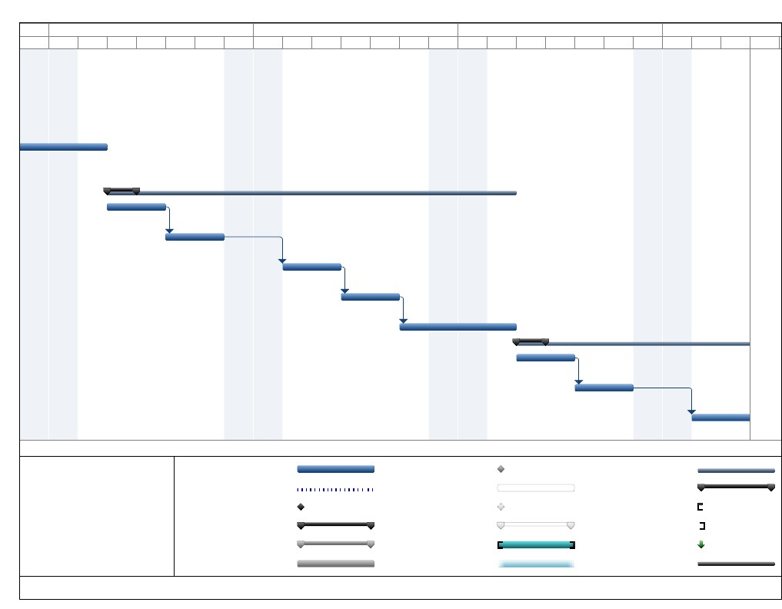
S
Apr 14, '19
SM
T
W
T
F
S
Apr 21, '19
SM
T
W
T
F
S
Apr 28, '19
SM
T
W
T
F
S
May 5, '19
SM
T
W
Task
Split
Project: WBS
Date: Thu 3/7/19
Milestone
Summary
Project Summary
External Tasks
External Milestone
Inactive Task
Inactive Milestone
Inactive Summary
Manual Task
Duration-only
Page 6
Manual Summary Rollup
Manual Summary
Start-only
Finish-only
Deadline
Progress

