Week 3 Homework (HW3) LANE C5 AND ILLOWSKY C3 AND C4
MUST SHOW YOUR WORK

OVERVIEW OF THIS WEEK’S VERY IMPORTANT CONCEPTS
The important concepts this week are the ADDITION RULE, MULTIPLICATION RULE, PERMUTATIONS, and COMBINATIONS AND THE BINOMIAL DISTRIBUTION PROBABILITIES. It’s a lot of new vocabulary and some math. LOT’S OF THIS IS ON THE FINAL EXAM!!
ALWAYS REMEMBER THAT THE HIGHEST PROBABILITY IS 100% OR 1.00 (A SURE THING). IF YOU GET AN ANSWER GREATER THAN 1.00, IT IS WRONG. ALWAYS DO A REALITY CHECK ON YOUR CALCULATED NUMBERS? (THE LOWEST PROBABILITY IS OF COURSE ZERO.) IN PROBABILITY, HOWEVER, LIKE MOST THINGS IS THERE IS NO “SURE THING” IN LIFE (EXCEPT DEATH AND TAXES AS THEY SAY) AND NO “IMPOSSIBILITY” (YOU COULD WIN THE LOTTERY !!).
LET’S START WITH THE “RULES”:
Always keep in mind that as with relative frequencies all the options MUST add up to 100% or 1.00. None of this works if we leave out an option or possibility.
SUBTRACTION RULE: The probability that event “A” will NOT occur is equal to 1.00 minus the probability that event “A” WILL occur. Not P(A) = 1 - P(A) ( This assumes that there is only ONE option: “A”)
MULTIPLICATION RULE: The probability that Events A and B both occur is equal to the probability that Event A occurs TIMES the probability that Event B occurs, given that A has occurred. THESE EVENTS MUST BE INDEPENDENT, “B” CAN’T DEPEND ON “A” OCCURRING. P(A ∩ B) = P(A) * P(B|A) (The “∩” means “and” and the “∪” means “or” and the “|” means “given that” as in B|A means the probability of B given that A has already occurred AND they are not related – they are “independent”.)
ADDITION RULE: The probability that Event A or Event B occurs is equal to the probability that Event A occurs PLUS (NOT TIMES) the probability that Event B occurs MINUS the probability that both Events A and B occur (DON’T FORGET THIS LAST SUBTRACTION). P(A ∪ B) = P(A) + P(B) - P(A ∩ B) where the P(A ∩ B) means that since we can’t use both the pen and pencil, it’s another option (e.g., write in blood) or could be zero.
AND, since P(A ∩ B) = P( A ) * P( B|A ), the Addition Rule can also be expressed as P(A ∪ B) = P(A) + P(B) - P(A)P( B|A )
An example of the addition rule could be that you take a pen and a pencil to fill out a job application. The probability that you will use the pen (A) is 60%, the pencil (B) is 30% and that you will use both (P(A ∩ B) )is 10% . Note that these probabilities MUST equal 100% ). This also means that the probability that you will use NO writing instrument is 0%, which would be the Subtraction Rule.
Solution: P(A ∪ B) = P(A) + P(B) - P(A ∩ B), so 0.60 + 0.30 – 0.10 = 0.80 = 80% chance you will use a pen or a pencil (not both and not neither). The P(A ∩ B) means that we since we cannot use BOTH the pen and pencil it means we use neither, hence it’s the 10% chance of this option. Now, if we HAD to use a pen OR pencil then those would add up to the 100% and P(A ∩ B) would be zero.
A second example: You have a mixed bag of M&M’s that has only 20 red and 30 yellow candies in it. You reach in and pull out one (blindly). What is the probability it is red? Ans: 20/50 = 2/5 = 0.40 = 40%. You decide you don’t want it so you put it back (this is called “replacement”). You reach in again, so what is the probability you get a red one again? Ans: 20/50. AS LONG AS YOU REPLACE THE ITEM BEFORE RE-DRAWING THE ODDS STAY THE SAME. LIKE FLIPPING A COIN: THE ODDS OF TAILS IS ½ THE FIRST TIME YOU FLIP IT AND ½ THE MILLION^{th} TIME YOU FLIP IT.
Back to the candy. So, if you pick one out, replace it, and pick one out again, what is the probability that both picks were red candies? This is a MULTIPLICATION RULE problem. Ans: P(A ∩ B) = P(A) P(B|A) = 20/50 x 20/50 = 0.16 = 16% NOT a very great chance. The first 20/50 is the probability of “A” and the second is the probability of “B” given that “A” has occurred (with replacement of the first A).
Let’s be more realistic: You want to EAT two candies. You reach in, pull one out. What is the probability it is red? Ans: 20/50. BUT, you EAT it, hence don’t replace it. You reach in again and draw out the second candy. What is NOW the probability of it being red? Ans: 19/49. There aren’t 20 reds now and the total is also one less = 49. Ans: P(A ∩ B) = P(A) P(B|A) = 20/50 x 19/49 = 0.155 = 15.5% If you eat that and want a third, The odds of it being red are now reduced to 18/48. Get the picture of how NON-replacement affects the results?
Now, try an ADDITION RULE problem. You have a regular deck of cards (52 cards). You draw one card, what is the probability it is a King OR a Heart? This is an ADDITION RULE problem. There are 4 Kings so that probability is 4/52 . There are 13 Hearts so that probability is 13/52. BUT, there is one King that is also a Heart and the odds of drawing it are 1/52 (This would be the probability that the card is BOTH a King AND a Heart or P(A ∩ B) ) DON’T FORGET TO SUBTRACT THE ‘’AND’’ POSSIBILITY OUT IN AN ‘’OR’’ PROBLEM.
Our Addition Rule formula is P(A ∪ B) = P(A) + P(B) - P(A ∩ B) = 4/52 + 13/52 – 1/52 = 16/52 = 0.308 or about 31% chance. Not bad odds. However, if you actually needed just the King of Hearts to fill a Royal Flush it might seem that the odds of drawing it are simply 1/52 or about 2%. Not so fast. You forget that the other players have cards that are no longer in the deck AND we don’t know if perhaps one of the other players already has the King of Hearts. Here we move from probability to LUCK and guts (IF BLUFFING).
Note that RELATIVE FREQUENCY Tables provide the probabilities for each of the events in the Table. You will have HW problems on this. The above RULES work here too.
NOW, LET’S GET A LITTLE TRICKIER AND USE DICE. Here are the possible totals for two tosses of one die (or it could be a pair of dice that you can tell die 1 from die 2 (different colors?) .
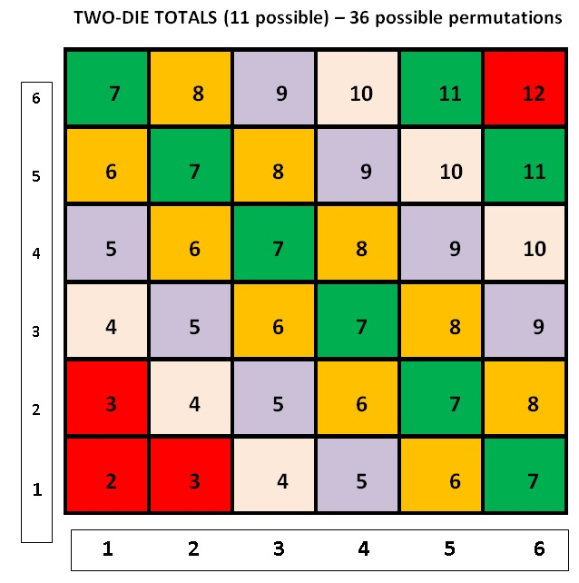
The upper left corner box : “7” is a sum of 1 and 6 (1,6) and the lower right corner box: “7” is the sum of 6 and 1 (6,1). The first die number is along the x-axis and the second die number is up the vertical y-axis. You can figure out the rest. In the dice game CRAPS, if you get a 7 or 11 on your first toss, you win. But, if you get a 2 (“snake eyes”), a 3 (“craps”), or a 12 (“box cars) on this first toss OR ANY SUBSEQUENT TOSS, you lose. Now, if you toss a 4, 5, 6, 8, 9, 10 on the first toss you keep going until you get that same number again, in which case you win, BUT if you get a 2, 3, 12 or NOW a 7 or 11, you LOSE. Check the odds and you will see why the HOUSE always wins.
Back to our probability problems.

WHAT IS THE PROBABILITY THAT IF YOU TOSS ONE DIE TWICE THE SUM OF THE TWO ROLLS IS AT LEAST 9 (i.e., 9, 10 , 11, or 12) (EVENT “A”) AND THAT ON THE FIRST TOSS, THE DIE NUMBER WAS A MULTIPLE OF 2 (EVENT “B”) ? WE WILL USE THE STAT JARGON AS WELL AS PLAIN ENGLISH.
The total number of possible pair totals is 36, so our SAMPLE SPACE or sample size, “n(S)” = 36
Event “A” would be all the pairs that total AT LEAST 9, which would be (3,6), (6,3), (4,5), (5,4), (6,4), (4,6), (5,5), (6,5), (5,6), and (6,6). There are 10 possible pairs, so n(A) = 10
Event “B” would be all pairs with the FIRST number being a multiple of 2 (this would include 2, 4, 6 only), which would be (2,1), (2,2), (2, 3), (2,4), (2,5), (2,6), (4,1), . . ., (4,6), (6,1),. . ., (6,6) or 18 pairs, hence n(B) = 18
NOW, since we asked for “A” AND “B” or (AB) we need to limit the pairs to those in “A” that also meet the “B” requirement: These would be: (6,3), (4,5), (6,4), (4,6), (6,5) and (6,6). So, the n(A and B) or n(AB) is 6.
We now calculate our PROBABILITIES and don’t forget that there are 36 possible pairs, which is the n(S) from above.
The Probability of “A” or P(A) = n(A)/n(S) = 10/36; The Probability of “B” or P(B) = n(B)/n(S) = 18/36; and the Probability of “A and B”, the P(AB) = n(AB)/n(S) = 6/36
The Probability of “A and B” GIVEN the the limitation of “B” is P(A|B) = P(AB) / P(B) = [(6/36) / (18/36)] = 6/18 = 1/3 or 0.333 or about 33%. Keep in mind also that these two events, “A” and “B” are NOT independent since “A” depends or on “B” or is modified or limited by “B”.
MOVING ON:
The math this week introduces a new symbol (!), which is the “FACTORIAL”. It just means a shortcut to writing out a long multiplication. For example 5! = 5 * 4 * 3 * 2 * 1 which equals 120. Imagine if you had 102!. One shortcut for an equation like 102! / 99! Is that a lo t cancels out. The 102 ! could be re-written as 102 * 101 * 100 * 99 ! / 99 ! The
99 ! ‘s cancel out leaving simply: 102 * 101 * 100 = 1,030,200 possibilities since everything from 99 down cancels out.

Let’s talk PERMUTATIONS. We could be dealing with a combination lock, or multi-colored marbles in a jar, or coins in your pocket, or students to call on in a class. You come up with some others. With PERMUTATIONS the ORDER of the numbers (or letters, or colors) MATTERS. For example: 1, 2, 3 would be considered a different permutation from 3, 2, 1.
We will first consider PERMUTATIONS WITH REPEATS (also referred to as “with replacement”). A combination lock is a good example (it should really be called a Permutation lock not a combination lock). Our lock has a three-number code, so we have 3 numbers required from sets of 10 choices: we can pick numbers from 0 to 9 (10 choices) for each of them. So, for the first setting we have 10 options, then 10 for the second and another 10 for the third. Our total choices are therefore 10 x 10 x 10 = 1000. You can see that since order matters in that a lock code of 1, 2, 3 is different than 3, 2, 1. Also since repeats are possible, codes like 2, 2, 2, and 0, 0, 0 are possible.
The general FORMULA for PERMUTATIONS is n ^{r} where “n” is the number of choices and “r” is the number of spots we need to fill with those choices. In the above problem n = 10 and r = 3 giving 10 ³ = 1000
PERMUTATIONS WITHOUT REPETITION (without replacement). Here the number of options (choices) is reduced every time we pick one. Let’s say we have 16 ping-pong balls numbered 1 – 16 in a bag. The first ball we pull out has 16 possibilities, but the second now only has 15 and the third 14, etc. (“without repetition” means that we are NOT replacing the balls after each withdrawal, so you could NOT get multiple 16’s or 8’s, etc.). So, if we are starting with 16 choices (and reducing by one with each selection), the number of possible permutations is: 16 x15 x 14 x 13 x 12 x 11 x 10 x 9 x 8 x 7 x 6 x 5 x 4 x 3 x 2 x 1 = 20,922,789,888,000. It is easier to write this type of multiplication as 16 !
If we were only concerned with the first 4 picks (not all 16), the permutations would simply be: 16 x 15 x 14 x 13 = 43,680
The mathematical formula for this determination is dividing our number of values we have to choose from (n = 16 here) by the number left after we take what we want (r = 4 here). This is 16 x 15 x 14 x 13 x 12 x . . . x 3 x 2 x 1 / 12 x 11 x 10 x . . .3 x 2 x 1 = 16 x 15 x 14 x 13 = 43, 680 since everything else cancels out. The formula is 16 ! / (16 – 4) ! = 16 ! / 12 ! Where everything 12 and below cancels out, leaving: 16 * 15 * 14 * 13 = 43,680.
The PERMUTATIONS FORMULA IS n ! / (n – r) !
Another example would be 15 horses in a race, how many ways can they come in first, second and third ? We have 15 values (n = 15) and we want to consider only the first three places (r = 3), hence using: n ! / (n – r) ! we have 15 ! / (15 – 3) ! = 15 ! / 12 ! = 15 x 14 x 13 = 2,730 possible permutations or ways our 15 horses could come in first, second and third. (Obviously, this is without repetition since the same horse can’t win, place and show.)
BUT, If we just wondered how many ways all 15 could come in, we would simply have 15 ! (THIS WOULD HAVE THE REPEATS INCLUDED). The permutations formula gives you this as well: Using the formula, this would be 15 ! / (15 – 15) ! = 15 ! /0 ! = 15 x 14 x 13 …x 3 x 2 x 1 = a very large number. NOTE THAT 0! EQUALS 1, NOT ZERO. You will need to remember this for one of the homework problems.
COMBINATIONS
We now move on to COMBINATIONS where the ORDER does NOT MATTER and NO REPEATS. This means that 3, 2, 1, is considered the same combination as 1, 2, 3 and 2, 3, 1 and 1, 3, 2 and 2, 1, 3 and finally 3, 1, 2 These 3 numbers can make 6 permutations (3!), but only 1 combination. The “no repeats” means that we won’t have 1, 1, 2 or 2, 3, 3, since we use each number only once in any series.
LOTTERIES are COMBINATIONS in that the order of your numbers does NOT matter, just getting the right numbers wins the prize. And, there are NO repeated numbers.
Our COMBINATIONS formula simply reduces the number of permutations by the number of ways the same numbers (or objects) could be in various orders (this is the “r” value).
The COMBINATIONS formula is n ! / (n-r) ! x 1 / r ! = n ! / [r ! * (n-r) ! ]
Remember the order in which to do calculations: take care of the ( ) first, then the [ ] and then FACTORIAL (which is a Multiplication) and finally the Division. Don’t forget that with factorials, a lot of number cancellation is usually possible, so you don’t have to multiply everything out. The COMBINATIONS formula can also be indicated as shown below.
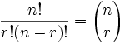
As an example, let’s say we have 10 Scrabble tiles, all with different letters: A, C, F, H, B, M, T, Q, S, P. How many 4 letter COMBINATIONS can we make from these 10 letters (I’m NOT asking how many actual words you can make). Remember too that these same 4 letters can be in any order but still only count as 1 combination (A,C, F, H is the same as H, A, F, C, etc). Plugging into the COMBINATIONS formula with n = 10 and r = 4, it’s

10 ! / [4 ! (10 – 4) !] = 10 ! / (4 ! * 6 !) = 10 * 9 * 8 * 7 / 4 ! = 5040 / 24 = 210 possible COMBINATIONS of 4 letters chosen from 10 possible letters. (The 6! In the denominator cancelled out the 6*5*4*3*2*1 part of the 10! Leaving only 10*9*8*7 in the numerator (and the 4! still in the denominator).
LASTLY, we come to COMBINATIONS WITH REPEATS (with replacement). This would be like being able to use the same Scrabble letter 1 or more times in each 4 letter combination: A, A, A, H.
A better example might be having 5 flavors of ice cream to choose from and wanting 3 scoops. But, you could have 3 scoops of the same flavor if you wanted (or you can have 3 different flavors, or you can have two dips of one flavor and 1 dip of another, etc.). We won’t derive this formula, so here it is
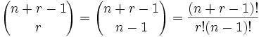
FORMULA SUMMARY: ORDER MATTERS OR IT DOESN’T AND REPEATS (replacements) ARE ALLOWED OR THEY ARE NOT ALLOWED.
1. (PERMUTATION) ORDER MATTERS AND REPEATS ALLOWED: WE HAVE “n” CHOICES AND WANT “r” OF THEM: n ^{r}
2. (PERMUTATION) ORDER MATTERS BUT NO REPEATS ALLOWED: “n” CHOICES AND WANT “r” OF THEM: n ! / (n – r) !
3. (COMBINATIONS) ORDER DOES NOT MATTER AND NO REPEATS: “n” CHOICES, WANT “r” OF THEM:
4. (COMBINATIONS) ORDER DOES NOT MATTER BUT REPEATS ALLOWED:
REMEMBER TOO THAT “r” CAN EQUAL “n” AND WE GET A “ 0 ! “ WHICH EQUALS 1 (NOT ZERO)
MOVING ON TO THE ACTUAL HOMEWORK (next page):
#1. You have a standard deck of playing cards (52 cards). What is the probability of pulling an ACE from this deck?
What is the probability of pulling a second ace? Then, a third ace? And, finally the fourth ace? What is the combined probability of pulling all four aces? (All of this is WITHOUT replacement, of course).
Solution
- A deck has 4 aces, therefore, the probability of pulling an ace is 4/52 = 1/13
- With 51 cards now left among them 3 aces, the probability of pulling a second ace is 3/51
- A third ace; P(3rd ace) = 2/50 = 1/25
- The fourth ace; P(4th ace) = 1/49
- Combined probability of pulling all the aces; P(all aces) = 1/13*3/51*1/25*1/49 = 24/6,497,400 or 0.0000037
#2. You toss a pair of DICE, once. (a) What are the odds (probability) that BOTH are EVEN numbers and their SUM equals “6”? (b) That both are ODD numbers and total “6” ? MAKE SURE TO SHOW YOUR SETUP AND WORK DETAILS (c) You toss a normal (balanced) COIN 6 times.?
- P(even) = ½, P(sum=6) = 5/36. This is because there 5 outcomes of a total of 6 and 37 possible outcomes. Therefore, the probability = ½ + 5/36 – 1/36 = 11/18
- P(both ODD and a total of 6) = 5/36 + 18/36 = 23/36
- Total number of outcomes is 2^6 = 64. So P(picking a head/tail) = 1/64
#3. 5,000 vehicles a day go through or around Baltimore continuing North on I-95. There are 4 major routes to do this: (H) I-295 the old Harbor Tunnel, (K) I-95 the new F.S. Key Tunnel, (B) I-695-s over the Sparrow’s Point Bridge, and (T) I-695-N past Towson: 35% use K, 20% use T, 25% use H and 20% use B. If you randomly select a vehicle approaching Baltimore from the South, what is the probability it will take route:
- H or K or B or T ?
P(H or K or B or T) = P(H) + P(K) + P(B) + P(T) = 0.25 + 0.4 + 0.15 + 0.2 = 1 or 100%
- B and T
P(B and T) = P(B)P(T) = 0.15 X 0.2 = 0.03 or 3%
- K or H or B
P(K or H or B) = P(K) + P(H) + P(B) = 0.4 + 0.25 + 0.15 = 0.8 or (80%)

BONUS (0.5 pts) A BINOMIAL problem has just TWO alternatives: heads/tails, right/wrong, black/white, yes/no, etc. An easy problem would be the COIN toss in question 2b above.

BUT, what if the coin is weighted so that heads comes up 75% (0.75) of the time and tails 25% ?
What is the probability that if you toss this coin 5 times you get at least 4 heads ? This problem requires a different formula since 4 wins and 5 wins are discrete numbers ( you can’t have 4.39 wins for example). You must calculate the probability of EACH options, 4 wins and then 5 wins in this case:

YOU NEED TO USE THE BINOMIAL FORMULA WHICH IS MORE COMPLEX.
P (k) = n! / [k! *(n-k)!] * p ^{k} * q ^{(n-k)}
To solve a complex equation like this all you need to know is the order in which to do the calculations. Here is that order: “Please Excuse My Dear Aunt Sally” of (PEMDAS). You FIRST do any calculations in { }, then [ ] then ( ). The order of the calculations is Exponents, then Multiplication, then Division, then Addition, and finally Subtraction. { } are “braces”, [ ] are brackets, and of course ( ) are parentheses: arranged like this { [ ( ) ] } For example: { 3+[4² * (5 – 2) +6] / 3} would be {3 + [16*(3) +6]/3} = {3+[54]/3} = {3+18} = 21

In the P(k) equation “n” is the number of tosses or 5 in this problem. “p” and “q’ are your binomial chances of success and failure and MUST add up to 1.00 In this case p = 0.75 and q = 0.25, (For a normal coin the probabilities of heads/tails are equal at 0.5 so in that case p and q would both be 0.5, but not here.)

“k” is the number of successes: 4 or 5 in this problem since we said “at least 4”. PLUG IN THE VALUES TO GET P(4) THEN TO GET P(5) AND THEN ADD THESE TWO CALCULATED PROBABILITIES UP to get the total probability of getting heads 4 or 5 times IN 5 TOSSES. REMEMBER that 0! = 1

You may notice that the first part of the complex equation with the factorials is the COMBINATIONS equation. These are the number of ways you can get “heads”. For example if you toss the weighted coin 4 times, how many ways can you get 4 “heads” (n = 4 and k = 4 here) combinations = 4!/[4! * (4 – 4) !] = 4!/(4!*0!) = 1 Only 1 way to get 4 “heads” meaning that you must get “heads” on each of the 4 tosses.
How about getting 3 heads (not 5) in 4 tosses? (n = 4 and k = 3 here) 4!/[3!*(4 – 3)!] = 4!/(3!*1!) = 4 (just 4 ways to get 3 heads. This means that you get “tails” on either toss 1, 2, 3, or 4 and heads on the 3 tosses you don’t get tails.
BUT, now we have to consider the PROBABILITIES (since this is a weighted coin) of heads/tails and how they affect the probabilities of these combinations. So, we multiply the number of combinations we calculated for 4 and 5 heads times those probabilities and then add those up to get the combined probability of tossing 4 or 5 heads out of 5 tosses with this particular coin.
BONUS HOMEWORK PROBLEM (0.5 pts): CALCULATE THIS TOTAL PROBABILITY OF GETTING 4 OR 5 HEADS IN 5 TOSSES WITH THIS WEIGHTED COIN USING THE ABOVE COMPLEX EQUATION.
An additional insight is that once you have calculated and totaled your binomial probabilities of tossing 4 or 5 heads (out of 5 tosses), if you subtract that probability from 1.00 you will have the probability that you only toss 0, 1, 2 or 3 heads out of those 5 tosses. Depending on HOW a binomial problem is stated, it may be easier to calculate the (1 – probability) but not in this case as you would have had FOUR different k-values to use: 0, 1, 2 and 3 rather than just 4 and 5. BY THE WAY WHAT IS THAT PROBABILITY OF GETTING ONLY 0, 1, 2 or 3 HEADS OUT OF 5 TOSSES?
THERE IS A SIMPLER WAY OF SOLVING THESE COMPLEX BINOMIAL PROBLEMS. LATER WE WILL IDENTIFY THE NORMAL APPROXIMATION OF THE BINOMIAL FORMULA, A MUCH SIMPLER APPROACH. IT IS NOT AS PRECISE, BUT CLOSE ENOUGH IN MOST CASES.
#4. You live in a small town that has 400 pick-up trucks in it of which 40% are Fords and 10% (of the total) have manual transmissions, and 5% have Fords with (and) manual transmissions. A pick-up drives down your street:
- What is the probability that it is a Ford OR has a manual transmission?
Hint: P ( F OR M) = P (F) + P (M) – P (F AND M) where “F” is FORD and “M” is Manual Transmission
P (F or M) = (0.4 + 0.05) – (0.4*0.05)
= 0.45 – 0.02
= 0.43
- What is P (NOT a FORD and does NOT have a Manual transmission) or P (NOT F AND M) (TRICKY)
= (1- 0.4)*(1-0.1)
= 0.6*0.9
= 0.54
#6. Table of Car Makes and their Colors on a Used Car Lot.
Car Make/ Color | Tan | Silver | Black | Red | Totals
Ford | 5 | 25 | 15 | 3 | 48
Chevy | 30 | 15 | 15 | 12 | 72
Totals | 35 | 40 | 30 | 15 | 120
(a) Fill in the Table
ASSUME A RANDOMLY SELECTED CAR FOR THE FOLLOWING
(b) Probability the car is a red Ford? (red AND Ford)
A: 3/120 = 1/40 or 0.025
(c) Probability the car is tan OR silver Ford?
P(A U B) = P(A) + P(B) – P(A)P(B I A)
5/48 + 25/48 = 30/48 0r 0.625
(d) Probability the car is a Ford OR Chevy
P(A U B) = P(A) + P(B) – P(A)P(B I A)
A: (48/120) + (72/120) = 6/25
120/120 = 1

(e) If there are other makes of cars on the lot, are the above probabilities still valid?
No. This is because more chances are added up besides Chevy or Ford hence lowering the total since all numbers are changed.
Problems based on Illowksy (Chapter 4)
#5. On Back-to-School night the teacher is offering raffle tickets to class parents to finance a field trip to the zoo. There are 100 tickets that cost $5 each. Assume all are sold. The stubs will be placed in a jar and the following SEVEN winning tickets will be drawn out: one $100, two $50 and four $25. HINT: This means that 93 persons lost $5.00
- WHAT IS YOUR CHANCE OF WINNING ANYTHING WITH 1 TICKET? What is the AVERAGE chance of winning anything?
Each of the 7 tickets has 1/100 chance of winning. I.e. 0.01
Tickets are replaced after each chance;
7 tickets, every chance = 1/100
P(100) = 1/100 or 0.01
P(50) = 2/100 or 0.02
P(25) = 4/100 or 0.04

Without replacement after drawing and big prices prioritized,
P(100) = 1/100 or 0.01
P(50) = 1/99 and 1/98 or 0.0101 and 0.0102
P(25) = 1/97, 1/96, 1/95 and 1/94 or 0.0103, 0.0104, 0.0105, and 0.0106

(b) WHAT IS YOUR POSSIBLE LOSS WITH 1 TICKET? AND, what is the AVERAGE loss for the group of 100 that bought these raffle tickets? Hint: Set up your Probability Distribution Table and don’t forget to subtract the cost of the ticket from any winnings. FILL IN THIS TABLE

X = (AMOUNT WON MINUS TICKET COST) |  |  | P(X) = (PROBABILITY OF X)
$WON | $COST | X = $NET | #/100 THIS APPLIES TO (AS 0.00) | X * P(X) = ($ AMOUNT LOST)
0.00 | 0 | 0 | _ | _
100 | 10 | 90 | 1/100 | 10
50 | 10 | 40 | 2/100 | 10
25 | 10 | 15 | 4/100 | 10
 |  |  | NET LOSS = | 30

I have higher chances of winning the smaller prizes as compared to the bigger prizes. I have a higher probability of wining $25. This means that I will have $15 after deducting the ticket price.
#6. UMUC has 30 Stat 200 classes each term (not true – there are more). Class size differs: two classes have 30, eight have 35, fifteen have 40 and five have 45 Determine the following:
- The total number of students in all these classes AND the average class size.
Total number of students = (2*30) + (8*35) + (15*40) + (5*45)
= 1,165 students
Average class size = total number of students / number of classes
= 1,165/30
= 38.83
(b) Assume full enrollment and pick a student name at random, what is the PROBABILITY, P(x), that this student is in any one of the 25 classes where “x” equals the size of the class., e.g. P(x = 35) = 9/25, etc. FILL IN THE FOLLOWING TABLE

STUDENTS PER CLASS = “X” | NUMBER OF CLASSES | # CLASSES/TOT CLASSES = P(X) | (x - μ)² * P(x)
30 | 1/25 | 30*0.04=1.2 | (30-38.83)²*1.2 = 93.563
35 | 8/25 | 35*0.32 = 11.2 | (35-38.83)²*11.2 = 164.292
40 | 15/25 | 40*0.6 = 24 | (40-38.83)²*24 = 32.854
45 | 5/25 | 45*0.2 = 9 | (45-38.83)²*9 = 342.620
TOTALS |  |  | 158.332
 |  | ^ THIS IS THE MEAN (μ) | ^THIS TOTAL IS THE VARIANCE
 |  | STANDARD DEVIATION =

Create and fill in the necessary Table
(In this TABLE the MEAN is the (µ) used in the last column to calculate the variance)
- Calculate the Mean of “x” the other way (not from the table): 1 class x 30 + 9 classes x 35 etc. / total classes =??
(93.563 + 164.292 + 32.854 + 342.620)/4
= 158.332
- Calculate the Variance and the Standard Deviation of “x” (THE SD IS THE SQRT OF THE VARIANCE)
93.563 + 164.292 + 32.854 + 342.620 = 633.329
Variance = 633.329
Standard deviation = √633.329
= 25.166

#7. REVIEW: LET’S TIE “REALTIVE FREQUENCY” TO PROBABILITY. FOR SIMPLICITY I HAVE GROUPED 45 NUMBERS INTO THE “USUAL” GROUPS OR RANGES. (One of the data points is “12”) FILL IN THIS TABLE
RANGE group | # DATA PTS =FREQUENCY | RELATIVE FREQ | CUMULATIVE REL FREQ
1-10 | 5 | 5 | 5
11-20 | 10 | 10 | 15
21-30 | 15 | 15 | 30
31-40 | 10 | 10 | 40
41-50 | 5 | 5 | 45

IF YOU PICKED A DATA POINT AT RANDOM, WHT IS THE PROBABILITY IT IS:
- In GROUP 1 5/45 = 0.111
- In GROUP 3 15/45 = 0.333
- Is the number 12 10/45 =0.222
- Is a number less than 31 (30 or less) 1-(10/45+5/45) = 0.555
- Is a number between AND including 21 and 40 15/45*10/45 = 0.555

#8 REVIEW: Here is a box plot. Answer the following questions:

30 45 60 80 110
(a) What does each of the five numbers refer to?
30 - Minimum value
45 – 25th percentile
60 – Median
80 – 75th percentile
110 – Maximum value
(b) What is the RANGE?
Range = 110 – 30
= 80
(c) What is the IQR?
IQR = 80 – 45
= 45
(d) What percent of data are between 45 and 80? Why?
80 – 45 = 35
35/80 * 100%
= 43.75%
(e) What percent of data points are less than 60?
80 – 60 = 25
(f) What percent of data points are greater than 80?
110 – 80 = 30
(g) How many TOTAL data points are there in this set of sample data (BE CAREFUL)?
Four (4).

TEXT PROBLEMS:
#9
An LG Dishwasher, which costs $800, has a 20% chance of needing to be replaced in the first 2years of purchase. A two-year extended warrantee costs $112.10 on a dishwasher. What is the expected value of the extended warranty assuming it is replaced in the first 2 years?
X = 800; P(x) = 0.2
X = 112.10; P(x’) = (1 - 0.2)
xP(x) = 800*0.2
= 160
xP(x) = 112.10*0.8
= 89.68

#10
Approximately 10% of all people are left-handed. Consider a grouping of fifteen people.
a.)State the random variable.
P (x) = 1, 2, 3, 4, 5, 6, 7, 8, 9, 10, 11, 12, 13, 14, 15
b.)Write the probability distribution.
X 1, 2, 3,,,15
P(x) 0.1
c.)Draw a histogram.

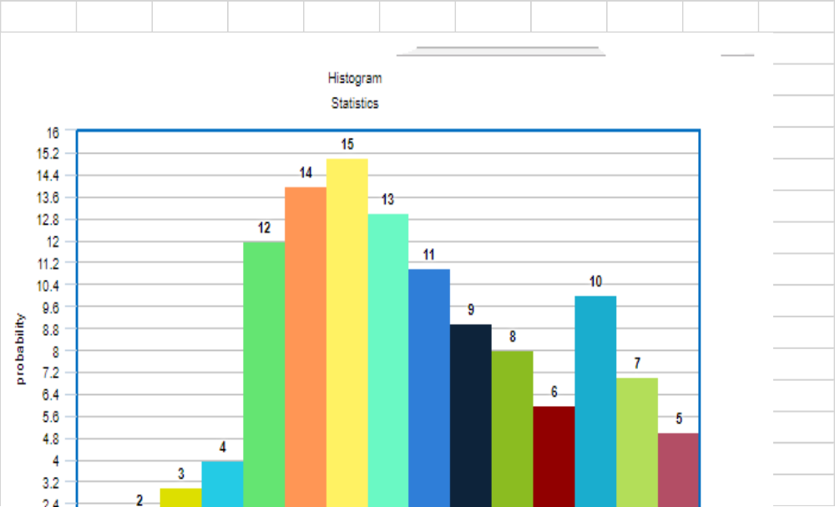
d.)Describe the shape of the histogram.
This histogram shows skewness to the left. This is an indication that it is weighted on the initial values of the distribution.
e.)Find the mean.
Mean = 7.5
f.)Find the variance.
=65
g.) Find the standard deviation
=8.06

#11 (0.5 pts). Qualitative data are “measured’ on which SCALE(S): (a) nominal, (b) ordnial, (c) ratio (d) interval (CIRCLE ALL THAT THIS APPLIES TO). Whis statistics can be calculated for qualitative data? : ordinal and nominal scales

#12 (0.5). WHICH OF THESE SCATTER PLOTS WOULD GIVE YOU MORE CONFIDENCE IN THE interval (WHICH STATISTIC?) AND WHY? (BECAUSE OF WHICH STATISTIC) Ratio

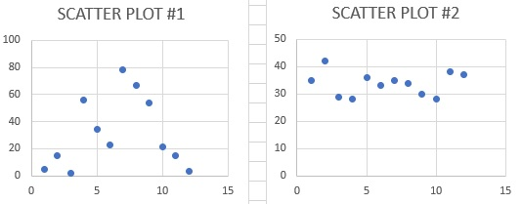 The second scatter diagram.

#13 (1). ELEVEN DATA x-Values: 2, 33, 41, 29, 41, 49, 41, 34, 56, 50, 97 (CALCULATE BY HAND, CHECK WITH SOFTWARE):
MEAN = 43 , VARIANCE = 276.363636 , STD DEV = 21.82575626, MODE = 41 (appeared 3 times) Q1 = 33.5, Q2 = 41 , Q3 = 49.5 , IQR = 41.5

#14 (1). (a) DRAW A BOX PLOT FOR THESE DATA (FROM #3) AND LABLE WHAT THE NUMBERS MEAN ON THE PLOT.

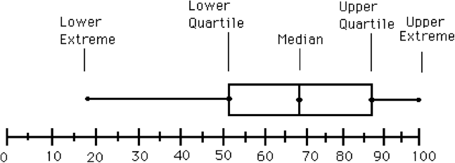

- Which of the statistics (from #3) are NOT shown on a box plot?
Mode, standard deviation, interquartile range and variance
- What else does a box plot NOT tell us about our data?
Samping distribution

#15 (1). Draw a STEM AND LEAF diagram of the data in #3
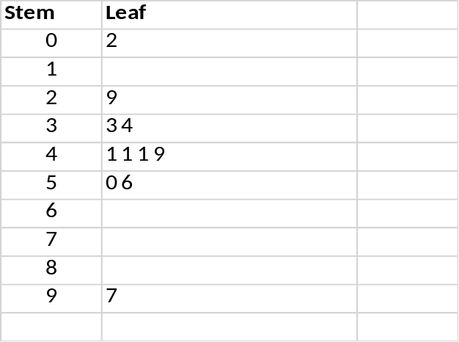

#16 (1). What are the RANK AND ACTUAL DATA VALUE OF THE 65th PERCENTILE (USE FORMULA: R = P/100 * (N+1) in the data list in #3 RANK IS 62/100 ; ACTUAL DATA VALUE WITH THAT RANK IS 61.75

#17 (1). Here are 7 letters (or we could have used numbers): A, T, Y, P, N, B, X MUST SHOW YOUR SETUPS
- How many COMBINATIONS can you make using all 7 letters ?
Combinations = 7! / 2! * (7-2)!
7*6*5*4*3*2*1 / (2*5*4*3*2)
= 21
- How many PERMUTATIONS can you make using all 7 letters
Permutations = 7!/ (7-2)! = 42
- How many COMBINATIONS can you make using 3 of the 7 letters ?
= 7! / 3! * (7-3)!
= 7*6*5*4*3*2*1 / 3*2*1*4*3*2*1
= 35
- How many PERMUTATIONS can you make using 3 of the 7 letters ?
= 7!/(7-3)!
= 7*6*5*4*3*2*1 / 3*2*1
= 210
#18 (1) Of 31 patients in a waiting room, 14 have colds, 6 have the flu, and 2 have both. Do these percentage account for all the patients? NO, only 22 patients are reported. What does this mean? It means that all patients have not been accounted for. To achieve a full representation, the percentages should add up to 100 percent.
What is the probability a patient picked at random has a cold or the flu?
14/31 * 6/31
= 84/961 or 0.087
#19 (1) HERE IS THE FREQUENCY DISTRIBUTION OF 100 DATA POINTS AND THE RESULTING FREQUENCY HISTOGRAM
RANGE | 1-10 | 11-20 | 21-30 | 31-40 | 41-50 | 51-60 | 61-70 | 71-80 | 81=90 | 91-100
FREQUENCY | 2 | 6 | 8 | 15 | 21 | 22 | 14 | 7 | 4 | 1
ASSUME THESE 100 DATA VALUES ARE ALSO WRITTEN ON SLIPS OF PAPER AND PUT IN A “HAT”
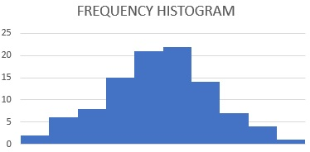 | ANSWER THE FOLLOWING QUESTIONS  IF YOU PULL A NUMBER FROM THE HAT, WHAT IS THE PROBABILITY IT IS IN  - GROUP 1 0.02  - GROUPS 1 OR 2 0.0012  - GROUPS 1, 2 OR 3 0.000096  - GROUP 10 0.01  - GROUPS 9 OR 10 0.0004  - GROUPS 8, 9 OR 10 0.00028  - GROUPS 1 through 7_1-0.0004 = 0.9996_____________

