Discriminant Function Analysis
Researchers use discriminant function analysis (DFA) to predict group membership based on two or more independent variables (Green & Salkind, 2017). The purpose of this study was to determine if population, grants, teaching, and committee can predict whether a professor is a research scientist or a teaching mogul. Prior to conducting the DFA, I tested the assumptions of multivariate normal distributions, equal variances and covariances, and random sampling.
Research Question
What is the contribution of population, grants, teaching, and committee to whether a professor is a research scientist or a teaching mogul?
Hypotheses
H₀: There is not a statistically significant relationship between population, grants, teaching, and committee to whether a professor is a research scientist or a teaching mogul.
H₁: There is a statistically significant relationship between population, grants, teaching, and committee to whether a professor is a research scientist or a teaching mogul.
Results
In this subheading, I present the descriptive statistics, including the means and standard deviations of the independent and dependent variables. I tested the assumptions of multivariate normal distributions, equal variances and covariances, and random sampling. The results conclude with the results of the discriminant function analysis.
Descriptive Statistics
A total of 50 professors participated in the study, with 25 in each group (research scientist/teaching mogul). Table 1 provides the means and standard deviations of the two groups by the four independent variables. Teaching mogul had higher mean scores on all four independent variables.

Table 1

Descriptive Statistics by Professor Type

Type of professor |  | M | SD
Research Scientist | Number of publications in last 2 years | 2.9200 | .81240
Research Scientist | Grant funding (in $10000) over the last 5 yrs
Research Scientist | Mean teaching rating for last 3 semesters
Research Scientist | Number of committees served on during last 5 yrs
Teaching Mogul | Number of publications in last 2 years | 3.48 | .82260
Teaching Mogul | Grant funding (in $10000) over the last 5 yrs
Teaching Mogul | Mean teaching rating for last 3 semesters
Teaching Mogul | Number of committees served on during last 5 yrs
Total | Number of publications in last 2 yrs | 3.2000 | .85714
Total | Grant funding (in $10000) over the last 5 yrs
Total | Mean teaching rating for last 3 semesters
Total | Number of committees served on during last 5 yrs

Tests of Assumptions
I tested the assumptions of multivariate normal distributions, equal variances, and random sampling. To test for multivariate normal distributions, I examined histograms of each independent variable by type of professor (see Figures 1 – 4). The results indicated that grant funding was skewed to the left for both groups. The other distributions appeared normal.
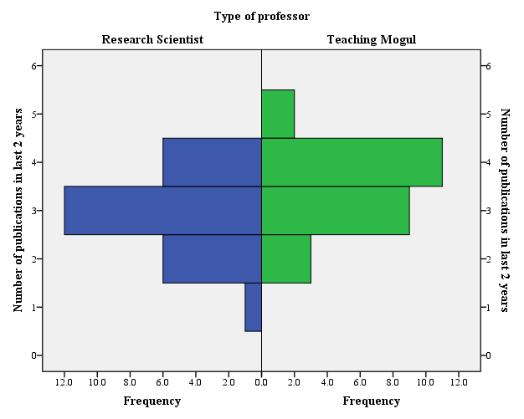

Figure 1. Histogram of number of publications by type of professor.
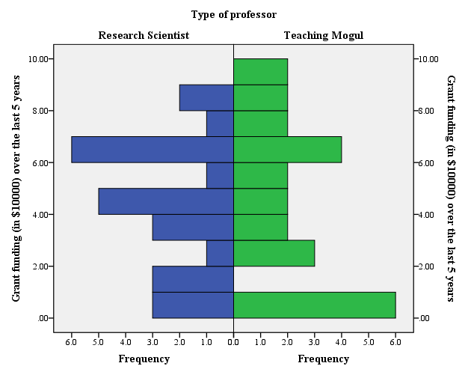
Figure 2. Histogram of grant funding by type of professor.

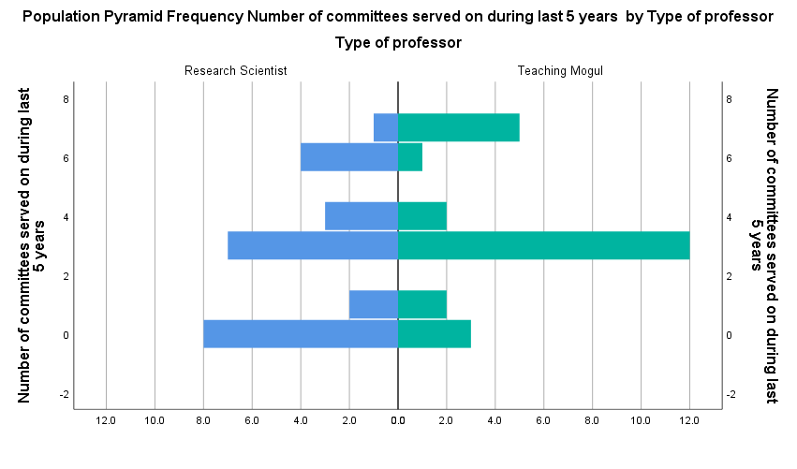

Figure 3. Histogram of committee membership by type of professor.

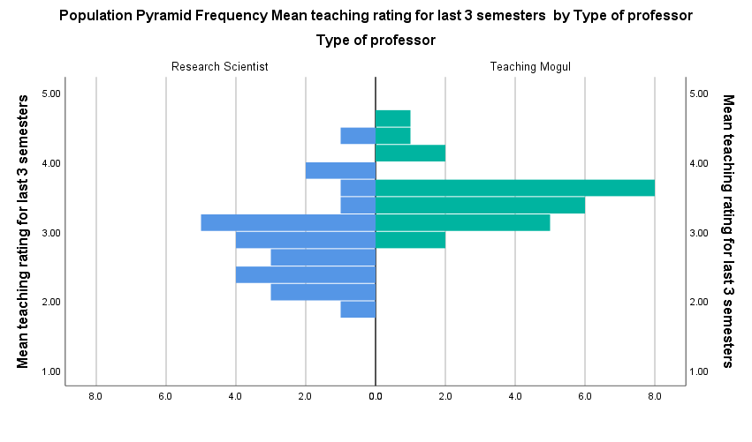

Figure 4. Histogram of teaching rating by type of professor.

To test the assumption of equal variances, I examined Box’s M. The results were not significant, F(10, 11015.14) = 1.283, Box’s M = 14.104, p = .234 (see Table 2). This result reveals the groups had equal variances. Participants were randomly selected from all professors at one university.
Table 2
Test of Equal Population Covariance Matrices
Box's M |  | 14.104
F | Approx. | 1.283
F | df1 | 10
F | df2 | 11015.139
F | p | .234
The results of the test of equality of group means (see Table 3) reveals that grant funding (p = 0) and number of committees (p = 0) were not significantly different. Both number of publications (λ = 0, p = 0) and mean teaching rate (λ = 0, p < .001) were significant (see Table 3).

Table 3
Tests of Equality of Group Means
 | Wilks' Lambda | F | df1 | df2 | P
Number of publications in last 2 years
Grant funding (in $10000) over the last 5 years
Mean teaching rating for last 3 semesters
Number of committees served on during last 5 years

Inferential Results
Discriminant function analysis, α = .05, was used to examine if there is a statistically significant relationship between population, grants, teaching, and committee, and whether a professor is a research scientist or a teaching mogul. The independent variables were population, grants, teaching, and committee. The dependent variable was type with 2 groups: research scientist and teaching mogul. The results indicate there is one significant discriminant function (λ = _, p < .001, see Table 4).
Table 4

Wilks' Lambda

Test of Function(s) | Wilks' Lambda | Chi-square | df | p
1

Table 5 presents the structure matrix. The results indicate that a one standard deviation increase on the _ variable will result in a standard deviation increase in the predicted values on discriminant function 1. A one standard deviation increase on the mean _ will result in a _ standard deviation increase in the predicted values on discriminant function 1. A one standard deviation increase on the mean _ will result in a _ standard deviation increase in the predicted values on discriminant function 1. Finally, a one standard deviation increase on the _ will result in a _ standard deviation increase in the predicted values on discriminant function 1.
Group membership = ._ * teaching + .44 * _ + _ * committees + _ * grants.
Table 5

Structure Matrix

Function
1
Mean teaching rating for last 3 semesters
Number of publications in last 2 years
Number of committees served on during last 5 years
Grant funding (in $10000) over the last 5 years

The discriminant function analysis classification correctly classified 20 of the _ _ and 22 of _ _. This resulted in an 84% correct classification of the participants. Cross-validating the results slightly decreased correct classification to 78% (see Table 6).

Table 6

Classification Results^{a,c}

 |  | Type of professor | Predicted Group Membership |  | Total
 |  | Type of professor | Research Scientist | Teaching Mogul | Total
Original | Count | Research Scientist
Original | Count | Teaching Mogul
Original | % | Research Scientist
Original | % | Teaching Mogul
Cross-validated^{b} | Count | Research Scientist
Cross-validated^{b} | Count | Teaching Mogul
Cross-validated^{b} | % | Research Scientist
Cross-validated^{b} | % | Teaching Mogul
a. 84.0% of original grouped cases correctly classified.
b. Cross validation is done only for those cases in the analysis. In cross validation, each case is classified by the functions derived from all cases other than that case.
c. 78.0% of cross-validated grouped cases correctly classified.

Differences Between Regression and Discriminant Analysis
According to Green and Salkind (2017) regression

Discuss the differences in the dependent variable, the hypothesis, and the conclusions.
References
Green, S. B., & Salkind, N. J. (2017). Using SPSS for Windows and Macintosh: Analyzing and understanding data (8th ed.). Upper Saddle River, NJ: Pearson.

Appendix

Analysis Case Processing Summary
Unweighted Cases |  | N | Percent
Valid |  | 25 | 50.0
Excluded | Missing or out-of-range group codes | 25 | 50.0
Excluded | At least one missing discriminating variable | 0 | .0
Excluded | Both missing or out-of-range group codes and at least one missing discriminating variable | 0 | .0
Excluded | Total | 25 | 50.0
Total |  | 50 | 100.0

Group Statistics
Type of professor |  | Mean | Std. Deviation | Valid N (listwise)
 |  | Mean | Std. Deviation | Unweighted | Weighted
Teaching Mogul | Number of publications in last 2 years | 3.4800 | .82260 | 25 | 25.000
Teaching Mogul | Grant funding (in $10000) over the last 5 years | 4.5471 | 3.17875 | 25 | 25.000
Teaching Mogul | Mean teaching rating for last 3 semesters | 3.5122 | .42025 | 25 | 25.000
Teaching Mogul | Number of committees served on during last 5 years | 3.4800 | 2.23830 | 25 | 25.000
Total | Number of publications in last 2 years | 3.4800 | .82260 | 25 | 25.000
Total | Grant funding (in $10000) over the last 5 years | 4.5471 | 3.17875 | 25 | 25.000
Total | Mean teaching rating for last 3 semesters | 3.5122 | .42025 | 25 | 25.000
Total | Number of committees served on during last 5 years | 3.4800 | 2.23830 | 25 | 25.000

Tests of Equality of Group Meansª
a. The univariate F-ratios cannot be computed because there is only one non-empty group.

Pooled Within-Groups Matricesª
 |  | Number of publications in last 2 years | Grant funding (in $10000) over the last 5 years | Mean teaching rating for last 3 semesters | Number of committees served on during last 5 years
Covariance | Number of publications in last 2 years | .677 | -.292 | -.149 | .302
Covariance | Grant funding (in $10000) over the last 5 years | -.292 | 10.104 | .068 | 4.630
Covariance | Mean teaching rating for last 3 semesters | -.149 | .068 | .177 | -.222
Covariance | Number of committees served on during last 5 years | .302 | 4.630 | -.222 | 5.010
Correlation | Number of publications in last 2 years | 1.000 | -.112 | -.431 | .164
Correlation | Grant funding (in $10000) over the last 5 years | -.112 | 1.000 | .051 | .651
Correlation | Mean teaching rating for last 3 semesters | -.431 | .051 | 1.000 | -.236
Correlation | Number of committees served on during last 5 years | .164 | .651 | -.236 | 1.000
a. The covariance matrix has 24 degrees of freedom.

Covariance Matricesª
Type of professor |  | Number of publications in last 2 years | Grant funding (in $10000) over the last 5 years | Mean teaching rating for last 3 semesters | Number of committees served on during last 5 years
Teaching Mogul | Number of publications in last 2 years | .677 | -.292 | -.149 | .302
Teaching Mogul | Grant funding (in $10000) over the last 5 years | -.292 | 10.104 | .068 | 4.630
Teaching Mogul | Mean teaching rating for last 3 semesters | -.149 | .068 | .177 | -.222
Teaching Mogul | Number of committees served on during last 5 years | .302 | 4.630 | -.222 | 5.010
Total | Number of publications in last 2 years | .677 | -.292 | -.149 | .302
Total | Grant funding (in $10000) over the last 5 years | -.292 | 10.104 | .068 | 4.630
Total | Mean teaching rating for last 3 semesters | -.149 | .068 | .177 | -.222
Total | Number of committees served on during last 5 years | .302 | 4.630 | -.222 | 5.010
a. The total covariance matrix has 24 degrees of freedom.

